Team Name: LXY Team

Project Name: Alpha FLY

### Tech:

·Python django

·Angular

·DATABASE - sqlite

### Purpose:

Stock traders need an application that will allow them to analyze and display information and metrics about assets such as stocks, or etf securities.

The tool will allow end users to request stock and etf securities and reports, including data analytics across the entire data set available, and visualize all the result data. The project includes functionality for logging use of the system on a user.

### Scope:

Download yfinance data from internet, help to manage users’ portfolio.

### Features:

1. Allow users to create and access user accounts for security reasos.

1.Allow customers to filter, sort data sets, visualize and calculate performance metrics across an entire data set.

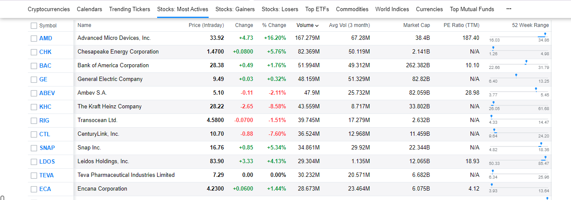

(click the column name to sort):

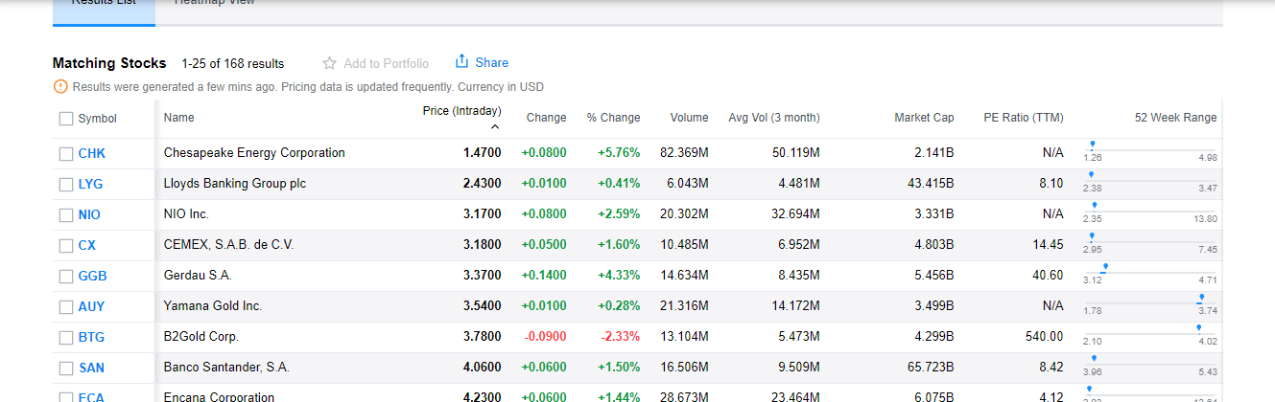

(click left options to filter)

2. Retrieve prices for FX Rates and Securities between 2 time points

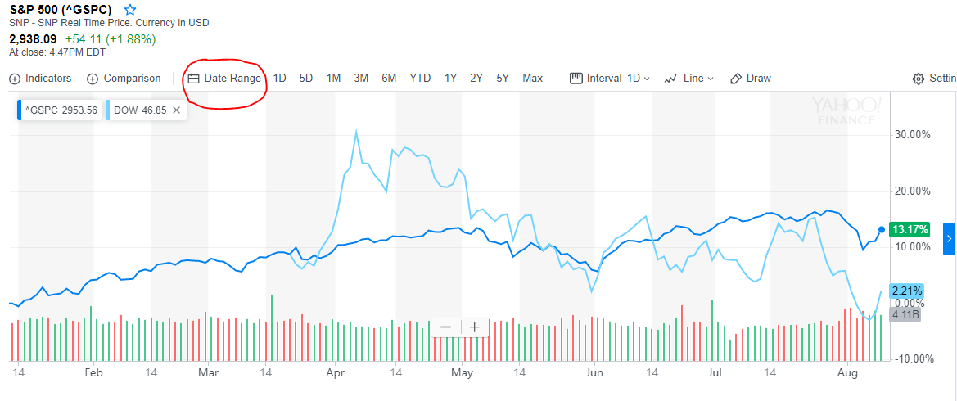

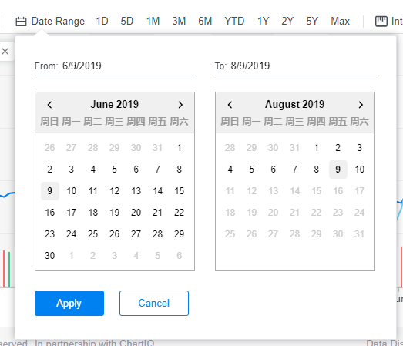

(click Date Range to choose two different dates to show prices for FX Rates and Securities between these.)

3. Securties are stocks, etfs



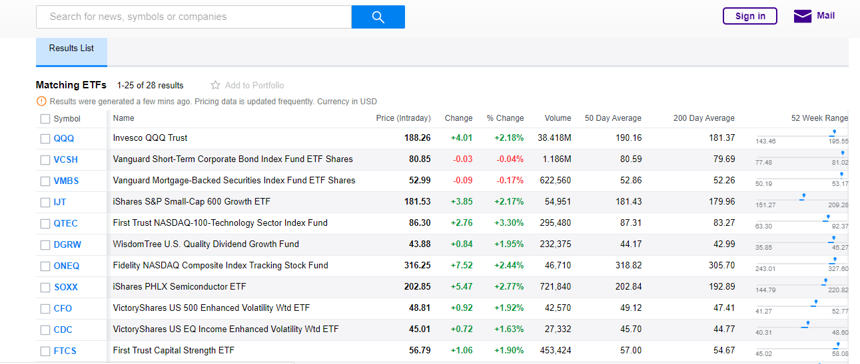

4. Allow the user to perform the following visualization features.

A. Compare performance of different securities on same screen

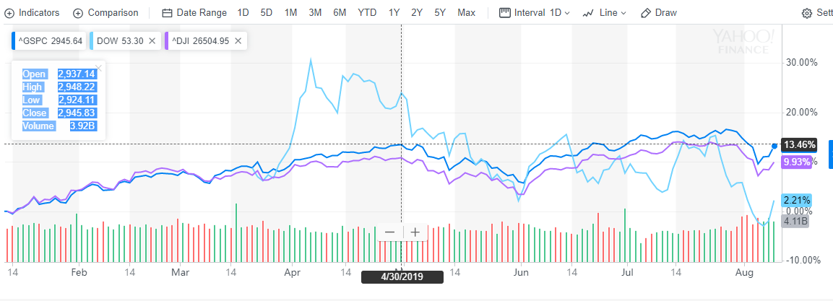

(click the Comparisen button to add one or more stocks which need to be compared with.)

B. Perform interpolation to day, week, month, quarter, year

C. Display OHLC and intra day prices for any set if assets

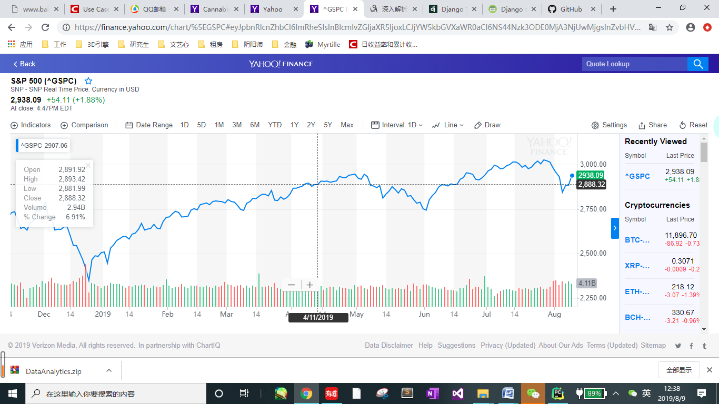

(When the cursor moves over the chart, OHLC and intra day prices are displayed.)

7. Support different chart types – line, bar, candle stick

## UseCase:

**For Logged-in User:**

create and view portfolios.

**For visitors:**

Register, log

Browse the stock/ETF interface

**For Administrator:**

Manage Users

Manage database

audit