
SCSM2223
Cross-Platform Application Development

SEMESTER 2 2025/2026

Chapter 8 - Connecting Vue to Backend

Employee Directory with Vue 3, Axios, Express and MySQL

Individual Assignment 1

SECTION 04
Lecturer: DR. HASMUNI
NAME: Zuo Boyu
MATRIC NO: A24CS4045
1. Working UI Screenshots
Figure 1 depicts the laptop screen layout with the summary cards, add/edit form, sorting/searching controls, pagination, and badges for active/inactive status. Figure 2 shows how the layout looks on a tablet-sized screen. All elements appear stacked without any need for horizontal scrolling.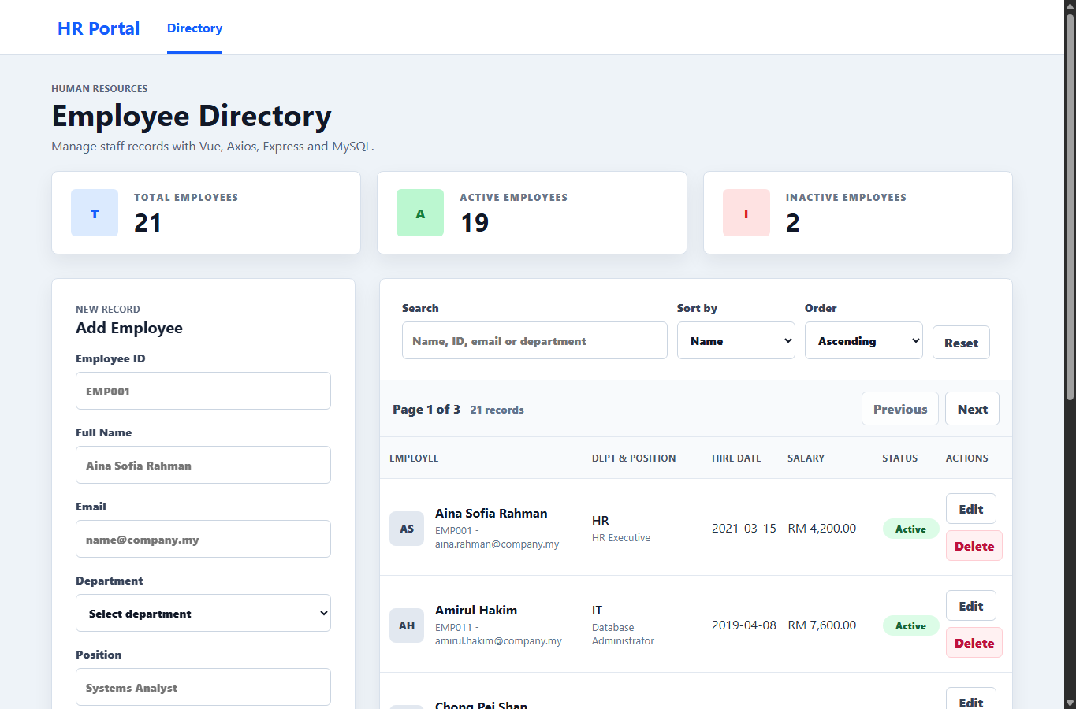
Figure 1. Laptop view (>=1024 px): summary cards, form, paginated table, status badges, RM salaries.
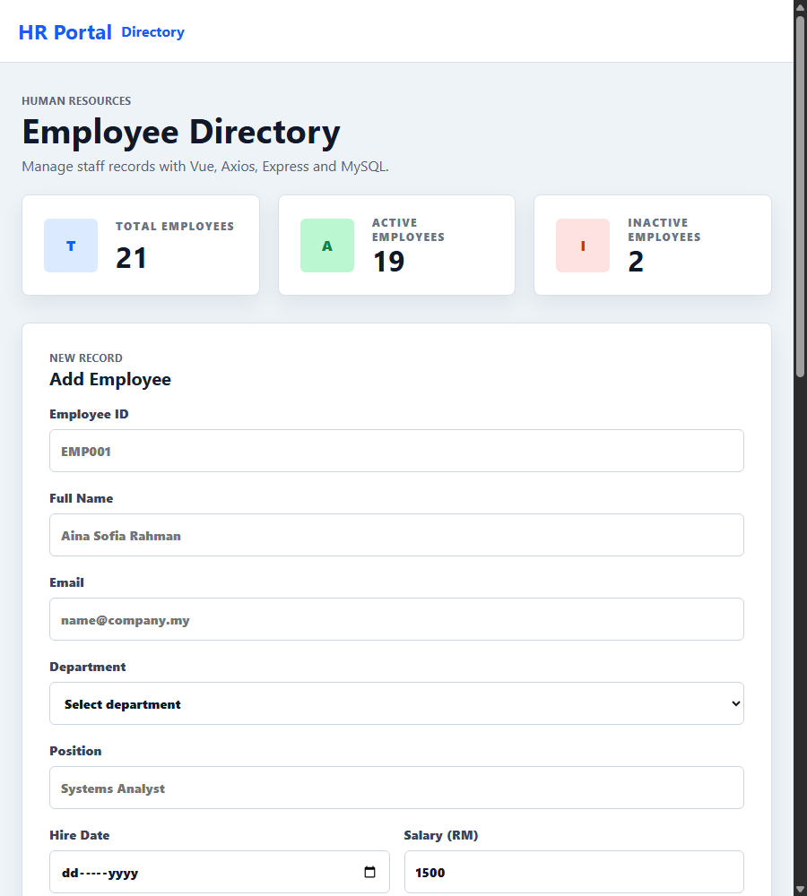
Figure 2. Tablet view (>=768 px): the workspace grid collapses to a single column.
2. Chapter 8 Learning Outcomes
Learning Outcome | How the project satisfies it | Where to look (file:line)
Connect Vue to a REST backend. | App.vue contains employees and loading flags, onMounted calls loadEmployees() and any errors will be reported using a banner. | src/App.vue:28, 30-53, 148
Use Axios with interceptors and async/await. | A single axios.create() with baseURL/timeout/headers. The request interceptor logs each request the response interceptor converts each error into an object {message, status, errors}. All usage is done through async/await. | src/services/api.js:3, 12, 18, 35-52
Validated Vue forms with v-model and emits. | EmployeeForm.vue uses v-model.trim for text inputs and v-model.number for Salary. validate() checks all seven conditions, field-level validation messages appear before submission, and the payload is sent up to the parent component. | src/components/EmployeeForm.vue:73-94, 135, 177, 50
CRUD against MySQL with prepared statements, search, and sort. | Express server handles GET/POST/PUT/DELETE /employees. LIKE searches across four columns; ORDER BY only allows whitelisted columns, all values have a placeholder ? including LIMIT/OFFSET; mysql2/promise pooling. | server/index.js:12, 26-73, 89, 120, 154; server/db.js:4
3. Architecture and Component Structure
- Parent state: App.vue owns employees, filters, pagination metadata, and the currently selected employee. Sub never calls the API directly.
- Children and emits: EmployeeForm can operate save/cancel; EmployeeList emits edit/delete/page-change; SearchSortControls emits change with debounced search and whitelisted sort keys.
- Service layer: src/services/api.js is the only file that imports Axios. Components import named functions and stay transport-agnostic.
- Validation boundary: in EmployeeForm.validate() for inline feedback, and in server validateEmployee() as the authoritative gate before any SQL write. Duplicate empId/email becomes a friendly per-field error via the ER_DUP_ENTRY handler.

4. Challenges and Resolutions
- Sorted safely: req.query.sortBy was mapped via a constant whitelist object, while unknown sortBy keys would fall back to the name field. The direction would be simplified to either ASC or DESC string literal.
- Diverse Axios errors: 5xx errors from server validation, server downtime, DNS issues and timeouts are all formatted as unique Axios errors. The response interceptor transforms these into uniform {message,status,errors} object consumable by the UI.
- IPv6 vs IPv4 on Windows/Laragon: Node 21 connects to 'localhost' as::1 IP, while the Laragon database listens only on IPv4. The pool and CORS allow list are restricted to the localhost address to prevent ECONNREFUSED.
- Table: When screens <= 768px, the workspace cards collapse to a single column, and the table resides in a safe horizontal container to ensure access to the Actions columns even when the card is shrunk.
5. Extensions Beyond the Brief
- Server-side paging with integer clamping and only one count query, which gives all three counts in one request.
- Search functionality expanded to include the fourth attribute (department), in addition to the three required attributes.
- Defensive server-side validation that duplicates client-side rules and ensures that the API is safe to be used even outside the Vue application.
6. Sources and References
- Vue 3 - Composition API :https://vuejs.org/guide/introduction.html
- Vite configuration: https://vitejs.dev/config/
- Axios - instance configuration: https://axios.rest/pages/advanced/interceptors

