Chapter 8 Individual Assignment Report
Employee Directory with Vue 3, Axios, Express and MySQL
Name | ZUO BOYU | Matric No. | A24CS4045
Course | Cross Platform Application Development | Project | Employee Directory
1. Working User Interface
The Employee Directory is a single-page HR admin interface with summary cards, an add/edit form, search and sort controls, paginated employee records, and visible active/inactive status badges.
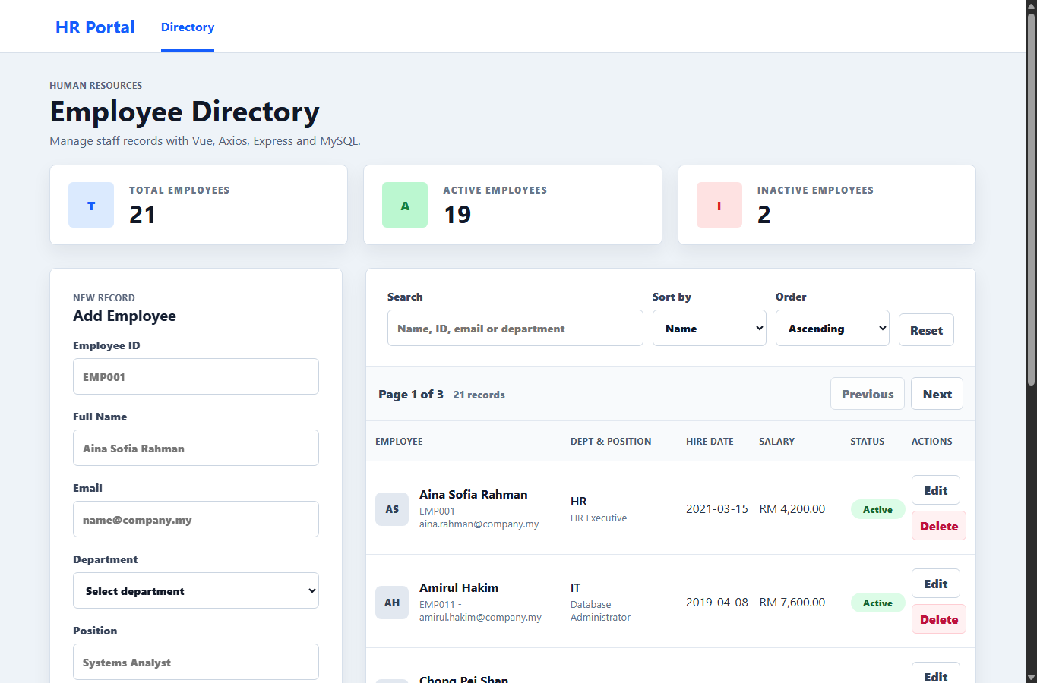
Figure 1. Employee Directory frontend with 21 seeded employees and pagination.

2. How the Project Meets the Brief
Area | Brief Requirement | Implementation
Frontend | Vue 3 Composition API with Vite. | Uses .vue components, <script setup>, parent-held state, props, and emits.
Axios | Single Axios instance with interceptors. | src/services/api.js defines baseURL, timeout, headers, request logging, and mapped error messages.
Backend | Express API with /employees CRUD. | server/index.cjs implements GET, POST, PUT, DELETE, search, sort, and pagination.
Database | MySQL with mysql2 promise pool and prepared statements. | server/db.cjs uses mysql2/promise; SQL values use ? placeholders.
Seed data | At least 7 employees across 3 departments with inactive staff. | schema.sql now inserts 21 employees across five departments, including inactive records.
UX | Loading, error, active/inactive display, RM formatting, responsive layout. | EmployeeList shows loading/empty states, badges, MYR currency, and page controls.
3. Learning Outcomes
- LO1: Vue connects to an external REST API and refreshes employee data from the Express backend.
- LO2: Axios is configured as a reusable service module with central request and response handling.
- LO3: The form uses v-model modifiers, custom validation rules, and inline messages before submission.
- LO4: MySQL persistence is handled through prepared statements with CRUD, server-side search, sort, and pagination.

4. Main Features
- Create, read, update, and delete employee records through /employees.
- Search by name, employee ID, email, or department using SQL LIKE.
- Sort by whitelisted fields: name, hire date, salary, and department.
- Switch pages with 7 employees per page across 21 seed records.
- Show total, active, and inactive headcount in summary cards.
5. Challenges and Resolutions
Database connection:
- The API was updated to use 127.0.0.1 by default to avoid localhost IPv6 connection issues on Windows/Laragon.
Safe sorting:
- The server maps requested sort fields to a whitelist before building the ORDER BY clause.
Responsive layout:
- The UI was adjusted to remove sidebar crowding, keep the Actions column visible, and stack the form above the table on tablet widths.
6. Setup Summary
- Import sql/schema.sql into Laragon MySQL.
- Run npm install in the employee-directory folder.
- Start the app with npm run dev or .\start-app.ps1.
- Open http://127.0.0.1:5174 for the Vue frontend; the API runs on http://127.0.0.1:3001.

