
SCSE2123 : Software Requirements Engineering
Semester 01, 2025/2026

Alternative Assessment
High-Fidelity Prototype:
Wallet Withdrawal & Fraud Control System
PART I
Scenario Document

Prepared by:
ZUO BOYU
A24CS4045
01

Contents
1. Introduction 2
2. Use Case Scenario — UC-008 Reinvest Funds 2
2.1 UC-008-N1 Normal Flow — Successful Reinvestment 2
2.2 Alternative Flow 3
2.3 Exception Flow 3
3. Misuse Case Scenario — MUC-003 Perform Fraudulent Reinvestment 4
3.1 Misuse Case Description 4
3.2 Misuse Scenario Flow 5
MUC-003-M1 Fraudulent Reinvestment Attempt 5
3.3 Misuse Outcome and Mitigation 5
4. Security Use Case Scenario — UC-010 Fraud & AML Screening 5
4.1 Security Use Case Description 5
4.2 Screening Outcomes 5
4.3 Security Notes 6
5. Security Mitigation and User Actions 6
5.1 Security Tips 6
5.2 Two-Factor Authentication (2FA) 6
5.3 Report Suspicious Activity 6
6. Admin and Audit Scenario — UC-014 6
6.1 Audit Evidence Scenario 6
6.2 Audit Scope 7
7. Kano Model Mapping (UC-008) 7
Basic Requirements 7
Performance Requirements 7
8. Supporting Notes 7

1. Introduction
This scenario document describes how the high-fidelity prototype demonstrates all required interactions for:
- Use Case: UC-008 -Reinvest Funds
- Misuse Case: MUC-003 – Perform Fraudulent Withdrawal
- Security Use Case: UC-010 – Fraud & AML Screening (Mitigation)
- Supporting Security & Audit Functions
The prototype is implemented using Express + EJS and follows a Maybank-inspired UI design.
All scenarios include normal, alternative, exception, misuse, and mitigation flows.

2. Use Case Scenario — UC-008 Reinvest Funds

2.1 UC-008-N1 Normal Flow — Successful Reinvestment
Scenario ID: UC-008-N1
Primary Actor: Customer
Goal: Reinvest wallet funds into an eligible Etiqa product
Preconditions: Logged in + passed 2FA; sufficient wallet balance; product exists; eligibility (UC-009) and screening (UC-010) available.
Step | User Action | System Response | Route / UI
1 | Customer selects Reinvest Funds | Displays reinvest form (product list + amount) | GET /reinvest
2 | Select product + enter amount | Stores input in session | POST /reinvest → redirect
3 | Review and confirm | Displays confirmation | GET /reinvest/confirm
4 | Tap Confirm | Checks wallet balance | POST /reinvest/confirm
5 | — | Runs eligibility validation (UC-009) | GET /reinvest/eligibility
6 | — | Eligibility passes | GET /reinvest/eligibility/result → redirect screening
7 | — | Runs Fraud/AML screening (UC-010) | GET /reinvest/screening
8 | — | Screening passes; creates reinvest transaction | GET /reinvest/screening/result
9 | — | Debits wallet balance and confirms to customer (receipt) | GET /reinvest/success
10 | — | Records reinvest activity in audit log | GET /admin/audit (evidence)
Postcondition: Reinvestment completed and audit log contains a success record.

2.2 Alternative Flow
UC-008-A1 Alternative Flow — Customer changes product selection
Scenario ID: UC-008-A1
Trigger: Customer wants another product before confirming
Step | User Action | System Response | Route / UI
1 | On confirm page, choose Edit | Returns to reinvest form | GET /reinvest
2 | Select another product | Refreshes product details/eligibility assumptions | POST /reinvest → confirm
3 | Confirm again | Continue from Normal Flow step 4 | GET /reinvest/confirm

2.3 Exception Flow
2.3.1 UC-008-E1 Exception — Insufficient balance
Scenario ID: UC-008-E1
Trigger: Amount > wallet balance
Step | User Action | System Response | Route / UI
1 | Tap Confirm | Balance check fails | POST /reinvest/confirm → redirect
2 | — | Shows “Insufficient balance” and recovery action | GET /reinvest/insufficient
3 | Tap Back | Returns to form | GET /reinvest
Supporting notes: No eligibility check, no screening, no debit, and no reinvest transaction created.
2.3.2 UC-008-E2 Exception — Not eligible for reinvestment
Scenario ID: UC-008-E2
Trigger: Eligibility fails (scenario=noteligible OR product rules fail)
Step | User Action | System Response | Route / UI
1 | Tap Confirm | Balance ok, start eligibility | GET /reinvest/eligibility
2 | — | Eligibility fails | GET /reinvest/eligibility/result → redirect
3 | — | Shows “Not eligible for selected product” | GET /reinvest/not-eligible
4 | — | Records rejection in audit log | GET /admin/audit (evidence)
Supporting notes: No screening, no debit, end of use case.

2.3.3 UC-008-E3 Exception — Fraud/AML screening failed (blocked)
Scenario ID: UC-008-E3
Trigger: screening fails (scenario=blocked)
Step | User Action | System Response | Route / UI
1 | Eligibility passes | Starts screening | GET /reinvest/screening
2 | — | Screening fails → block request | GET /reinvest/screening/result
3 | — | Generates alert for finance review + shows reference ID | GET /reinvest/blocked
4 | — | Records blocked outcome in audit log | GET /admin/audit
Supporting notes: No debit occurs. Use case ends as blocked.

2.4 Supporting Notes
Eligibility validation (UC-009) and Fraud/AML screening (UC-010) are simulated for prototype purposes using ?scenario= routing.
- Wallet debit occurs only after eligibility + screening succeed (UC-008 step 8).
- All outcomes (success/rejected/blocked) must be visible in Admin Audit Log as evidence.

3. Misuse Case Scenario — MUC-003 Perform Fraudulent Reinvestment

3.1 Misuse Case Description
Misuse Case ID: MUC-003
Misuse Case Name: Perform Fraudulent Reinvestment
Misuser: Fraudster / Malicious User
This misuse case describes a scenario where an attacker attempts to perform a fraudulent reinvestment by exploiting the reinvestment functionality (UC-008). The attacker may attempt to reinvest an abnormal amount or select a high-risk or ineligible product in order to misuse wallet funds.
This misuse case is mitigated by UC-010 Fraud & AML Screening, supported by audit logging and user-facing security actions.

3.2 Misuse Scenario Flow

MUC-003-M1 Fraudulent Reinvestment Attempt
Step | Misuser Action | System Response | Route / UI
1 | Attacker initiates reinvestment | Displays reinvest form | GET /reinvest
2 | Selects high-risk or abnormal product/amount | Stores input | GET /reinvest/confirm
3 | Confirms reinvestment | Triggers eligibility and screening | GET /reinvest/eligibility
4 | — | Fraud/AML screening detects risk GET | GET /reinvest/screening
5 | — | Reinvestment request is blocked | GET /reinvest/blocked
6 | — | Security alert generated and recorded | GET /admin/audit

3.3 Misuse Outcome and Mitigation
- The reinvestment request is blocked before wallet balance is debited.
- A security alert with a reference ID is generated for finance review.
- The blocked attempt is recorded in the audit log.
- The user is shown mitigation actions (security tips, reporting options).

4. Security Use Case Scenario — UC-010 Fraud & AML Screening

4.1 Security Use Case Description
Use Case ID: UC-010
Use Case Name: Fraud & AML Screening
This use case describes how the system detects and mitigates suspicious reinvestment activity during UC-008. Fraud and AML screening is applied after eligibility validation and before transaction creation.

4.2 Screening Outcomes
Outcome | Description | Route
Pass | Reinvestment proceeds to success | GET /reinvest/screening/result → /reinvest/success
Blocked | Reinvestment is stopped and flagged | GET /reinvest/blocked

4.3 Security Notes
- Fraud/AML screening is mandatory for all reinvestment requests.
- Screening failure immediately terminates the reinvestment process.
- No wallet debit occurs when screening fails.
- Screening outcomes are recorded in the audit log for compliance review.

5. Security Mitigation and User Actions
To mitigate potential fraud and provide user protection, the system provides several supporting security features.

5.1 Security Tips
- Route: /security/tips
- Displays guidance to users on securing their account after a blocked or suspicious activity.

5.2 Two-Factor Authentication (2FA)
- Route: /security/2fa
- Allows users to enable or disable 2FA (mock) as an additional security measure.

5.3 Report Suspicious Activity
- Route: /security/report
- Allows users to report suspicious reinvestment attempts.
- Submitted reports are recorded in the audit log with a reference ID.

6. Admin and Audit Scenario — UC-014

6.1 Audit Evidence Scenario
Use Case ID: UC-014
Use Case Name: View Audit Log
This scenario demonstrates how administrators or auditors can review reinvestment and security-related activities.
Step | Actor Action | System Response | Route
1 | Admin accesses audit page | Displays audit records | GET /admin/audit
2 | — | Shows reinvestment attempts, outcomes, and alerts | admin_audit.ejs
3 | Admin reviews logs | Confirms traceability and compliance | —

6.2 Audit Scope
The audit log includes:
- Successful reinvestments
- Rejected reinvestments (not eligible)
- Blocked reinvestments (fraud/AML)
- Security alerts and reports

7. Kano Model Mapping (UC-008)

Basic Requirements
- Reinvestment form
- Confirmation and receipt screen
- Wallet balance update after success

Performance Requirements
- Eligibility validation feedback
- Fraud & AML screening results
- Clear rejection and blocked messages
- Audit log visibility
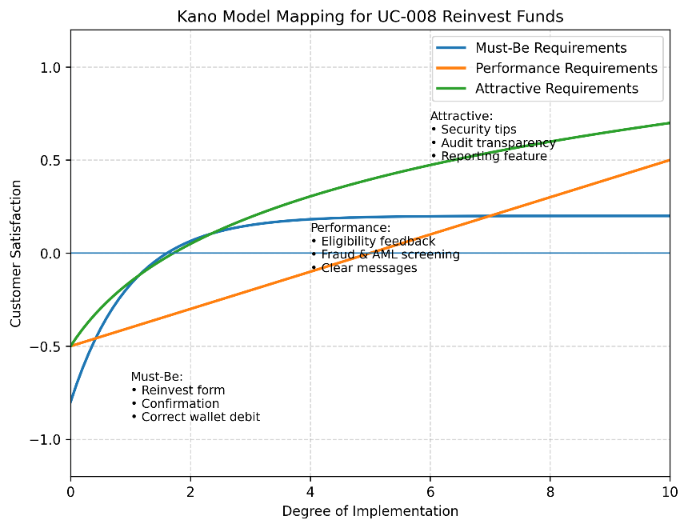

8. Supporting Notes
- This prototype is a high-fidelity demonstration and not a production system.
- Eligibility validation (UC-009) and Fraud/AML screening (UC-010) are simulated for demonstration purposes.
- Wallet balance is only debited after eligibility validation and Fraud/AML screening pass, and a reinvestment transaction is successfully created.
- For all rejected or blocked scenarios, no wallet debit occurs.
- All reinvestment attempts and outcomes are recorded in the audit log to support traceability and compliance.
- Route names retained from earlier iterations do not affect the logical correctness of UC-008 scenarios.

Appendix: High-Fidelity Prototype Screenshots
Paste or generate screenshots evidence for the prototype below. This section is auto-filled by script.

UC-014 – Admin Audit Log (Evidence)
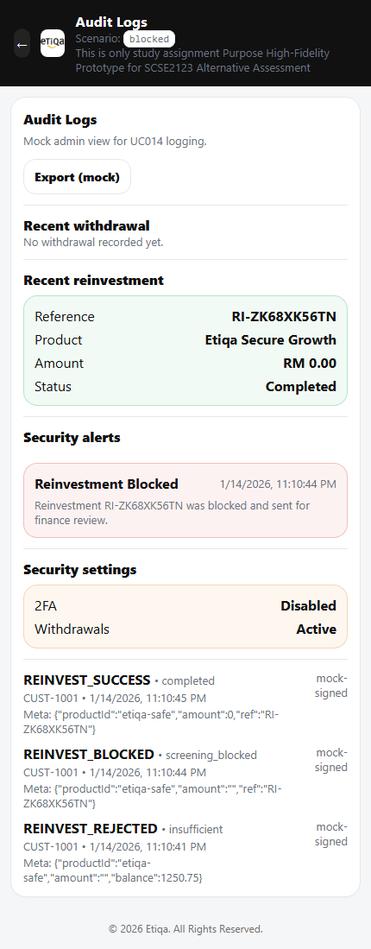
Figure 1: UC-014 – Admin Audit Log (Evidence)

Dashboard (UC-008 Entry)
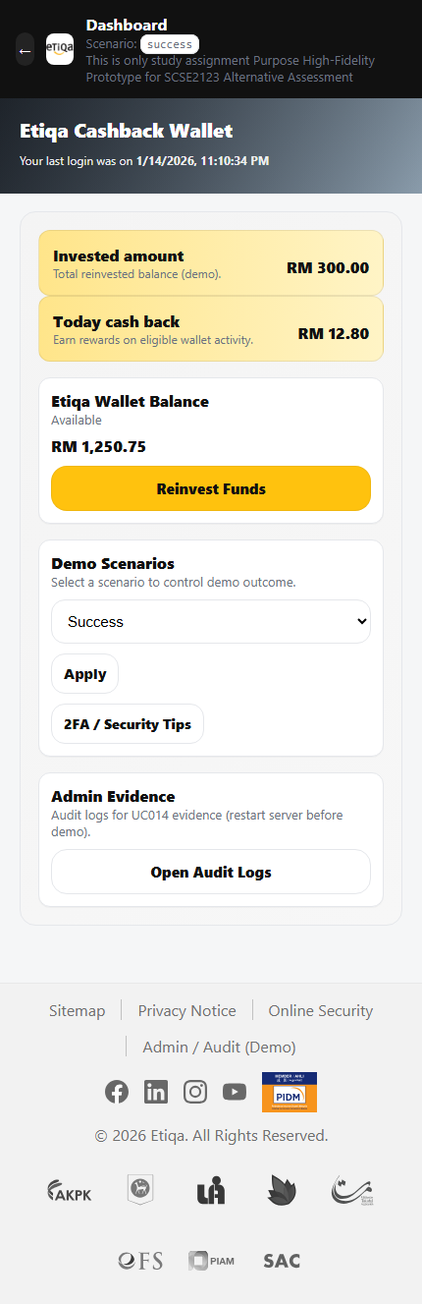
Figure 2: Dashboard (UC-008 Entry)

MUC-003 – Fraudulent Reinvestment Demonstration
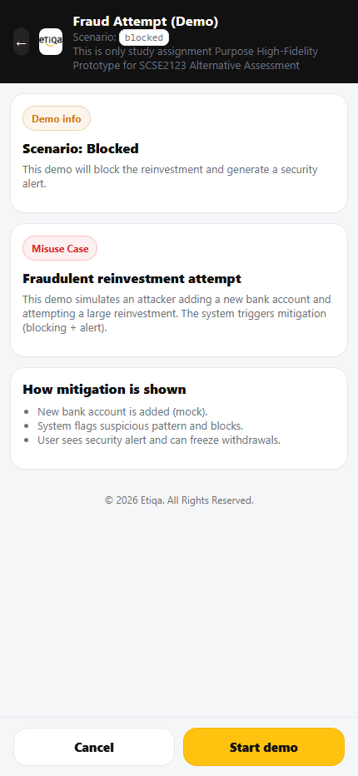
Figure 3: MUC-003 – Fraudulent Reinvestment Demonstration

UC-008 – Reinvest Form (Product + Amount)
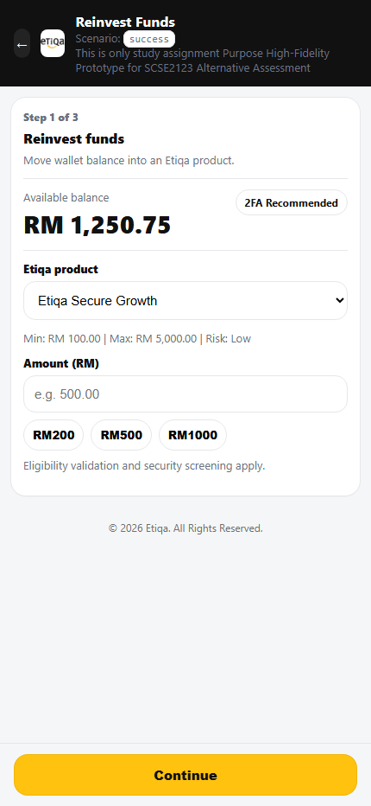
Figure 4: UC-008 – Reinvest Form (Product + Amount)

UC-008 E3 – Blocked (Fraud/AML Failed) + Finance Alert
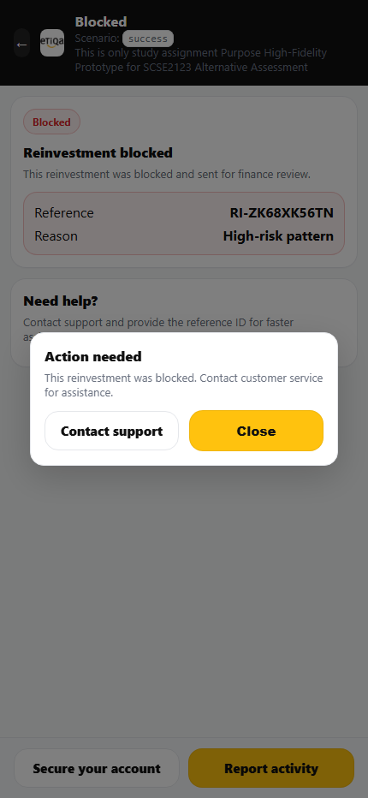
Figure 5: UC-008 E3 – Blocked (Fraud/AML Failed) + Finance Alert

UC-008 – Reinvest (Confirm Details)
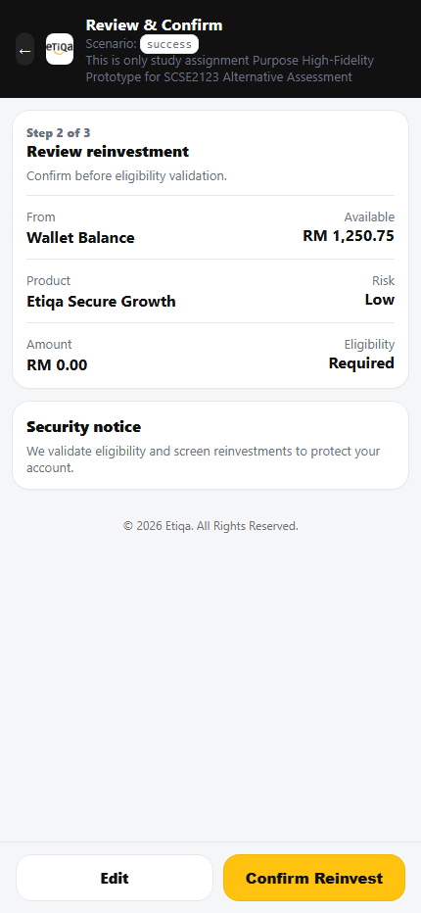
Figure 6: UC-008 – Reinvest (Confirm Details)

UC-008 – Reinvest (Confirm Details)
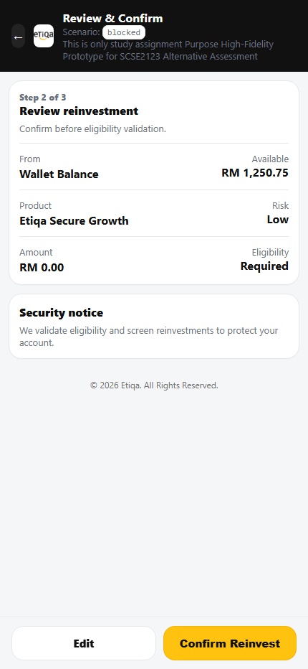
Figure 7: UC-008 – Reinvest (Confirm Details)

UC-008 – Reinvest (Confirm Details)
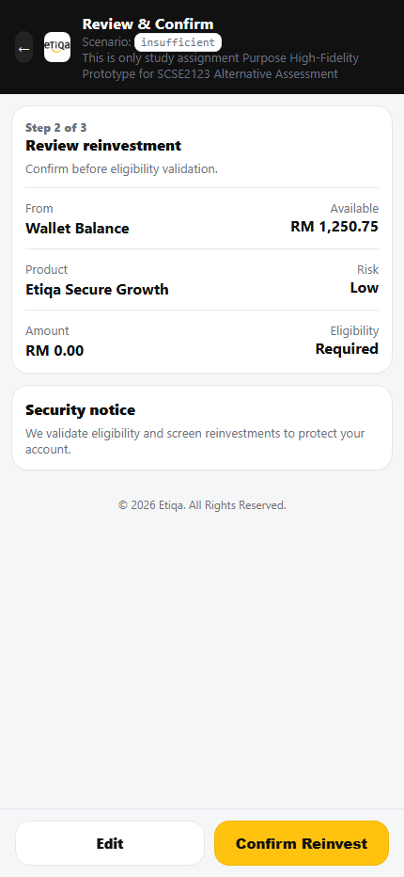
Figure 8: UC-008 – Reinvest (Confirm Details)

UC-008 – Reinvest (Confirm Details)
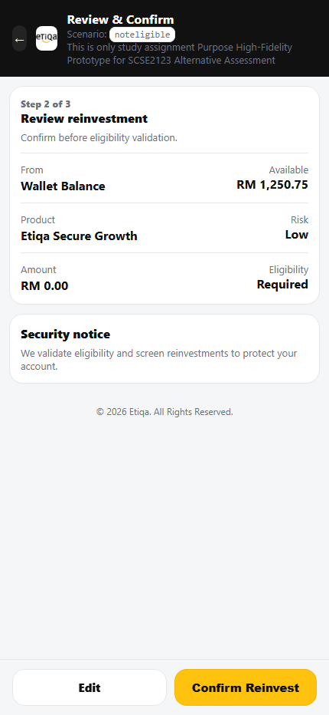
Figure 9: UC-008 – Reinvest (Confirm Details)

UC-008 – Reinvest (Confirm Details)
Figure 10: UC-008 – Reinvest (Confirm Details)

UC-009 – Eligibility Check in Progress
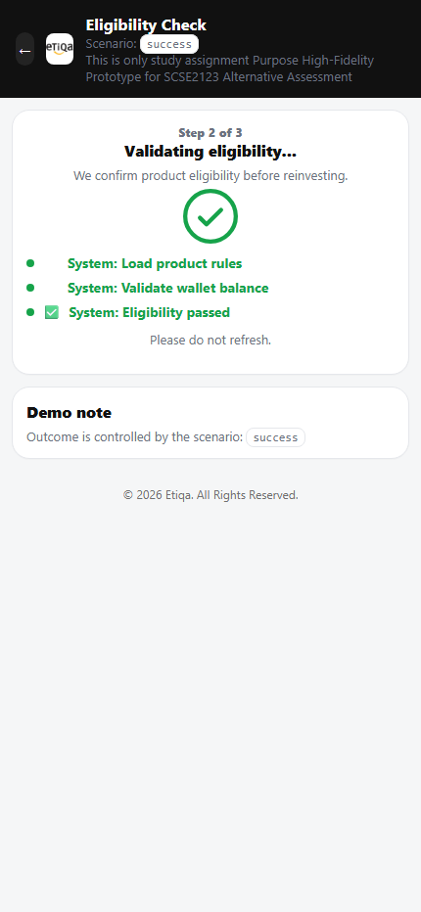
Figure 11: UC-009 – Eligibility Check in Progress

UC-009 – Eligibility Check in Progress
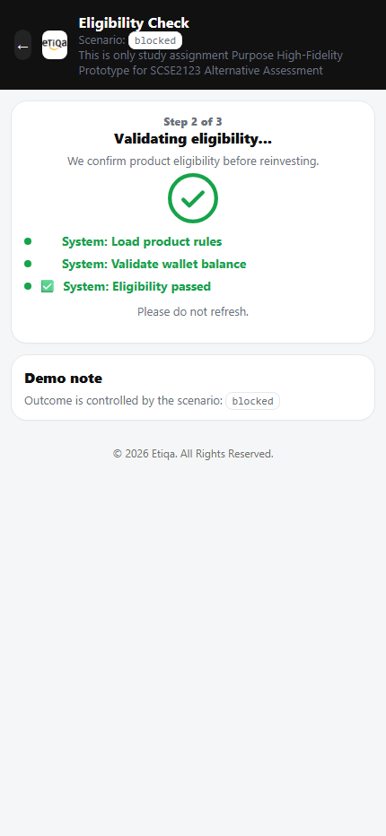
Figure 12: UC-009 – Eligibility Check in Progress

UC-008 E1 – Insufficient Balance
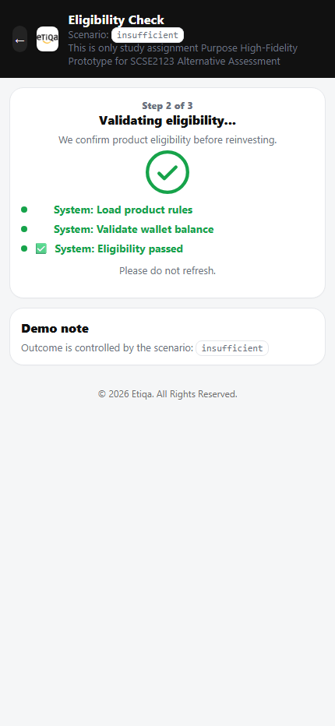
Figure 13: UC-008 E1 – Insufficient Balance

UC-009 E2 – Not Eligible (Rejected)
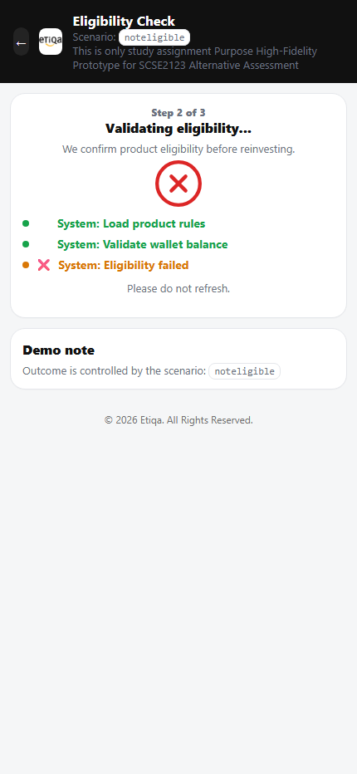
Figure 14: UC-009 E2 – Not Eligible (Rejected)

UC-008 – Reinvest Success (Receipt + Debit)
Figure 15: UC-008 – Reinvest Success (Receipt + Debit)

UC-008 E1 – Insufficient Balance
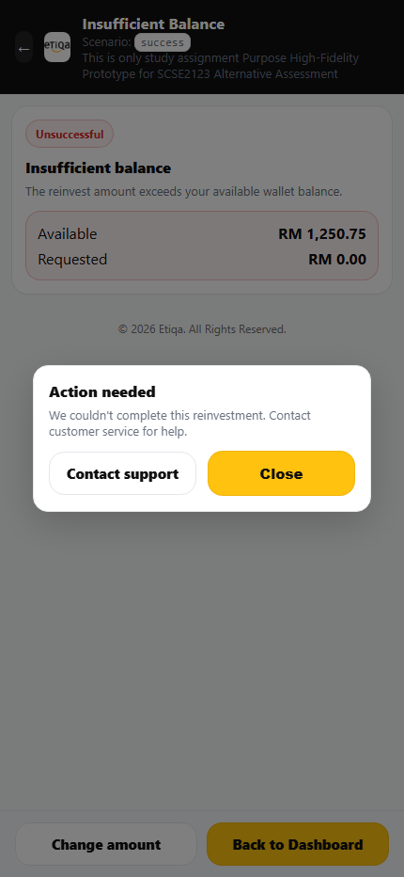
Figure 16: UC-008 E1 – Insufficient Balance

UC-009 E2 – Not Eligible (Rejected)
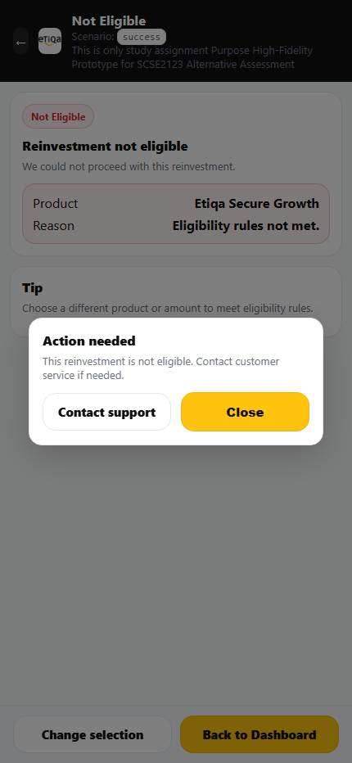
Figure 17: UC-009 E2 – Not Eligible (Rejected)

UC-008 E3 – Blocked (Fraud/AML Failed) + Finance Alert
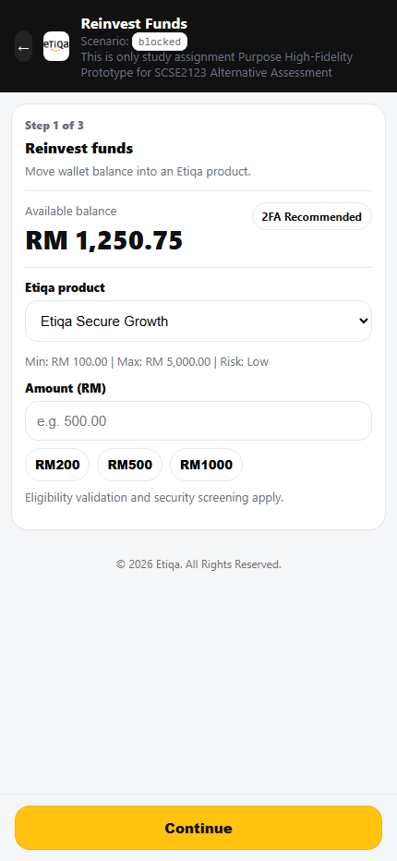
Figure 18: UC-008 E3 – Blocked (Fraud/AML Failed) + Finance Alert

UC-008 E1 – Insufficient Balance
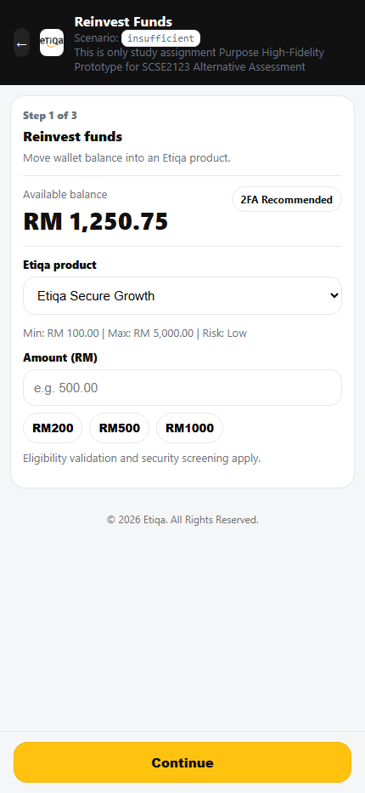
Figure 19: UC-008 E1 – Insufficient Balance

UC-008 – Reinvest Form (Product + Amount)
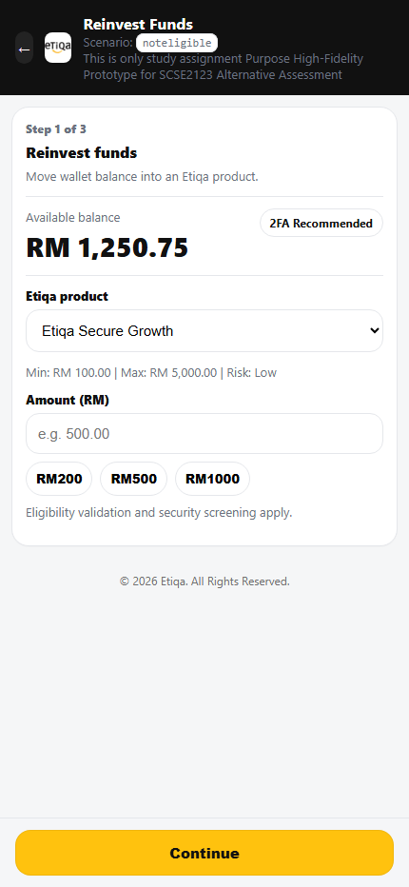
Figure 20: UC-008 – Reinvest Form (Product + Amount)

UC-008 – Reinvest Success (Receipt + Debit)
Figure 21: UC-008 – Reinvest Success (Receipt + Debit)

UC-010 – Fraud & AML Screening in Progress
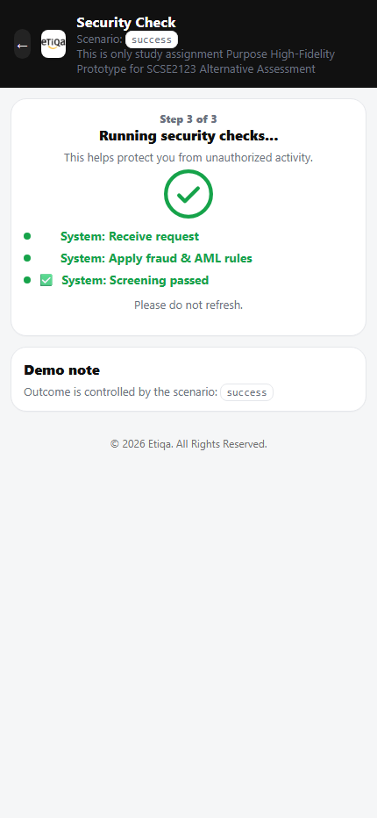
Figure 22: UC-010 – Fraud & AML Screening in Progress

UC-010 – Fraud & AML Screening in Progress
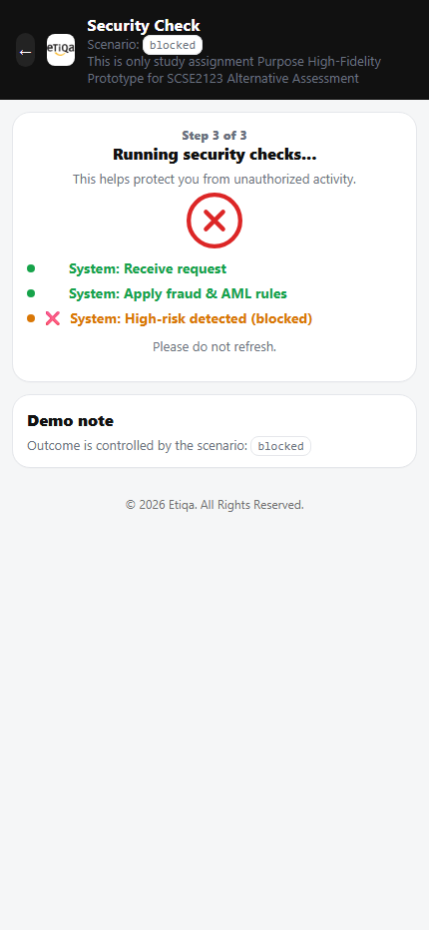
Figure 23: UC-010 – Fraud & AML Screening in Progress

UC-008 E1 – Insufficient Balance
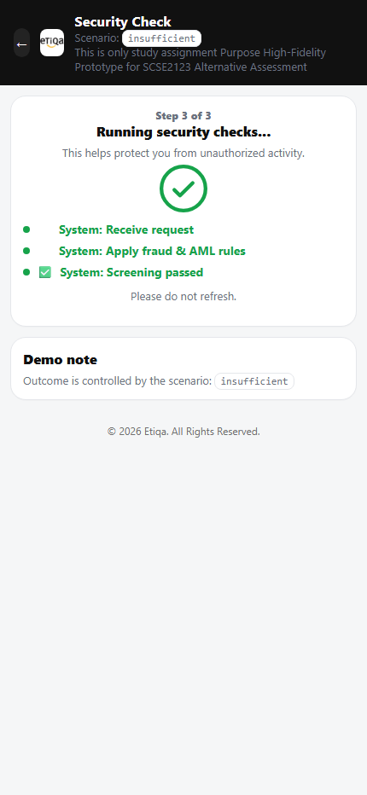
Figure 24: UC-008 E1 – Insufficient Balance

UC-010 – Fraud & AML Screening in Progress
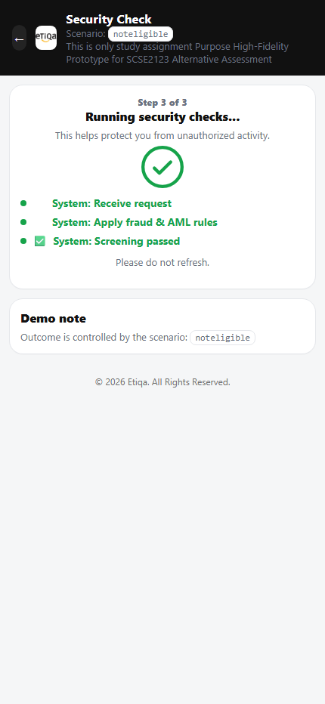
Figure 25: UC-010 – Fraud & AML Screening in Progress

UC-008 – Reinvest Success (Receipt + Debit)
Figure 26: UC-008 – Reinvest Success (Receipt + Debit)

UC-008 – Reinvest Success (Receipt + Debit)
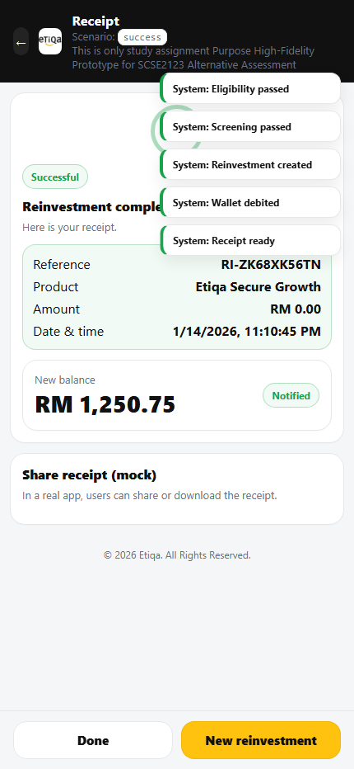
Figure 27: UC-008 – Reinvest Success (Receipt + Debit)

Security Mitigation – Two-Factor Authentication (2FA)
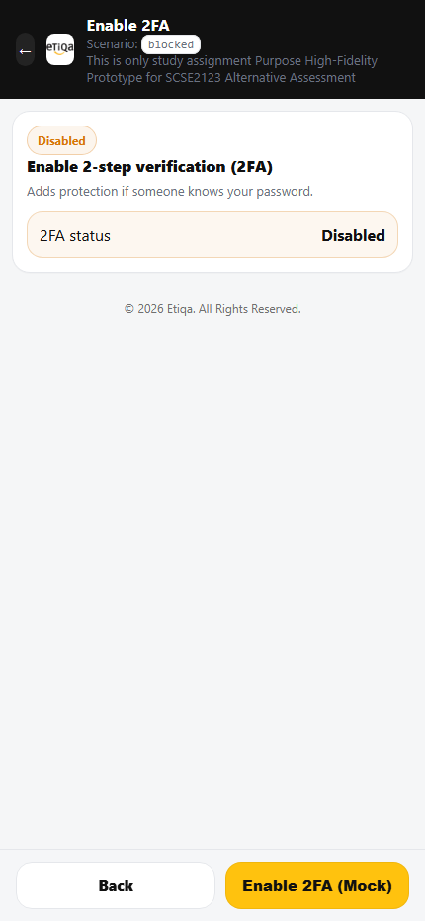
Figure 28: Security Mitigation – Two-Factor Authentication (2FA)

Security Mitigation – Manage Limits
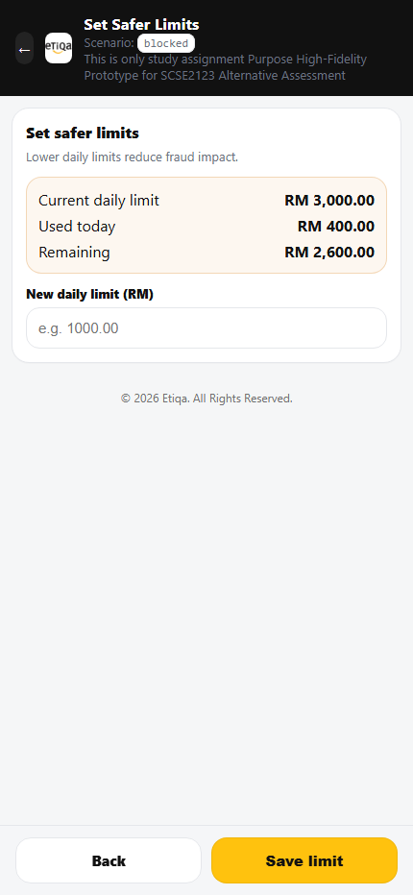
Figure 29: Security Mitigation – Manage Limits

Security Mitigation – Manage Linked Banks
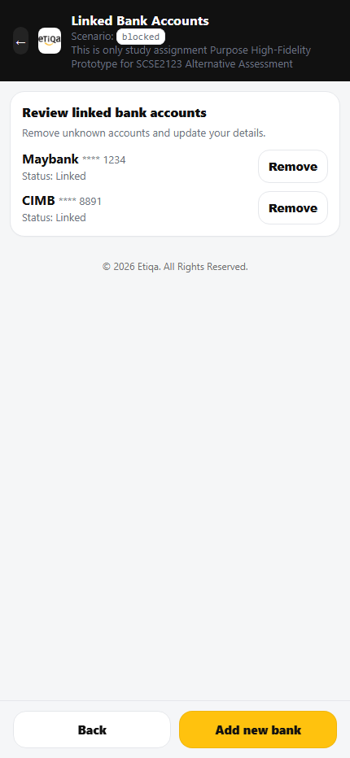
Figure 30: Security Mitigation – Manage Linked Banks

Security Mitigation – Report Suspicious Activity
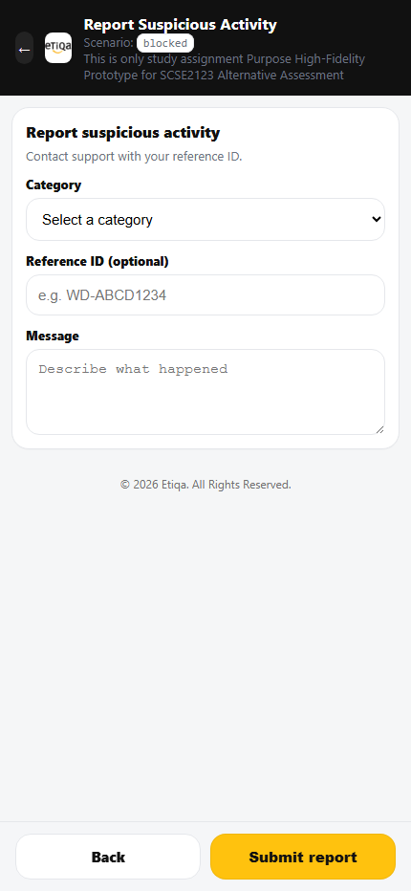
Figure 31: Security Mitigation – Report Suspicious Activity

Security Mitigation – Security Tips
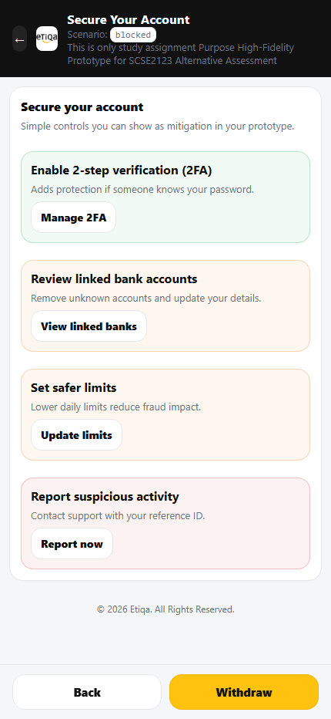
Figure 32: Security Mitigation – Security Tips

