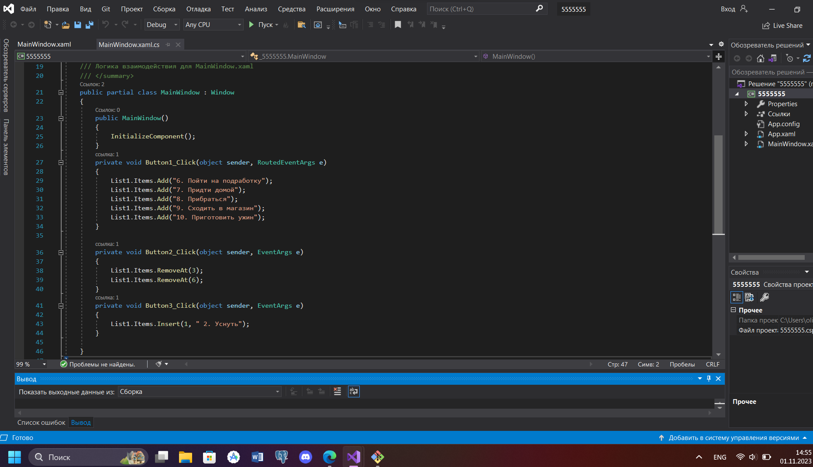

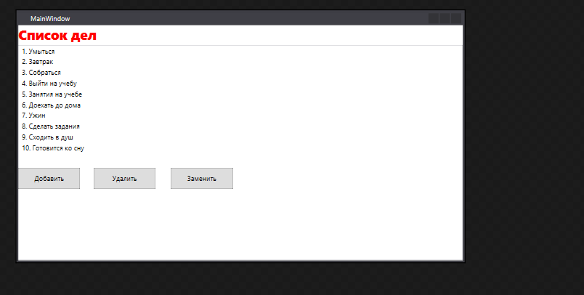

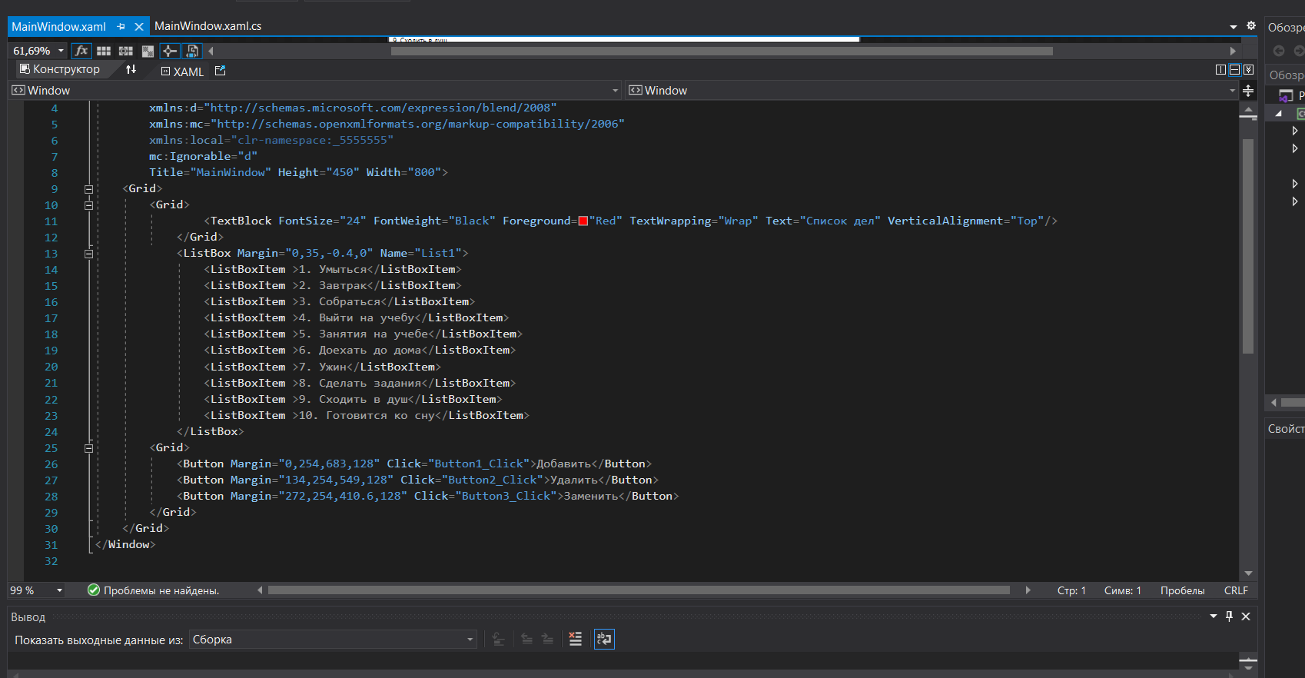

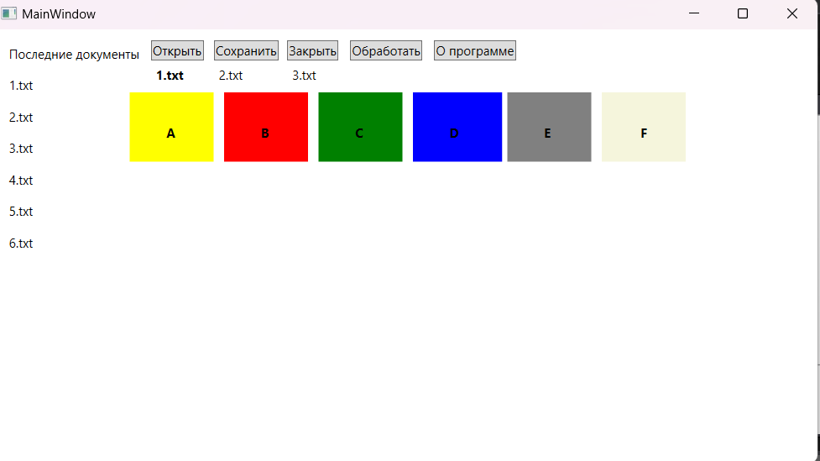

<Window x:Class="WpfApp2.MainWindow"

xmlns="http://schemas.microsoft.com/winfx/2006/xaml/presentation"

xmlns:x="http://schemas.microsoft.com/winfx/2006/xaml"

xmlns:d="http://schemas.microsoft.com/expression/blend/2008"

xmlns:mc="http://schemas.openxmlformats.org/markup-compatibility/2006"

xmlns:local="clr-namespace:WpfApp2"

mc:Ignorable="d"

Title="MainWindow" Height="450" Width="800">

<Grid Margin="0,0,-0.4,-86">

<Canvas Margin="0,0,0,178">

<Label Canvas.Left="10" Canvas.Top="10" Content="Последние документы" />

<Button Canvas.Left="150" Canvas.Top="10" Content="Открыть"/>

<Button Canvas.Left="210" Canvas.Top="10" Content="Сохранить"/>

<Button Canvas.Left="280" Canvas.Top="10" Content="Закрыть"/>

<Button Canvas.Left="340" Canvas.Top="10" Content="Обработать"/>

<Button Canvas.Left="420" Canvas.Top="10" Content="О программе"/>

<Label Canvas.Left="10" Canvas.Top="40" Content="1.txt"/>

<Label Canvas.Left="10" Canvas.Top="70" Content="2.txt"/>

<Label Canvas.Left="10" Canvas.Top="100" Content="3.txt"/>

<Label Canvas.Left="10" Canvas.Top="130" Content="4.txt"/>

<Label Canvas.Left="10" Canvas.Top="160" Content="5.txt"/>

<Label Canvas.Left="10" Canvas.Top="190" Content="6.txt"/>

<Label Canvas.Left="150" Canvas.Top="30" Content="1.txt" FontWeight="Bold"/>

<Label Canvas.Left="210" Canvas.Top="30" Content="2.txt" />

<Label Canvas.Left="280" Canvas.Top="30" Content="3.txt" />

<Rectangle Fill="Yellow" Width="80" Height="66" Canvas.Left="130" Canvas.Top="60" RenderTransformOrigin="0.51,0.583"/>

<Rectangle Fill="Red" Width="80" Height="66" Canvas.Left="220" Canvas.Top="60" />

<Rectangle Fill="Green" Width="80" Height="66" Canvas.Left="310" Canvas.Top="60" />

<Rectangle Fill="Blue" Width="85" Height="66" Canvas.Left="400" Canvas.Top="60" />

<Rectangle Fill="Gray" Width="80" Height="66" Canvas.Left="490" Canvas.Top="60" />

<Rectangle Fill="beige" Width="80" Height="66" Canvas.Left="580" Canvas.Top="60" />

<Label Content="A" HorizontalAlignment="Left" Canvas.Top="85" VerticalAlignment="Top" Canvas.Left="160" FontWeight="Bold" RenderTransformOrigin="0.541,-0.5" Height="28"/>

<Label Content="B" HorizontalAlignment="Left" Canvas.Top="85" VerticalAlignment="Top" Canvas.Left="250" FontWeight="Bold" Height="28"/>

<Label Content="C" HorizontalAlignment="Left" Canvas.Top="85" VerticalAlignment="Top" Canvas.Left="340" FontWeight="Bold" RenderTransformOrigin="0.603,-0.413" Height="28"/>

<Label Content="D" HorizontalAlignment="Left" Canvas.Top="85" VerticalAlignment="Top" Canvas.Left="430" FontWeight="Bold" Height="41"/>

<Label Content="E" HorizontalAlignment="Left" Canvas.Top="85" VerticalAlignment="Top" Canvas.Left="520" FontWeight="Bold" Height="41" Width="22"/>

<Label Content="F" HorizontalAlignment="Left" Canvas.Top="85" VerticalAlignment="Top" Canvas.Left="612" FontWeight="Bold" Height="41" Width="20"/>

</Canvas>

</Grid>

</Window>

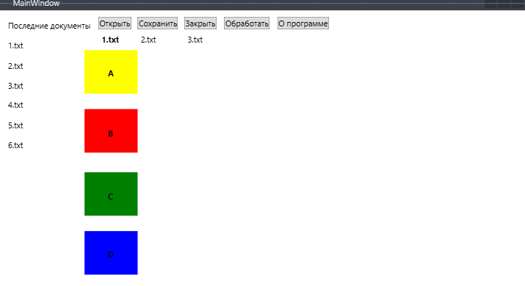

<Window x:Class="WpfApp2.MainWindow"

xmlns="http://schemas.microsoft.com/winfx/2006/xaml/presentation"

xmlns:x="http://schemas.microsoft.com/winfx/2006/xaml"

xmlns:d="http://schemas.microsoft.com/expression/blend/2008"

xmlns:mc="http://schemas.openxmlformats.org/markup-compatibility/2006"

xmlns:local="clr-namespace:WpfApp2"

mc:Ignorable="d"

Title="MainWindow" Height="450" Width="800">

<Grid Margin="0,0,0,-179">

<Canvas Margin="0,0,0,178">

<Label Canvas.Left="10" Canvas.Top="10" Content="Последние документы" />

<Button Canvas.Left="150" Canvas.Top="10" Content="Открыть"/>

<Button Canvas.Left="210" Canvas.Top="10" Content="Сохранить"/>

<Button Canvas.Left="280" Canvas.Top="10" Content="Закрыть"/>

<Button Canvas.Left="340" Canvas.Top="10" Content="Обработать"/>

<Button Canvas.Left="420" Canvas.Top="10" Content="О программе"/>

<Label Canvas.Left="10" Canvas.Top="40" Content="1.txt"/>

<Label Canvas.Left="10" Canvas.Top="70" Content="2.txt"/>

<Label Canvas.Left="10" Canvas.Top="100" Content="3.txt"/>

<Label Canvas.Left="10" Canvas.Top="130" Content="4.txt"/>

<Label Canvas.Left="10" Canvas.Top="160" Content="5.txt"/>

<Label Canvas.Left="10" Canvas.Top="190" Content="6.txt"/>

<Label Canvas.Left="150" Canvas.Top="30" Content="1.txt" FontWeight="Bold"/>

<Label Canvas.Left="210" Canvas.Top="30" Content="2.txt" />

<Label Canvas.Left="280" Canvas.Top="30" Content="3.txt" />

<Rectangle Fill="Yellow" Width="80" Height="66" Canvas.Left="130" Canvas.Top="60"/>

<Label Content="A" HorizontalAlignment="Left" Canvas.Top="82" VerticalAlignment="Top" Canvas.Left="160" FontWeight="Bold" Height="44"/>

<Rectangle Fill="Red" Width="80" Height="66" Canvas.Left="130" Canvas.Top="149" />

<Label Content="B" HorizontalAlignment="Left" Canvas.Top="173" VerticalAlignment="Top" Canvas.Left="160" FontWeight="Bold" Height="30"/>

<Rectangle Fill="Green" Width="80" Height="66" Canvas.Left="130" Canvas.Top="244" />

<Label Content="C" HorizontalAlignment="Left" Canvas.Top="267" VerticalAlignment="Top" Canvas.Left="160" FontWeight="Bold" Height="27"/>

<Rectangle Fill="Blue" Width="80" Height="66" Canvas.Left="130" Canvas.Top="333" />

<Label Content="D" HorizontalAlignment="Left" Canvas.Top="355" VerticalAlignment="Top" Canvas.Left="160" FontWeight="Bold" Height="29"/>

</Canvas>

</Grid>

</Window>

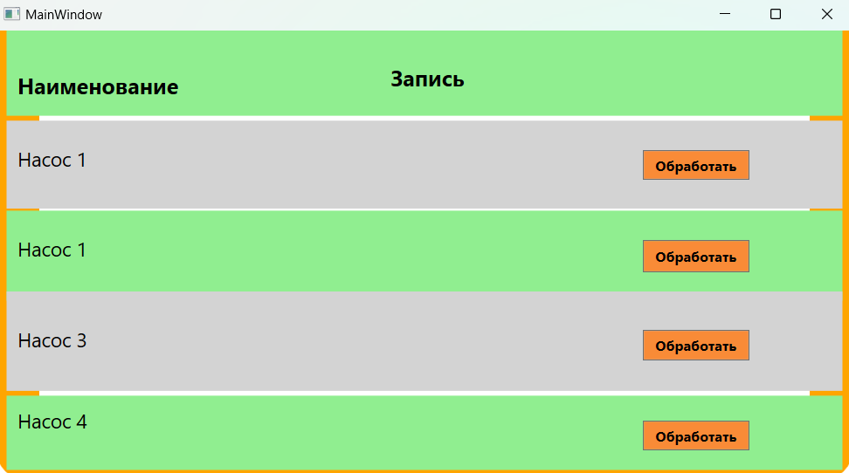

<Window x:Class="_3.MainWindow"

xmlns="http://schemas.microsoft.com/winfx/2006/xaml/presentation"

xmlns:x="http://schemas.microsoft.com/winfx/2006/xaml"

xmlns:d="http://schemas.microsoft.com/expression/blend/2008"

xmlns:mc="http://schemas.openxmlformats.org/markup-compatibility/2006"

xmlns:local="clr-namespace:_3"

mc:Ignorable="d"

Title="MainWindow" Height="450" Width="800">

<Grid>

<Border

BorderThickness="40"

BorderBrush="Orange"

CornerRadius="10" Margin="0,-41,0,0" Grid.ColumnSpan="6" Grid.RowSpan="6" />

<Grid>

<TextBlock FontSize="24" FontWeight="Black" Foreground="Red" TextWrapping="Wrap" Text="Таблица №1" VerticalAlignment="Top" Margin="314,-41,-394.2,0"/>

</Grid>

<Border Background="LightGreen" Margin="10,0,10,87" Grid.RowSpan="2" Grid.ColumnSpan="3"/>

<Label Grid.Column="0" Grid.Row="0" Content="Наименование" Margin="15,32,75,13" FontWeight="Bold" FontSize="20" RenderTransformOrigin="0.465,-0.005" />

<Border Background="LightGray" Margin="10,0,10,70" Grid.RowSpan="2" Grid.Row="1" Grid.ColumnSpan="3"/>

<Label Grid.Column="0" Grid.Row="1" Content="Насос 1" Margin="15,18,15.8,26" FontSize="18"/>

<Border Background="LightGreen" Grid.Row="2" Grid.ColumnSpan="3" Margin="10,0,10,0" Grid.RowSpan="2"/>

<Label Grid.Column="0" Grid.Row="2" Content="Насос 1" Margin="15,18,16,20" FontSize="18"/>

<Border Background="LightGray" Margin="10,6,10,0" Grid.RowSpan="2" Grid.Row="3" Grid.ColumnSpan="3"/>

<Label Grid.Column="0" Grid.Row="4" Content="Насос 3" Margin="15,18,15.8,28" FontSize="18"/>

<Border Background="LightGreen" Grid.Row="4" Margin="10,87,10,10" Grid.RowSpan="2" Grid.ColumnSpan="3"/>

<Label Grid.Column="0" Grid.Row="5" Content="Насос 4" Margin="15,10,27,35" FontSize="18" RenderTransformOrigin="0.501,9.021"/>

<Label Grid.Column="1" Grid.Row="0" Content="Запись" Margin="95,25,74.8,13" FontWeight="Bold" FontSize="20"/>

<Button Grid.Column="2" Grid.Row="1" Content="Обработать" Margin="69.2,27,95.6,28" Background="#FFF98B37" FontSize="13" FontWeight="Bold"/>

<Button Grid.Column="2" Grid.Row="2" Content="Обработать" Margin="69.2,27,95.6,11.6" Background="#FFF98B37" FontSize="13" FontWeight="Bold"/>

<Button Grid.Column="2" Grid.Row="4" Content="Обработать" Margin="69.2,27,95.6,28" Background="#FFF98B37" FontSize="13" FontWeight="Bold"/>

<Button Grid.Column="2" Grid.Row="5" Content="Обработать" Margin="69.4,27,95.6,28" Background="#FFF98B37" FontSize="13" FontWeight="Bold"/>

<Button Height="30" Content="0" RenderTransformOrigin="2.997,3.911" Grid.Column="1" Margin="134,28,134,39" Grid.Row="1" Background="White" HorizontalContentAlignment="Left" />

<Button Height="30" Content="0" RenderTransformOrigin="2.997,3.911" Grid.Column="1" Margin="134,28,134,22" Grid.Row="2" Background="White" HorizontalContentAlignment="Left" />

<Button Height="30" Content="0" RenderTransformOrigin="2.997,3.911" Grid.Column="1" Margin="134,32,134,35" Grid.Row="4" Background="White" HorizontalContentAlignment="Left" />

<Button Height="30" Content="0" RenderTransformOrigin="2.997,3.911" Grid.Column="1" Margin="134,27,134,40" Grid.Row="5" Background="White" HorizontalContentAlignment="Left" />

<Grid.RowDefinitions>

<RowDefinition Height="97*"></RowDefinition>

<RowDefinition Height="97*"></RowDefinition>

<RowDefinition Height="80*"></RowDefinition>

<RowDefinition Height="17*"/>

<RowDefinition Height="97*"></RowDefinition>

<RowDefinition Height="97*"></RowDefinition>

</Grid.RowDefinitions>

<Grid.ColumnDefinitions>

<ColumnDefinition></ColumnDefinition>

<ColumnDefinition></ColumnDefinition>

<ColumnDefinition></ColumnDefinition>

</Grid.ColumnDefinitions>

</Grid>

</Window>