

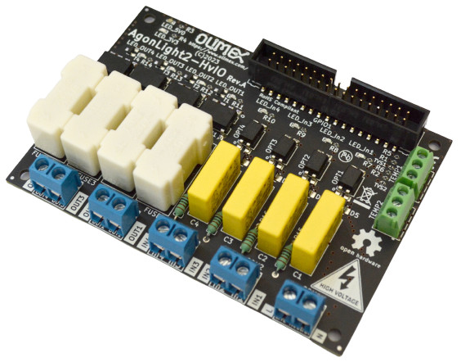

AgonLight2-HvIO
User Manual
Rev.1.0 October 2023 olimex.com
Table of Contents
Introduction to AgonLight2-HvIO 3
Order codes for AgonLight2-HvIO: 4
HARDWARE 5
AgonLight2-HvIO layout: 6
AgonLight2-HvIO schematic 7
AgonLight2 GPIO connector: 8
SOFTWARE: 10
Revision History 12

Introduction to AgonLight2-HvIO

AgonLight2-HvIO is Open Source Hardware board designed to work with AgonLight2.
It has these features:
- Four Solid-State-Relays SSR capable working on 240VAC with 1 A loads connected to AgonLight2 GPIO outputs
- SSR are with zero cross switching noise free
- Four opto isolated 240VAC inputs connected to AgonLight2 GPIO inputs
- Status LEDs for each output and input
- Status LEDs for 3.3V and 5V power supply of AginLight2
- Two Dallas DS18B20 temperature sensor inputs capable to work with SNS-TMP-DS18B20
- Dimensions 100x70 mm

Order codes for AgonLight2-HvIO:

AgonLight2-HvIO AgonLight high voltage IO board
SNS-TMP-DS18B20 temparature sensor
CABLE-IDC34-15CM not available yet cable between AgonLight2 and AgonLight2-HvIO

HARDWARE

AgonLight2-HvIO layout:
AgonLight2 GPIO connector
Power supply status LEDs
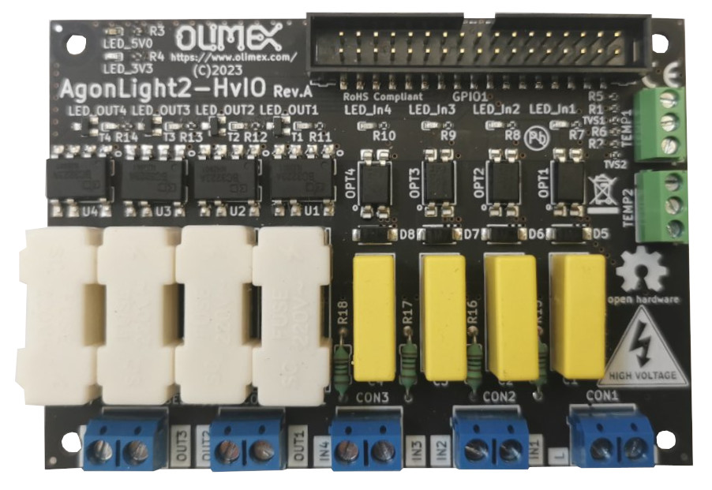

Temperature Sensors DS18B20

High voltage Outputs
High voltage Inputs
Power supply Live and Neutral

AgonLight2-HvIO schematic

The schematic of AgonLight2-HvIO is on GitHub. On the next page there is picture of it.
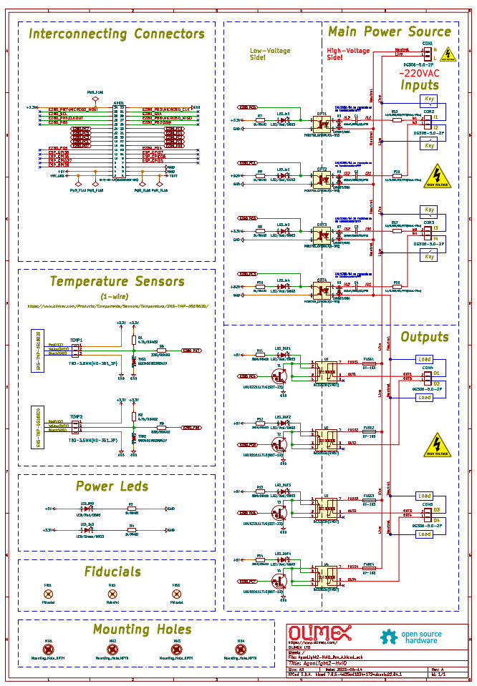

AgonLight2 GPIO connector:

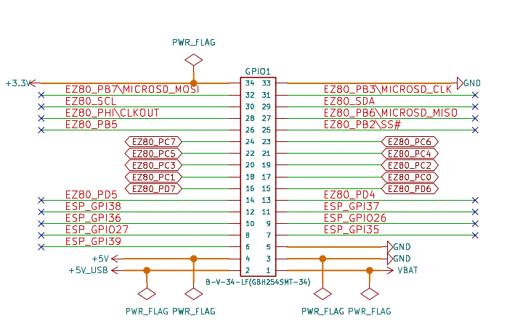

AgonLight2-HvIO temperature sensors connector:

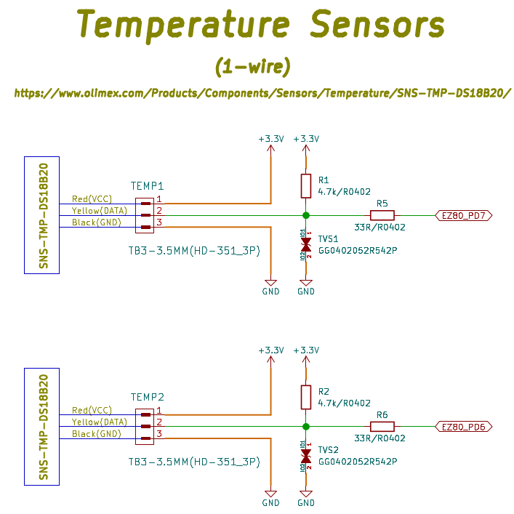

SOFTWARE:

Reading the Inputs and Writing to the Outputs:

The outputs are assigned as follows:
OUT1 → PC4
OUT2 → PC5
OUT3 → PC6
OUT4 → PC7

The inputs are assigned as follows:
IN1 → PC0
IN2 → PC1
IN3 → PC2
IN4 → PC3

Port-C Data Direction Register is at address 159. To make port Input 1 should be written in the corresponding bit, to make it Output 0 should be written.
To make PC0-3 as inputs and PC4-7 as outputs the following basic command should be executed:
PUT 159 , %00001111
Port-C Data Value register is at address 158, so to read the Port-C status you can use:
PRINT GET(158)
and to set OUT1 = HIGH
PUT 158, %00010000
to set OUT1 = LOW
PUT 158, %00000000

Revision History
Revision 1.0 October 2023 initial

