

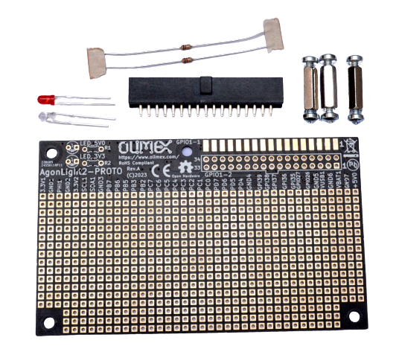

AgonLight2-Proto
User Manual
Rev.1.0 June 2023 olimex.com
Table of Contents
What is AgonLight2-Proto 3
Order codes for AgonLight2-Proto: 4
HARDWARE 5
AgonLight2-Proto layout: 6
Revision History 7

What is AgonLight2-Proto

AgonLight2-Proto is small board with dimensions 100x80mm. It allows you to fast prototype concept and ideas for AgonLight2 computer.

AgonLight2-Proto has these features:

- IDC connector 34 pin for connection on AgonLight2 GPIO
- 3mm RED LED for 5V power indication
- 3mm GREEN LED for 3.3V power indication
- Sea-of-Pads
- GND and 3.3V bus connecting vertically all pads on the left edge
- GND and 5V bus connecting vertically all pads on the right edge
- Dimensions 100x80mm
- 3 hex distance spacers for keeping board horizontally when ICD connector is plug to AgonLight2 GPIO

Order codes for AgonLight2-Proto:

AgonLight2-Proto prototype board with components not soldered

HARDWARE

Assembled view:
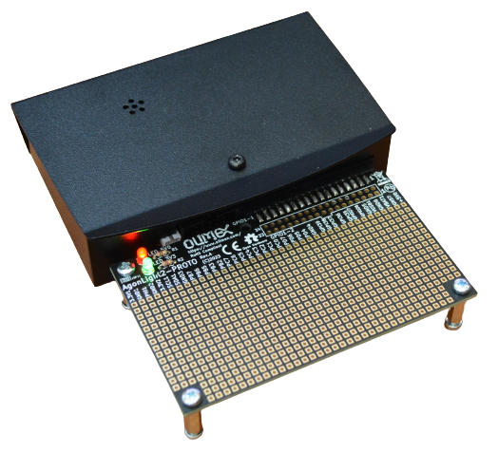

AgonLight2-Proto layout:

GPIO connector can be soldered horizontally or side-way
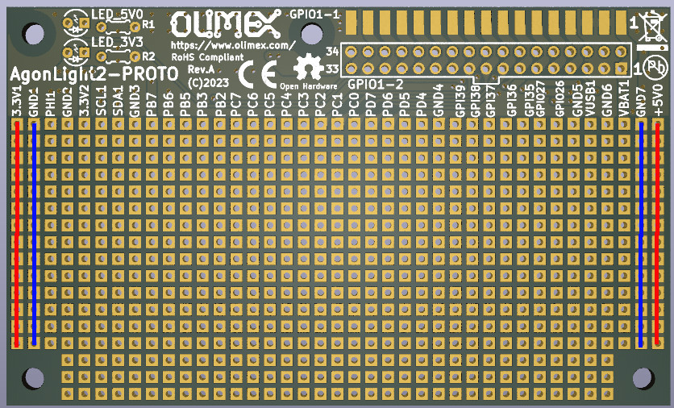
All GPIO signals are available close to the prototype area
Power LEDs

Power busses

Revision History
Revision 1.0 June 2023

