

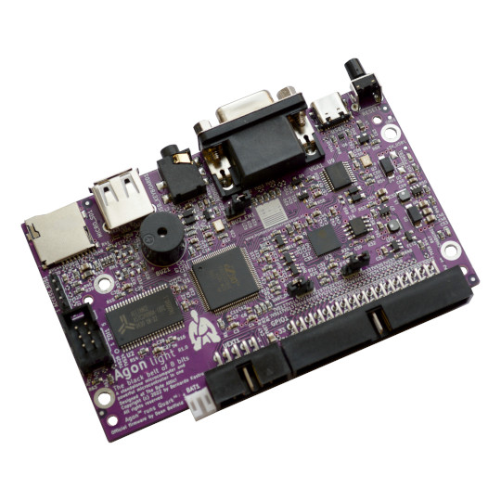
AgonLight2
User Manual
Document revision 1.2., June 2023
www.olimex.com

Table of Contents
Introduction 3
What is AgonLight2? 4
Order codes for AgonLight2 and accessories: 5
The differences between AgonLight and AgonLight2: 6
First time start up or how to prepare the SD card and boot 7
AgonLight references documents: 8
HARDWARE 9
AgonLight2 layout: 10
AgonLight2 schematic: 11
AgonLight2 power supply and consumption: 16
GPIO connector: 17
UEXT connector: 18
Access bus connector: 19
eZ80 programming connector: 20
Jumpers: 21
SOFTWARE: 22
General AgonLight2 Firmware 23
Olimex tested firmware and examples 23
MOS commands: 24
BBC Basic commands reference: 25
Software access to GPIOs: 26
Software access to I2C: 27
Software access to SPI: 28
Software access to VPU: 29
Revision History 30

Introduction



What is AgonLight2?

AgonLight2 is a re-design of the original AgonLight eZ80F92 retro computer, designed as a hobby project by Bernardo Kastrup;
AgonLight2 is a complete Single Board Computer (SBC) with VGA display output, PS2 keyboard, and SD card (acting as an external disk). This means that to write and run programs you do not need an external computer like Arduino boards do;
AgonLight2 has a GPIO connector with GPIO ports, I2C, SPI, and more signals which are accessible and can be used to interact with other hardware (sensors, expansions, etc;)
AgonLight and AgonLight2 are Open Source Hardware and officially OSHWA certified;
All CAD source files are available at AgonLight and AgonLight2 GitHub repositories. They are released under CERN Open Hardware License Version 2 – Strongly Reciprocal and allow users to learn, study, edit, modify, produce, and sell same or derivative products based on these designs. The only requirements is to open source their work under the same licensee.
The firmware of AgonLight is written by Dean Belfield and reproduces BBC Basic for Z80. The firmware is also Open Source Software and available on GitHub. The same firmware works on AgonLight2 without any modifications.

AgonLight2 is RoHS, REACH, CE and UKCA compliant.

Order codes for AgonLight2 and accessories:

AgonLight2 | Single board BBC Basic Z80 Retro style Computer
MICRO-SD-CLASS | You need a microSD card to store Basic and software (demos, examples)
AgonLight2-Proto | DIY expansion kit with big proto area; compatible with AgonLight2
BOX-AGONLIGHT2-BLACK | Metal box for AgonLight2
CABLE-USB-A-C-1M | USB-C data and power cable
BATTERY-LIPO1400mAh | Li-po battery 3.7V 1400mAh – note that these batteries can be shipped only by ground so we can deliver only to EU destinations
USB-KEYBOARD-PS2 | USB keyboard which supports PS2 and can be used for AgonLight2
BREADBOARD-1 | Breadboard for experimenting with AgonLight2
JW-200x10-FM | 10 pieces female-male jumper wires for breadboarding
JW-200x10 | 10 pieces male-male jumper wires for breadboarding
JW-200x10-FF | 10 pieces female-female jumper wires for breadboarding
UEXT modules | Different sensors, relays, LCDs, RTC, GSM, GPS etc accessories which can be connected to AgonLight2 UEXT connector
MOD-Wii-UEXT-NUNCHUCK | 3 axis joystick, two buttons game controller with UEXT connector

The differences between AgonLight and AgonLight2:

AgonLight2 has these differences from the original design:
- KiCad is used for the CAD, instead of EasyEDA. KiCad is open source software – free to download and use, it is a more fitting CAD tool for an Open Source Hardware project;
- USB-C connector for power supply;
- DCDC power converter with up to 2A output instead of linear power converter;
- Li-Po battery backup power supply, the battery acts like a UPS and will power the computer even if the USB-C gets disconnected. The battery is charged automatically when USB or external power supply is present;
- USB connector for keyboard (but the keyboard must be PS2 compatible!!!);
- SRAM routed with 40 ohm impedance as per part datasheet;
- Fixed some wrong signal naming on ESP32-PICO-D4 GPU co-processor;
- Fixed GPIO and programming connector pin ordering;
- Replaced the naked header 32-pin connector with a plastic boxed 34-pin connector following the same layout and adding two additional signals Vbat and Vin which allow AgonLight2 to be powered by this connector too;
- Added a UEXT connector (https://www.olimex.com/Products/Modules/) which allows AgonLight2 to be connected to: temperature sensors, environmental air quality sensors, pressure, humidity, gyroscope, light, RS485, LCDs, LED matrix, relays, Bluetooth, Zigbee, Lora, GSM, RFID reader, GPS, Pulse, EKG, RTC etc;
- Added 4 grounded mount holes with 3mm diameter, but also kept the original 2.5 mm mount holes.

First time start up or how to prepare the SD card and boot

Important! Notice that AgonLight2 comes completely assembled, tested, and programmed with firmware. The only thing you would need to do is prepare a microSD card with BBC basic and some examples, then connect your display and peripherals and apply power supply.

1. Open a web browser and navigate to:
https://github.com/OLIMEX/AgonLight2
2. Click on: Code -> Local tab, Download ZIP;
3. Uncompress the downloaded ZIP file in your PC;
4. Enter the folders “SOFTWARE” and then “FIRMWARE” and then “1-SD-card-contents”, then copy the contents of the folder;
5. Insert a class-10 microSD card in your Windows PC (pre-formatted as Fat32 and with a partition of maximum 32GB).
6. Paste the contents of the folder “1-SD-card-contents” which you’ve copied in step 4, onto the microSD card. Files should be placed directly into main folder of the card.
7. Eject the microSD card from your Windows PC.
8. Insert the microSD card into the board.
9. Connect a VGA monitor and a PS/2 keyboard (or a PS/2-compatible USB keyboard,
via a PS/2 adapter) to the AgonLight2 unit.
10. Turn the AgonLight2 board on by connecting it to the USB cable:

AgonLight references documents:

Here we link original AgonLight Hardware Manual, QuickStart Guide and Firmware Installation Guide.

HARDWARE

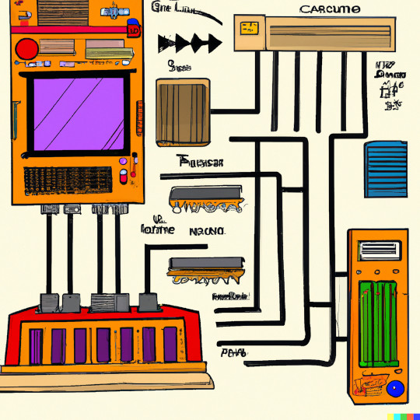

AgonLight2 layout:

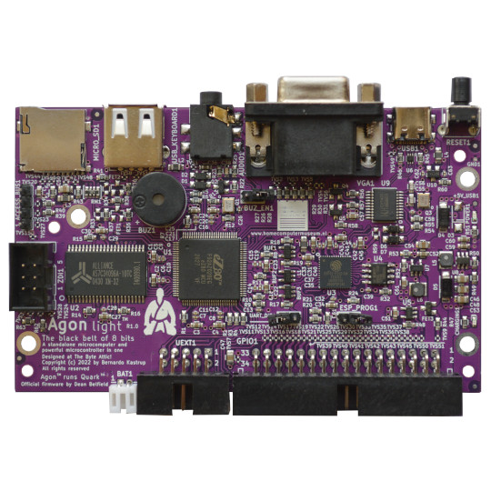
Micro SD card
USB-PS2 keyboard
Buzzer
LiPo battery
UEXT
GPIO
ESP32 programming
ESP32 UART disable
Buzzer enable
EZ80 programming
Access bus
Audio Out
VGA
USB-C Power
Reset

AgonLight2 schematic:

The current AgonLight2 schematic is available for download and print on GitHub
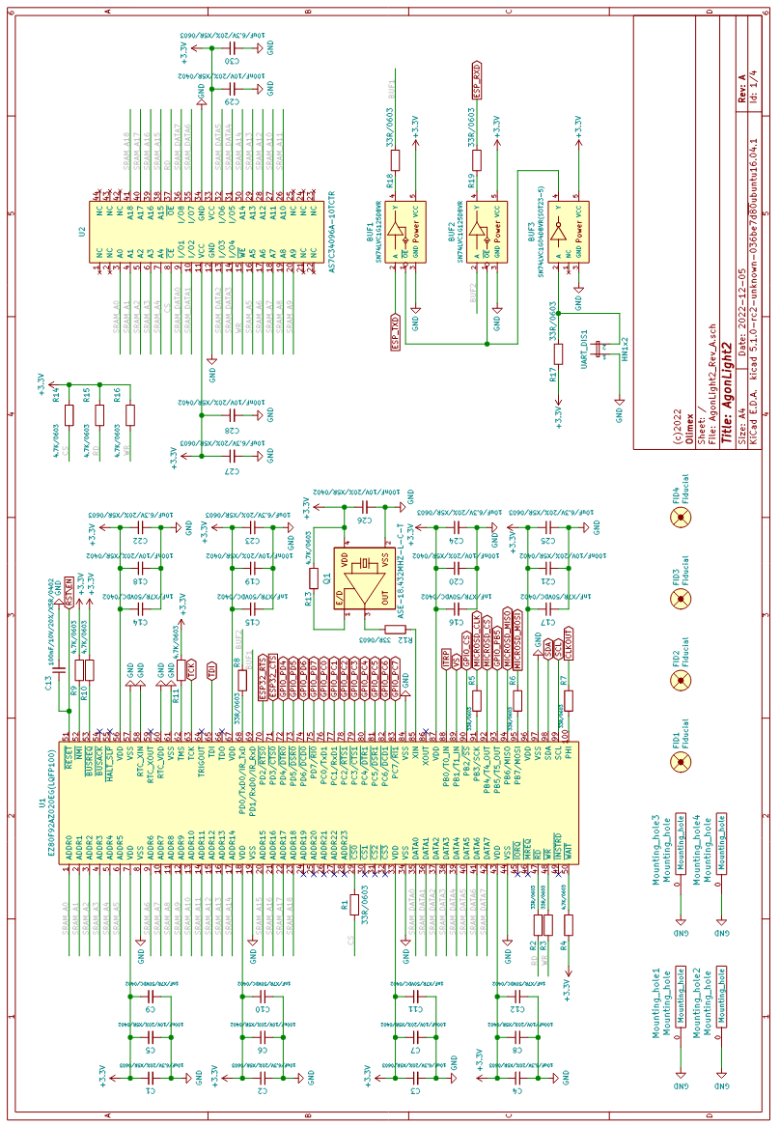
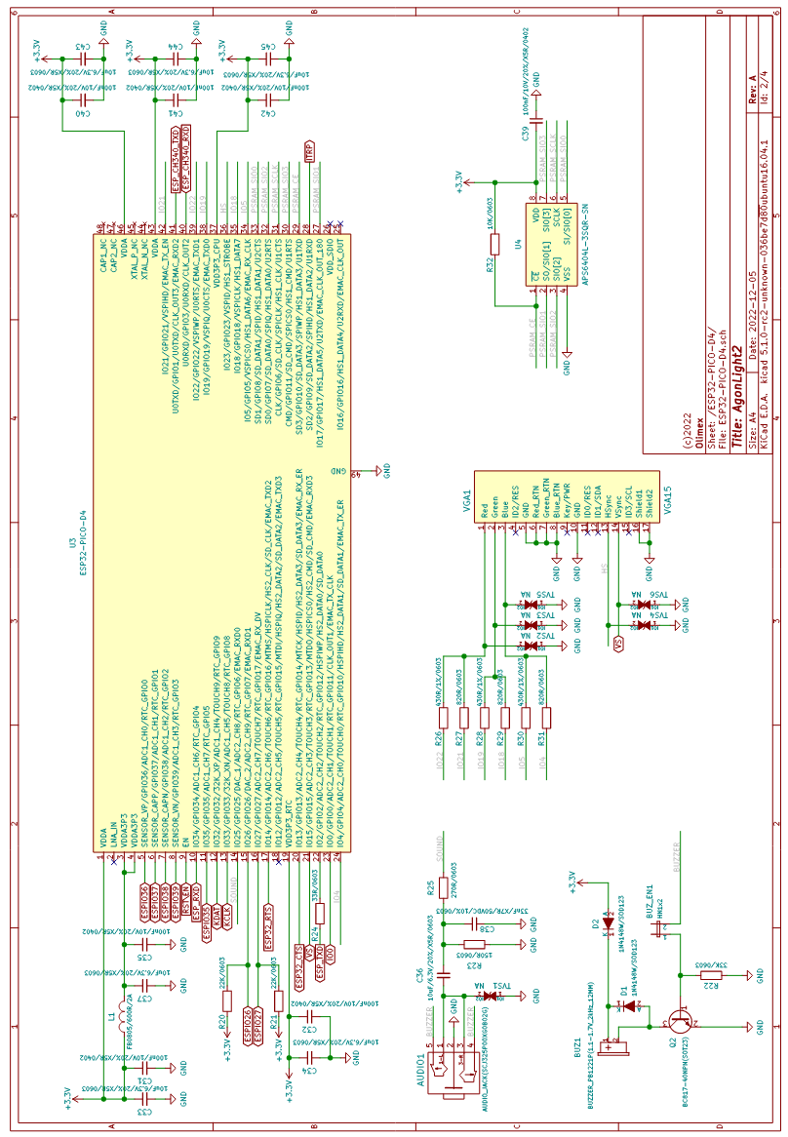
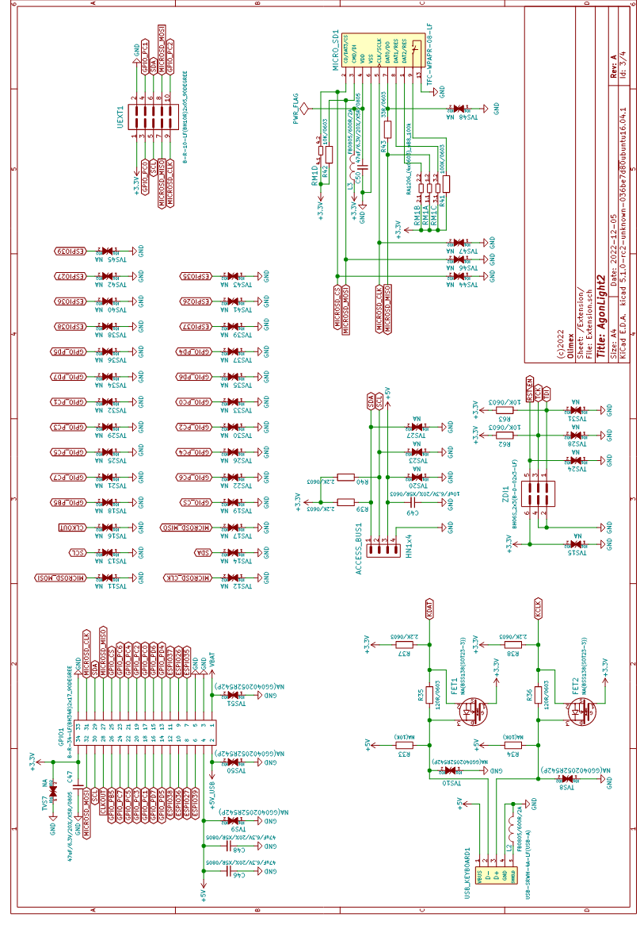
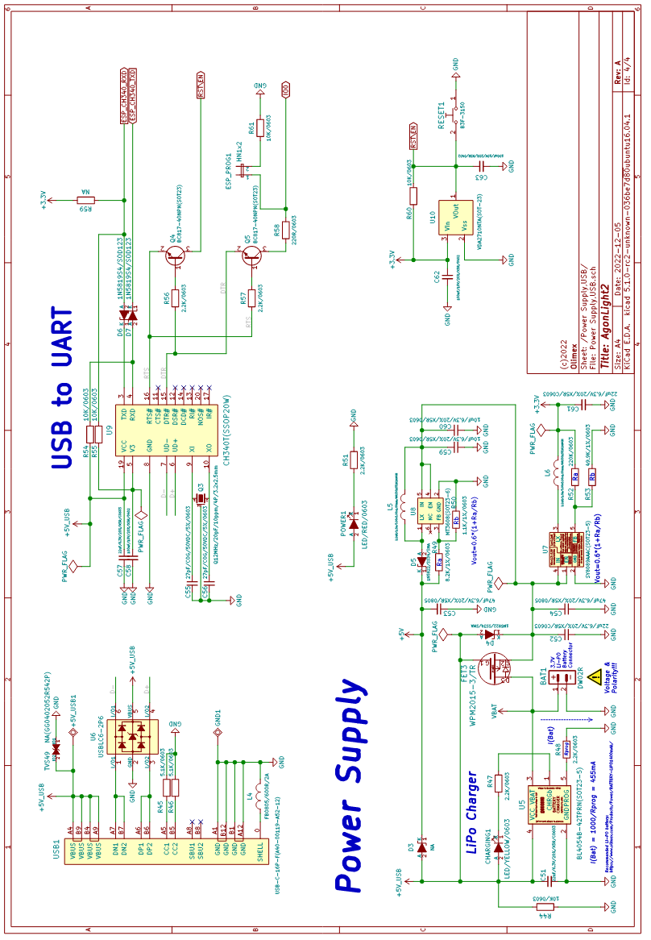

AgonLight2 power supply and consumption:

AgonLight2 can be powered by 3 sources:
- USB-C connector;
- Li-Po battery connector;
- GPIO.pin2 (5V_USB) note that this signal is connected to USB 5V signal so when you power AgonLight2 with this pin you should not connect it to the USB!!!
The power consumption of AgonLight2 is approximately 130mA without a keyboard and around 180mA with connected keyboard.
If a Li-Po battery is connected it will get charged automatically when power supply is attached with up to 100mA.
When the LiPo battery is attached and external power supply is missing internal DCDC step-up converter and switching circuit automatically powers AgonLight2 from the battery. 1400mAh battery will provide about 8 hours of stand-alone operation.
+ The LiPo battery connector is JST 2.0 mm connector and with Olimex’s battery polarity. If you use batteries from other manufacturers please make PLUS and MINUS are connected properly as you may damage the board!!!

GPIO connector:

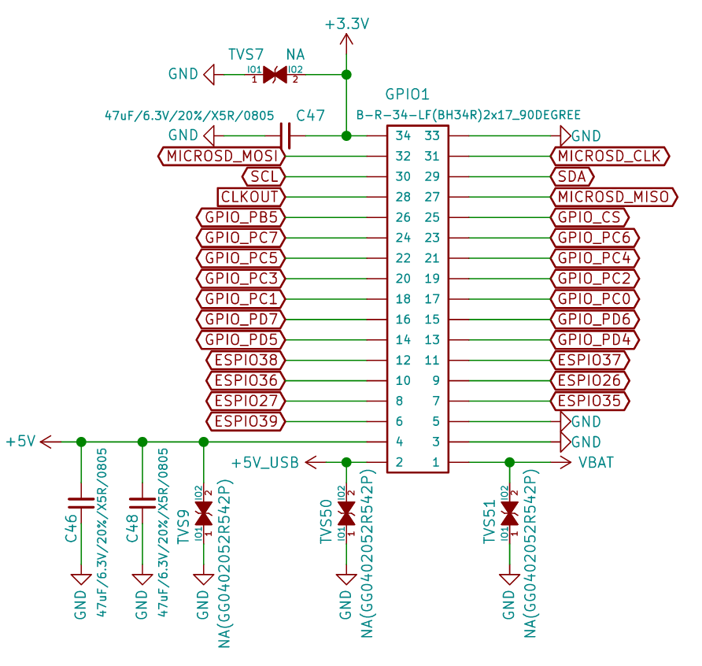
Pin.1 is connected to the Li-Po battery PLUS you can connect external battery on this pin or to use battery voltage to external circuits.
Pin. 2 is 5V power supply connected to USB-C +5V signal, you can power the board from this signal if the USB-C is not connected. It must be regulated 5V power supply, applying more than 5V will damage the board.
Pin.3, Pin.5, Pin.33 are GND
Pin.34 is +3.3V output capable to source up to 2A note that 200mA are used by AgonLight2
Pin.4 is +5V output capable to source up to 2A (1.8A + AgonLight2 0.2A), it’s backed by LiPo UPS so even if there is interruption on power supply if LiPo battery is attached there will be 5V on this pin.

All GPIOs are operating on +3.3V. This means you should not connect signals above 3.3V on these ports as this will damage the board.

UEXT connector:

UEXT connector stands for Universal EXTension connector and contain +3.3V, GND, I2C, SPI, UART signals:
UEXT is 0.1” 2.54mm step boxed plastic connector. All signals are with 3.3V levels.
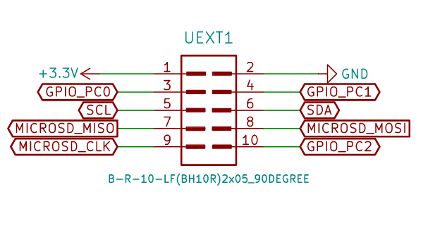

Olimex has developed number of MODULES with this connector. There are temperature, humidity, pressure, magnetic field, light sensors. Modules with LCDs, LED matrix, relays, Bluetooth, Zigbee, WiFi, GSM, GPS, RFID, RTC, EKG, etc.

Access bus connector:

This is I2C and power supply with 3.3V levels.
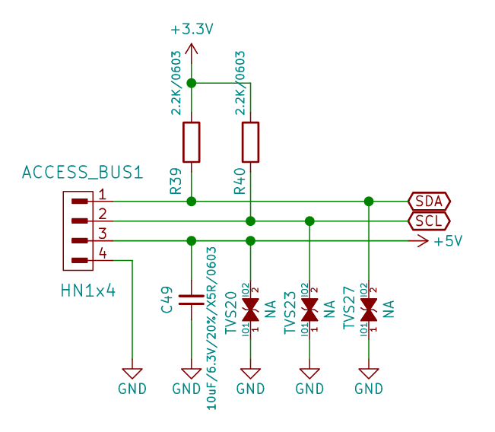

eZ80 programming connector:

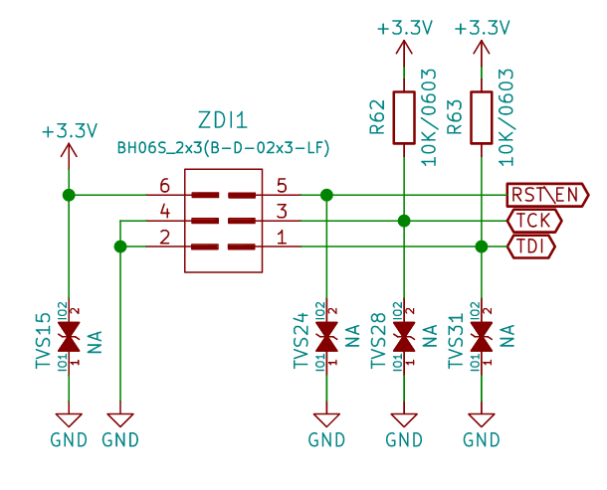
This connector is used for initial programming of eZ80 microcontroller. AgonLight2 comes with pre-programmed firmware so you do not need to use this connector nor programmer for it.
If you want to develop your own firmware Jeroen Venema wrote flash utility which allows you to flash new firmware without need of external programmer.

Jumpers:

Typically you don’t need to change the positions of the jumpers to use the board.

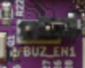
BUZ_EN1 – buzzer enable jumper – when closed the buzzer plays the sound commands.
Default state: Open (Buzzer disabled)

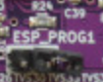
ESP_PROG1 – ESP programming enabled when closed ESP32 enters bootloader mode at reset and can be programmed over the USB connector.
Default state: Open (ESP programming handled by software)

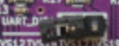
UART_D – UART disable – when closed the UART connection between eZ80 and ESP32 is disconnected. This is necessary when ESP32 is programming.
Default state: Open (communication between eZ80 and ESP32 enabled)

SOFTWARE:

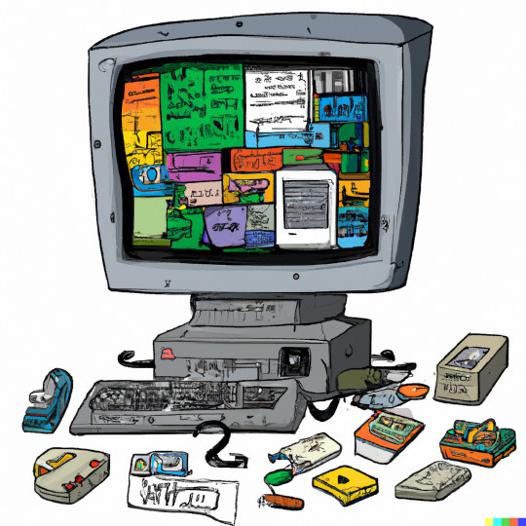

General AgonLight2 Firmware
The three modules of AgonLight2 official firmware, called Quark™, can be found here:
- Quark™ BBC BASIC – BBC Basic interpreter
- Quark™ MOS - command line machine operating system, similar to CP/M or DOS
- Quark™ VDP - The VDP is a serial graphics terminal that takes a BBC Basic text output stream as input. The output is via the VGA connector on the Agon.

Olimex tested firmware and examples
Can be found in the repository here:
https://github.com/OLIMEX/AgonLight2/tree/main/SOFTWARE/FIRMWARE
Disclaimer: Most of the examples located in the repository above are NOT written by Olimex. We have just tested them and confirmed them working at the time of release.
The repository contains: examples taken from AgonLight repository, solutions to our weekly programming challenge, and other interesting examples we found online.

MOS commands:

LOAD “”
SAVE “”
*CAT *DIR
*CD /
*MKDIR
*BYE *CPM
*ERA file
*ESC [ON OFF]
*EXEC file
*OPT
*REN oldfile ewfile
*SAVE file aaaa bbbb
*SPOOL file
*TYPE file
*| comment

BBC Basic commands reference:

Variables:
X – float
X% - integer
X$ - string
&X – hex

Pressing ESC key breaks the code execution
This is list of the BBC Basic commands click on the command name for more info and use.

ABS
ACS
ADVAL
AND
ASC
ASN
ATN
AUTO
BGET
BPUT
CALL
CHAIN
CHR$
CLEAR
CLG
CLOSE
CLS
COLOUR
COS
COUNT
DATA
DEF
DEG
DELETE
DIM
DIV
DRAW
ELSE
END
ENDPROC
ENVELOPE
EOF
EOR
ERL
ERR
ERROR
EVAL
EXP
EXT
FALSE
FN
FOR
GCOL
GET
GET()
GET$
GOSUB
GOTO
HIMEM
IF
INKEY
INKEY$
INPUT
INSTR(
INT
LEFT$
LEN
LET
LINE
LIST
LN
LOAD
LOCAL
LOG
LOMEM
MID$
MOD
MODE
MOVE
NEW
NEXT
NOT
OFF
OLD
ON ERROR
ON ERROR OFF
ON X%
OPENIN
OPENOUT
OPT
OR
PAGE
PAGE
PI
PLOT
POINT(
POS
PRINT
PROC
PTR
PUT A, X
RAD
READ
REM
RENUMBER
REPEAT
REPORT
RESTORE
RETURN
RIGHT$(
RND
RUN
SAVE
SGN
SIN
SOUND
SPC
SQR
STEP
STOP
STR$
STRING$(
TAB(X)
TAB(X,Y)
TAN
THEN
TIME
TO
TRACE
TRUE
UNTIL
USR
VAL
VDU
VPOS
WIDTH

Software access to GPIOs:

eZ80 ports are described in the eZ80-specification.

Port direction register set if the port is INPUT or OUTPUT. Upon RESET all GPIOs are set as Inputs.
Direction registers are 8 bit and each bit corresponds to port signal. If 1 is written on the corresponding port will be set as Input if 0 as Output.
Port B data direction register is at address: 009Bh = 153 decimal
Port C data direction register is at address: 009Fh = 159 decimal
Port D data direction register is at address: 00A3h = 163 decimal
If we read the Port C direction register we can PRINT GET(159) and it should return 255
If we want to set GPIO_PC0 as output we should write 0 in bit 0 with the command PUT 159,254.

Data registers are 8 bit and each bit corresponds to port signal. If 1 is written on the corresponding port will be set 3.3V if 0 is written 0V will be set.
Port B data register is at address: 009Ah = 152 decimal
Port C data register is at address: 009Eh = 158 decimal
Port D data register is at address: 00A2h = 162 decimal
If we read data register with GET() command, for instance PRINT GET(158) it will return the state of Port C.
We can write the data register with PUT command, for instance PUT 158,1 will set GPIO_PC0 to +3.3V and PUT 158,0 will set it to 0V.

Software access to I2C:

TBD

Software access to SPI:

TBD

Software access to VPU:

TBD

Revision History
Revision 1.0 January 2023
- initial release
Revision 1.1 January 2023
- added “How to prepare the SD card and boot the first time”, taken and edited from “Agon light™ Firmware Installation Guide.pdf”
Revision 1.2 June 2023
-general improvements to the structure of the document; added more info about first steps with the board

