

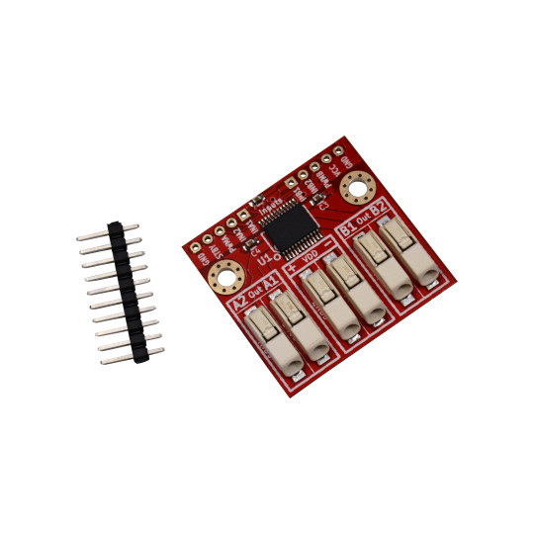

BB-TB6612
User Manual

Rev.1.0 April 2020
olimex.com

Table of Contents
What is USB-gLINK 3
USB-gLINK ordering options 4
USB-gLINK Open Source Licensee 5
USB-gLINK software installation 6
USB-gLINK connectors description: 7
USB-gLINK power consumption 10
Revision History 11

What is BB-TB6612

BB-TB6612 is dual DC motor driver with digital logic working from 2.7 up to 5.5V and motor voltage from 2.5 up to 13.5V
It's perfect for driving small robot cars with MG-06-120 or MG-06-48 with chassis like: ROBOT-3-WHEEL-KIT, ROBOT-2WD-KIT, ROBOT-2WD-KIT2 and ROBOT-2WDL-KIT with 12V battery.

These are BB-TB6612 features:
- Digital logic power supply: 2.7-5.5V
- Motor Power supply: 2.5-13.5V
- Output current 1.2(3A max)
- Output ON 0.5ohm
- Power save mode
- CW/CCW motor rotation
- short brake and stop states
- Thermal shut-down
- operating temperature -20 to 85C
- dimensions: 34 x 34 mm

Software Control modes:

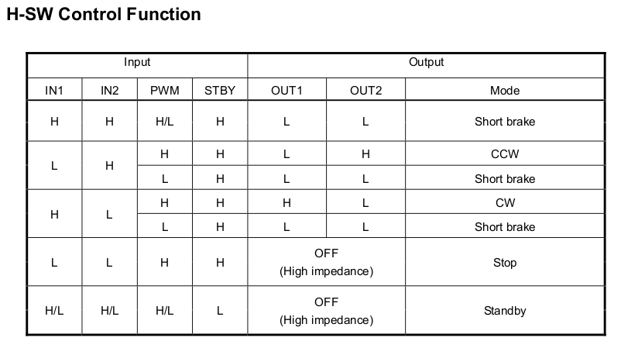

When STBY is 0 the module enter power saving mode and both motors are released as outputs are in high impedance state.
When IN1 and IN2 are High or if PWM is Low the motors are in Short brake state.
If IN1 is High and IN2 is Low motor turns CW (clock-wise).
If IN1 is Low and IN2 is High motor turns CCW (counter-clock-wise).
If IN1 and IN2 are Low the motor is released as outputs are in high impedance state.

Typical wiring is:

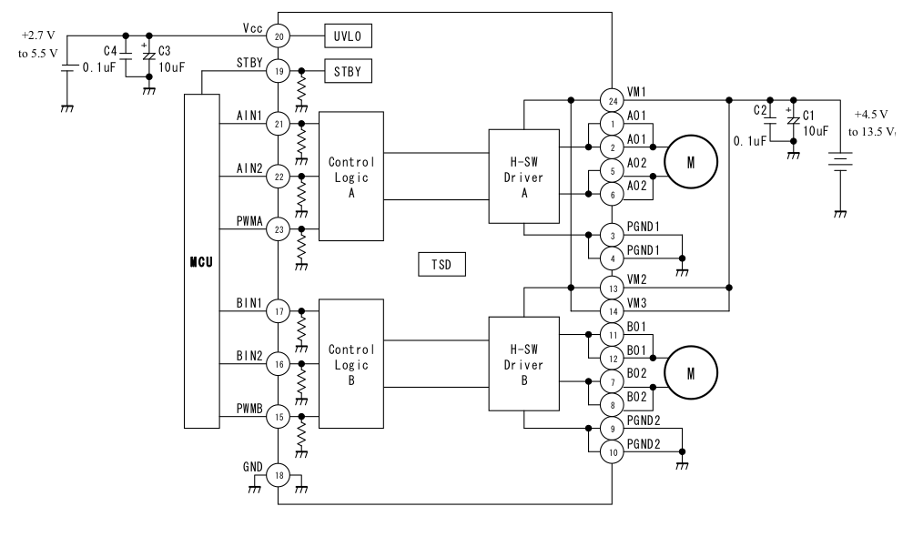

Revision History
Revision 1.0 April 2020

