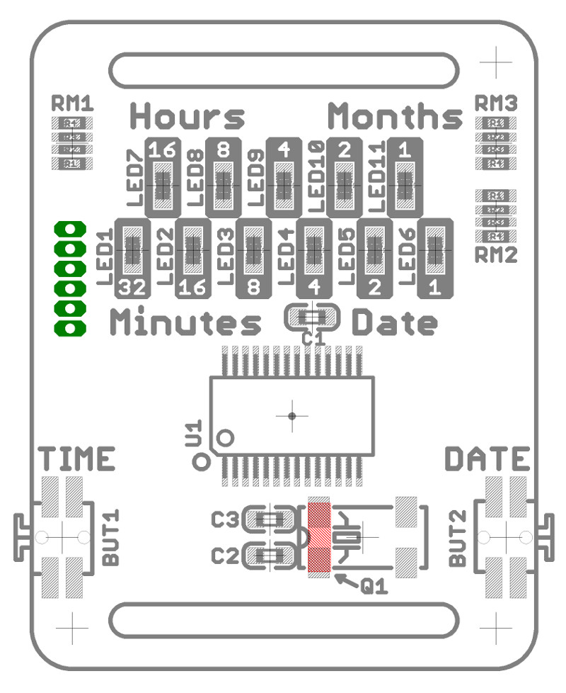
BINARY-WATCH assembly cheatsheet

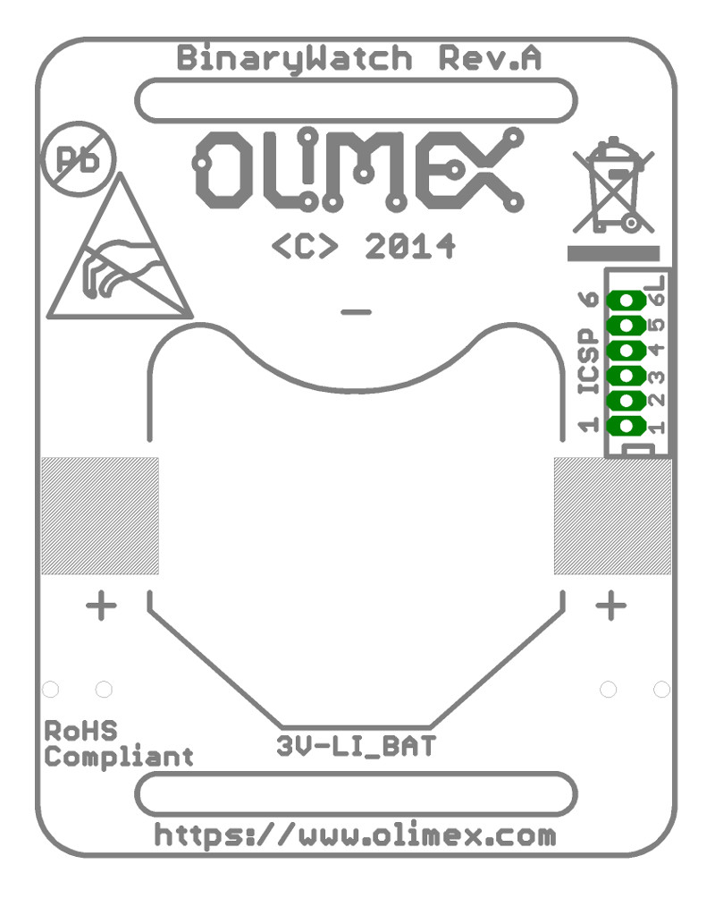
Binary-Watch design is made with small SMT components in mind.

There are several ways how to assemble the SMT components, the harder one requires no extra tools but experience with soldering iron, good eyesight. You hold the components with tweezers then solder the legs one by one.

Easier assembly process for SMT components requires some tools and preparation and follows these steps:
1. Apply solder paste
2. Place the components
3. Reflow

Capacitors:

Name | Size | Value
C1 | 0603 | 100nF, 50VDC, 10%
C2, C3 | 0603 | 10pF, 50VDC, 10%

Resistor matrices:

Name | Size | Value
RM1, RM2, RM3 | 4×0603 | 4.7K, 5%

LEDs:

Warning! They have polarity! Green mark indicates cathode and should be facing top!

Name | Size | Value
LED1..LED6 | 0603 | GREEN 100mCd
LED7..LED11 | 0603 | RED 100 mCd

Buttons:

Name | Value
BUT1, BUT2 | WTCM-TR

MCU:

Warning first pin is marked with DOT!

Name | Size | Value
U1 | SSOP28 | PIC16F722A-I/SS

Quartz:

Name | Size | Value
Q1 | 1206 | CM7V-T1A 32.768kHz 12.5pF 20ppm

BAT holder:

Name | Value
3V-LI_BAT | BC2001

