Assembly of SMT components without expensive tools

The SMT assembly contains three simple steps:

- Apply solder paste
- Place components
- Reflow soldering

Depending on your budget and scale of production you can have different setups but in this tutorial we will cover the very basic materials and instruments necessary.

Before we proceed let's learn a bit about the materials used:

SOLDER PASTE

Solder paste is made of small tin alloy particles mixed with tackle flux.

The ROHS industry standard used paste is SAC305 which has content of Sn 96.5% Ag 3% Cu 0.5%.

The function of the solder paste is to hold the component placed on the PCB, then when heated to solder the component pads to the PCB.

The tin alloy particles in the solder paste are with sizes typically from 20μm up to 45μm. Solder paste Class defines the size of the particles. Class 3 has particles from 25-45μm, Class 4 has particles from 20-38μm.

The number of solder particles in solder paste must be at least 4.5 times the smallest opening i.e. if you use Class 3 solder paste with 45 micron particles you will be able to print reliable only pads which are above 200 microns (0.2mm) size.

Class 4 is used when small pitch components has to be soldered like BGA 0.5 mm step or QFN 0.4 mm step. The smaller the particles – the better and the more expensive the paste. Class 4 is more expensive than Class 3.

Solder paste should be kept in refrigerator at 5-6C temperature when not used. Make sure it doesn't freeze, as the flux will change its properties. It should not be kept at higher temperatures than 22-24C for long time as the flux separation would happen i.e. the heavy metal contents will settle down and the flux will go up.

When solder paste is taken from the refrigerator it needs to be left at room temperature for at least 4-5 hours to heat up. Do not forcibly heat the paste.

Before applying the past you have to stir it very good to achieve the same viscosity.

Solder paste should not be left in contact with air for long, as it tends to absorb moisture and the flux evaporates. Usually the time solder paste can be left in open air is called solder paste “open time” and it's usually accumulated 24 hours.

Solder paste which has been used and exposed on open air can be reused again but it's a good idea to mix it with fresh paste 50%-50%.

STENCIL

Stencil is used to apply solder paste to the PCB easily.

When printing solder paste tack on stencil walls, so to may release good amount of paste there should be Area ratio >= 0.66

What is area ratio: this is the pad area divided by the stencil wall area.
If the pad size is L * W and the stencil is with thickness “t” the Area ratio is:

L * W / 2 * t * (L + W)

So for smaller pads thinner stencils should be used.

Standard stencil thickness is 0.1 mm, 0.12 mm, 0.15mm. What mostly is used is 0.12mm. If you have to deal with 0.5 mm step BGA and 0.3mm step QFNs you should use 0.1 mm stencil to achieve good Area ratio.

SQUEEGEE

Squeegee is a thin, flat, and smooth tool used to apply the solder paste evenly. It can be made of metal or rubber. Sometimes a plastic card or metal spatula can be used. When metal tip tool is used, the amount of solder paste is always same. When the squeegee is rubber the amount of solder paste may be changed by apply more or less pressure when printing.

REFLOW

The reflow process depends on solder paste used. If this is SAC305 type solder paste there are usually three phases:

Preheat: takes between 60 and 80 seconds and rise the temperature from 20C to 150C the temperature should not rise with more than 2C/sec. During this phase the flux in the solder paste is activated, some of flux volatile components evaporate and flux starts to eliminate the oxides in the PCB and component parts.

Soak: this lasts between 60 and 120 seconds. The temperature will change from 150 to 220C. During this phase all components on the PCB should have enough time to heat up so there is no thermal shock when PCB is entering next phase. The bigger components you have more time is necessary for the PCB to stay at this phase.

Reflow: During this phase the temperature should rise from 220C up to 240C for about 5-10 seconds then to decrease back to 220C. In this phase solder paste becomes liquid (SAC305 melting temperature is 217-220C), and should stay liquid at least for 30 seconds so the solder tin make good bond with the PCB copper and component pads.

Cooling: during this phase PCB cools from 220 to 20C it should not cool with more than 4C/seconds as deformations may occur.

Apply solder paste

To apply the solder paste to the PCB you need stencil printer or you can make simple DIY solution – fix your PCB to flat surface so it's not moving then fix the stencil above the PCB so the stencil openings are exactly at the PCB pads where paste is to be printed:

1. You need flat surface, we will use tile as it has good flat surface and will also protect the table later from heat when we do the reflow:

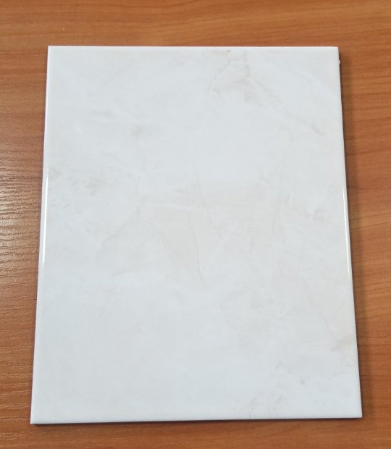

we place the board which will be assembled:

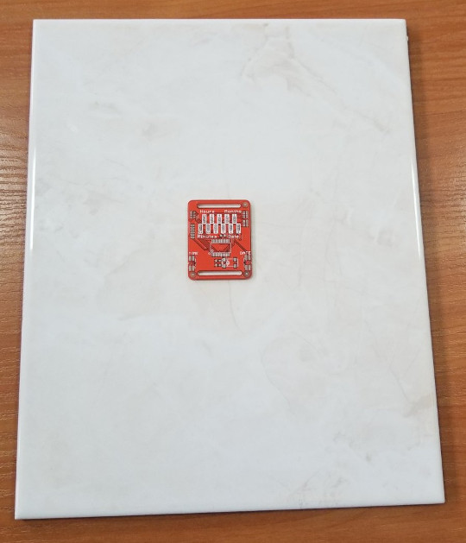

and fix it with some other boards with same height:

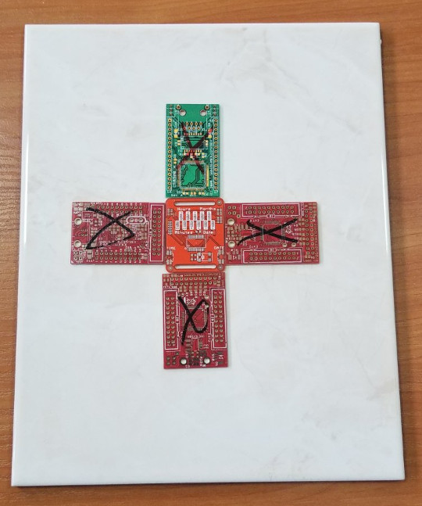

then tape them to stay firmly in place:

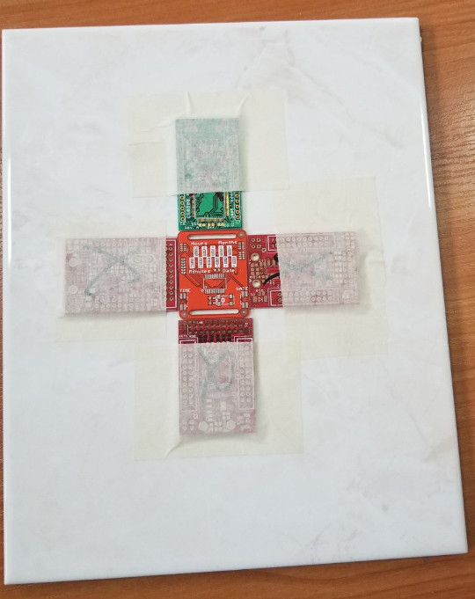

Now you can place all boards for soldermask printing in exactly the same position:

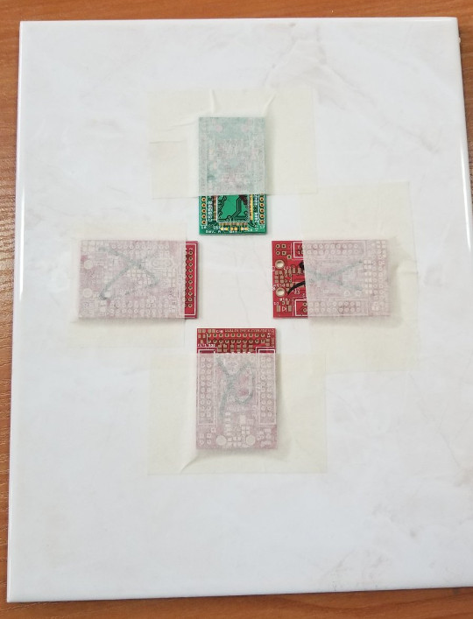

Now position the metal stencil so the pad openings match exactly the PCB pads and tape it so it doesn't move:

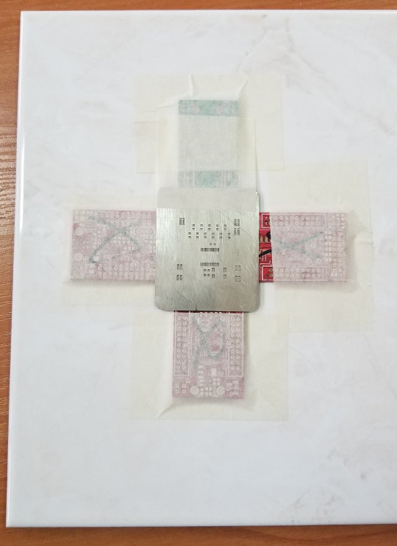

Open the solderpaste jar and mix it very well for several minutes so the flux mix well with the solder particles:

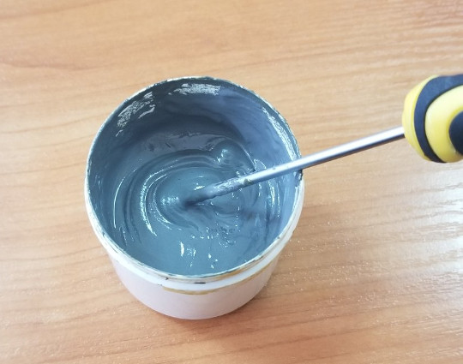

Put some paste on top of the PCB:

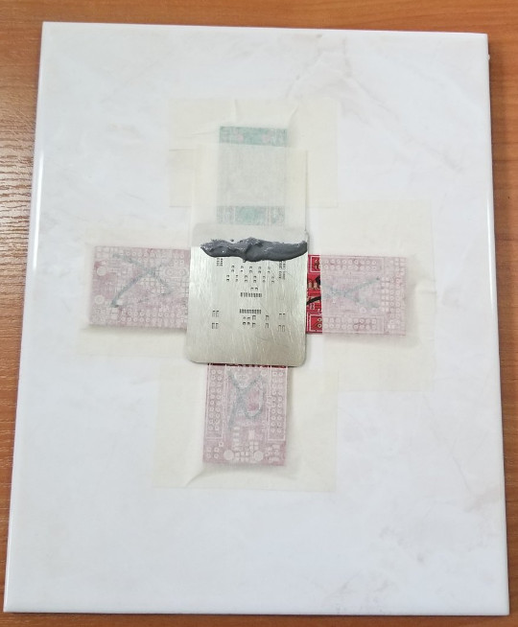

Then press the squeegee tool and move it from top to bottom of PCB without stop and carefully lift the stencil:

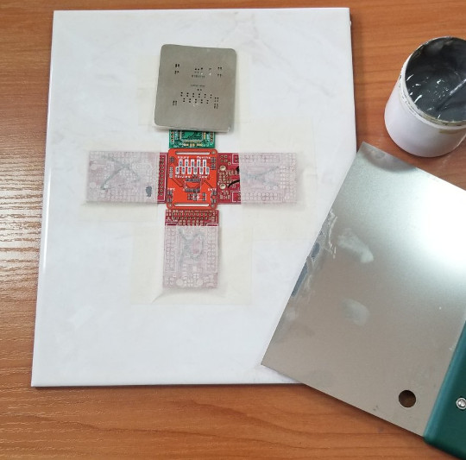

The solder paste should be printed on the pads and cover them with sharp edges without bridges between near pads:

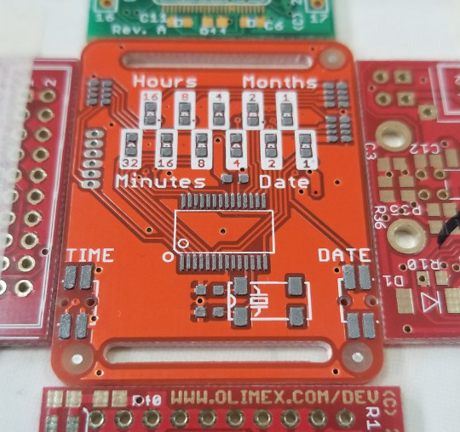

The PCB is ready for assembly:

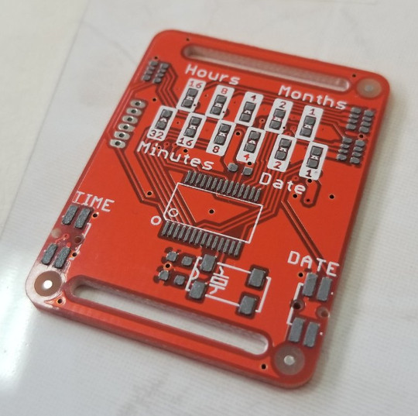

Place components

Components can be placed with tweezers or vacuum nozzle:

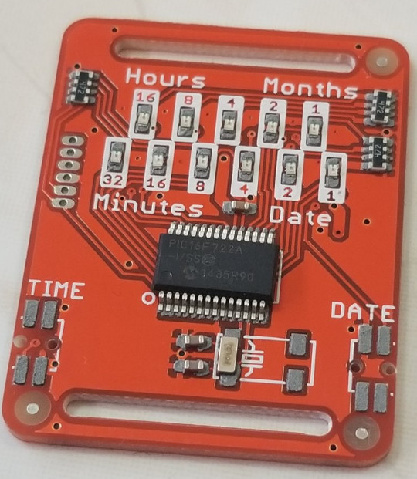

Do not worry if they are not perfectly aligned, during the reflow the melted alloy forces will align them:

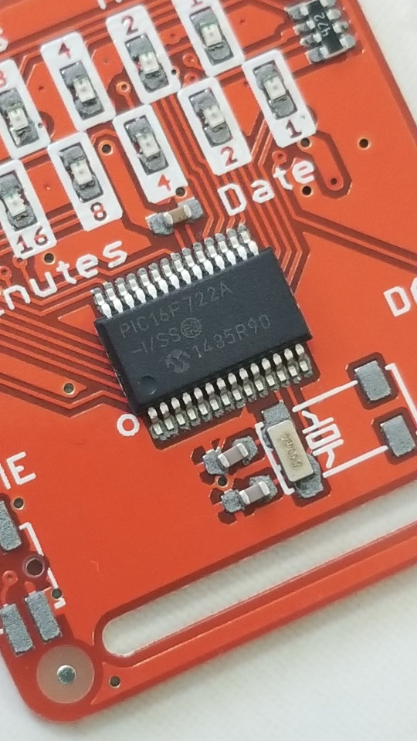

Reflow

The simplest way to reflow is by using hot air gun. Set the temperature to 350C and start heating the board with circulating movements above all PCB area so all PCB get equally heated. It will take 2-3 minutes before solder start to melt, be patient do not heat too fast as this may damage the PCB. When the solder paste start to melt do not stop but make sure it stay at least 20-30 seconds in liquid state to make reliable solder joint. Good solder joints are shiny and smooth:

