

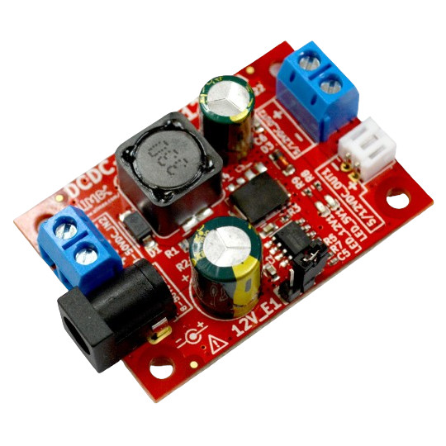

DCDC-50-5-12
User Manual
Rev.1.0 February 2024 olimex.com
Table of Contents
What is DCDC-50-5-12 3
Order codes for DCDC-50-5-12: 4
HARDWARE 5
DCDC-50-5-12 layout: 6
DCDC-50-5-12 schematics: 7
Revision History 8

What is DCDC-50-5-12

DCDC-50-5-12 is high effeciency DC to DC which delivers 5V/1.5A or 12V/1.5A from wide range of input voltage up to 50VDC.
It is suitable to deliver 5V for OlinuXino Linux computers from automotive 12V-24VDC power system.
When the output is 5VDC/1.5A the input power can be in range 8-50VDC.
When the output is 12VDC/1.5A the input power can be in 17-50VDC.
Default power output is 5VDC whrn 12V_E1 jumper is opened.
When 12V-E1 jumer is closed (cap on) the output voltage is 12VDC/1.5A.

The dimensions are: 50 x 35 x 15 mm.

The input can be supplied on two connectors:
1. Power barrel jack with 2.2 mm inner positive and outer 5.5 mm which is compatible with PWR-CABLE and PWR-CABLE-RA
2. Screw terminal connector with 5 mm step for wires 0.2-2.0mm2

The output can is provided on two connectors:
1. Screw terminal connector with 5 mm step for wires 0.2-2.0mm2
2. 2.0 mm step JST cable connector which can be used with BATTERY-CABLE (note colors are red for – and black for +)

Order codes for DCDC-50-5-12:

DCDC-50-5-12 industrial grade -40+85C DCDC power supply
BATTERY-CABLE output power cable
PWR-CABLE input cable
PWR-CABLE-RA input cable

HARDWARE

DCDC-50-5-12 layout:

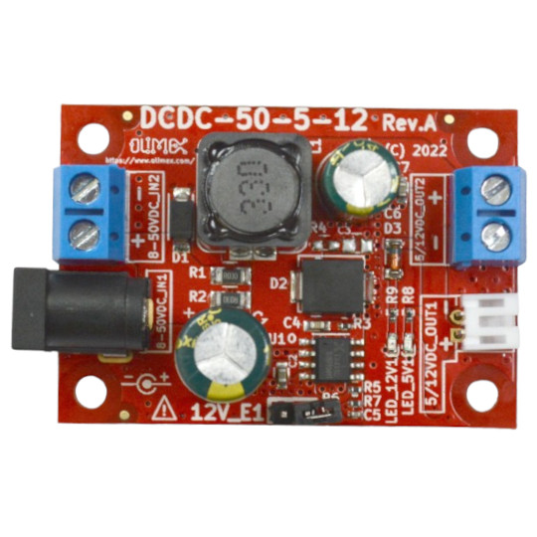

Output terminal block
Input terminal block

JST 2.0 mm connector
Input barrel jack 5.5mm
Output voltage jumper selection: open = 5V closed = 12V

DCDC-50-5-12 schematics:

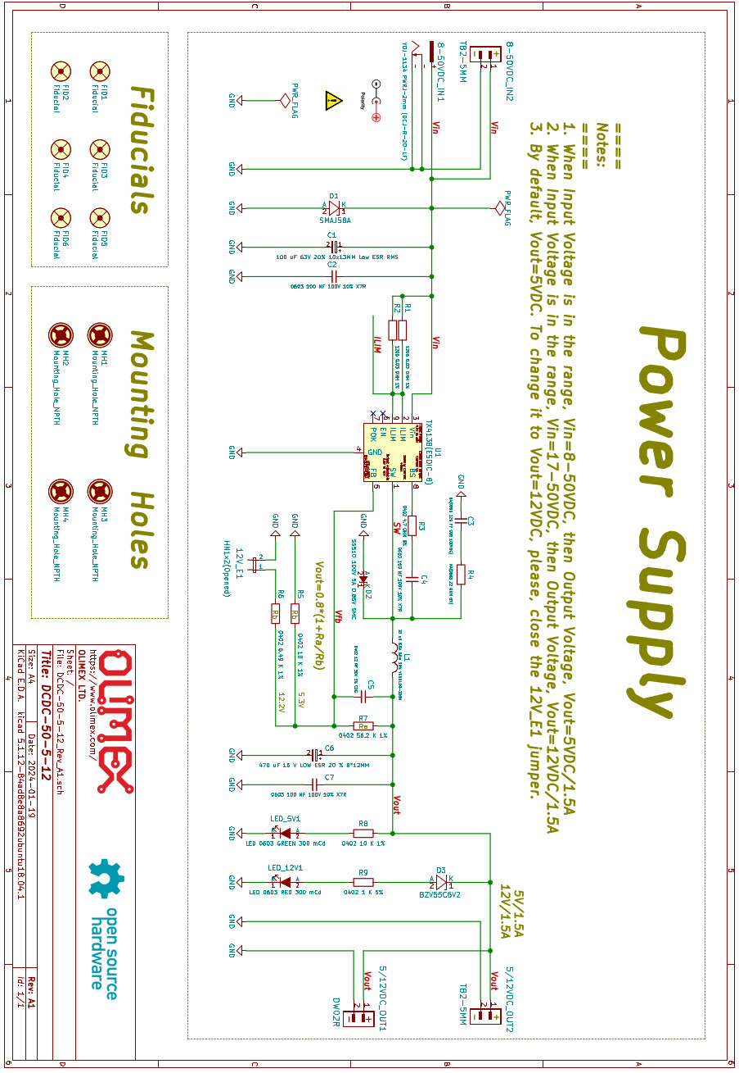

Revision History
Revision 1.0 February 2024

