

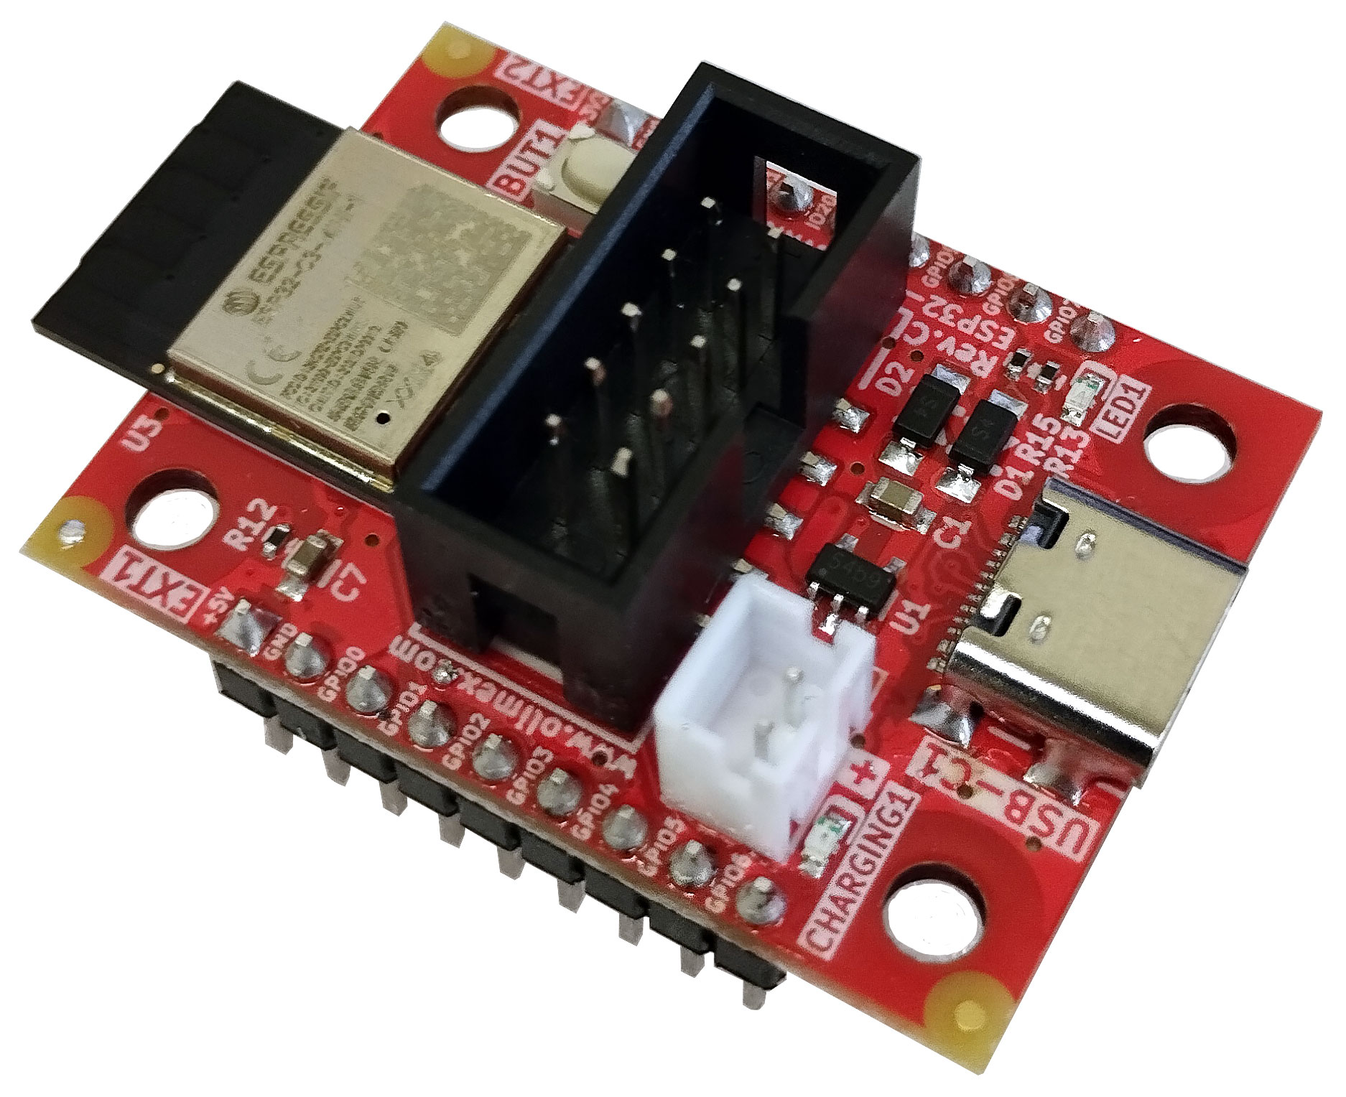

ESP32-C3-DevKit-Lipo
User Manual
Document version 2.1 August 2026

olimex.com

Table of Contents
What is ESP32-C3-DevKit-Lipo 3
Board layout 4
ESP32-C3-DevKit-Lipo ordering options 5
ESP32-C3-DevKit-Lipo Open Source Licensee 6
ESP32-C3-DevKit-Lipo software installation 7
ESP32-C3-DevKit-Lipo pinout description 8
UEXT pinout 8
External power sense and battery measurement 9
ESP32-C3-DevKit-Lipo power supply and consumption 10
ESP32-C3-DevKit-Lipo dimensions 11
ESP32-C3-DevKit-Lipo schematic 12
Document version history 13

What is ESP32-C3-DevKit-Lipo

ESP32-C3-DevKit-Lipo is an Open Source Hardware industrial grade (-25+85ºC) development board with Espressif ESP32-C3-MINI module and WIFI and BLE5 capabilities. It has the following features:

- ESP32-C3-MINI-1N4 module with the following features:
  - RISC-V single core processor running on 160 Mhz
  - 384 KB ROM, 400 KB SRAM (16 KB for cache), 8 KB SRAM in RTC
  - 4 MB embedded flash
  - 2.4 GHz WiFi (802.11 b/g/n) 1T1R mode with data rate up to 150 Mbps
  - Bluetooth® 5 module
- 15 GPIOs
- On-board antenna
- Built-in Li-Po battery charger with STATUS LED, for handheld operations
- Li-Po battery connector for Olimex Li-Po batteries
- User button
- STATUS LED
- UEXT 0.1" step connector
- 4 mount holes
- USB-C connector for powering, debugging, and programming
- EXT1, EXT2 headers with all signals and power supply
- Tiny size: (1.1 x 1.5)" ~ (28 x 38)mm

Board layout

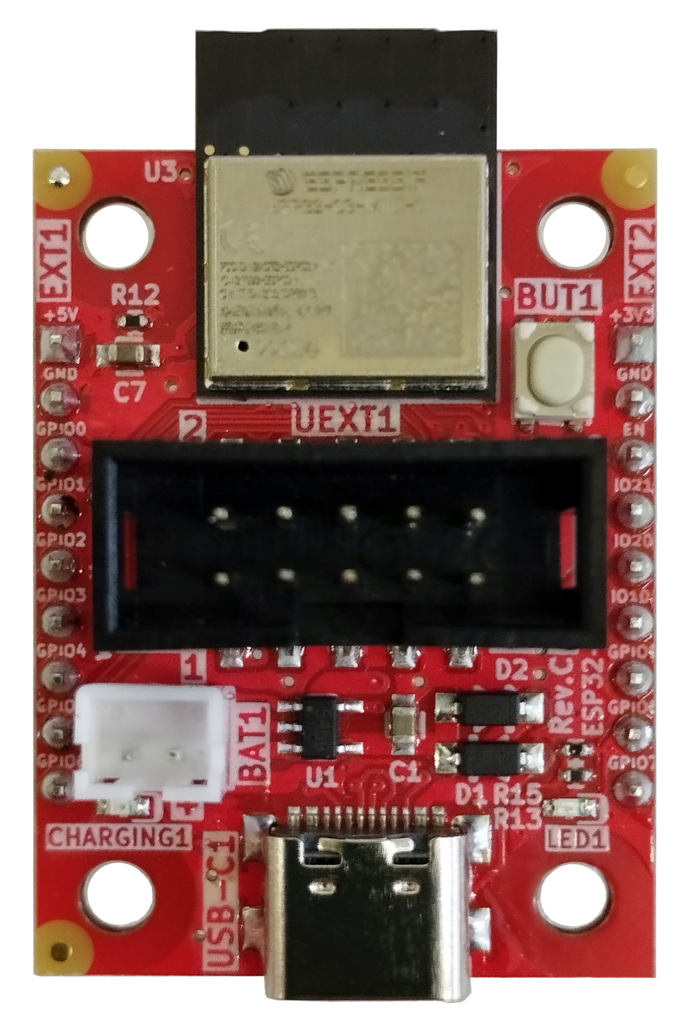
ESP32-C3-MINI-1
User LED1 - GPIO8
Li-Po battery connector
Battery charger LED indicator
USB C connector
User button BUT1 - GPIO9
UEXT

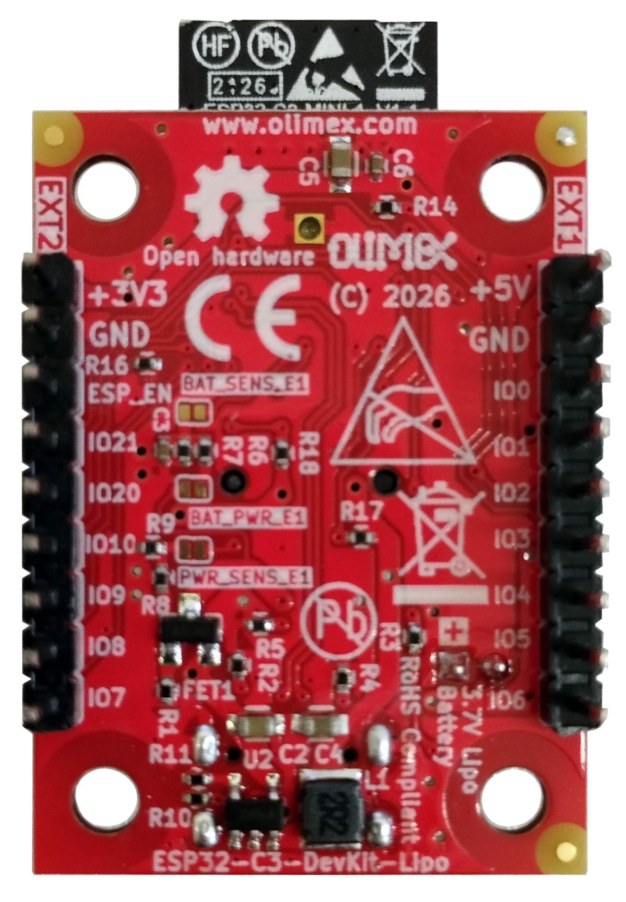

ESP32-C3-DevKit-Lipo ordering options

ESP32-C3-DevKit-Lipo can be ordered as:
- ESP32-C3-DevKit-Lipo
Additional accessories:
- USB-C cable: CABLE-USB-A-C-1M
- LiPo batteries: Olimex LiPo batteries
- Breadboard: BREADBOARD1
- Jumper wires: JW-200x10, JW-200x10-FM

ESP32-C3-DevKit-Lipo Open Source Licensee
ESP32-C3-DevKit-Lipo is Open Source Hardware, ESP32-C3-DevKit-Lipo is certified Open Source Hardware with UID BG000083: https://certification.oshwa.org/bg000083.html

The Hardware files are released under CERN OSHW licensee.
The software is released under GPL 3 licensee.
The documentation is released under CC BY-SA 3.0 licensee.

ESP32-C3-DevKit-Lipo software installation

How to program the board? Usually you use software that has support for ESP32-C3 chip and then plug the board to the USB. No extra steps with the hardware are needed but if you have trouble you can force the board into bootloader mode – disconnect the USB cable, press and hold button BUT1, connect the USB cable, release button BUT1.

Esspresif guide for Arduino IDE installation
You can find simple Arduino demo here: Button, LED, serial demo

Esspressif guide for PlatformIO installation
Espressif ESP-IDF installation
JTAG debugging installation

ESP32-C3-DevKit-Lipo pinout description

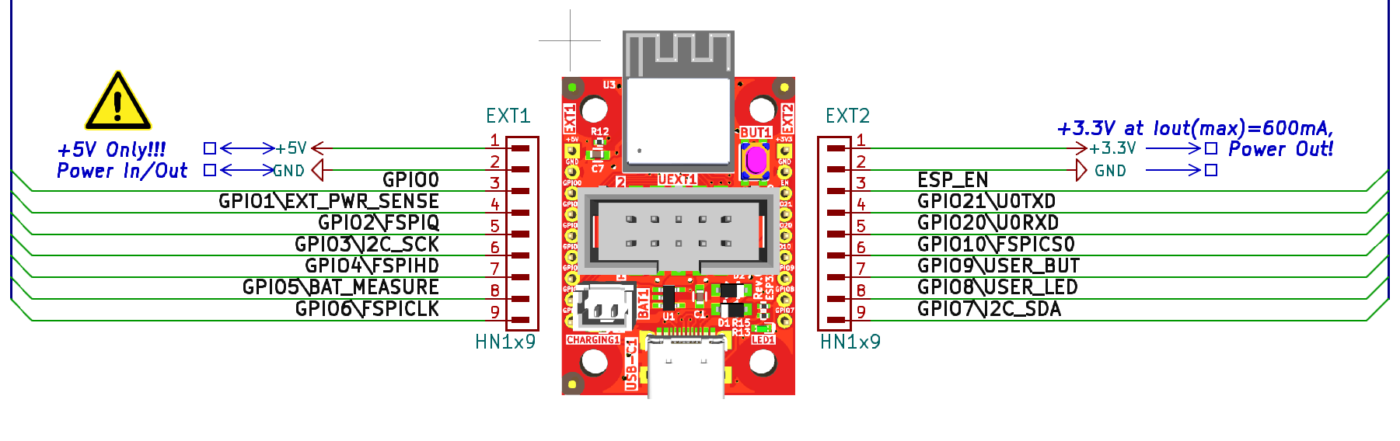
UEXT pinout

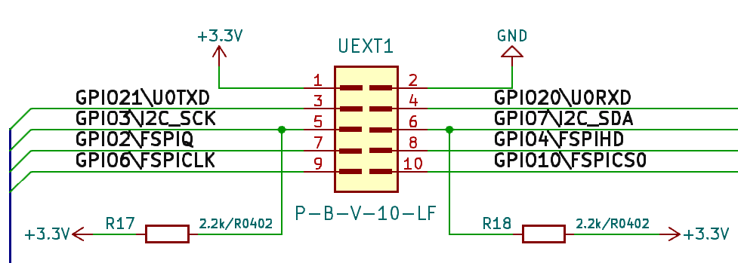

External power sense and battery measurement
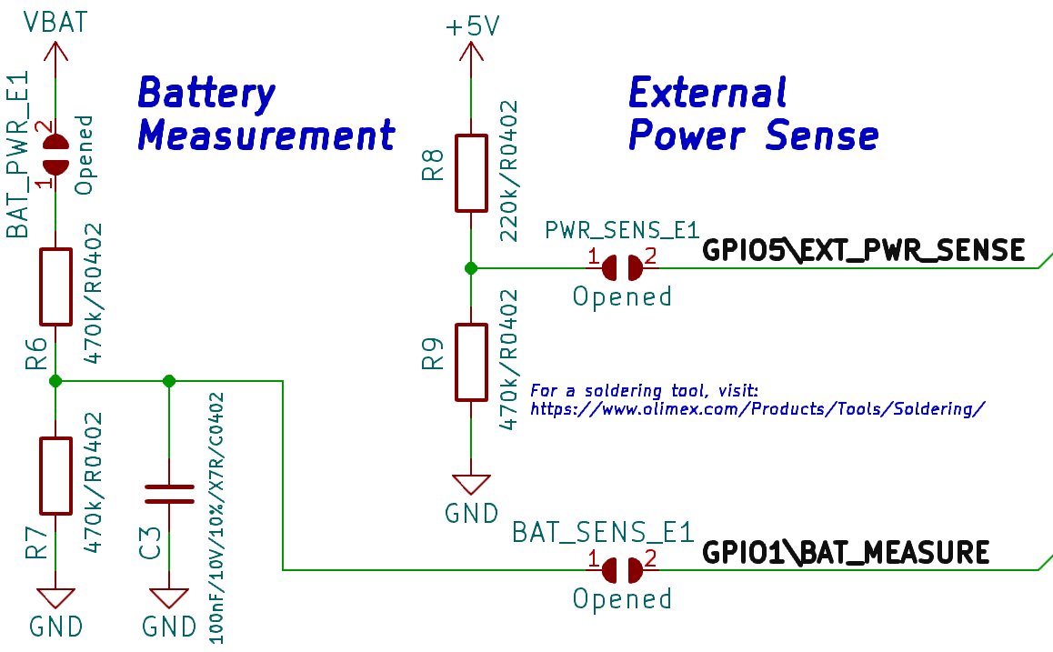
There are external power sense and battery measurement circuits. By default these are disconnected and can be enabled if you solder together a couple of PTH jumpers.
If you wish to enable the external power sense function, close PWR_SENSE_E1 – this function allows you to detect whether the board is powered from the battery or externally – very helpful if you want to conserve battery when main power supply is missing. Notice the voltage divider R8 and R9 (220K and 470K) and consider the resistor values in your calculations about the threshold. The pin that handles the external power sense function is GPIO5.
If you wish to enable the battery measurement function – you need to close two jumpers (solder pads of each jumper together) – BAT_PWR_E1 and BAT_SENS_E1. This function helps keeping track of the voltage of the battery connected so you can take certain precautions when the voltage of battery goes dangerously low. Notice the voltage divider R6 and R7 (470k and 470k) and consider the resistor values in your calculations. The pin that handles the external power sense function is GPIO1.
Note! The power sense and battery measurement pins were swapped in hardware revision D. Refer to the hardware revision changes document and the schematics for further info.

ESP32-C3-DevKit-Lipo power supply and consumption

- 0.2A @ Active operation
- 22mA @ Idle
- 3mA @ Sleep
- 20uA @ Power off

ESP32-C3-DevKit-Lipo dimensions
The dimensions apply to hardware revisions C and newer. Dimensions for revision B boards are available at our GitHub.
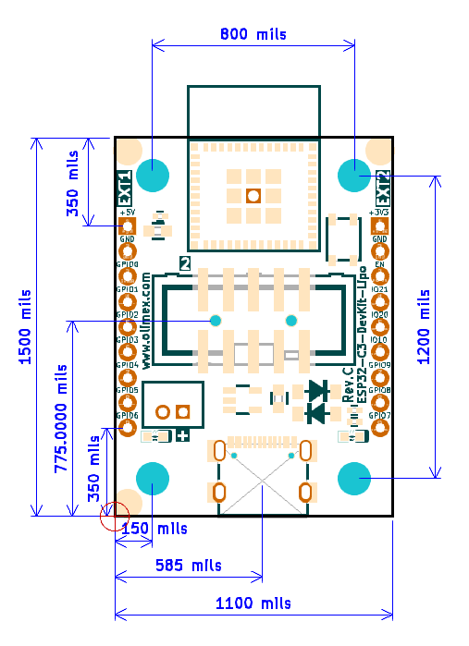

ESP32-C3-DevKit-Lipo schematic

ESP32-C3-DevKit-Lipo schematics (including for older revisons) are available at GitHub hardware
Hardware revision changes can be found in this text document: Hardware revision changes text at GitHub
Notice that there were major changes in the hardware design in hardware revision C (added UEXT connector; removed PROG connector; removed reset button but added user button; rotated BAT1 connector; and more).

Document version history
Revision 1.0 September 2022
- Initial release
Revision 2.0 April 2026
- Edited the document to fit hardware revision C of the board
- Documents for hardware revision B boards available at GitHub for reference
Revision 2.1 August 2026
- Edited the document to fit hardware revision D of the board (the only change is the swap of battery measurement and external power pins)

