

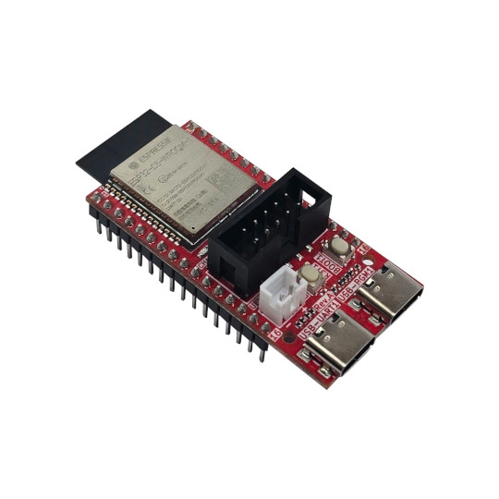
ESP32-C5-DevKit-Lipo User Manual

Document revision 2.0 www.OLIMEX.com
Table of Contents
What is ESP32-C5-DevKit-Lipo 3
Order codes for ESP32-C5-DevKit-Lipo and accessories 4
HARDWARE 5
ESP32-C5-DevKit-Lipo layout 5
Power supply 6
UEXT connector 8
ESP32-C5-DevKit-Lipo UEXT connector 8
J1 and J2 connectors signals 8
LEDs 9
ESP32-C5-DevKit-Lipo schematics 10
SOFTWARE 11
Document revision history 12

What is ESP32-C5-DevKit-Lipo

ESP32-C5-DevKit-Lipo is a breadboard-friendly development board with ESP32-C5-WROOM-N8R4 module (8MB of SPI flash memory and 4MB of PSRAM memory) which features dual-band 2.4Ghz and 5Ghz WiFi 6 support, Bluetooth 5 LE support, Zigbee support, Thread and Matter support. The board comes with UEXT connector, DIL GPIO rows, and LiPo battery UPS, dual USB type C connectors, user LED, buttons, and more.

The features of ESP32-C5-DevKit-Lipo are:
- ESP32-C5-WROOM-N8R4 module:
- 32 bit RISC-V processor 240Mhz
- Dual-Band Wi-Fi (2.4 GHz + 5 GHz)
- Bluetooth 5, Zigbee, Thread, Matter support
- 8 MB Flash + 4 MB PSRAM
- USB-C for CH340x USB-serial adapter (power and serial programming)
- USB-C for native USB (power and JTAG debug)
- UEXT connector
- User/boot button
- Reset button
- User LED
- Two extension headers with all GPIOs
- Breadboard-friendly header spacing - 0.9" (22.86 mm)
- Li-Po UPS battery with charger
- Battery charger status LED
- External power sense and battery measurement option
- Two mounting holes
- Compact design size with dimensions 53x25 mm
ESP32-C5-DevKit-Lipo is an Open Source Hardware project, all CAD files and software are available for download, so people can study and modify the design.
+ Important notice: ESP32-C5-DevKit-Lipo comes without a protective box so be careful where you place it – avoid placing it on metal or conductive surfaces. Do not drop metal or conductive objects on top of the PCB! This can lead to hardware damage.

Order codes for ESP32-C5-DevKit-Lipo and accessories

ESP32-C5-DevKit-Lipo ESP32-C5 development board, subject of this document
USB-CABLE-AM-USB3-C High-speed, high-current cable for powering and programming
UEXT modules Extension modules that can be connected to the on-board UEXT header
BATTERY-LiPo1400mAh LiPo battery compatible with ESP32-C5-EVB
BATTERY-CABLE JST2.0 cable can be used for external power supply +5V on PWR1 connector instead to power via USB-C
ESP32-C5-EVB ESP32-C5 development board with relays and optoisolated inputs

HARDWARE

ESP32-C5-DevKit-Lipo layout

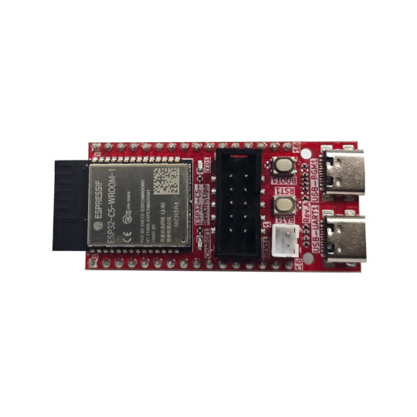
ESP32-C5-WROOM
4MB PSRAM
8MB SPI flash
UEXT
BOOT button
RESET button
Lipo battery connector
Watch the polarity!!!
USB-C
Native USB
JTAG
USB-C
UART CH340T

Power supply
RELAY2
RESET button
INPUT1 status LED
INPUT1
INPUT2

ESP32-C5-DevKit-Lipo can be powered from several sources:

- USB-UART1 – this is USB-C connector with USB-to-serial converter attached. It works as debug UART and can be used for programming with esptool.py with automatic bootloader mode invoke. Can be connected to a personal computer via USB cable with type C to type A connectors.

- USB-PGM1 – this is USB-C connector connected directly to ESP32-C5 USB pins, it can act as software JTAG and also as software serial. Can be connected to a personal computer via USB cable with type C to type A connectors.

- Li-Po battery – ESP32-C5-DevKit-Lipo have smart switching between the different power supplies and LiPocharger, so when USB-C and PWR1 external power supply is missing LiPo battery with step-up converter used to keep all ESP32-C5-DevKit-Lipo functionality even when powered by a 3.3V battery

- Connector J1, pin #14 (5V) and pin #15 (GND) – J1 and J2 are 0.1” step connectors exposing all available GPIOs. The 5V power is present there on pin 14 is +5V on pin 15 is GND.

+ Important notice: Never supply more than 5V on pin #14 of J1 header! This will damage the board!
+ Important notice: The USB-C VCC is directly connected to the 5V of pin #14 of J1 header so you shouldn’t apply external power supply to this pin while you are connected to USB-C connector, or there is risk to damage your USB-host.

When working on LiPo battery there are provisions to sense if the board is powered by LiPo battery or external source with GPIO9 and the battery voltage with GPIO6. By default these are not connected so GPIO9 and GPIO6 can be used for other purpose, but SMT jumper can be shorten in case this functionality is necessary.
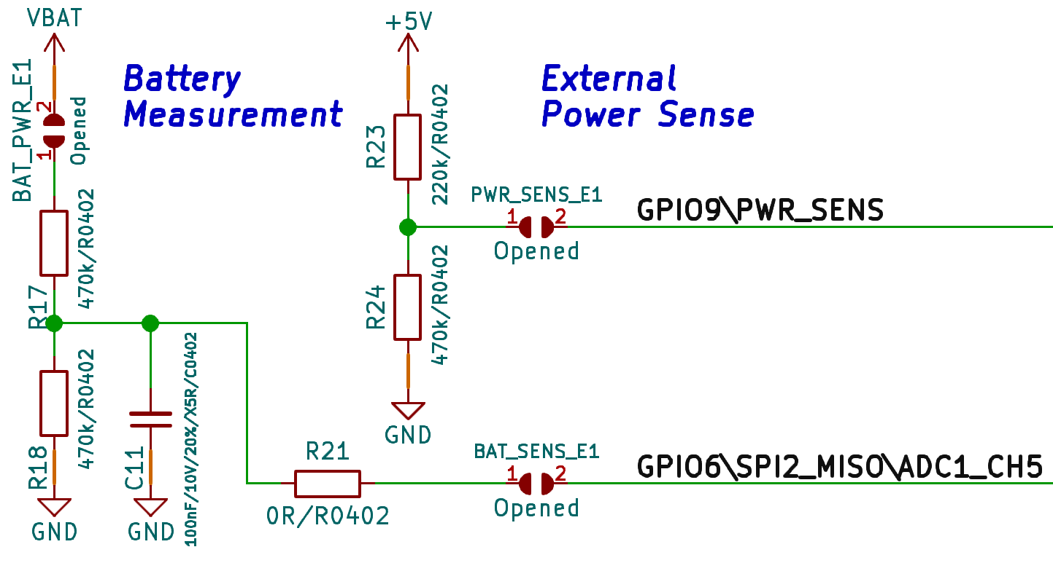

UEXT connector

UEXT connector stands for Universal EXTension connector and the purpose is to easily attach Olimex-made expansion boards. Of course, it can be used for any other purpose via jumper wires. The connector contains +3.3V, GND, and pins that can be used for UART, I2C, SPI interfaces. In the case of ESP32-C5 – there are
The UEXT connector is 0.1” 2.54mm step boxed plastic connector. All signals are at 3.3V levels.
Olimex has developed number of MODULES with this connector. There are temperature, humidity, pressure, magnetic field, light sensors. Modules with LCDs, LED matrix, relays, Bluetooth, Zigbee, WIFI, GSM, GPS, RFID, RTC, EKG, sensors, etc.

ESP32-C5-DevKit-Lipo UEXT connector

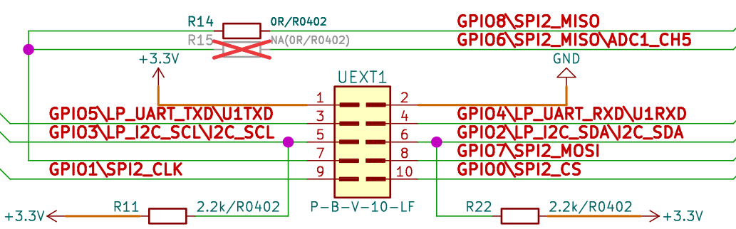

J1 and J2 connectors signals

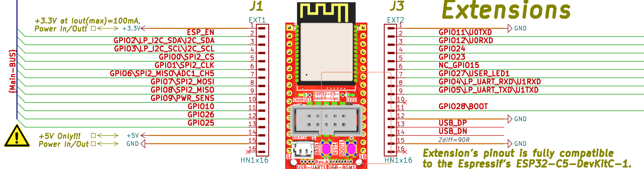

LEDs

GPIO27 is connected to GREEN user LED, when the level is LOW LED is ON, when the level is HIGH the LED is OFF.

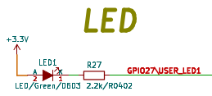

YELLOW LED for CHARGING status: OFF – battery is fully charged, ON – battery is charging, Blink – No battery.

ESP32-C5-DevKit-Lipo schematics

ESP32-C5-DevKit-Lipo latest schematic is available at GitHub:

https://github.com/OLIMEX/ESP32-C5-DevKit-Lipo/tree/main/HARDWARE

SOFTWARE

ESP32-C5-DevKit-Lipo can be programmed with any software that supports ESP32-C5 chip. We provide demo examples for Espressif IDF and Arduino, these can be found here:

https://github.com/OLIMEX/ESP32-C5-DevKit-Lipo/tree/main/SOFTWARE

Document revision history
Revision 2.0 November 2025
- updated schematics to reflect release variant of the board
- improved product description
Revision 1.0 November 2025

