

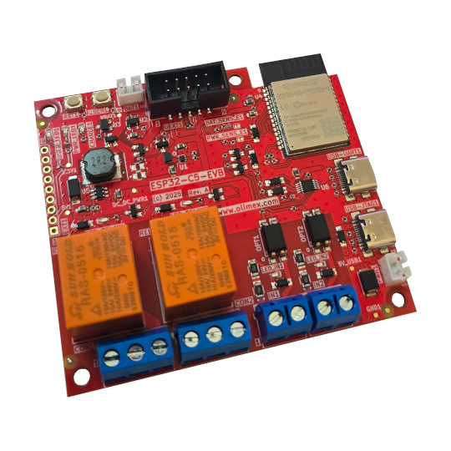

ESP32-C5-EVB
User Manual
Rev.1.0 September 2025 olimex.com
Table of Contents
What is ESP32-C5-EVB 3
Order codes for ESP32-C5-EVB and accessories: 4
HARDWARE 5
ESP32-C5-EVB layout: 6
Power supply: 7
UEXT connector: 9
ESP32-C5-EVB UEXT connector: 10
EXT1 connector signals: 10
Digital High Voltage Inputs: 11
RELAY outputs: 12
LEDs: 13
ESP32-C5-EVB schematics: 14
SOFTWARE: 15
Revision History 16

What is ESP32-C5-EVB

ESP32-C5-EVB is Dual band 2.4Ghz and 5Ghz WiFi 6, Bluetooth 5 LE, Zigbee, Thread, Matter development board with Relays, optoisolated inputs and LiPo battery UPS. The board is equiped with ESP32-C5-WROOM-N8R4 module with 8MB of Flash and 4MB of RAM

The features of ESP32-C5-EVB are:
- ESP32-C5-WROOM-N8R4 module
- 32 bit RISC-V processor 240Mhz
- Dual-Band Wi-Fi (2.4 GHz + 5 GHz)
- Bluetooth 5, Zigbee, Thread, Matter
- 8 MB Flash + 4 MB RAM
- Two relays – rated 250V / 10A
- Two opto-isolated inputs
- UEXT connector
- USB-C (Power & Debug)
- USB-C JTAG
- Boot & Reset buttons
- Extension connector
- LiPo UPS charger & step-up converter
- Three mouting holes
- Dimensions 80x70mm

ESP32-C5-EVB is Open Source Hardware, all CAD files and firmware and available, so people can study and modify.
+ Important notice: If ESP32-C5-EVB is not mounted in box be careful to not place it on metal surface, nor drop metal objects on top of the PCB! This will lead to damage.

Order codes for ESP32-C5-EVB and accessories:

ESP32-C5-EVB ESP32-C5-EVB development board
BOX-ESP32-C5-EVB Plastic box for ESP32-C5-EVB
USB-CABLE-AM-USB3-C High speed, High current cable for power supply and programming
UEXT modules many UEXT modules which can connect to UEXT connector
BATTERY-LiPo1400mAh LiPo battery compatible with ESP32-C5-EVB
BATTERY-CABLE JST2.0 cable can be used for external power supply +5V on PWR1 connector instead to power via USB-C

HARDWARE

ESP32-C5-EVB layout:

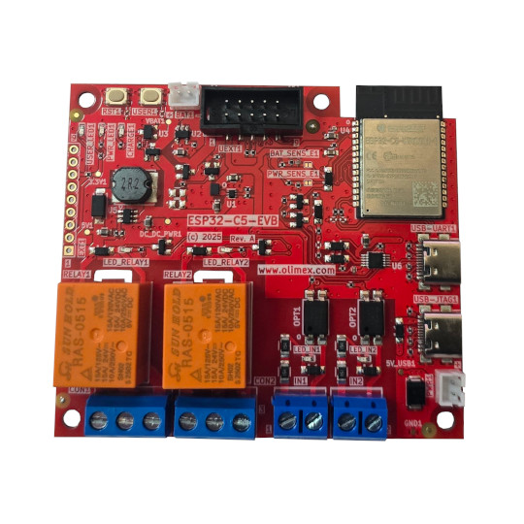
ESP32-C5-WROOM-N8R4
Power USB-C
Debug UART
Power USB-C JTAG
POWER SUPPLY
UEXT
EXT connector
RELAY1
RELAY1 status LED
RELAY2
RELAY2 status LED
UPS LiPo battery
USER button
RESET button
INPUT1 status LED
INPUT1
INPUT2
INPUT2 status LED
USER LED
POWER LED
CHARGE LED

Power supply:

ESP32-C5-EVB can be powered from several sources:

USB-UART1 – this is USB-C connector with USB to serial convertor attached. It works as debug UART and can be used for programming with esptoo.py with automatic bootloader mode invoke.

USB-JTAG1 – this is USB-C connector connected directly to ESP32-C5 JTAG ports.

PWR1 – this is JST2.0 connector compatible with BATTERY-CABLE . This is reliable connection for industrial solutions, as USB-C cable connection can be easily pulled out and it’s great for development but not in more demanding environments.
+ Important notice: Never connect more than 5V on PWR1!This will damage the board
+ Important notice: The USB-C VCC is directly connected to PWR1 +5V so you should not apply external power supply to PWR1 connector while you are connected to USB-C connector, or there is risk to damage your USB-host.

LiPo battery – ESP32-C5-EVB have smart switching between the different power supplies and LiPO charger, so when USB-C and PWR1 external power supply is missing LiPo battery with Step-Up connector is used to keep all ESP32-C5-EVB functionality.

When working on LiPo battery there are provisions to sense if the board is powered by LiPo battery or external source with GPIO0 and the battery voltage with GPIO3. By default these are not connected so GPIO0 and GPIO3 can be used for other purpose, but SMT jumper can be shorten in case this functionality is necessary.
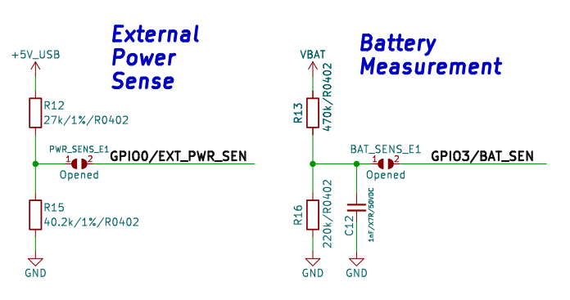

UEXT connector:

UEXT connector stands for Universal EXTension connector and contain +3.3V, GND, I2C, SPI, UART signals.
UEXT connector can be in different shapes.
The original UEXT connector is 0.1” 2.54mm step boxed plastic connector. All signals are with 3.3V levels.
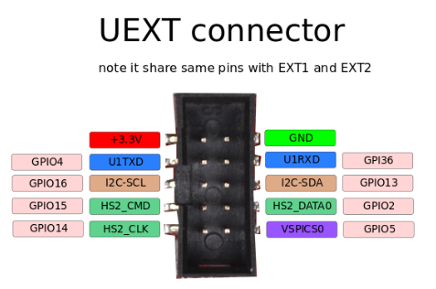

Olimex has developed number of MODULES with this connector. There are temperature, humidity, pressure, magnetic field, light sensors. Modules with LCDs, LED matrix, Relays, Bluetooth, Zigbee, WiFi, GSM, GPS, RFID, RTC, EKG, sensors and etc.

ESP32-C5-EVB UEXT connector:

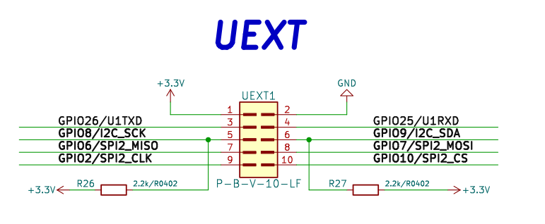

EXT1 connector signals:
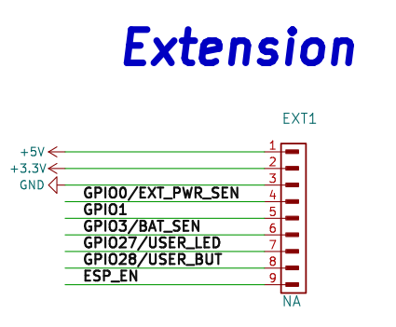

Digital High Voltage Inputs:

GPIO4 and GPIO5 are connected to terminal blocks via opto insulators with status LEDs.

These inputs are very useful when you want for instance to measure the time machine is ON – you connect directly to the machine power line. When the machine is powered the corresponding GPIO port will become LOW. When the machine not work it will be HIGH.

When AC or DC voltage is applied between IN1 terminals RED status LED will switch ON and GPIO4 will be LOW, when no voltage is present the LED is off and GPIO4 is in HIGH state.

When AC or DC voltage is applied between IN2 terminals RED status LED will switch ON and GPIO5 will be LOW, when no voltage is present the LED is off and GPIO5 is in HIGH state.

The input voltage should be between 100 and 300VDC or 120-220VAC when DC voltage is applied you should mind the + and – marking on the connectors.

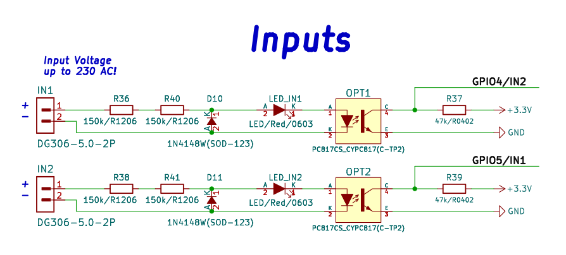

RELAY outputs:

GPIO23 and GPIO24 drive RELAY1 and RELAY2. When HIGH level is assigned to these ports, the RELAY and the GREEN status LED are switched ON and the relay contacts NO-COM are closed, NC-COM opened.

When GPIO23 and GPIO24 have LOW level the RELAY and STATUS LED are OFF and NO-COM is opened, NC-COM is closed.
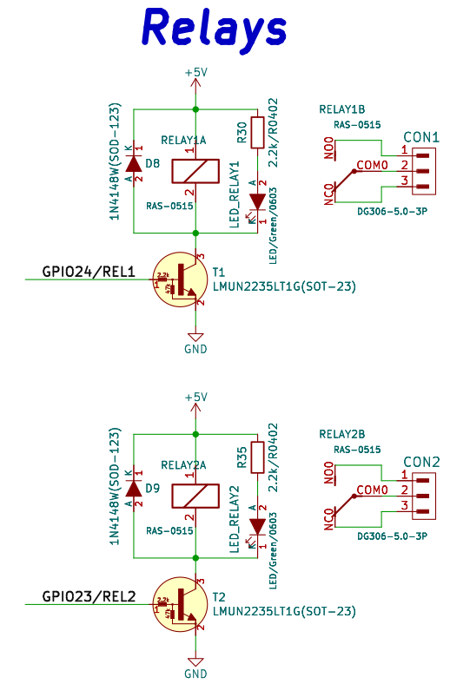

LEDs:

GPIO27 is connected to GREEN user LED, when the level is LOW LED is ON, when the level is HIGH the LED is OFF.

RED power LED is ON when the board is powered.

YELLOW LED for CHARGING status: OFF – battery is fully charged, ON – battery is charging, Blink – No battery.

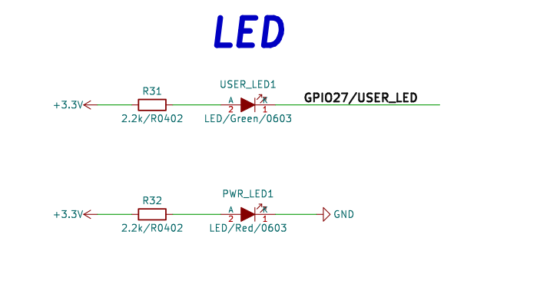
GREEN RELAY status LED – ON relay is energized, OFF relay is not powered.

RED input status LED – ON when voltage is present, OFF when no voltage on the input.

ESP32-C5-EVB schematics:

ESP32-C5-EVB latest schematic is on GitHub

SOFTWARE:

ESP32-C5-EVB can be programmed with Espressif IDF 5.5

It’s very new board and Arduino, PlatformIO, MicroPython and ESPHome are still not supporting it.

Revision History
Revision 1.0 September 2025

