

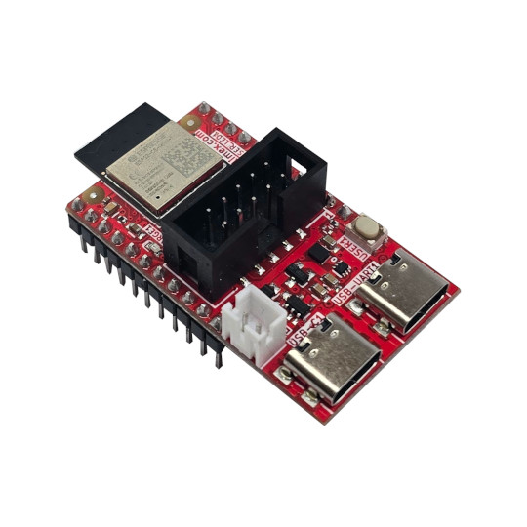

ESP32-C6-DevKit-Lipo
User Manual
Rev.1.0 December 2025 olimex.com
Table of Contents
What is ESP32-C6-DevKit-Lipo 3
Order codes for ESP32-C6-DevKit-Lipo and accessories: 4
HARDWARE 5
ESP32-C6-DevKit-Lipo layout: 6
Power supply: 7
UEXT connector: 9
ESP32-C6-DevKit-Lipo UEXT connector: 10
EXT1 and EXT2 connectors signals: 11
LEDs: 12
ESP32-C6-DevKit-Lipo schematics: 13
SOFTWARE: 14
Revision History 15

What is ESP32-C6-DevKit-Lipo

ESP32-C6-DevKit-Lipo is WiFi 6, Bluetooth 5 LE, Zigbee, Thread, Matter breadboard friendly development board UEXT connector, DIL GPIO ports and LiPo battery UPS. The board is with ESP32-C6-MINI-1-N4 module with 4MB of Flash and 512KB of RAM

The features of ESP32-C6-DevKit-Lipo are:
- ESP32-C6-MINI-1-N4 module
- 32 bit RISC-V processor 160Mhz
- Bluetooth 5, Zigbee, Thread, Matter
- 4 MB Flash + 512KB RAM
- UEXT connector
- USB-C (Power & Debug)
- USB-C JTAG
- Boot button
- Extension connectors spaced at 0.9”
- LiPo UPS charger & step-up converter
- Dimensions 45x25mm

ESP32-C6-DevKit-Lipo is Open Source Hardware, all CAD files and firmware and available, so people can study and modify.
+ Important notice: If ESP32-C6-DevKit-Lipo is not mounted in box be careful to not place it on metal surface, nor drop metal objects on top of the PCB! This will lead to damage.

Order codes for ESP32-C6-DevKit-Lipo and accessories:

ESP32-C6-DevKit-Lipo ESP32-C6 development board
USB-CABLE-AM-USB3-C High speed, High current cable for power supply and programming
UEXT modules many UEXT modules which can connect to UEXT connector
BATTERY-LiPo1400mAh LiPo battery compatible with ESP32-C5-EVB
BATTERY-CABLE JST2.0 cable can be used for external power supply +5V on PWR1 connector instead to power via USB-C

HARDWARE

ESP32-C6-DevKit-Lipo layout:

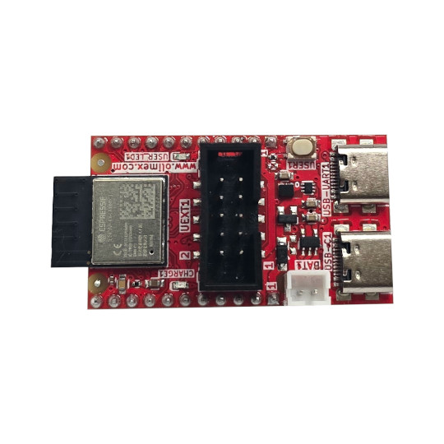
ESP32-C6-MINI-1-N4
UEXT connector
Boot button
USB-C serial
USB-C JTAG
LiPo battery connector

Power supply:
RELAY2
INPUT1 status LED
INPUT1

ESP32-C6-DevKit-Lipo can be powered from several sources:

USB-UART1 – this is USB-C connector with USB to serial converter attached. It works as debug UART and can be used for programming with esptool.py with automatic bootloader mode invoke.

USB-C1 – this is USB-C connector connected directly to ESP32-C5 JTAG ports.

EXT1/1 – EXT1 and EXT2 are 0.1” step connectors exposing all available GPIOs. The 5V power is present there on pin EXT1/1 is +5V on pin EXT2/2 is GND
+ Important notice: Never connect more than 5V on EXT1/1!This will damage the board
+ Important notice: The USB-C VCC is directly connected to EXT1/1 +5V so you should not apply external power supply to this pin while you are connected to USB-C connector, or there is risk to damage your USB-host.

LiPo battery – ESP32-C6-DevKit-Lipo have smart switching between the different power supplies and LiPO charger, so when USB-C and USB-C1 external power supply is missing LiPo battery with Step-Up connector is used to keep all ESP32-C6-DevKit-Lipo functionality.

When working on LiPo battery there are provisions to sense if the board is powered by LiPo battery or external source with GPIO2 and the battery voltage with GPIO3. By default these are not connected so GPIO9 and GPIO6 can be used for other purpose, but SMT jumper can be shorten in case this functionality is necessary.
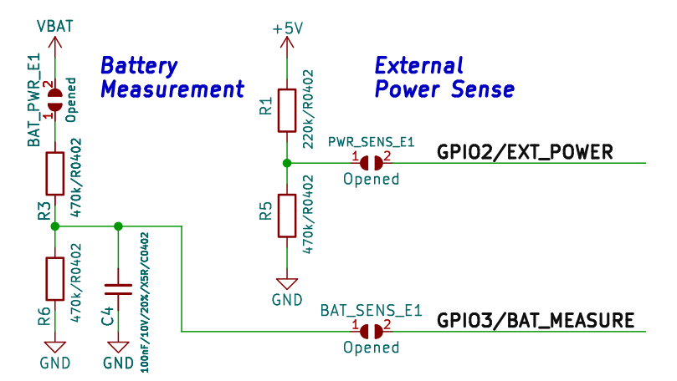

UEXT connector:

UEXT connector stands for Universal EXTension connector and contain +3.3V, GND, I2C, SPI, UART signals.
UEXT connector can be in different shapes.
The original UEXT connector is 0.1” 2.54mm step boxed plastic connector. All signals are with 3.3V levels.
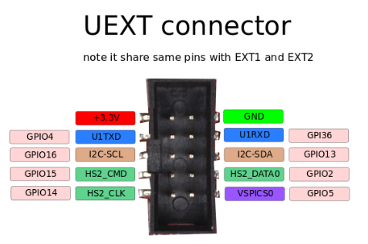

Olimex has developed number of MODULES with this connector. There are temperature, humidity, pressure, magnetic field, light sensors. Modules with LCDs, LED matrix, Relays, Bluetooth, Zigbee, WiFi, GSM, GPS, RFID, RTC, EKG, sensors and etc.

ESP32-C6-DevKit-Lipo UEXT connector:

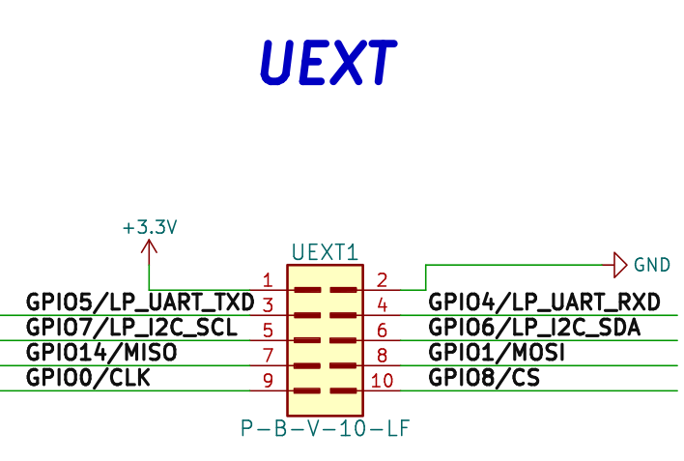

EXT1 and EXT2 connectors signals:

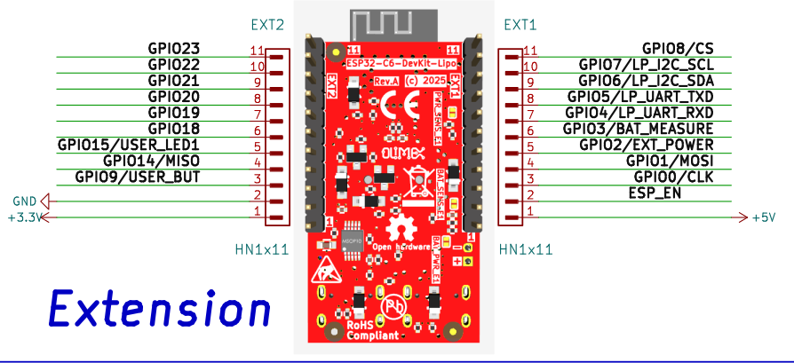

LEDs:

GPIO15 is connected to GREEN user LED, when the level is LOW LED is ON, when the level is HIGH the LED is OFF.

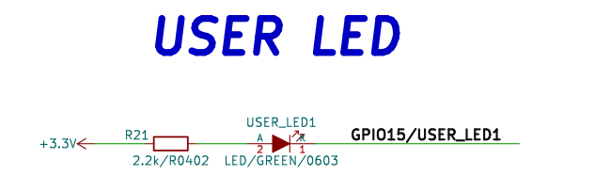

YELLOW LED for CHARGING status: OFF – battery is fully charged, ON – battery is charging, Blink – No battery.

ESP32-C6-DevKit-Lipo schematics:

ESP32-C6-DevKit-Lipo latest schematic is on GitHub

SOFTWARE:

ESP32-C6-DevKit-Lipo can be programmed with Espressif IDF 5.5 and Arduino.

Revision History
Revision 1.0 December 2025

