
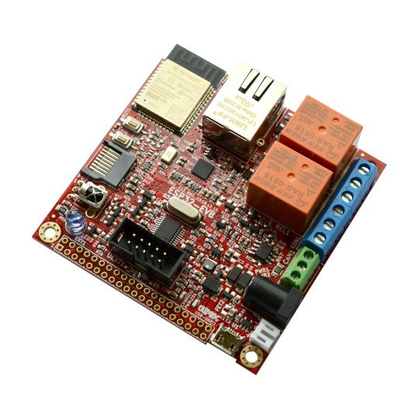
ESP32-EVB
User Manual

Document revision 1.0, August 2024 | www.olimex.com

Table of Contents
1. What is ESP32-EVB 3
1.1 ESP32-EVB variants 4
1.2 Board use requirements 4
1.3 ESP32-EVB Open Source Licenses 4
2. ESP32-EVB general layout 5
3. ESP32-EVB power supply and consumption 6
4. ESP32-EVB schematics and dimensions 7
5. ESP32-EVB pinout description: 7
6. ESP32-EVB software installation 8
7. Document revision history 8

1. What is ESP32-EVB

ESP32-EVB is a mature Open Source Hardware development board that incorporates n ESP32 module. The ESP32-EVB board is designed and manufactured by Olimex, while the ESP32 module is designed and manufactured by Espressif systems. The ESP32 modules are extremely popular WIFI/BT modules due to their size, price, and very good documentation.

The ESP32-EVB board has the following features:
- ESP32-WROOM-32E or ESP32-WROOM-32UE module (depending on variant) with WiFi, BLE connectivity
- USB micro connector for powering and programming
- Built-in CH340T programmer for Arduino and ESP-IDF
- Ethernet 100Mb interface with ETH8710A
- MicroSD card
- 2x10A/250VAC (15A/120VAC 15A/24VDC) relays with connectors and status LEDs
- CAN transceiver and interface
- IR received and transmitter, up to 5 meters distance
- LiPo charger for stand alone operation during power breaks with 4 status LEDs
- Power jack for external power supply, 5V DC
- UEXT connector to for expansion modules
- Reset and user buttons
- GPIO 40 pin connector with all ESP32 ports
- Dimensions: (75x75)mm ~ (2.95x2.95)"
- Optional external antenna (-EA)
- Industrial grade -40+85C version available (-IND)

1.1 ESP32-EVB variants

The board has 4 variants – ESP32-EVB, ESP32-EVB-EA, ESP32-EVB-EA-IND, ESP32-EVB-IND. The base variant ESP32-EVB works in commercial temperature range (0-70 degrees C) and has on-module antenna.

ESP32-EVB and ESP32-EVB-IND come with ESP32-WROOM-32E module;
ESP32-EVB-EA and ESP32-EVB-EA-IND come with ESP32-WROOM-32UE and external antenna;
ESP32-EVB and ESP32-EVB-EA work in the commercial temperature range 0-70C;
ESP32-EVB-IND and ESP32-EVB-EA-IND are functionally identical, but have all components rated for operating in the industrial temperature range -40+85C.

1.2 Board use requirements

You only need a fitting USB cable and a personal computer. The board requires USB micro connector. Usually only such cable is required:

https://www.olimex.com/Products/Components/Cables/USB-CABLE-A-MICRO-1.8M/

The computer needs software compatible with ESP32 modules. Most commonly used tools are ESP-IDF and Arduino IDE with ESP32 package. You can use ESP32-EVB with any software tool that supports the main ESP32 module.

1.3 ESP32-EVB Open Source Licenses

ESP32-EVB is Open Source Hardware, listed in OSHWA.org here:
https://certification.oshwa.org/bg000011.html

The hardware files are released under CERN OSHW license.
The software is released under GPL 3 license.
The documentation is released under CC BY-SA 3.0 license.

2. ESP32-EVB general layout

ESP32 module
Ethernet commector
Relay 2
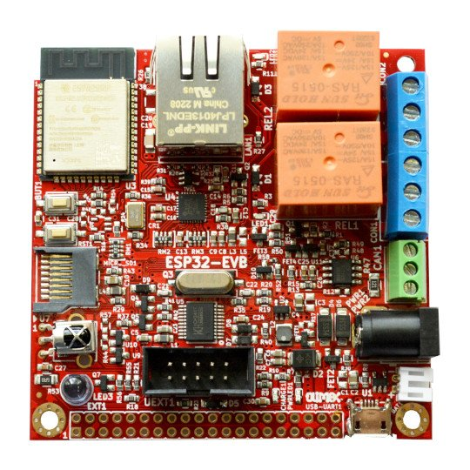
UEXT connector
EXT header
Relay
terminals
CAN
terminal
Power jack
Li-Po
connector
Mount hole
Battery
LEDs
Micro USB
User
button
Reset
button
MicroSD
card holder
Infrared
User LED

3. ESP32-EVB power supply and consumption

ESP32-EVB typically consumes between 40mA and 200mA of current depending on the software. The board can consume much less using the power saving modes.

The absolute maximum power ESP32-EVB can draw from the power supply would be the determined by the maximum input of the regulator on the power input line. Of course, consider that on-board peripherals and the main module would use some of that current. There are two major cases:

1) If you power the board from the PWR jack or the USB – > the regulator is SY8089 can output maximum 2000mA continuously
2) If you power the board from battery –> the Li-Po battery charger MCP73833 can output up to 1200mA

4. ESP32-EVB schematics and dimensions

ESP32-EVB was designed with KiCAD (free and open-source CAD tool). ESP32-EVB schematics and sources can be found at GitHub here:

https://github.com/OLIMEX/ESP32-EVB/tree/master/HARDWARE

There are also PDF exports if you don’t want to install KiCAD.

Board dimensions can be found here:

https://github.com/OLIMEX/ESP32-EVB/blob/master/HARDWARE/ESP32-EVB_dimensions.pdf

5. ESP32-EVB pinout description:

The board doesn’t have many free pins, most of the free pins are available at the UEXT connector. Even at the UEXT some of the pins are multiplex with the SD card, meaning that if you have SD card attached these won’t work.

The ESP32 chip has very good multiplexer so you can set the free GPIO pins for alternative functions via software means.

The SD card interface is in 1-bit eMMC mode.

The CAN is controlled by SIT1050T (different hardware revisions might use different CAN transceiver chip) and by default the CAN terminating resistor is disconnected. If this is end CAN device (or if you just have 2 CAN devices on that bus) it is good idea to close it. Solder CAN_T1 jumper to connect the terminating resistor.

6. ESP32-EVB software installation

Esspresif guide for Arduino IDE installation – after installation – there is own entry for the board, it should be listed as OLIMEX ESP32-EVB in the board selection
Espressif ESP-IDF installation
Esspressif guide for PlatformIO installation.
Olimex provides some ESP-IDF and Arduino examples here:
https://github.com/OLIMEX/ESP32-EVB/tree/master/SOFTWARE

7. Document revision history
Revision 1.0 August 2024

