
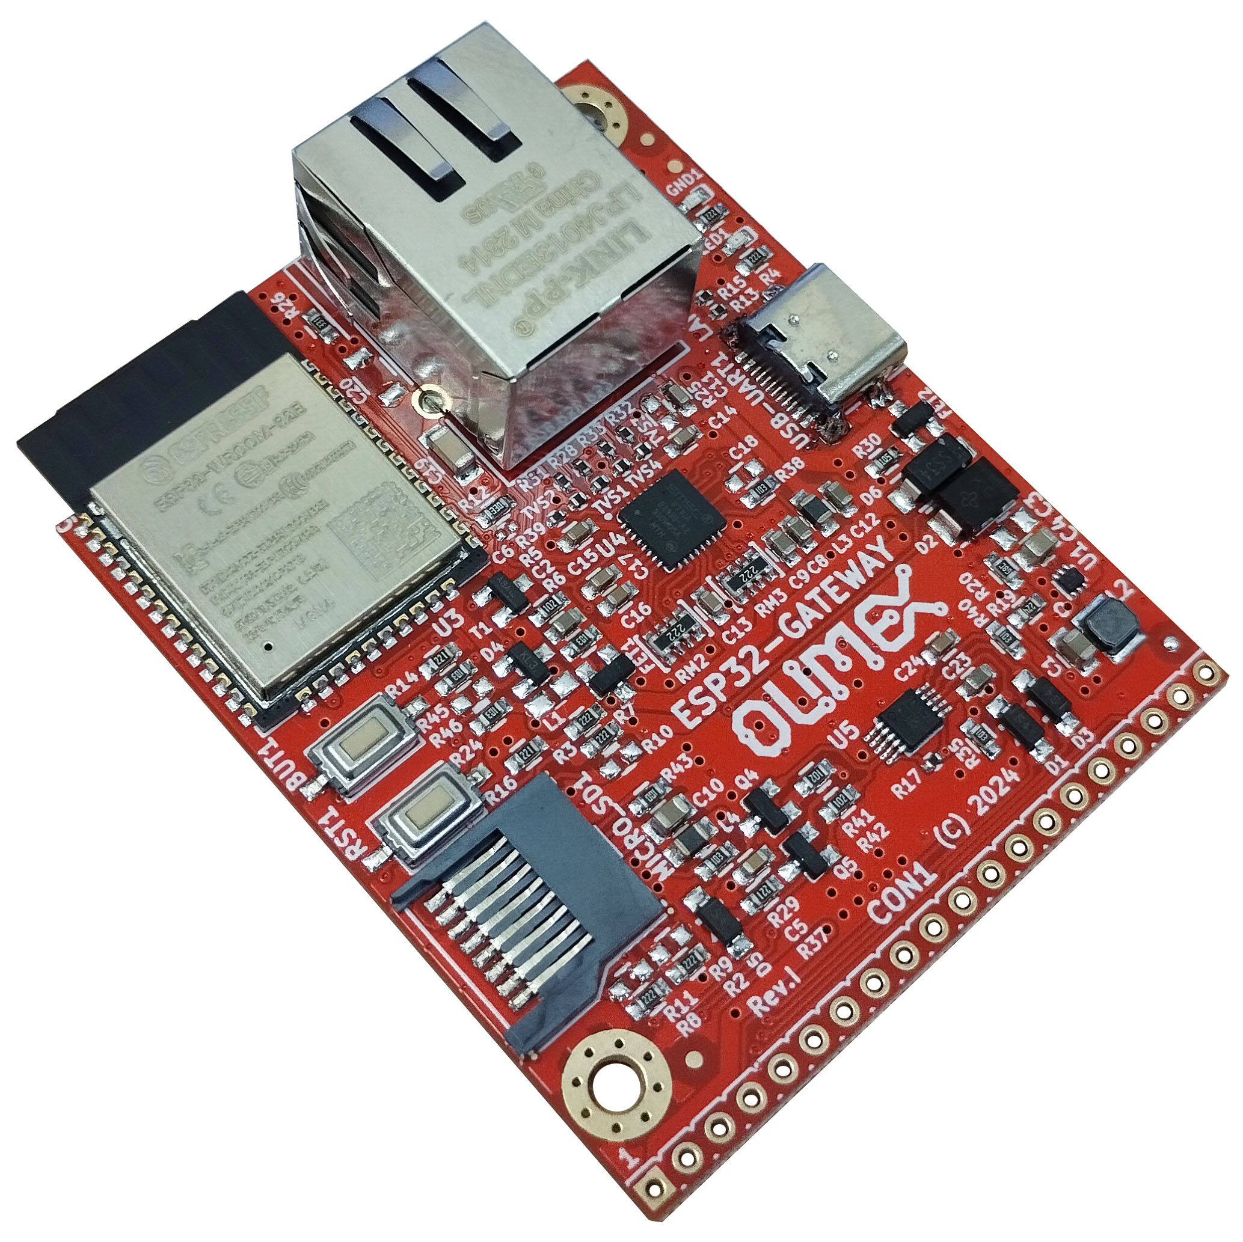
ESP32-GATEWAY
User Manual

Document revision 2.0, October 2024 | www.olimex.com

Table of Contents
1. What is ESP32-GATEWAY 3
1.1 ESP32-GATEWAY variants 4
1.2 Board use requirements 4
1.3 ESP32-GATEWAY Open Source Licenses 5
2. ESP32-GATEWAY general layout 6
3. ESP32-GATEWAY power supply and consumption 7
4. ESP32-GATEWAY schematics and dimensions 8
5. ESP32-GATEWAY pinout description: 8
6. ESP32-GATEWAY software installation 9
7. Document revision history 9

1. What is ESP32-GATEWAY

ESP32-GATEWAY is a mature Open Source Hardware development board that incorporates n ESP32 module. The ESP32-GATEWAY board is designed and manufactured by Olimex, while the ESP32 module is designed and manufactured by Espressif systems. The ESP32 modules are extremely popular WIFI/BT modules due to their size, price, and very good documentation.

The ESP32-GATEWAY board has the following features:
- ESP32-WROOM-32E or ESP32-WROOM-32UE module with WiFi, BLE connectivity
- USB type C connector for powering and programming with CH340 USB serial converter
- Ethernet 100Mb interface with LAN8710A driver
- MicroSD card
- Reset button
- User button
- Power status LED
- User LED
- GPIO 20 pin connector with all ESP32 ports
- Dimensions: (50 x 62)mm ~ (1.95 x 2.45)"
- Optional external antenna (-EA)
- Industrial grade -40+85C version available (-IND)

1.1 ESP32-GATEWAY variants

The board has 4 variants – ESP32-GATEWAY, ESP32-GATEWAY-EA, ESP32-GATEWAY-EA-IND, ESP32-GATEWAY-IND. The base variant ESP32-GATEWAY works in commercial temperature range (0-70 degrees C) and has on-module antenna.

ESP32-GATEWAY and ESP32-GATEWAY-IND come with ESP32-WROOM-32E module;
ESP32-GATEWAY-EA and ESP32-GATEWAY-EA-IND come with ESP32-WROOM-32UE and external antenna;
ESP32-GATEWAY and ESP32-GATEWAY-EA work in the commercial temperature range 0-70C;
ESP32-GATEWAY-IND and ESP32-GATEWAY-EA-IND have all components rated for operating in the industrial temperature range -40+85C.

1.2 Board use requirements

You only need a fitting USB cable and a personal computer. The latest hardware revision of the board requires USB type C connector. Usually only such cable is required:

https://www.olimex.com/Products/Components/Cables/USB-CABLE-A-TO-C-1M/

Notice that older hardware revisions came with USB micro connector and require USB micro cable.

The computer needs software compatible with ESP32 modules. Most commonly used tools are ESP-IDF and Arduino IDE with ESP32 package. You can use ESP32-GATEWAY with any software tool that supports the main ESP32 module.

1.3 ESP32-GATEWAY Open Source Licenses

ESP32-GATEWAY is Open Source Hardware, listed in OSHWA.org here:
https://certification.oshwa.org/bg000012.html
The hardware files are released under CERN OSHW license.
The software is released under GPL 3 license.
The documentation is released under CC BY-SA 3.0 license.

2. ESP32-GATEWAY general layout

ESP32 module
Ethernet commector
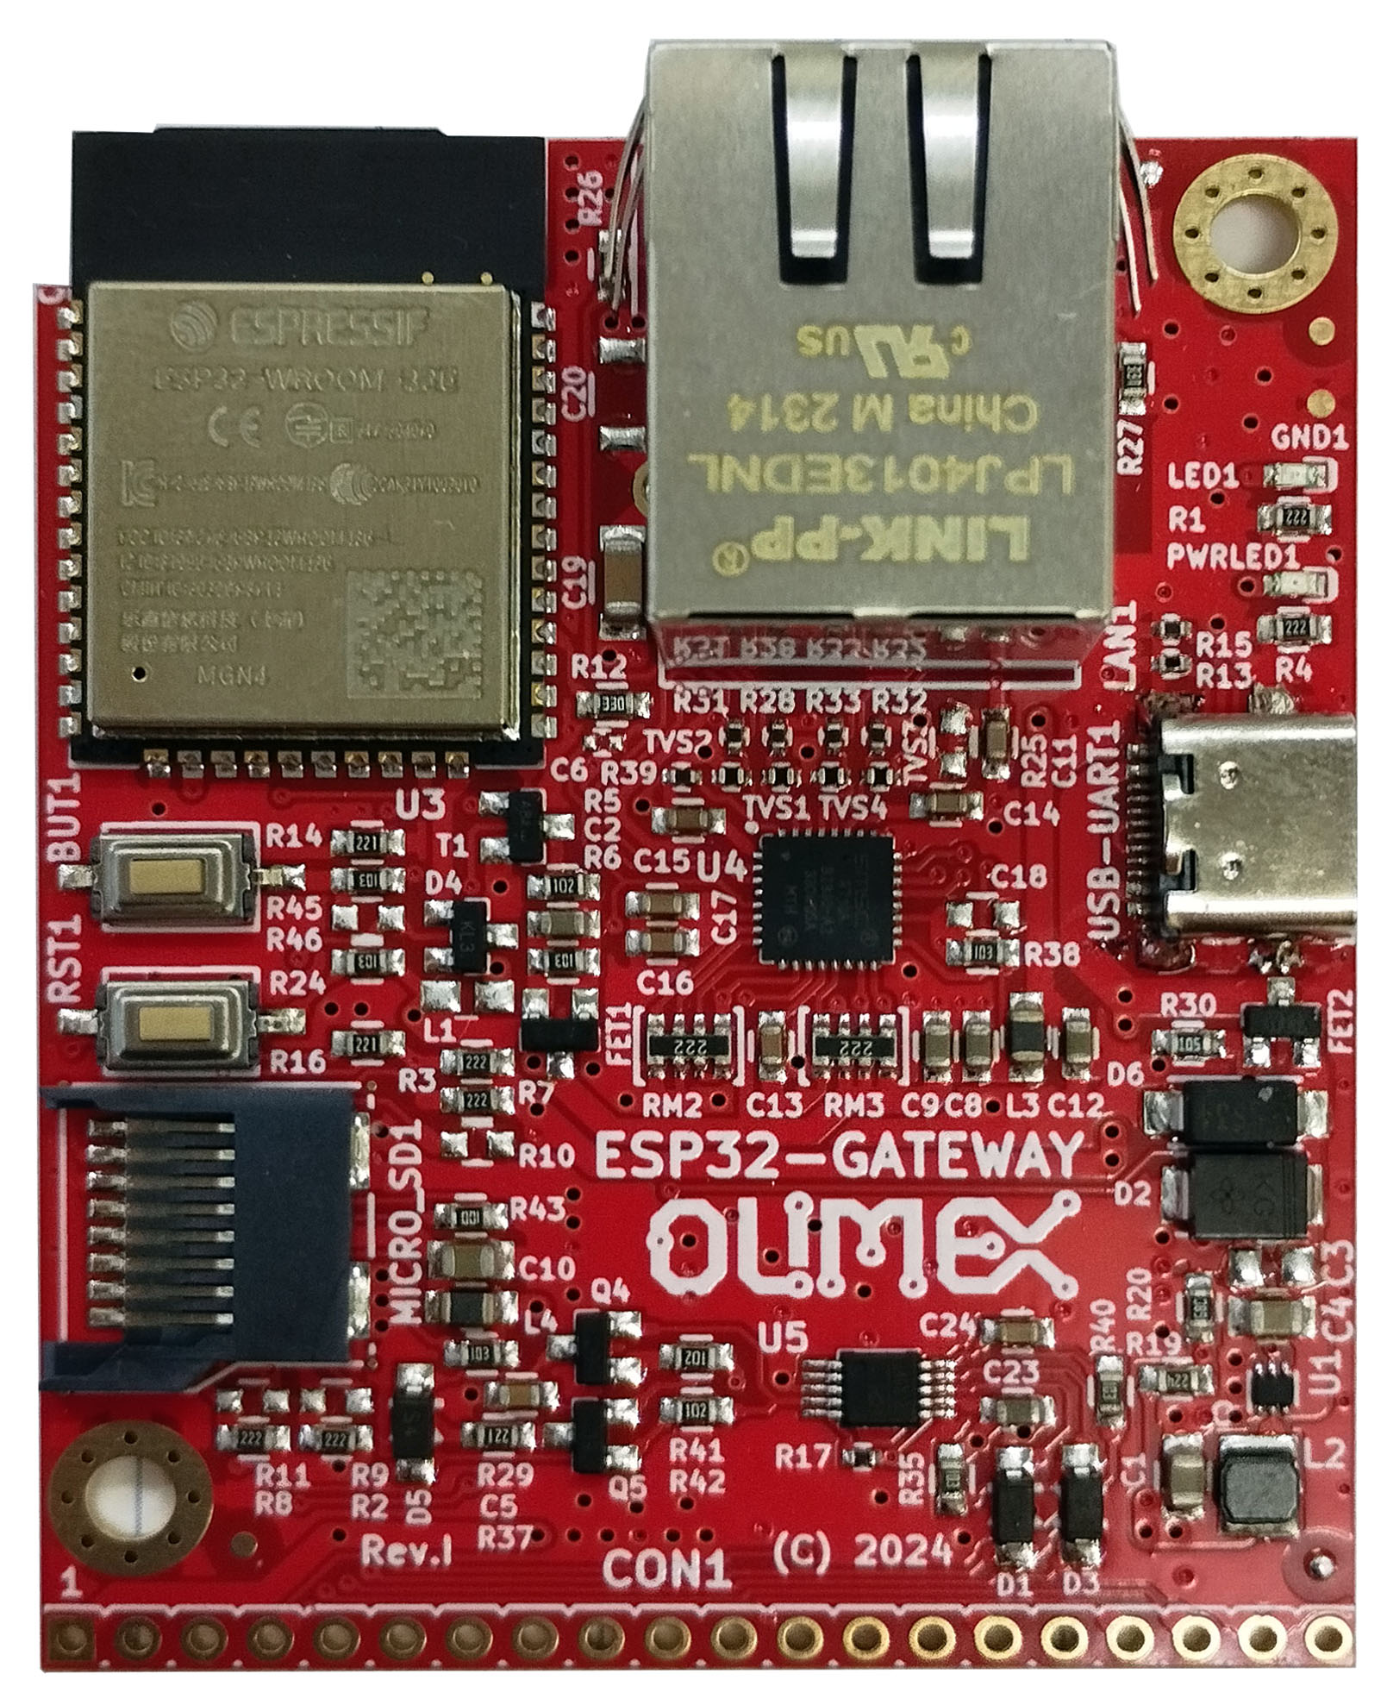
Mount hole
CON1 header
User LED
Power status LED
USB type C
User
button
Reset
button
MicroSD
card holder

3. ESP32-GATEWAY power supply and consumption

ESP32-GATEWAY typically consumes around 50mA of current depending on the software. The board can consume much less using the power saving modes.

The absolute maximum power ESP32-GATEWAY can draw from the power supply would be the determined by the maximum input of the regulator on the power input line. Of course, consider that on-board peripherals and the main module would use some of that current. When you power the board from either the USB or the +5V pin of the CON1 header – > the regulator is TPS62A02ADRLR can output maximum 2000mA continuously.

4. ESP32-GATEWAY schematics and dimensions

ESP32-GATEWAY was designed with KiCAD (free and open-source CAD tool). ESP32-GATEWAY schematics and sources can be found at GitHub here:

https://github.com/OLIMEX/ESP32-GATEWAY/tree/master/HARDWARE

There are also PDF exports if you don’t want to install KiCAD.

Board dimensions can be found here:

https://www.olimex.com/Products/IoT/ESP32/ESP32-GATEWAY/resources/ESP32-GATEWAY-general-dim.png

5. ESP32-GATEWAY pinout description:

The board’s pinout can be seen here:

https://www.olimex.com/Products/IoT/ESP32/ESP32-GATEWAY/resources/ESP32-GATEWAY-GPIOs-Rev.F-up.pdf

The ESP32 chip has very good multiplexer so you can set the free GPIO pins for alternative functions via software means.

The SD card interface is in 1-bit eMMC mode.

6. ESP32-GATEWAY software installation

Esspresif guide for Arduino IDE installation – after installation – there is own entry for the board, it should be listed as OLIMEX ESP32-GATEWAY in the board selection
Espressif ESP-IDF installation
Esspressif guide for PlatformIO installation.
Olimex provides some ESP-IDF and Arduino examples here:
https://github.com/OLIMEX/ESP32-GATEWAY/tree/master/SOFTWARE

7. Document revision history
Revision 2.0 October 2024
- Hardware design changed – main changes are USB connector now USB type C and Ethernet clock routing improved, jumpers added at bottom
Revision 1.0 August 2024

