

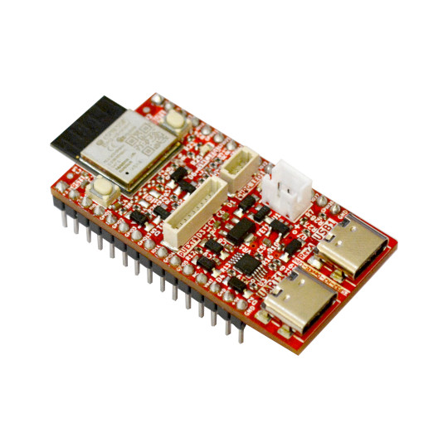

ESP32-H2-DevKit-Lipo
User Manual

Document revision 2.0, August 2024 | www.olimex.com

Table of Contents
What is ESP32-H2-DevKit-Lipo 3
ESP32-H2-DevKit-Lipo features 4
Order codes for ESP32-H2-DevKit-Lipo and accessories: 5
HARDWARE 6
ESP32-H2-DevKit-Lipo layout: 6
ESP32-H2-DevKit-Lipo GPIOs: 7
ESP32-H2-DevKit-Lipo schematics: 8
ESP32-H2-DevKit-Lipo power supply: 8
UEXT connector: 8
External power sense and battery measurement: 9
SOFTWARE: 10
Revision History 11

What is ESP32-H2-DevKit-Lipo

ESP32-H2 combines IEEE 802.15.4 connectivity with Bluetooth 5 (LE).
The SoC is powered by a single-core, 32-bit RISC-V microcontroller that can be clocked up to 96 MHz.
The ESP32-H2 has been designed to ensure low power consumption and security for connected devices.
ESP32-H2 has 320 KB of SRAM with 16 KB of Cache, 128 KB of ROM, 4 KB LP of memory, and a built-in 2 MB or 4 MB SiP flash.
It has 19 programmable GPIOs with support for ADC, SPI, UART, I2C, I2S, RMT, GDMA and LED PWM.
Bluetooth supports: Bluetooth Low Energy (Bluetooth 5.3 certified), Bluetooth mesh, Bluetooth Low Energy long range (Coded PHY, 125 Kbps and 500 Kbps), Bluetooth Low Energy high speed (2 Mbps)
IEEE Standard 802.15.4-2015 compliant
Supports Thread 1.3
Supports Zigbee 3.0
Supports Matter
Supports HomeKit, MQTT

ESP32-H2-DevKit-Lipo features

- ESP32-H2 embedded, RISC-V single-core 32-bit LX7 microprocessor, up to 96 MHz, 128 KB ROM, 320 KB SRAM, 4 KB LP Memory, 4 MB flash
- USB-C with USB to Serial converter for programming / debugging
- USB-C connected directly to ESP32-H2
- LiPo battery charger and connector
- pUEXT UEXT connector
- Qwiic/Stemma connector
- Reset button
- User button
- User LED
- all GPIOs available on two headers at 25.4 mm space
- Dimensions: 48 x 25 mm
- Operating temperature: -40+85C

Order codes for ESP32-H2-DevKit-Lipo and accessories:

ESP32-H2-DevKit-Lipo commercial grade -40+85C board with internal antenna
USB-CABLE-A-TO-C-1M USB-C cable
BATTERY-LIPO1400mAh - Lipo battery 3.7V 1400mAh – note these batteries can be shipped only by ground so we can deliver only to EU destinations.
UEXT modules - different sensors, relays, LCDs, RTC, GSM, GPS etc accessories which can be connected to UEXT connector

HARDWARE

ESP32-H2-DevKit-Lipo layout:

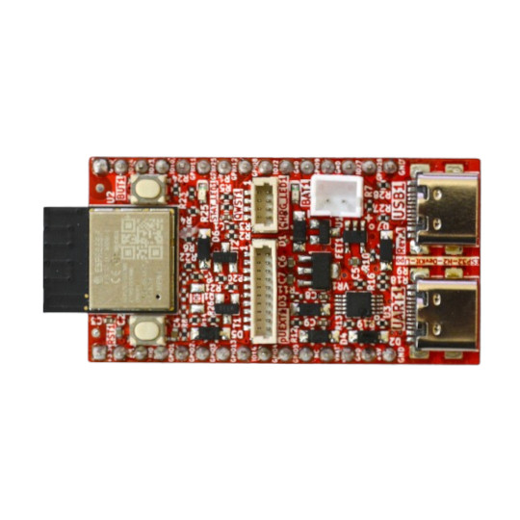
ESP32-H2-MINI-1-N4
RESET button
pUEXT connector
USB-C with USB-to-Serial converter for debug and programming
User Button
User LED
QWIIC-STEMMA
Battery Charge LED
LiPo battery
connector
USB-C serial/JTAG

ESP32-H2-DevKit-Lipo GPIOs:

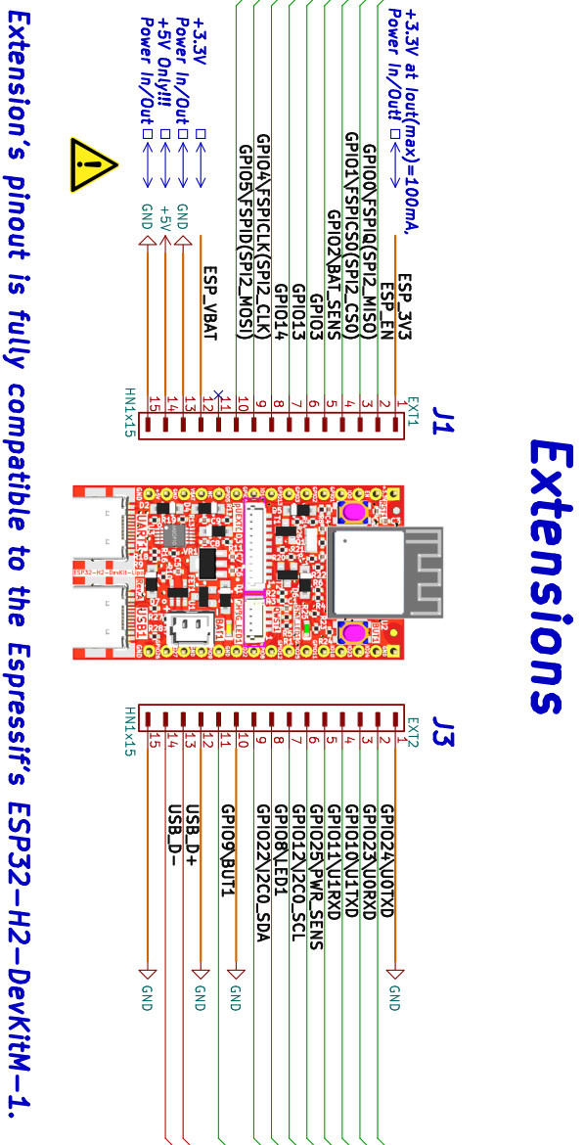

ESP32-H2-DevKit-Lipo schematics:

ESP32-H2-DevKit-Lipo latest schematic is on GitHub

ESP32-H2-DevKit-Lipo power supply:

ESP32-H2-DevKit-Lipo can be powered by either:
- USB-C connectors USB1 or UART1
- EXT1 pin 14 (+5V)
- LiPo battery
The switch between these is automatically without voltage drop.
Power consumption of ESP32-H2-DevKit-Lipo is less 10uA in deep sleep mode.

UEXT connector:

UEXT connector stands for Universal EXTension connector and contains +3.3V, GND, I2C, SPI, UART signals.
pUEXT is 1mm step boxed plastic connector. All signals are with 3.3V levels.
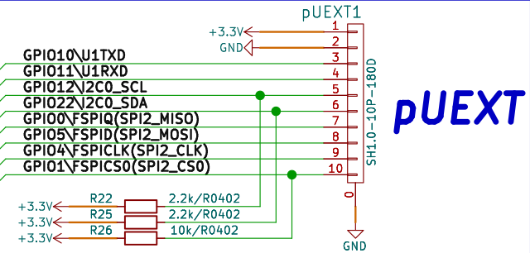

Olimex has developed number of MODULES with this connector. There are temperature, humidity, pressure, magnetic field, light sensors. Modules with LCDs, LED matrix, Relays, Bluetooth, Zigbee, WiFi, GSM, GPS, RFID, RTC, EKG, sensors and etc.

External power sense and battery measurement:

Battery measurements are disabled by default to provide more free GPIOs but they can be enabled by closing a couple of jumpers. In order to measure the battery you first need to close SMT jumper BAT_SENS_E (solder its pads together). This will allow you to measure the battery voltage via ESP32-H2 pin GPIO2. The board also has external power sense – aka whether you have external power or board is powered via battery (it is good idea to know if you have external power so you can put the board in some power saving mode or perform some saves). This can be enabled if you close jumper PWR_SENSE_E1 (again solder its pads together). This will allow you to determine if external power is present via pin GPIO25.
After the jumper or jumpers are closed you need some simple code to read voltage and detect external power presence. Code in Arduino should be similar to this:
#define POWER_SENSE 25
#define BATTERY 2
void setup()
{
Serial.begin (115200);
pinMode (POWER_SENSE, INPUT);
pinMode (BATTERY, INPUT);
}
void loop()
{
Serial.print ("External power sense: ");
Serial.println (digitalRead (POWER_SENSE));
Serial.print ("Battery measurement: ");
Serial.print (analogReadMilliVolts (BATTERY)*2);
Serial.println (" mV");
Serial.println ();
delay (250);
}

SOFTWARE:

ESP32-H2-DevKit-Lipo is supported by
- Espressif ESP-IDF
- Arduino IDE

The board has own config in Arduino IDE.

Revision History
Revision 2.0 August 2024
- added info about the battery measurement
Revision 1.0 January 2024

