

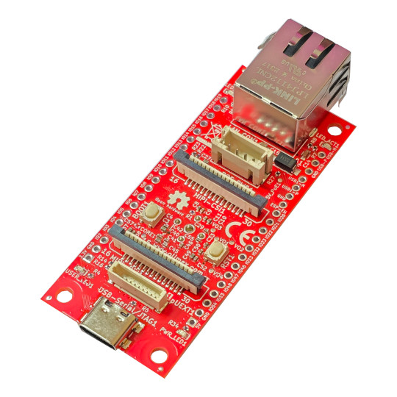
ESP32-P4-DevKit
User Manual

Document revision 2.1, April 2026 | www.olimex.com
Table of Contents
What is ESP32-P4-DevKit 3
Order codes for ESP32-P4-DevKit and accessories: 4
HARDWARE 5
ESP32-P4-DevKit layout 6
ESP32-P4-DevKit POE connector 8
ESP32-P4-DevKit CSI connector 9
ESP32-P4-DevKit MIPI connector 10
ESP32-P4-DevKit UEXT connector 11
ESP32-P4-DevKit EXT1 and EXT2 connectors 12
ESP32-P4-DevKit schematics 13
SOFTWARE 14
FAQ 15
Revision History 16

What is ESP32-P4-DevKit

ESP32-P4-DevKit is a development board with ESP32-P4 Dual Core RISC-V processor from Espressif.

The features of ESP32-P4-DevKit board are:

- Espressif ESP32-P4NRW32 module:
- Dual core 400Mhz RISC-V
- 768KB RAM
- 32MB PSRAM
- SPI flash memory 16MB
- USB type C connector for powering, programming, and debugging
- Ethernet PHY (TI TLK110) and connector with POE option via extension
- Camera CSI interface with connector
- Display DSI interface with connector
- MicroSD card
- Boot and Reset buttons
- pUEXT connector
- All GPIOs available on two 0.1″ 2.54 mm 20 pin DIL headers
- Four mounting holes 3.3mm diameter
- Dimensions: (72 x 30)mm

ESP32-P4-DevK is an Open Source design, all design CAD files and firmware are available for download even without a purchase, so people are free to use, study, and modify the design.

Order codes for ESP32-P4-DevKit and accessories:

ESP32-P4-DevKit ESP32-P4 development board with Ethernet
UEXT-PQ pUEXT to UEXT adapter
pUEXT-CABLE 1mm step pUEXT cable with 50, 100 and 200mm lenght
POEv3 PoE add-on board allowing board to be powered by Ethernet POE
UEXT modules Many UEXT modules which can connect to Neo6502 UEXT connector
USB-CABLE-AM-USB3-C High speed, high current cable for power supply and programming

HARDWARE

ESP32-P4-DevKit layout

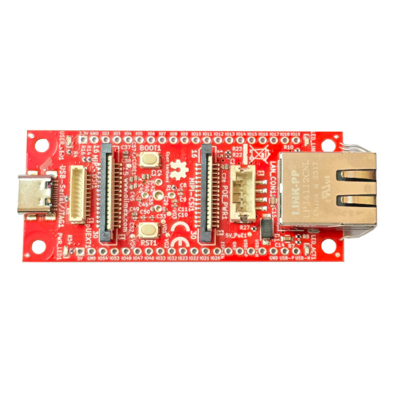
LED
USB-C JTAG
Power LED
MIPI-DSI
UEXT connector
BOOT button
RESET buttoon
MIPI-CSI
Ethernet
POE

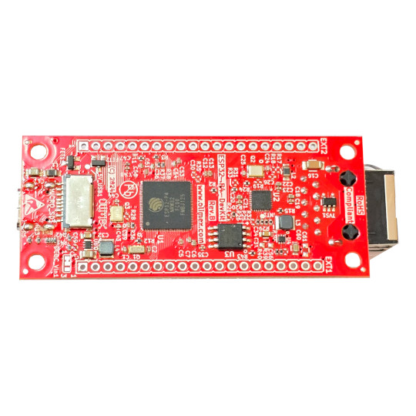
GPIO connector 2
Micro SD card
GPIO connector 1
SPI flash

ESP32-P4-DevKit POE connector

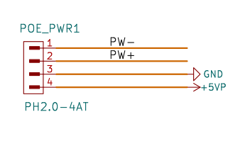
PW+ and PW- come from the LAN transformer. POEv3 external board have POE negotiator and DCDC step down circuit which produce 5V/3A which is feed back to the ESP32-P4-DevKit.

If you don’t use POE powering, nor POEv3, then header POE_PWR1 can also be used as power input, where pin #4 (+5VP) and pin GND can be used to power the board!

ESP32-P4-DevKit CSI connector

MIPI-CSI connector follows the standard Raspberry Pi 1, 2, 3, and 4 camera FPC layout. So you can connect standard RPi camera to it.
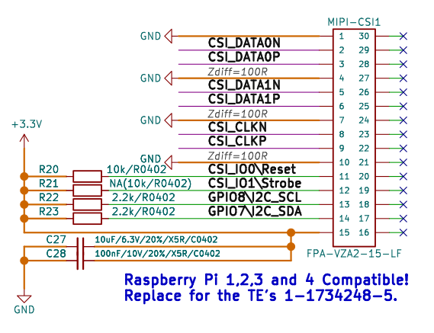

We have compatible camera here:

https://www.olimex.com/Products/Components/Camera/CAMERA-OV5647-5MPIX/

Demos with the camera are available at the GitHub page of the product.

ESP32-P4-DevKit MIPI connector

MIPI-DSI is Raspberry Pi DSI connector layout:
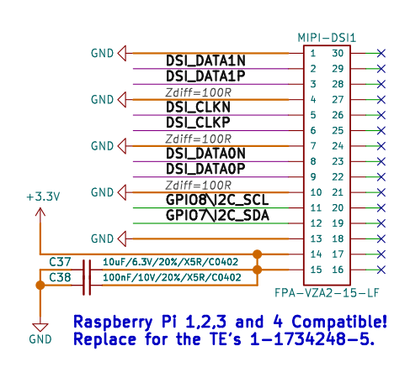
The ESP32-P4-DevKit board is compatible with Olimex MIPI-HDMI adapter. There is also ESP-IDF demo code for the combo:

https://github.com/OLIMEX/ESP32-P4-DevKit/tree/main/SOFTWARE/Demo_Examples/display_lvgl_demos

The ESP32-P4-DevKit board is compatible with Olimex MIPI-LCD2.8-640x480 LCD. There is also ESP-IDF demo code for the combo:

https://github.com/OLIMEX/ESP32-P4-DevKit/tree/main/SOFTWARE/Demo_Examples/mipi_dsi

ESP32-P4-DevKit UEXT connector

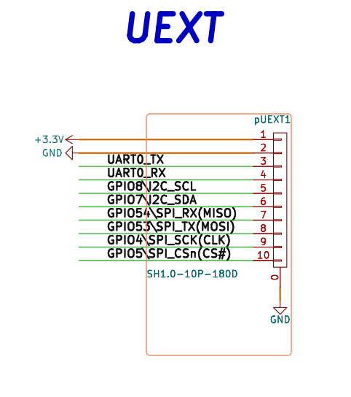
ESP32-P4-DevKit is very compact board so standard UEXT connector was impossible to be used, this is why we used pUEXT connector. pUEXT is 1.0 mm step connector but you can use UEXT-PQ adapter for bigger 2.54mm step. All signals are at 3.3V levels.

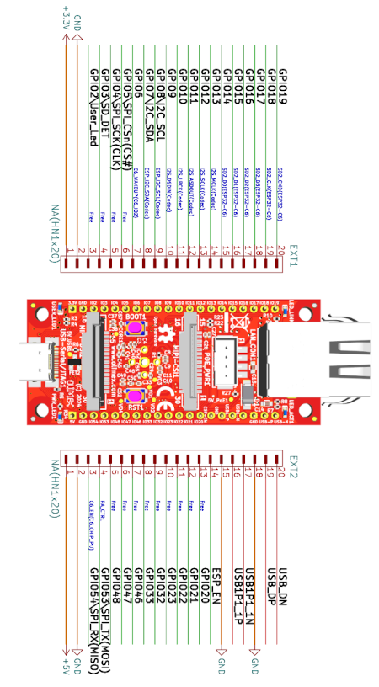
ESP32-P4-DevKit EXT1 and EXT2 connectors

ESP32-P4-DevKit schematics

ESP32-P4-DevKit latest design file are available at GitHub
It is open source hardware design made with KiCAD.

SOFTWARE

ESP32-P4-DevKit can be programmed with ESP-IDF version 5.4 or later.
You can learn how to install it here:

https://docs.espressif.com/projects/esp-idf/en/stable/esp32p4/get-started/index.html

ESP32-P4 is also supported in the official Espressif Arduino IDE package here:

https://github.com/espressif/arduino-esp32

Below is a link to some Arduino demos for ESP32-P4-DevKit:

https://github.com/OLIMEX/ESP32-P4-DevKit/tree/main/SOFTWARE/Arduino

FAQ

Q: I erased the memory of the board and now it won’t program anymore. I get a notification that the board is disconnected. Did I break the board? Did I receive a broken board?
A: Some boards might experience timeout or perpetual reboot problems after being erased. The workaround is to force higher capacitance via the cable – either use a very long USB cable or if possible extra USB extender cable USB type A male to type A female also connect it to the regular USB type A – type C cable (as sort of USB extension) or maybe connect some USB hubs. The idea of this is to have cabling with higher capacitance between the board and the computer. For more details, refer to this forum thread:
https://www.olimex.com/forum/index.php?topic=9794.0

Q: I can’t seem to find the right settings for this board under Arduino IDE. There are many options. What are the proper settings?
A: Make sure Espressif package is installed and then from Tools → Board use the settings from the picture below:
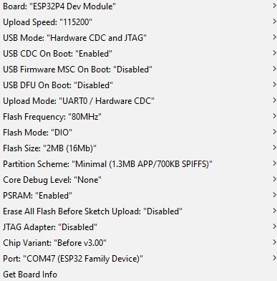

Revision History
Revision 2.1 April 2026
- Added FAQ section
Revision 2.0 October 2025
- Removed 2.54mm UEXT connector since it was incorrect.
Revision 1.0 December 2024

