

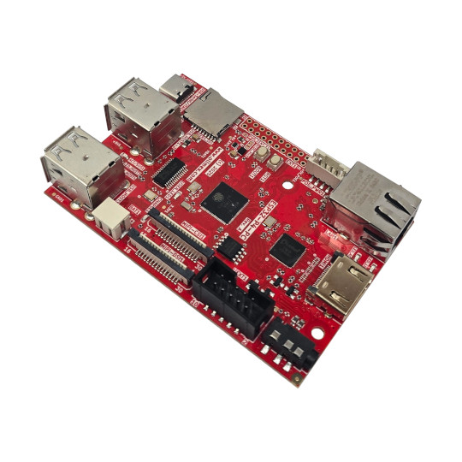

ESP32-P4-PC
User Manual
Document 2.0 September 2026 | www.olimex.com

Table of Contents
What is ESP32-P4-PC 3
Order codes for ESP32-P4-PC and accessories 4
HARDWARE 5
ESP32-P4-PC layout: 5
UEXT connector: 6
ESP32-P4-PC UEXT connector: 6
SD-card interface 7
HDMI 7
MIPI CSI and MIPI DSI connectors 8
Audio connector 9
USB-C connector 10
Power supply 11
ESP32-P4-PC schematics 12
SOFTWARE 13
Document revision history 14

What is ESP32-P4-PC

ESP32-P4-PC is complete all in one computer based on ESP32-P4NRW32 Dual core RISC-V processor from Espressif.

The features of ESP32-P4-PC are:
- Espressif ESP32-P4NRW32 processor:
- Dual core 400Mhz RISC-V
- 768KB RAM
- 32MB PSRAM
- SPI Flash external 16MB
- USB JTAG for programming and debugging
- Ethernet MACPHY and connector with POE option via extension
- Camera CSI interface
- LCD Display DSI interface
- HDMI converter and output
- Audio output 3.5mm jack
- LiPo battery charger and step up converter for LiPo battery operation
- MicroSD card
- Boot and Reset buttons
- UEXT connector
- All free GPIOs available on 0.1″ 2.54 mm 20 pin connector
- Three mounting holes 3.3mm diameter
- Dimensions: (90 x 60)mm
ESP32-P4-PC is Open Source Hardware, all CAD files and firmware are available, so people can study and modify.
+ Important notice: Do not place ESP32-P4-PC on metal surface when powered, nor drop metal objects on the top of the PCB! This will lead to hardware damage. Consider plastic box to avoid hardware damage.
+ Important notice: Most users associate ESP32 with wireless support but ESP32-P4 chip has no WIFI nor Bluetooth!

Order codes for ESP32-P4-PC and accessories

ESP32-P4-PC ESP32-P4 all-in-one computer with 4 USB hosts and HDMI display
CAMERA-OV5647-5MPIX MIPI CSI compatible camera
MIPI-LCD2.8-640x480 MIPI DSI compatible display
POEv3 POE module compatible with ESP32-P4-PC
BOX-ESP32-P4-PC Plastic box designed specifically for ESP32-P4-PC
CABLE-IDC10-15CM UEXT cable
USB-KEYBOARD-PS2 USB keyboard which is compatible with ESP32-P4-PC
USB-CABLE-AM-USB3-C High speed, high current cable for power supply and programming
CABLE-HDMI-50CM HDMI cable
UEXT modules many UEXT modules
BATTERY-LiPo1400mAh LiPo battery compatible with the board

HARDWARE

ESP32-P4-PC layout:

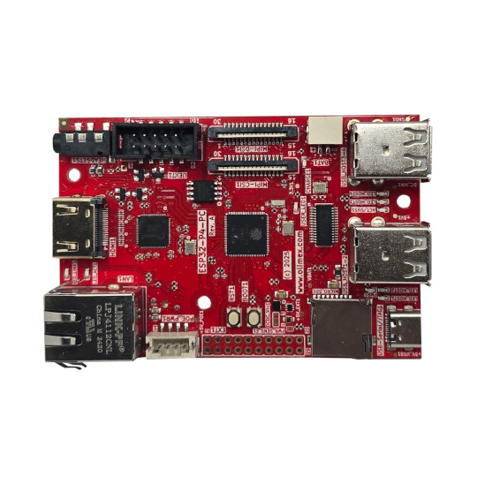
Audio 3.5mm jack
Camera MIPI
LiPo battery
UEXT
Display MIPI
USB 3-4
USB 1-2
USB-C
Micro SD card
GPIO extension
Boot button
Reset button
POEv3 connector
Ethernet 10/100Mb
HDMI

UEXT connector:

UEXT connector stands for Universal EXTension connector and contain +3.3V, GND, I2C, SPI, UART signals.
UEXT connector can be in different shapes.
The original UEXT connector is 0.1” 2.54mm step boxed plastic connector. All signals are with 3.3V levels.
Olimex has developed number of MODULES with this connector. There are temperature, humidity, pressure, magnetic field, light sensors. Modules with LCDs, LED matrix, Relays, Bluetooth, Zigbee, WiFi, GSM, GPS, RFID, RTC, EKG, sensors and etc.

ESP32-P4-PC UEXT connector:

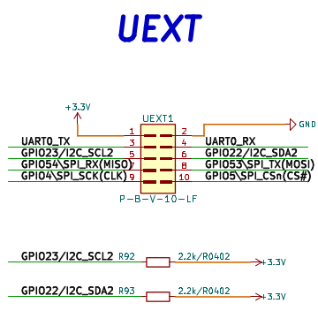

SD-card interface
The ESP32-P4-PC microSD socket is wired as a native 4-bit SD/SDMMC interface.
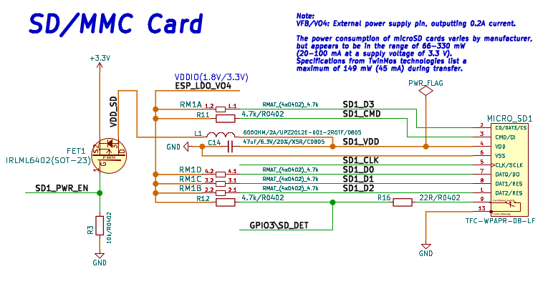

HDMI
HDMI is possible due to LT8912B(QFN64) converter. HDMI and external MIPI-DSI are not independent displays. They share the ESP32-P4’s same DSI clock/data lanes. Users should normally select either the onboard HDMI bridge or an external DSI panel. Simultaneous independent output is not possible.

HDMI is video-only. No audio on the HDMI connector.

The maximum possible resolution for the HDMI output is:
- 1920×1080 at 30 Hz
- 1280×800 at 60 Hz

MIPI CSI and MIPI DSI connectors
+ Important notice: Power down the board before inserting/removing CSI or DSI ribbon cables and double check the cable-contact orientation.
+ Important notice: HDMI and external MIPI-DSI are shared (they use the same DSI clock/data lanes). You can use either the onboard HDMI bridge or an external DSI panel. Simultaneous independent output is not possible.
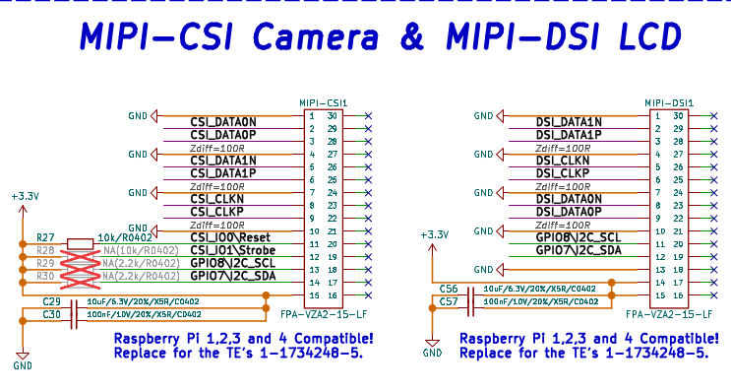

Audio connector
The audio is handled by ES8311 mono audio codec. There is 3.5mm output jack.
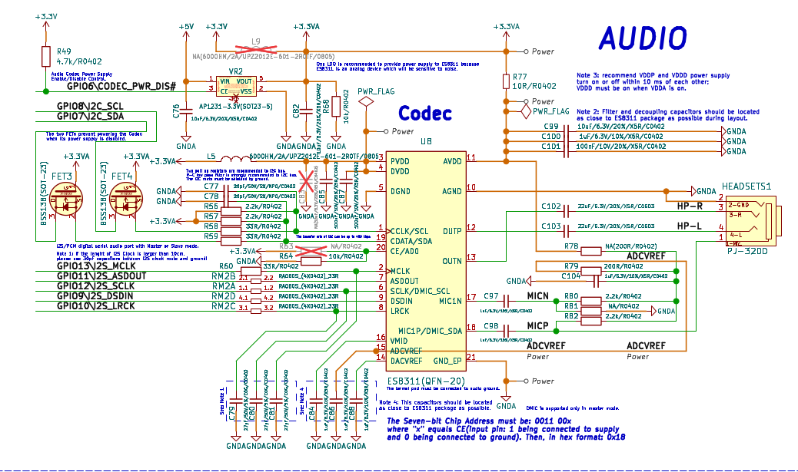

USB-C connector

USB-C is 5-V power plus the built-in USB Serial/JTAG interface. It is not another host port, has no USB-PD negotiation. It’s used for power supply, serial port programming and JTAG/debugging:

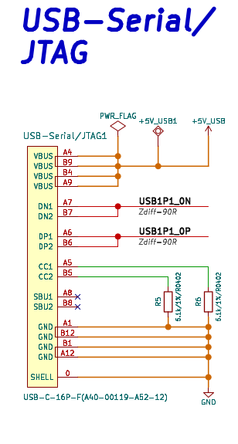

Power supply

ESP32-P4-PC can be powered by USB-C connector or Ethernet POE (if you have POEv3 additional board attached), the USB-C connector has priority i.e. if both are present the power will be taken from the USB-C connector. The board can be also powered from 3.7V Li-Po battery attached to the BAT1 connector. The LiPo battery is used only if no other external power supply is available. In this case step up U14 powers all 5V peripherals and everything is working even when no external power supply is present.
+ Important notice: If not using with Olimex-made battery, double check the polarity of the connector since these are not standard, ensure “+” of battery goes to “+” of connector and “–” of battery goes to the “–” of connector!
The voltage is labeled +5V-EXT and is used to charge LiPo battery. There is an option to detect this voltage with GPIO32 via voltage divider, but it is not connected by default to keep GPIO32 free for other apps if the external power sense is not necessary.
GPIO20 can be used to measure the battery charge. By default this port is not connected so GPIO20 is free for other applications if no battery sense is necessary.

ESP32-P4-PC schematics

ESP32-P4-PC latest schematic is on GitHub

SOFTWARE

ESP32-P4-PC can be programmed with Espressif IDF or Arduino IDE.

ESP-IDF demos: https://github.com/OLIMEX/ESP32-P4-PC/tree/main/SOFTWARE/ESP-IDF
Arduino IDE demos: https://github.com/OLIMEX/ESP32-P4-PC/tree/main/SOFTWARE/Arduino

Document revision history
Revision 2.0 September 2026
-clarified the PoE powering
-added info about the HDMI converter
-add info about SD card and audio
-fixed links
Revision 1.0 February 2026

