

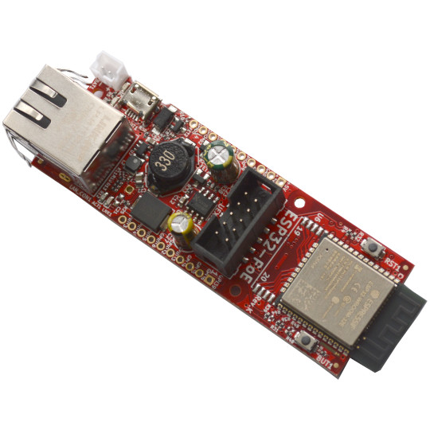

ES32-POE
ESP32-POE-ISO
User Manual
Document revision 2.7.
September 2026
www.olimex.com

Table of Contents
1. Introduction to ESP32-POE and ESP32-POE-ISO 3
1.1. ESP32-POE features 4
1.2. ESP32-POE-ISO features 5
1.3. PoE standard 6
1.4. The difference between ESP32-POE and ESP32-POE-ISO 6
1.5. The differences between different variants of ESP32-POE and ESP32-POE-ISO 6
1.6. Order codes for ESP32-POE and accessories 8
1.7. Order codes for ESP32-POE-ISO and accessories 8
2. HARDWARE 9
2.1. ESP32-POE layout 9
2.2. ESP32-POE GPIOs 10
2.3. ESP32-POE-ISO GPIOs 12
2.4. ESP32-POE(-ISO) schematics 14
2.5. ESP32-POE(-ISO) power supply 15
2.5.1. External power sense feature 16
2.5.2. Battery measurement feature 16
2.6. UEXT connector 17
2.7. ESP32-POE(-ISO) Ethernet connector 18
2.8. LED description 20
3. SOFTWARE 21
3.1. Olimex-made software 21
4. Frequently asked questions 22
5. Useful links 25

1. Introduction to ESP32-POE and ESP32-POE-ISO

ESP32-PoE and ESP32-PoE-ISO are ESP32-powered Wi-Fi/Bluetooth/Ethernet development boards with Power-Over-Ethernet feature. The boards are the perfect addition to any project that requires extra connectivity.
The PoE is currently handled by TPS2375/6 chip (Si3402-B in older revisions) that is IEEE 802.3af-compliant, including pre-standard (legacy) PoE support.
The PoE powering requires at least 37V DC to operate successfully. The board can takes power from the Ethernet cable and can be expanded with sensors and more. Perfect solution for Internet-of-Things projects.
Both ESP32-POE and ESP32-POE-ISO are mature, popular, and well-known products, with wide software support.
+ Important notice: ESP32-PoE has no galvano isolation of Ethernet's power supply, when you program the board via the micro USB connector the Ethernet cable should be disconnected (if you have power over the Ethernet enabled)! Consider using Olimex USB-ISO to protect your computer and board from accidental short circuits. Also consider using Olimex ESP32-PoE-ISO board instead since it is insulated.

1.1. ESP32-POE features

Features depend on the exact variant of the board chosen, the common features are:

- ESP32-WROOM module WiFi + Bluetooth ® + Bluetooth LE module from Espressif Inc (ESP32-WROOM-32E/IE-N4 or ESP32-WROVER-E/IE or ESP32-WROOM-32E/UE-N16 depending on variant)
- ESP32-WROOM-32E/UE-N4 have 4MB flash and 520 KB SRAM
- ESP32-WROOM-32E/UE-N16 has 16MB flash and 520 KB SRAM
- ESP32-WROVER-E/IE have 4MB flash 520KB SRAM and 8MB PSRAM
- CE-RED and LVD certification
- Original design by OLIMEX Ltd
- Low power design – 200uA consumption in deep sleep
- Power Over Ethernet negotiation circuit, 802.3af-compliant, with minimum operating voltage of 37VDC
- Li-Po battery charger and connector
- Battery level monitor pin on ADC
- External power supply detection pin on ADC
- UEXT connector
- User button
- Reset button
- Micro USB with programmer for ESP32 programming
- MicroSD card working in 1-bit mode
- Two extension connectors 0.1" step spaced at 1"
- PCB dimensions: (80 x 28)mm ~ (3.15 x 1.10)"

These following features are available in some of the board variants:

- External antenna variant (-EA)
- High reliable industrial grade (-40+85C) variant available (-IND)
- Bigger flash variant available (-16MB)
- PSRAM version available (-WROVER)

1.2. ESP32-POE-ISO features

- ESP32-WROOM-32 WiFi + Bluetooth ® + Bluetooth LE module by Espressif Inc (ESP32-WROOM-32E/IE-N4 or ESP32-WROVER-E/IE or ESP32-WROOM-32E/UE-N16 depending on variant)
- ESP32-WROOM-32E/IE-N4 and ESP32-WROOM-32UE have 4MB flash and 520 KB SRAM
- ESP32-WROOM-32E/UE-N16 has 16MB flash and 520 KB SRAM
- ESP32-WROVER-E/IE have 4MB Flash 520KB SRAM and 8MB PSRAM
- Power Over Ethernet negotiation circuit 802.3 compliant, with minimum operating voltage of 35VDC
- High reliable industrial grade -40+85C available (-IND)
- CE-RED and LVD certification
- Original design by OLIMEX Ltd
- Low power design – 200uA consumption in deep sleep
- Ethernet 100Mb interface with IEEE 802.3 PoE support
- 3000VDC galvanic insulation between the PoE Ethernet part and board's power supply circuit Micro USB connector for ESP32 programming
- MicroSD card working in 1-bit mode
- LiPo battery charger with LiPo battery connector
- Battery level monitor pin on ADC
- External power supply detection pin on ADC
- UEXT connector
- User button
- Reset button
- Two extension connectors, 0.1" step spaced at 1"
- PCB dimensions: (98x28)mm ~ (3.8x1)"
The following features are available in some of the board variants:

- External antenna variant (-EA)
- High reliable industrial grade (-40+85C) variant available (-IND)
- Bigger flash variant available (-16MB)
- PSRAM version available (-WROVER)

1.3. PoE standard

ESP32-POE and ESP32-POE-ISO are compliant with the IEEE 802.3af PoE standard with network devices that provide up to 15.4 W of DC power (minimum 37V DC and 350 mA). The PoE boards have LAN connectors suitable for both modes of PoE operation (mode A and mode B) – the LAN connector is visible in the schematic.

1.4. The difference between ESP32-POE and ESP32-POE-ISO

ESP32-POE is not galvanically isolated which means that it’s not safe to connect it to other devices which use non isolated power supply while it is powered. It should have only one power supply and one ground attached to it at a time.
+ This means YOU SHOULD NOT CONNECT ESP32-POE to computer’s USB port while it is powered by Ethernet POE!!! If you connect USB while ESP32-POE is powered by Ethernet you will damage the board or your computer or both. This will also void the warranty!

ESP32-POE-ISO, on the other hand comes with 3000VDC galvanic insulation between the Ethernet POE part and ESP32 power supply, so there is no problem to connect to USB and program or debug while the board is also powered from a PoE source.

ESP32-POE can provide more power to devices powered from it – up to 4W. ESP32-POE-ISO can provide only up to 2W for additionally connected devices (due to the 2W DC-DC 5V-5V insulation converter which prevents electrical influence between different sources of power)! If you need more power for your circuits, consider ESP32-POE2 board.

1.5. The differences between different variants of ESP32-POE and ESP32-POE-ISO

ESP32-POE and ESP32-POE-ISO are the base versions with ESP32-WROOM-32E-N4 module with 4MB flash memory and nothing extra.

ESP32-POE-16MB, ESP32-POE-EA-16MB, ESP32-POE-ISO-16MB and ESP32-POE-ISO-EA-16MB feature ESP32-WROOM with 16MB flash memory (as opposed to 4MB).

ESP32-POE-EA and ESP32-POE-ISO-EA have ESP32-WROOM-32UE module with U.FL connector and external antenna attached.
ESP32-POE-IND and ESP32-POE-EA-IND and ESP32-POE-ISO-IND and ESP32-POE-ISO-EA-IND use industrial grade components suitable for -40+85C operating temperature.
ESP32-POE-WROVER and ESP32-POE-ISO-WROVER comes with ESP32-WROVER-E chip with 4MB flash and 8MB PSRAM, while ESP32-POE-WROVER-EA and ESP32-POE-ISO-WROVER-EA have a WROVER module with extra U.FL connector and external antenna attached.

Features table:

Name/Features | ESP32 module | Flash size, MB | External antenna | Industrial range | PSRAM, MB | Isolated POE
ESP32-POE | ESP32-WROOM-32E-N4 | 4 | - | - | - | -
ESP32-POE-16MB | ESP32-WROOM-32E-N16 | 16 | - | - | - | -
ESP32-POE-EA | ESP32-WROOM-32UE | 4 | Y | - | - | -
ESP32-POE-EA-16MB | ESP32-WROOM-32UE-N16 | 16 | Y | - | - | -
ESP32-POE-EA-IND | ESP32-WROOM-32UE | 4 | Y | Y | - | -
ESP32-POE-IND | ESP32-WROOM-32E-N4 | 4 | - | Y | - | -
ESP32-POE-WROVER | ESP32-WROVER-E | 4 | - | - | 8 | -
ESP32-POE-WROVER-EA | ESP32-WROVER-IE | 4 | Y | - | 8 | -
ESP32-POE-ISO | ESP32-WROOM-32E-N4 | 4 | - | - | - | Y
ESP32-POE-ISO-16MB | ESP32-WROOM-32E-N16 | 16 | - | - | - | Y
ESP32-POE-ISO-16MB-IND | ESP32-WROOM-32E-N16 | 16 | - | Y | - | Y
ESP32-POE-ISO-EA | ESP32-WROOM-32UE | 4 | Y | - | - | Y
ESP32-POE-ISO-EA-16MB | ESP32-WROOM-32UE-N16 | 16 | Y | - | - | Y
ESP32-POE-ISO-EA-IND | ESP32-WROOM-32UE | 4 | Y | Y | - | Y
ESP32-POE-ISO-IND | ESP32-WROOM-32E-N4 | 4 | - | Y | - | Y
ESP32-POE-ISO-WROVER | ESP32-WROVER-E | 4 | - | - | 8 | Y
ESP32-POE-ISO-WROVER-EA | ESP32-WROVER-IE | 4 | Y | - | 8 | Y

+ WROVER module uses two extra ESP32 pins for the PSRAM and these pins can’t be used for other purposes. This is important especially if you switch from regular version to WROVER version. This is easily noticeable in the middle of the schematic. GPIO16 and GPIO17 are used by the PSRAM, so GPIO17 that was used for Ethernet clock was replaced by GPIO0 and GPIO16 was replaced by GPIO33. You should do the requires software changes in your code if you switch from ESP32-POE to WROVER version.

1.6. Order codes for ESP32-POE and accessories

ESP32-POE commercial grade 0-70C board with internal antenna
ESP32-POE-16MB commercial grade 0-70C board with internal antenna and 16MB flash
ESP32-POE-EA commercial grade 0-70C board with external antenna
ESP32-POE-EA-16MB commercial grade 0-70C board with external antenna and 16MB flash
ESP32-POE-IND industrial grade -40+85C board with internal antenna
ESP32-POE-EA-IND industrial grade -40+85C board with external antenna
ESP32-POE-WROVER commercial grade 0-70C board with 8MB PSRAM and internal antenna
ESP32-POE-WROVER-EA commercial grade 0-70C board with 8MB PSRAM and external antenna

BATTERY-LIPO1400mAh Lipo battery 3.7V 1400mAh – note these batteries can be shipped only by ground so we can deliver only to EU destinations.
UEXT modules Different sensors, relays, LCDs, RTC, GSM, GPS, accessories which can be connected to UEXT connector

1.7. Order codes for ESP32-POE-ISO and accessories

ESP32-POE-ISO commercial grade 0-70C board with internal antenna
ESP32-POE-ISO-16MB commercial grade 0-70C board with internal antenna and 16MB flash
ESP32-POE-ISO-16MB-IND industrial grade -40+85C board with internal antenna and 16MB flash
ESP32-POE-ISO-EA commercial grade 0-70C board with external antenna
ESP32-POE-ISO-EA-16MB commercial grade 0-70C board with external antenna and 16MB flash
ESP32-POE-ISO-IND industrial grade -40+85C board with internal antenna
ESP32-POE-ISO-EA-IND industrial grade -40+85C board with external antenna
ESP32-POE-ISO-WROVER commercial grade 0-70C board with 8MB PSRAM, internal antenna
ESP32-POE-ISO-WROVER-EA commercial grade 0-70C board with 8MB PSRAM, external antenna

BATTERY-LIPO1400mAh Lipo battery 3.7V 1400mAh – note these batteries can be shipped only by ground so we can deliver only to EU destinations.
UEXT modules different sensors, relays, LCDs, RTC, GSM, GPS, accessories which can be connected to UEXT connector

2. HARDWARE

2.1. ESP32-POE layout
User button
Ethernet connector
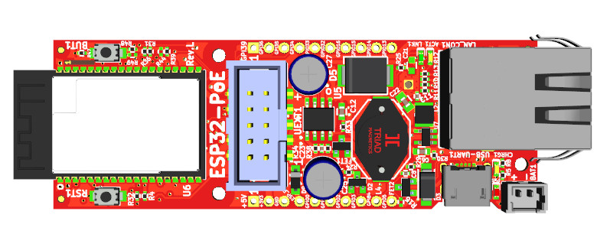
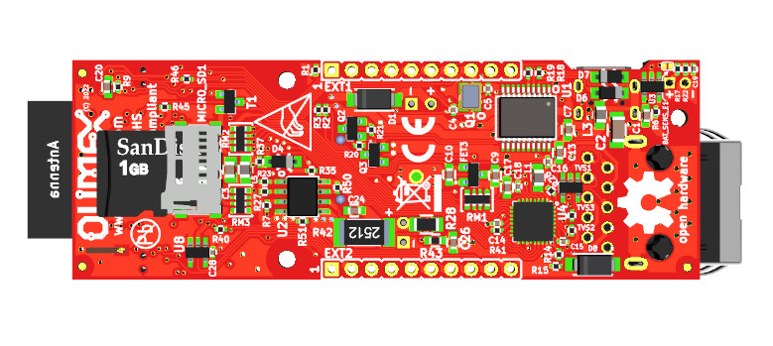
mout hole
ESP32 module
reset button
mout hole
GPIOs
GPIOs
USB connector
LiPo battery connector
mout hole
Micro SD card connector

2.2. ESP32-POE GPIOs

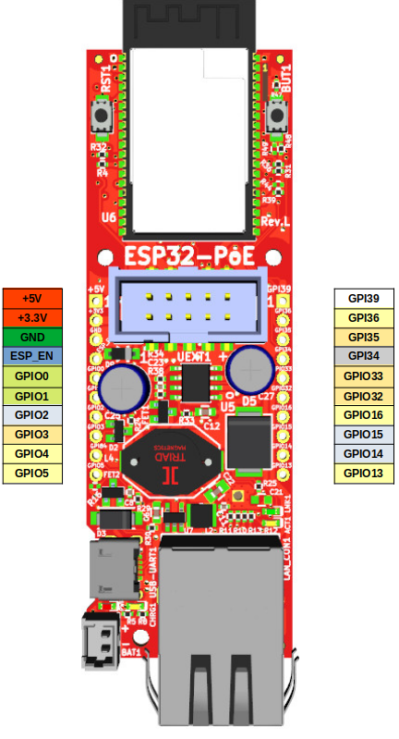
POWER SUPPLY pads:
+5V 1. Can be input and output; if you use it as input make sure no other 5V sources are applied to the board (having Li-Po battery is OK);
2. When the board is attached to USB or to Ethernet PoE this line can be used ONLY as output to power attached peripherals;
3. If you want to use as input i.e. to feed power from external 5V to this line make sure that board is not connected to USB!
4. When you use the 5V line as output to power external devices it can provide up to 0.8A @ 5V (i.e. 4W) maximum. This includes the 3.3V power output. The combined power draw of +5V output and +3.3V output must not exceed 4W!
+3.3V output which can source up to 0.5A @ 3.3V i.e. (1.65W) Make sure the combined power sourced from +3.3V and +5V does not exceed 4W!
GND Ground, the board has common ground.

GPIO pads:
ESP_EN resets the ESP32 module
GPIO0, GPIO2 are boot mode bootstrap pins make sure they are properly configured during power up
GPIO1, GPIO3 are used for USB programming, they can be freed up if you won’t further program the board via USB
GPIO2, GPIO14, GPIO15 are used for the SD-card, if no SD card is preset they are free to use
GPIO2, GPIO4, GPIO5, GPIO13, GPIO14, GPIO15, GPIO16, GPIO36 are shared on both UEXT and EXT headers so if you use them on the one connector do not use them at the other
GPI39 is connected to measure external power supply voltage
GPI34 is connected to user button and has 10K pullup
GPI35 is free to use by default but may be connected to measure the LiPo battery voltage if you close BAT_SENS_E1 jumper
+ESP32-POE-WROVER and ESP32-POE-WROVER-EA have no GPIO16 or GPIO17 led out, since they are used for the PSRAM. These are replaced by GPIO33 and GPIO0. GPIO17 being replaced by GPIO0 is crucial for the Ethernet connectivity, since GPIO17/GPIO0 is Ethernet clock out. Make sure to use new assignments in your software if your board variant comes with the WROVER chip.
The ESP32 chip has very advanced multiplexing and you can define any free GPIO pin for I2C, UART, SPI operation as long as you are within the maximum supported (some penalties to SPI's maximum frequency apply, when not using the dedicated pins). Notice that some ESP32 pins can only be inputs. Defining pins for another function is purely software effort.
For further analysis of pins it is highly recommended to check on the schematic and also check the ESP32-WROOM/ESP32-WROVER documentation.

2.3. ESP32-POE-ISO GPIOs
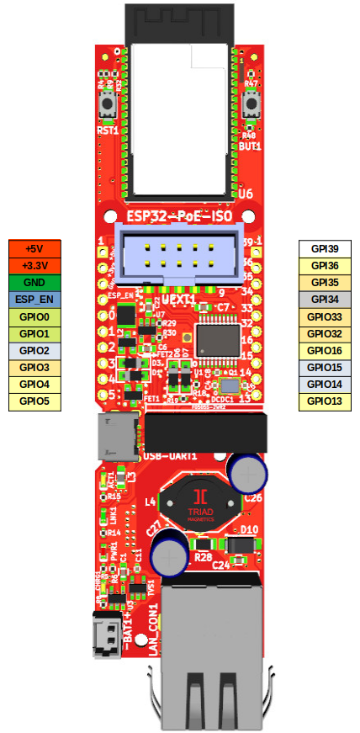

POWER SUPPLY pads:
+5V 1. Can be used as either input and output. f you use it as input make sure no other 5V source is applied to the board (Li-Po battery is OK);
2. When the board is connected to USB or to Ethernet PoE this line can be used as output and power supplement electronic
3. if you want to use as input i.e. to feed power from external 5V to this line make sure board is not connected to USB!
4. when you use as output i.e. you feed external electronics from it up to 0.4A @ 5V (i.e. 2W) can be sourced maximum. This includes the 3.3V power output. The combined power must not exceed 2W.
+3.3V output which can source up to 0.6A @ 3.3V i.e. (2W) - make sure the combined power sourced from +3.3V and +5V does not exceed 2W; notice the board itself requires some wattage to operate
GPIO pads:
ESP_EN resets ESP32 module
GPIO0, GPIO1 are used only during programming, after that are free to use
GPIO2, GPIO14, GPIO15 are used for the SD-card, if no SD card they are free to use
GPIO2, GPIO4, GPIO5, GPIO13, GPIO14, GPIO15, GPIO16, GPIO36 are shared on both UEXT and EXT headers so if you use them on the one connector do not use on the other
GPI39 is connected to measure external power supply voltage;
GPI35 is used for battery measurement of the LiPo battery;
GPI34 is connected to used button and has a 10K pullup resistor.
+ESP32-POE-ISO-WROVER and ESP32-POE-ISO-WROVER-EA have no GPIO16 and GPIO17 led out, since they are used for the PSRAM. GPIO16 is replaced by GPIO33. GPIO17 is replaced by GPIO0, this is important for the Ethernet connectivity, since GPIO17/GPIO0 is Ethernet clock out. Make sure to use new assignments if your board variant comes with the WROVER chip.
The ESP32 chip has very advanced multiplexing and you can define any free GPIO pin for I2C, UART, SPI operation as long as you are within the maximum supported (some penalties to SPI's maximum freqncy apply, when not using the dedicated pins). Notice that some ESP32 pins can only be inputs. Defining pins for another function is purely software effort.
For further analysis of pins it is highly recommended to check on the schematic and also check the ESP32-WROOM/ESP32-WROVER documentation.

2.4. ESP32-POE(-ISO) schematics

This is an open hardware design made with KiCAD. All design files and exports can be found at our GitHub.

ESP32-POE schematics are available at GitHub
ESP32-POE board revision changes are at GitHub

ESP32-POE-ISO schematics are available at GitHub
ESP32-POE-ISO board revision changes are at GitHub

2.5. ESP32-POE(-ISO) power supply

ESP32-POE(-ISO) can be powered by 4 sources:
- Ethernet PoE
- USB-micro connector
- Li-Po battery
- EXT1 pin 1 (+5V) but note that this signal is connected to USB 5V signal so when you power via this EXT1 pin you should not connect the board to the USB!

- The standard power consumption of ESP32-POE(-ISO) is between 50mA and 200mA depending on the operation mode. When using power-down modes and Li-Po battery power it can go down to micro amperes.
- Li-Po battery gets automatically charged with about 100mA when external power supply is present.
When the LiPo battery is attached and external power supply is missing internal DCDC step-up converter and switching circuit automatically powers ESP32-POE from the battery. 1400mAh battery will provide about 8 hours of stand alone operation.
+The LiPo battery connector is JST 2.0 mm connector and with Olimex’s battery polarity. If you use batteries from other manufacturers please make PLUS and MINUS are connected properly as you may damage the board!
+ Is it safe to have USB and PoE connected and enabled at the same time? If you are using ESP32-POE or any of its variants – no, it is not safe and should be avoided at all costs. If you are using ESP32-POE-ISO or any of its variants – yes, it is safe to have them both attached and enabled.

2.5.1. External power sense feature
This allows to detect when the board has external powering. This is helpful if you want to switch between different power modes depending on whether the board is powered from a battery or external power source. By default the external power sense is enabled and it is available on GPI39!
Refer to this Arduino IDE example to see how you can check for the presence external power and check the battery measurement:
https://github.com/OLIMEX/ESP32-POE/blob/master/SOFTWARE/ARDUINO/ESP32_PoE_PowerReading/ESP32_PoE_PowerReading.ino

2.5.2. Battery measurement feature
This allows to measure the Li-Po battery’s voltage. This is helpful so you can evaluate when the battery is going to drain out so you can power off the board safely or switch to more conservative power method.
In ESP32-POE and its variants the battery measurement features is disabled by default but you can enabled it by soldering together the pads of STM jumper BAT_SENS_E1 jumper, after closing it – it will be routed to GPI35!
In ESP32-POE-ISO and its variants – the battery measurement is enabled and it is available on GPI35!
Refer to this Arduino IDE example to see how you can check for external power and check the battery measurement:
https://github.com/OLIMEX/ESP32-POE/blob/master/SOFTWARE/ARDUINO/ESP32_PoE_PowerReading/ESP32_PoE_PowerReading.ino

2.6. UEXT connector

UEXT connector stands for Universal EXTension connector and typically contains +3.3V, GND, UART, I2C, SPI signals.
UEXT is 0.1” 2.54mm step boxed plastic connector. All signals are with 3.3V levels.
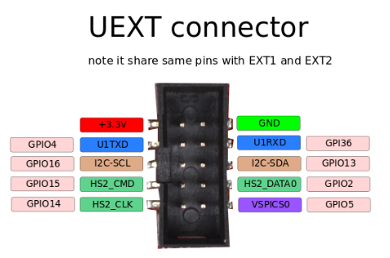

The 3.3V pin is output only!
In board variants with WROVER module GPIO16 is replaced by GPIO33 (since WROVER uses GPIO16 and GPIO17 for the PSRAM)!
Notice that the ESP32 GPIOs have to be defined in the code for their respective functions, e.g. define GPIO4 and GPIO36 for UART function before using them; define GPIO16 and GPIO13 for I2C, define GPIO15, GPIO2, GPIO14, GPIO5 for SPI.
GPIO15, GPIO2, GPIO14 are multiplexed with the SD card and if you have SPI device attached to them you’d have to use the chip select to switch between the card and the device connected to the UEXT.
Olimex has developed number of extension MODULES compatible with this connector. There are temperature, humidity, pressure, magnetic field, light sensors. Modules with LCDs, LED matrix, relays, Bluetooth, Zigbee, Wi-Fi, GSM, GPS, RFID, RTC, EKG, sensors, and more.

2.7. ESP32-POE(-ISO) Ethernet connector

ESP32-POE and ESP32-POE-ISO have ETH8720 chip. All board variants use RJ45 LAN connector that is compatible with both PoE mode A and PoE mode B for PoE power delivery. Either mode is fine for the board.
How to define the Ethernet in the software?
It Arduino IDE this is done in the board configuration and you don’t have to specify the pins. Install the espresiff ESP32 package for Arduino IDE and make sure ESP32-POE or ESP32-POE-ISO is selected in the board selector and you are good to go. You can run the default Ethernet demo for LAN8720 without changes, go to File → Examples → Ethernet → ETH_LAN8720 verify and upload and open the serial terminal to see the results.
In other tools you might need to manually configure the pins. The pinout is as follows:
MDC – 23
MDIO – 18
PHY reset – 12
PHY RMII clock – 17 or 0 (17 in boards with WROOM module, 0 in boards with WROVER module)
If you use ESP-IDF v5.5 or newer just load the default Ethernet demo that comes with it and configure manually via menuconfig and edit the settings. Run:
idf.py menuconfig
Then navigate under "Example Ethernet Configuration" and make sure internal EMAC is selected and Ethernet PHY device is LAN87xx and set:
MDC – 23
MDIO – 18
PHY Reset – 12
PHY address – 0
It should look like this:
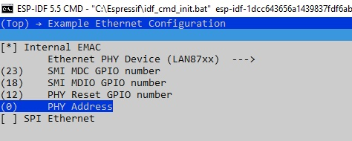
Then you also need to edit the settings for the Ethernet clock source – go back to Component config -> Ethernet -> Support ESP32 internal EMAC controller and remove the tick from Output RMII clock from GPIO0 (Experimental) and put RMII clock GPIO number to 17. Notice that if you use WROVER variant of the board put the tick om Output RMII clock from GPIO0 (Experimental).
For a regular board with WROOM module it should look like this:
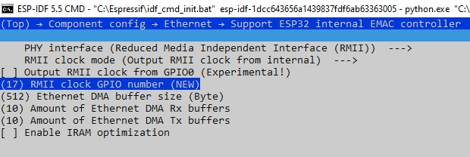
Notice the ESP32-POE and ESP32-POE-ISO boards use LAN8720A Ethernet chip. It is very important the LAN8720A to stay in reset (via GPIO12) until the ESP32 has generated the PHY clock (GPIO17/GPIO0, depending whether WROOM or WROVER variant). If there is no PHY clock generated when LAN8720A gets powered, the LAN8720A might hang! For more info refer to LAN8720A’s datasheet.
Usually the libraries take care of this by keeping the board in reset via GPIO12, but if it doesn’t you can do in your code. For example, in Arduino IDE you can first enable pin 17 (or pin 0 in WROVER module) to output and then hold pin 12 in reset for some moments BEFORE the Ethernet initialization like this:
pinMode(17, OUTPUT);
digitalWrite(17, HIGH); // enable external clock

// PHY reset sequence
pinMode(12, OUTPUT);
digitalWrite(12, LOW); // Hold PHY in reset
delay(300); // Keep it low for 300ms
digitalWrite(12, HIGH); // Release PHY reset
delay(50); // Wait 50ms for PHY clock to stabilize

// Start Ethernet: PHY reset = 12, PHY clock = 17
ETH.begin(ETH_PHY_LAN8720, 0, 23, 18, 12, ETH_CLOCK_GPIO17_OUT);

2.8. LED description

Board comes with 4 on-board status LEDs. These are not connected to the ESP32 directly and can’t be used as general purpose LEDs.

LED CHRG1 shows whether the Li-Po battery attached to the board is currently charging. When it is off it means that either there is no battery attached or it is already fully charged. Refer to "BL4054/BL4054B" datasheet and check for "CHRGb" port for more detailed information.
LED PWR1 is turned on when there is 5V DC applied to the board. It only actives from external power supply, USB power supply, or PoE powering. It won't turn on when board is powered from a Li-Po battery at BAT1 connector (to conserve energy required to power that LED).
LEDs LNK1 and ACT1 are Ethernet link and activity LEDs. LNK1 is turned on when 100 Mbps speed is detected, and turns off at 10Mbps or less. ACT1 blinks when activity is detected. For more information about their behavior, refer to the manual of "LAN8710A/LAN8710AI" and check the table describing "REGOFF" port (ACT1 is connected to it) and "nINTSEL" port (LNK1 is connected to it).

During USB power up the CHRG1 and PWR1 LEDs should light up.

Important! In order to reduce current consumption the LEDs would remain off when the board is powered from Li-Po battery! Do not count on the LEDs when the board is powered only from a Li-Po battery!

3. SOFTWARE

ESP32-POE and ESP32-POE-ISO are very popular boards and supported by a lot of software tools, among them (there are ready-to-use configs for ESP32-POE and ESP32-POE-ISO):

- Espressif ESP-IDF
- Arduino IDE
- MicroPython
- ESPhome
- PlatformIO

3.1. Olimex-made software

We provide some examples for basic functions at our GitHub:

- For Arduino you can find them here:

https://github.com/OLIMEX/ESP32-POE/tree/master/SOFTWARE/ARDUINO

- For ESP-IDF here:

https://github.com/OLIMEX/ESP32-POE/tree/master/SOFTWARE/ESP-IDF

4. Frequently asked questions

- Is it safe to have USB powering and PoE powering connected and enabled at the same time?
- If you are using ESP32-POE or any of its variants – no, it is not safe and should be avoided at all costs.
- If you are using ESP32-POE-ISO or any of its variants – yes, it is safe to have them both enabled.

- Where are I2C, UART, SPI pins exposed?
The ESP32 chip has very advanced multiplexing and you can define any free GPIO pin for I2C, UART, SPI operation as long as you are within the maximum supported (some penalties to SPI's maximum frequency apply, when not using the dedicated pins). Notice that some ESP32 pins can only be inputs. Double check if the pins you want to use are free. Defining pins for another function is a purely software effort.
- I provide 24V to the Ethernet of ESP32-PoE-ISO's but it doesn't seem powered. What is the problem?
TPS2375PW (Si3402) would NOT work with 24V DC. The recommended voltage is 48V DC and the minimum is around 37V DC. For more info refer to TPS2375PW's (Si3402-B's) datasheet.

- What is the PoE class of the devices?
ESP32-POE and ESP32-POE-ISO are set for class PoE class 0 operation (0.44W-12.95W).
There was one batch of ESP32-POE devices, hardware revision M, that are setup to class 4 operation (similar to ESP32-POE2). Class 4 operation might require more current since it requires at least 12.95W up to 25.5W, if you have trouble with ESP32-POE revision M devices refer to the schematic and remove resistor R54 to switch back to class 0 operation. This only applies to ESP32-POE boards from hardware revision M. ESP32-POE revision M1 were set to class 0 operation again.

- I have 10 of your boards connected to my switch but some doesn't seem to work. Are they broken?
- Switches reserve the maximum power for the board. Make sure the total power output of the switch is not exceeded. For 10 of these boards it needs to be capable to provide at least 150W (this is with the default setting for PoE Class 0, and if you changed the jumper state to upgrade the Class 0 to Class 4, then double it).

- What is the power delivery mode of these boards? Is it mode A or mode B?
ESP32-POE and ESP32-POE-ISO and all variants use LAN connector that is compatible with both mode A or mode B. Either one is fine.
- I power the board from the Ethernet connector. What current do I have available for additional circuits?
The ESP32-POE circuit can safely provide up to 4W in total. Part of this wattage is used to power the ESP32 module, the battery charger, and other circuits part of the board design; the remaining wattage is available for additional circuits (up to around 3W). So you can use 3W for own circuits around 600mA @ 5V or 900mA @ 3.3V (combined draw from 3.3V and 5V lines shouldn't be more than 3W) safely.
The isolated DCDC in the design of ESP32-POE-ISO provides up to 2W in total but some power is used for the module itself and the battery charger. So you can use around 1.5W for own circuits around 300mA @ 5V or 450mA @ 3.3V (combined draw from 3.3V and 5V lines shouldn't be more than 1.5W) safely.

- I power the board from the battery connector. The LEDs remain off. Is it broken?
Probably not. This is a low-power design. The LEDs would not turn on when operating on battery to save power. You need other ways to determine if it works or not. For example, something over the serial lines or over the Ethernet (with no PoE enabled else it would get powered from there).
- A specific resistor gets very hot! What is this component? Is it safe? Can I remove it?
This resistor is required by the IEEE standards. It is used for MPS (maintain power signature).
Search online "maintain power signature poe" to get the general idea. It consumes around 0.5W, when the board is powered from Power-Over-Ethernet (notice the MPS resistor consumes 0 when the board is powered from other sources). We didn't ensure MPS in the first hardware revisions of the board (e.g. had no resistor in place), but this caused availability problems when using some power saving modes – the board consumed less wattage than PoE equipment can detect, which led to PoE equipment shutting the board off.
If you have soldering experience and the resistor bothers you, you might try desoldering it and see if that effects your setup negatively. Notice that we don't recommend doing so.

- ESP32-PoE and ESP32-POE-ISO don't work well with bauds over 115200. What to do?
We use CH340 daily for bauds up to 2M so it is not a hardware issue. Some older drivers might have wrong timings, causing worse throughput. Download and install the latest drivers for CH340. If you are using Linux make sure to try with these drivers: high-speed driver for Linux.

- Help! Ethernet is not working. I use ESP32-POE-WROVER and ESP32-POE-ISO-WROVER. Is the device broken?
Your board with a WROVER chip is not broken and we test each device with Ethernet, chances of broken device are very low. However, there is hardware difference in the pinout between boards with WROOM and WROVER modules – the WROVER module requires two extra pins for the PSRAM memory. One of the pins affects the Ethernet, the other – the I2C. When WROVER module is used (instead of the default WROOM) then GPIO16 and GPIO17 are unavailable (both are used for the PSRAM inside the module). In that case we have set GPIO33 to go on UEXT1 pin #5 (instead of GPIO16). Also the clock for the Ethernet is now GPIO0 (instead of GPIO17). Modify your software for these differences.

- Help! Ethernet is not working always upon power-up. If I press the reset or power cycle the board a few times it starts working. Is my device faulty?
It is probably because your software didn’t utilize the PHY_PWR pin (GPIO12) properly. This behavior happens when the PHY controller (LAN8720) gets powered before the ESP32 module can generate the PHY clock. What your software should do is hold the LAN8720 in reset for few milliseconds via the PHY_PWR pin and release it from reset only after PHY clock is already generated by the ESP32 module. Simple software workarounds that can be tested are adding delay before Ethernet initialization or toggling GPIO12 to reset only the Ethernet chip until connection is restored.

- Even if I power the board from power jack the USB-serial converter CH340T appears to remain powered. This affects my readings of the serial. What can I do?
Look at the schematic, the CH340 can get parasitically powered via GPIO3 if you haven't set the GPIO as input. It is a problem if GPIO3 is set as output. So make sure it is set as input.

5. Useful links

The main pages of ESP32-POE and ESP32-POE-ISO are the main hubs for other locations, make sure to first check the product page at our web-site.
ESP32-POE main product page:
https://www.olimex.com/Products/IoT/ESP32/ESP32-POE/open-source-hardware

ESP32-POE-ISO main product page:
https://www.olimex.com/Products/IoT/ESP32/ESP32-POE-ISO/open-source-hardware

