

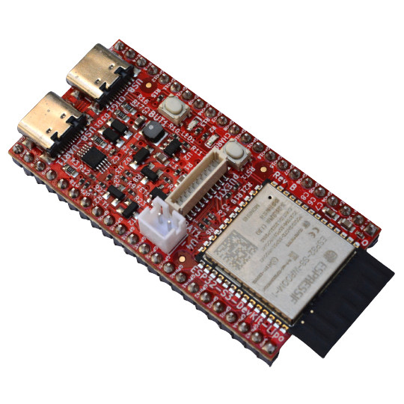

ESP32-S3-DevKit-LiPo
User Manual
Rev.1.0 July 2023 olimex.com
Table of Contents
Introduction to ESP32-S3-DevKit-LiPo 3
Order codes for ESP32-S3-DevKit-Lipo and accessories: 4
HARDWARE 5
ESP32-S3-DevKit-LiPo layout: 6
ESP32-S3-DevKit-LiPo GPIOs: 8
ESP32-S3-DevKit-Lipo schematics: 10
UEXT connector: 11
pUEXT signals: 12
SOFTWARE: 13
Revision History 14

Introduction to ESP32-S3-DevKit-LiPo

ESP32-S3 is a dual-core XTensa LX7 MCU, capable of running at 240 MHz. Apart from its 512 KB of internal SRAM, it also comes with integrated 2.4 GHz, 802.11 b/g/n Wi-Fi and Bluetooth 5 (LE) connectivity that provides long-range support. It has 45 programmable GPIOs and supports a rich set of peripherals. ESP32-S3 supports larger, high-speed octal SPI flash, and PSRAM with configurable data and instruction cache.

ESP32-S3-DevKit-LiPo board is development board with ESP32-S3 and these features:

- ESP32-S3-WROOM-1-N8R8 8MB RAM 8 MB Flash
- Green Status LED
- Yellow Charge LED
- UEXT connector (pUEXT 1.0 mm step connector)
- USB-C power supply and USB-Serial programmer
- USB-C OTG JTAG/Serial connector
- LiPo charger
- LiPo battery connector
- External power sense
- Battery measurement
- Automatic power supply switch between USB and LiPo
- RESET button
- USER button
- Dimensions 56x28 mm

Order codes for ESP32-S3-DevKit-Lipo and accessories:

ESP32-S3-DevKit-LiPo ESP32-S3 development board with USB JTAG/Debugger and Lipo charger

USB-CABLE-A-TO-C-1M USB-C power and programming cable
LiPo batteries
UEXT sensors and modules

HARDWARE

ESP32-S3-DevKit-LiPo layout:

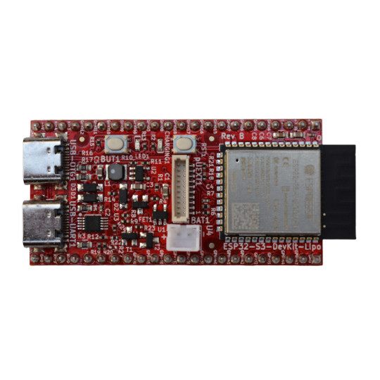
USB-C JTAG/OTG
User Button
Status LED
Charge LED
RESET
ESP32-S3
pUEXT connector
LiPo battery connector
USB-C UART

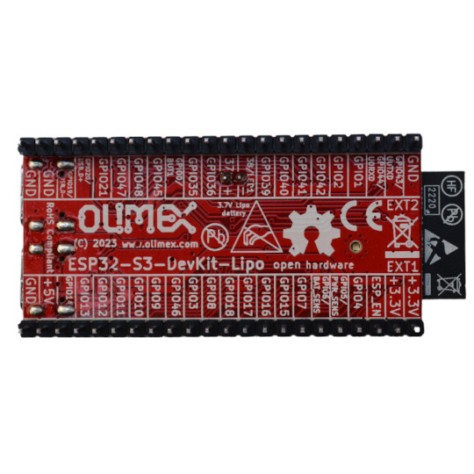

ESP32-S3-DevKit-LiPo GPIOs:
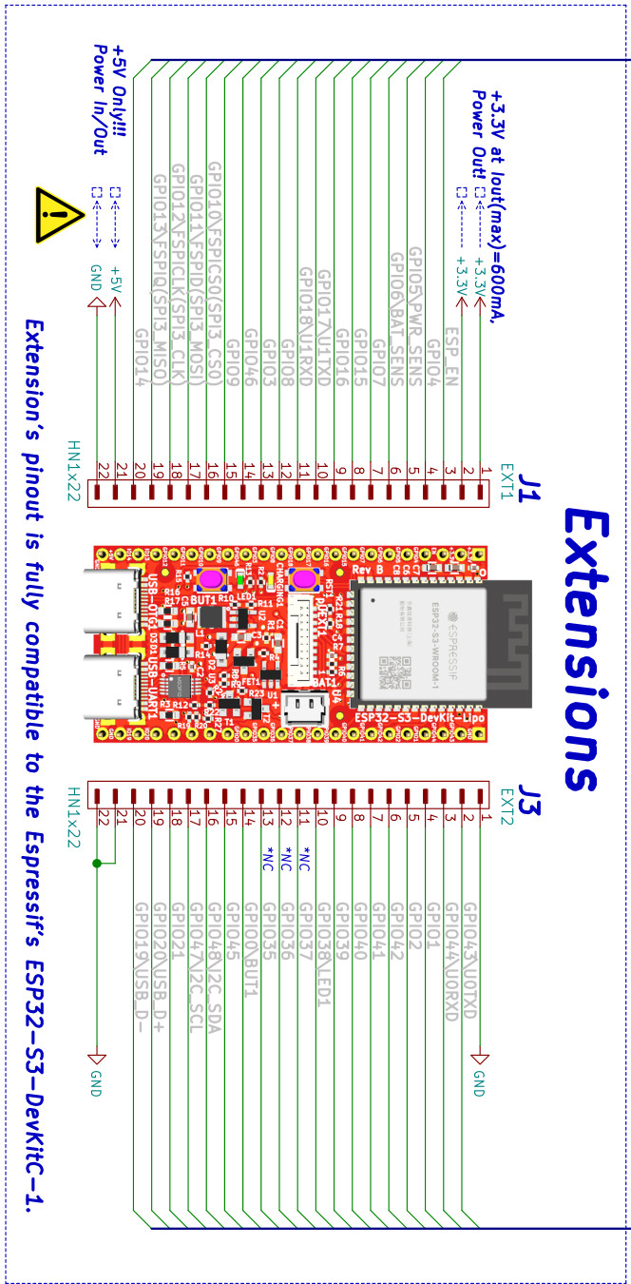

POWER SUPPLY:

This board can be powered by:
+5V EXT1.pin 21 can be input or output
USB-UART USB-C connector
USB-OTG1 USB-C connector
LiPo battery

ESP32-S3-DevKit-Lipo schematics:

ESP32-S3-DevKit-LiPo latest schematic is on GitHub

UEXT connector:

UEXT connector stands for Universal EXTension connector and contain +3.3V, GND, I2C, SPI, UART signals.
UEXT connector can be in different shapes.
The original UEXT connector is 0.1” 2.54mm step boxed plastic connector. All signals are with 3.3V levels.
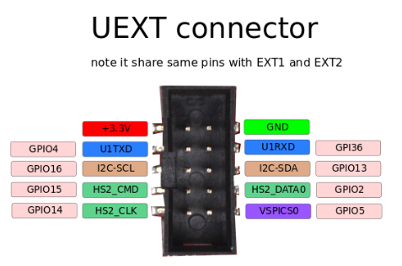

As the boards become smaller and smaller some smaller packages were introduced too beside the original UEXT connector
- mUEXT is 1.27 mm step boxed header connector which is with same layout as UEXT
- pUEXT is 1.0 mm single row connector (this is the connector used in RP2040-PICO30)

Olimex has developed number of MODULES with this connector. There are temperature, humidity, pressure, magnetic field, light sensors. Modules with LCDs, LED matrix, Relays, Bluetooth, Zigbee, WiFi, GSM, GPS, RFID, RTC, EKG, sensors and etc.

pUEXT signals:

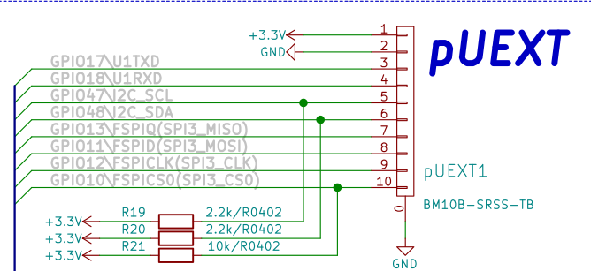

SOFTWARE:

- ESP32-S3-DevKit-Lipo Linux image
- ESP32-S3-DevKit-LiPo Linux build instructions from jcmvbkbc and here
- ESP32-S3-DevKit-Lipo Linux build instructions form ESP32DE

Revision History
Revision 1.0 July 2023

