FOSDEM MUSIC BOX – Assembly cheatsheet

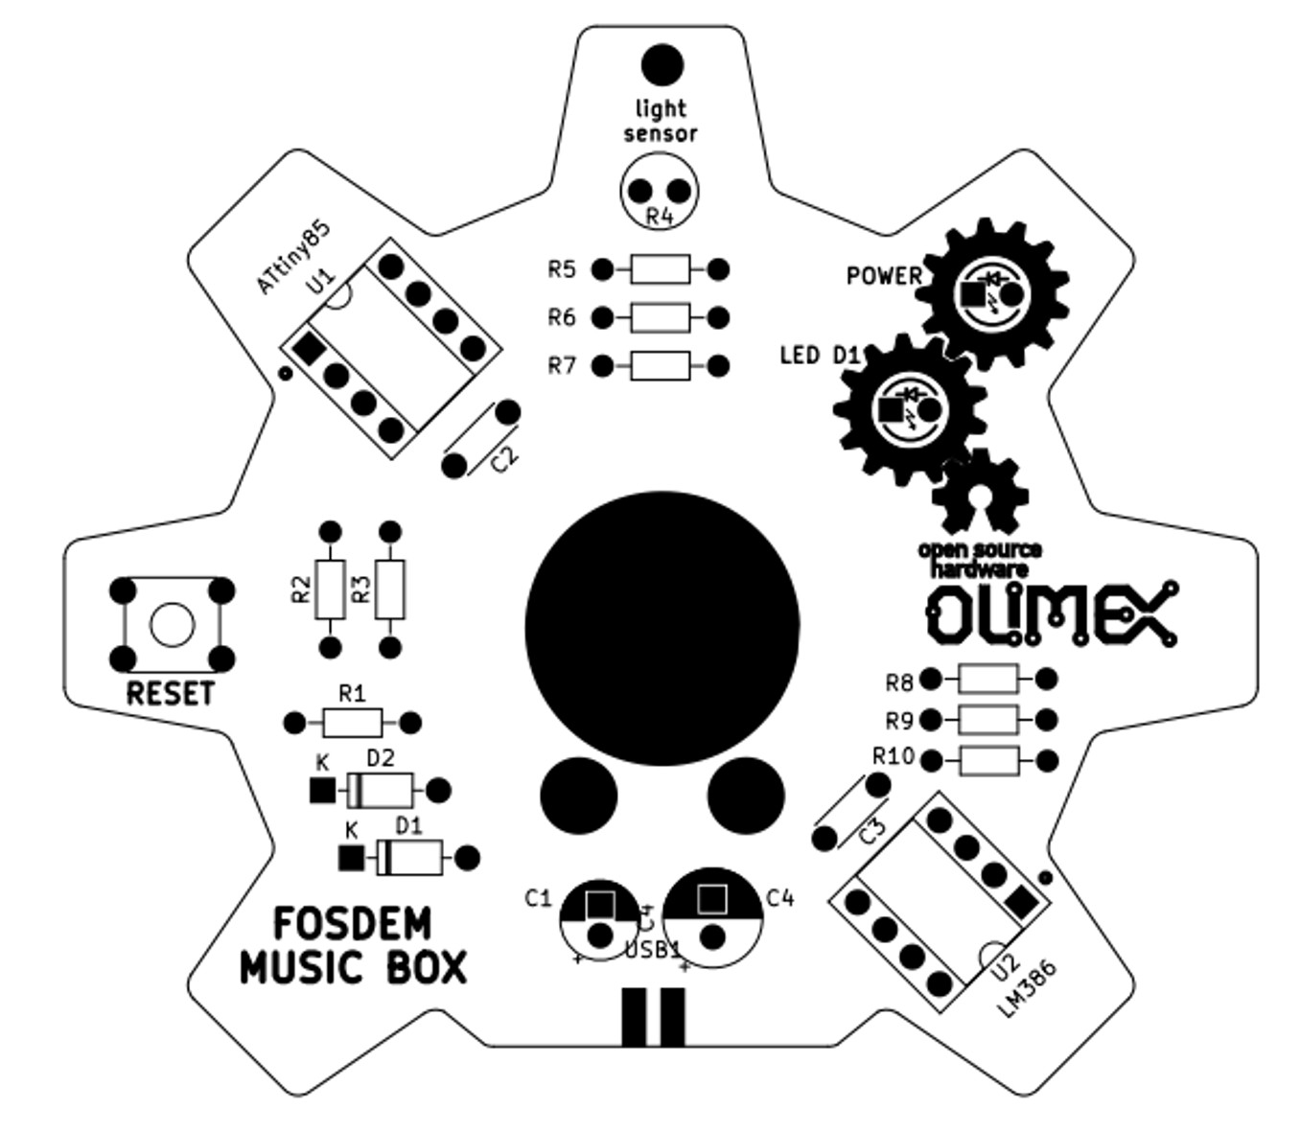
1. Resistors

R2, R3, R8 – 22R – 1/8W 5% - RED-RED-BLACK-GOLD
R1, R6, R9 – 1.5K – 1/8W 5% - BROWN-GREEN-RED-GOLD
R5, R7, R10 – 10K – 1/8W 5% - BROWN-BLACK-ORANGE-GOLD

2. Diodes

D1, D2 - 1N4148 – Warning! Polarity matters! Black stripe should be placed at the (K)athode side.
3. IC sockets

The first pin is marked!

U1 – ATTiny85 – Warning! Polarity matters! Orient properly!
U2 – LM386 – Warning! Polarity matters! Orient properly!

4. Button

RESET – 4-pin button

5. Speaker

SOLDER THE SPEAKER CAREFULLY! DO NOT OVERHEAT!

Hold soldering iron for NO more than 3 seconds soldering on pad or you will destroy the speaker.

6. USB connector – big metal shield pins soldering on bottom!

7. Capacitors

C2, C3 - 100nF X5R – 50VDC
C1 – 10uF 50VDC – Warning! Insert longer pin into circle pad.
C4 – 220uF 16VDC – Warning! Insert longer pin into circle pad.

8. LEDs

LED D1 – RED – Warning! Insert longer pin into circle pad
POWER – GREEN(clear) – Warning! Insert longer pin into circle pad

9. Light Sensor

R4 – 10K LDR

