

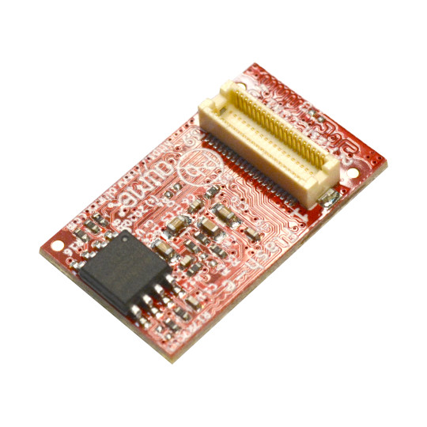

Flash-eXXGs16M
User Manual
Rev.1.0 April 2024 olimex.com
Table of Contents
What is Flash-e16Gs16M 3
Flash-eXXGs16M features: 4
Order codes for Flash-eXXGs16M: 5
HARDWARE 6
Flash-eXXGs16MB layout: 7
Flash-eXXs16M schematics: 8
Revision History 9

What is Flash-e16Gs16M

Flash-e16Gs16M is an open source hardware board which adds external eMMC and SPI Flash to Olimex’s OLinuXino and SOM modules which are compatible with it.
For the moment these are:
STMP157-OLinuXino-LIME2
A20-OLinuXino-LIME2 Rev.N
STMP157-BASE-SOM-EVB
STMP1-A13—EVB
iMX8MP-SOM-EVB
S3-OLinuXino
and others to come

Flash-eXXGs16M features:

- eMMC 5.0 16GB or 32GB
- SPI flash 16MB
- Dimensions are: 25 x 15 mm

Order codes for Flash-eXXGs16M:

Flash-e16Gs16M Flash module with 16GB eMMC Flash and 16MB SPI Flash
Flash-e32Gs16M Flash module with 32GB eMMC Flash and 16MB SPI Flash

HARDWARE

Flash-eXXGs16MB layout:
connector

SPI Flash

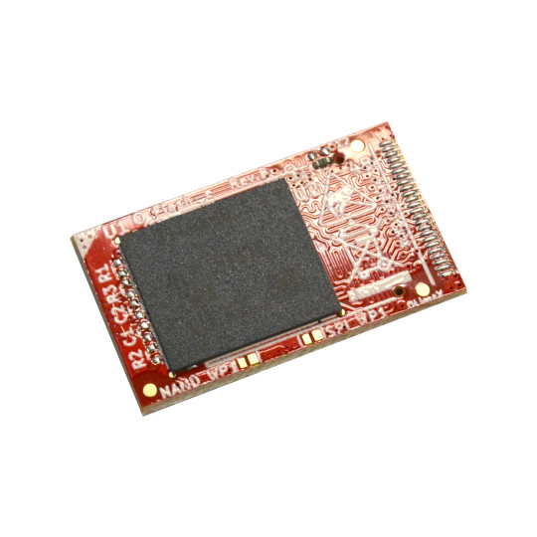
Orientation mark
eMMC

Flash-eXXs16M schematics:
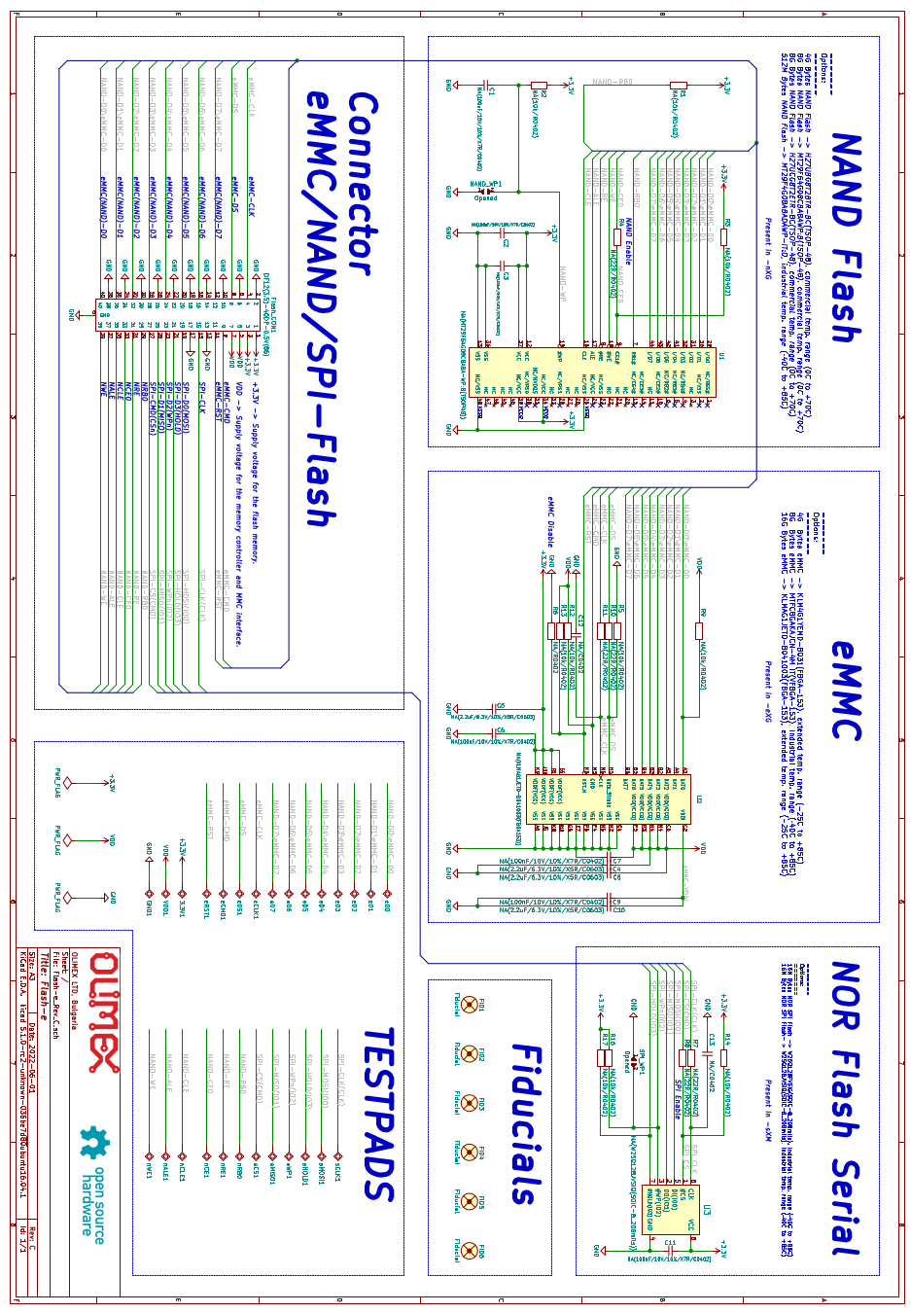

Revision History
Revision 1.0 April 2024

