

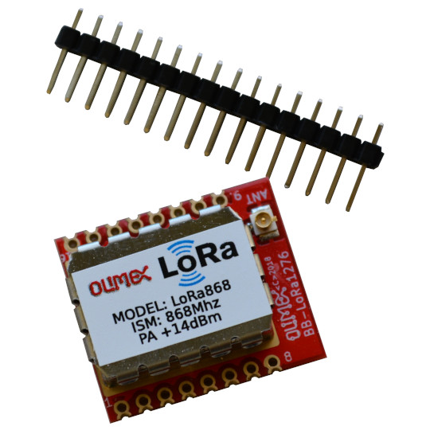

LoRa868 - LoRa915
User Manual
Rev.1.0 May 2021
olimex.com

Table of Contents
Overview 3
General information 4
Order codes 6
Software 7
Power supply 8
Pinout 9
Open Source Hardware design 10
Revision History 11
Contact information 12

Overview

LoRa (short for long range) is a spread spectrum modulation technique derived from chirp spread spectrum (CSS) technology. LoRa devices and wireless radio frequency technology is a long range, low power wireless platform that has become very popular for Internet of Things (IoT) networks worldwide. LoRa devices and the open LoRaWAN® protocol enable smart IoT applications that solve some of the biggest challenges facing our planet: energy management, natural resource reduction, pollution control, infrastructure efficiency, disaster prevention, and more.
LoRa advantages are:
- Easy to install – wireless technology, no need to install wires, dig channels etc.
- Uses license free frequancy – no need to pay licensee fees like GSM frequencies.
- Low power – LoRa devices can work up to 10 years from small lithium battery (depend on how many messages per day device will send).
- Long Range – LoRa devices can communicate up to 15 km at rural and up to 1-2km in urban area.
- Secure communication – all messages are AES128 encrypted
- Low Cost – LoRa devices are under EUR 10
- No taxes for traffic like other technologies which require operator like GSM, LTE, NB-IoT, SigFox etc.

LoRa is not solution for any problem, some limitations are:
- small messages 51 up to 222 bytes
- slow speed of transmission 292 up to 550 bps

The long range is good but also bad as when one device start to transmit all other devices in it’s range can’t transmit. This creates some issues when for instance thousands of devices are installed in their transmission range reach. When we add to this that there is no moderation/operator who to set rules, if one participant do not follow the rules and start to transmit without pause this participant will jam/silence all others withing his transmission ranges.

General information

The core of LoRa868 / LoRa915 is Semtech's SX1276 transciever.
The interface to host microcontroller is via SPI interface with up to 10Mhz SCK.
SX1276 takes care for all details for the modulation, encryption and etc.
RF front end is with 168 dB maximum link budget, which allow communication even in harsh environments.
Low RX current of 10 mA and 200 nA register retention in deep sleep.
SX1276 has built-in temperature sensor and low battery indicator.
LoRa868 and LoRa915 have no antenna by default, they have u.FL connector where external antenna must be connected. 16 pin header is provided if customer wants to solder and use on breadboard.

For LoRa868 and LoRa915 we do offer PCB antenna with +2dBi gain :
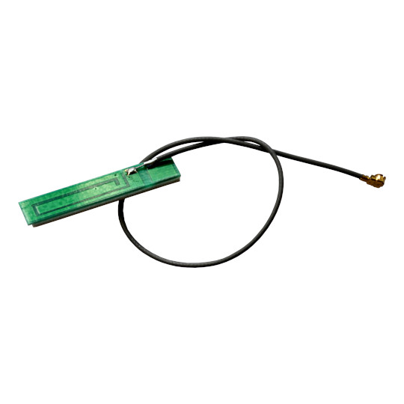

LoRa868-ANT and LoRa915-ANT includes this antenna.
For LoRa868 we offer also +3dBi duck antenna:
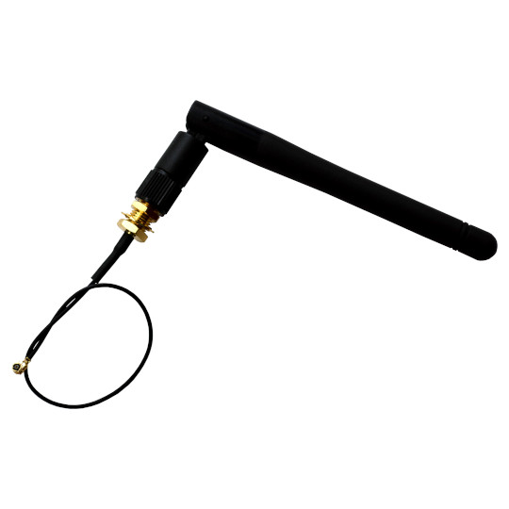

LoRa868-EANT includes this antenna. We do not offer duck antenna for LoRa915.

Order codes

LoRa in Europe operates at 868Mz and in North America operates at 915Mhz. Please make sure you select the proper LoRa module for your region.

LoRa868 industrial grade -40+85°C, European frequency, no antenna, u.FL IPEX connector
LoRa868-ANT industrial grade -40+85°C, European frequency, includes cable and PCB antenna
LoRa868-EANT industrial grade -40+85°C, European frequency, includes cable and external duck antenna +3dBi
LoRa915 industrial grade -40+85°C, North American frequency, no antenna, u.FL IPEX connector
LoRa915-ANT industrial grade -40+85°C, North American frequency, includes cable and PCB antenna

Software

SX1276 is mature chip and has good software support.
Libraries for direct LoRa modulation and for LoRaWAN stack are available for different processors.
Note that the Chinese clones of SX1276 like RFM95W have bug in low data rate optimization flag settings and high power mode, due to the popularity of these clones all default Arduino libraries for LoRa has wrong setup to work around the RFM95W bug. We recommend to use the libraries and examples from our web.

Power supply

LoRa868/915 supply voltage is 3.3V, but operates from 1.8 up to 3.7VDC, this allow full utilization of LiPo 3.7V battery (discharged 2.0V, charged 3.7V)
Make sure your power source can provide peak current at least 120mA.
Power consumption is:
- Supply current in Sleep mode 0.2mA
- Supply current in Standby mode 1.6-1.8mA
- Supply current in Receive mode 10-12mA
- Supply current in Transmit mode +13 dBm 29 mA
- Supply current in Transmit mode +20 dBm 120 mA

Pinout

All SX1276 signals are available on two 0.1 inch (2.54 mm) step row of 8 pads where headers can be soldered.
The distance between the rows is 0.8 inch (20.32mm)
There is second cut through row of pads which is spaced at 0.05 inch (1.27mm), so the distance between these two rows is 0.9 inch (22.86 mm).
Total board dimensions are 0.9 inch (22.86 mm) x 1.023 inch (26 mm)
These cut through pads are convenient to solder LoRa868/915 module directly on main PCB.
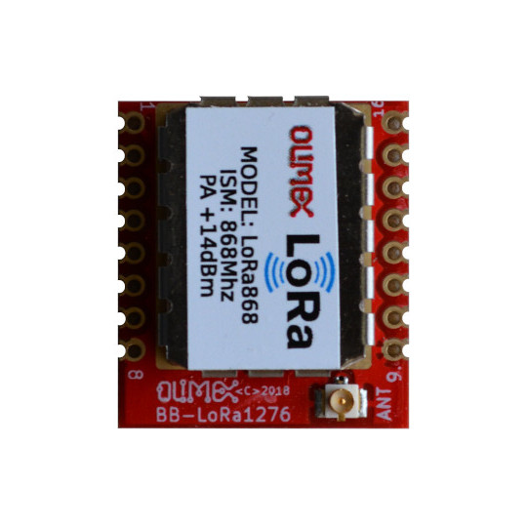

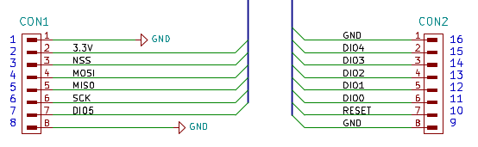

Open Source Hardware design

LoRa868 / LoRa915 is open source hardware, this means that all CAD sources are available and free to be learn, study, modify, distribute, make, and sell the design or hardware based on that design.
The board is designed using KiCad.
KiCad is open source software and completely free to download and use.
All files are available on GitHub.

Revision History
Revision 1.0 May 2021

Contact information

Headquarters and Factory address:

OLIMEX Ltd
ul. Pravda 2
Plovdiv 4000
BULGARIA

Sales: sales@olimex.com
Technical Support: support@olimex.com
Corporate Website: www.olimex.com

For latest news and developments - follow our
- Blog
- GitHub
- Twitter
- Facebook
- Mastodon
- Pluspora
- IRC
- flicr

