

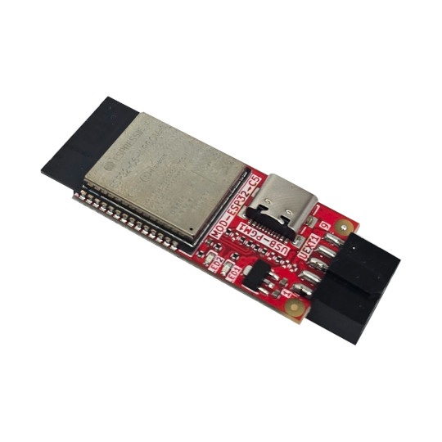

MOD-ESP32-C5
User Manual
Rev.1.0 November 2025 olimex.com
Table of Contents
What is MOD-ESP32-C5 3
Order codes for MOD-ESP32-C5 and accessories: 4
HARDWARE 5
MOD-ESP32-C5 layout: 6
UEXT connector: 7
MOD-ESP32-C5 UEXT connector wiring: 8
LEDs: 9
MOD-ESP32-C5 schematics: 10
SOFTWARE: 11
Revision History 12

What is MOD-ESP32-C5

MOD-ESP32-C5 is Dual band 2.4Ghz and 5Ghz WiFi 6, Bluetooth 5 LE, Zigbee, Thread, Matter development board with UEXTconnector.
The board is with ESP32-C5-WROOM-N8R4 module with 8MB of Flash and 4MB of RAM

The features of MOD-ESP32-C5 are:
- ESP32-C5-WROOM-N8R4 module
- 32 bit RISC-V processor 240Mhz
- Dual-Band Wi-Fi (2.4 GHz + 5 GHz)
- Bluetooth 5, Zigbee, Thread, Matter
- 8 MB Flash + 4 MB RAM
- UEXT connector
- USB-C JTAG
- Two status LEDs
- Dimensions 40x20mm

MOD-ESP32-C5 is Open Source Hardware, all CAD files and firmware and available, so people can study and modify.

Order codes for MOD-ESP32-C5 and accessories:

MOD-ESP32-C5 ESP32-C5 development board
USB-CABLE-AM-USB3-C High speed, High current cable for power supply and programming

HARDWARE

MOD-ESP32-C5 layout:

UEXT connector:

MOD-ESP32-C5 has UEXT connector which is compatible with the UEXT connector on all our other development boards.
Note that UEXT connector have UART which signals have to be crossed. So there is UEXT HOST and UEXT device connectors.
The UEXT HOST connector is male connector with pins. The UEXT DEVICE connector is with receptacle connector.
Our development boards with UEXT have UEXT HOST connector.
MOD-ESP32-C5 is with UEXT DEVICE connector.
UEXT connector can be in different shapes.
The original UEXT connector is 0.1” 2.54mm step boxed plastic connector. All signals are with 3.3V levels. Here is picture of UEXT HOST connector (with pins):
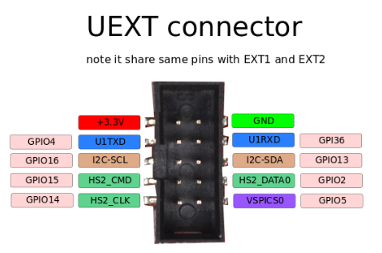

MOD-ESP32-C5 UEXT connector wiring:

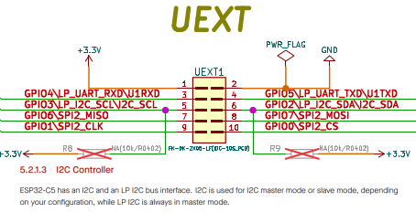

LEDs:

MOD-ESP32-C5 has two status LEDs
LED1 is Green and connected to GPIO27
LED2 is Red and connected to GPIO26
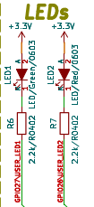

MOD-ESP32-C5 schematics:

MOD-ESP32-C5 latest schematic is on GitHub

SOFTWARE:

ESP32-C5-DevKit-Lipo can be programmed with Espressif IDF 5.5 and Arduino.

Revision History
Revision 1.0 November 2025

