NB-IoT-DevKit

1. How to install Platformio platform:
1.1 Go to Platforms. Then click on "Advanced Installation" button
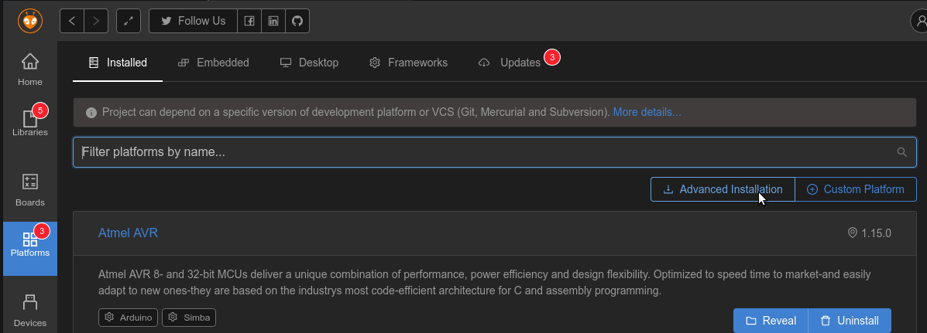
1.2 Copy and paste the following link in the text box:
https://github.com/StefanMavrodiev/platform-quectel.git#olimex
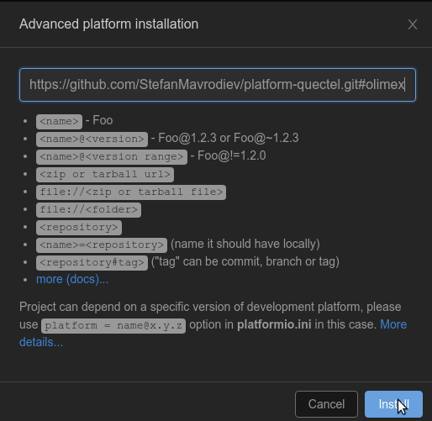

2. How to import project.

2.1 Click "Open Project" button
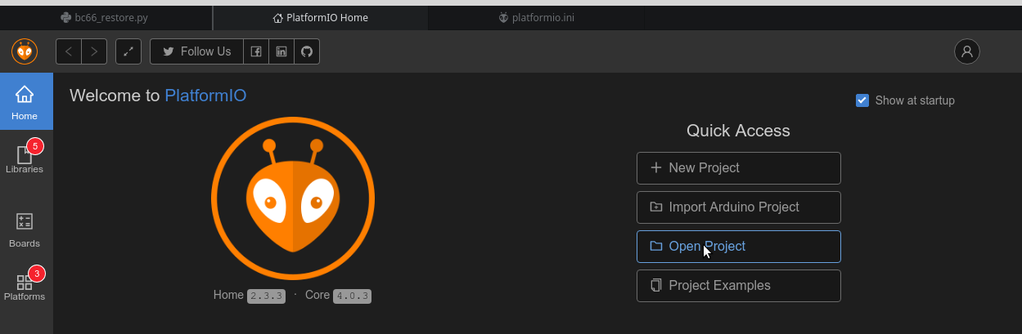
2.2 Browse the path to the example project you want to try:
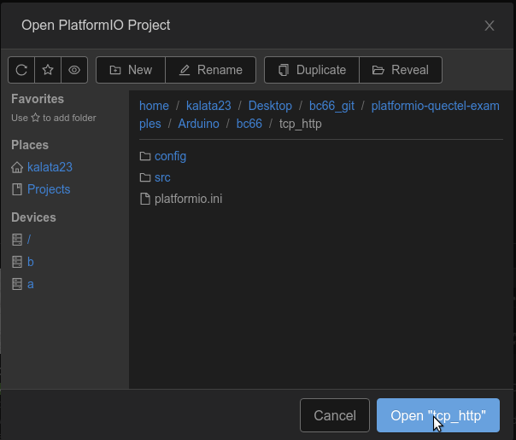

2.3 Click Open

2.4 Open platformio.ini from the left pane
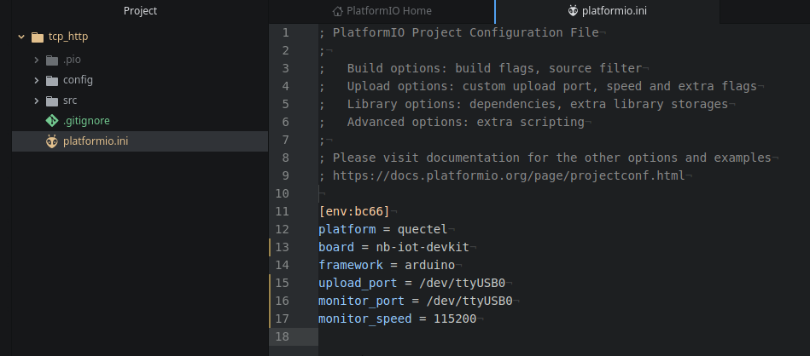

2.5 Change monitor_port and upload_port values with the Serial port of your
device

2.6 Build the project and upload

NOTE: Before uploading any application, back-up your NVDM.
Firmware, schemes, IoT Flashtool (Windows)

