

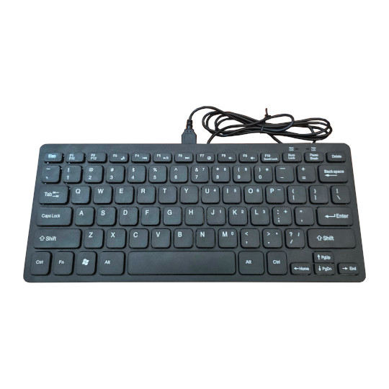

Neo6502kbd
User Manual
Rev.1.0 August 2026 olimex.com
Table of Contents
Introduction to Neo6502 3
Order codes for Neo6502kbd and accessories: 5
HARDWARE 6
Neo6502kbd layout: 7
Neo6502kbd schematics: 8
UEXT connector: 9
SOFTWARE: 11
Programming RP2040 12
Revision History 13

Introduction to Neo6502

The design goal with Neo6502 was to make simple modern retro computer with 6502 processor.
By modern we mean computer with modern video interface like HDMI, USB keyboard and USB Flash drive as storage. HDMI as everyone have TV with HDMI at home and USB keyboards now are mainstream device for input.
With the task to provide HDMI and USB interface we choose RP2040 which already have DVI bit bang project and USB host.
RP2040 also have enough RAM so we decided to use RP2040 to emulate also the RAM memory for 6502.
For the 6502 processor we choose W65C02 from WDC as they are still in mass production and can be purchased freely.
The Neo name was taken for two reasons, first it imply the modern design, then we liked the analogy with the movie The Matrix as W65C02 lives in virtual world and thinks it have real memory, video and keyboard but actually all this is virtual and emulated by RP2040.
Neo6502 is Open Source Hardware, all CAD files and firmware and available, so people can study and modify.
Neo6502kbd is new derivate of Neo6502 it includes other peripherials which were not available on the original Neo6502 – embedded keyboard and USB hub.
All software and code for Neo6502 will run same way on Neo6502kbd.
The features of Neo6502kbd are:
- real W65C02 processor executing every instruction as it was executed in early retro computers, no emulation for the processor, all timing is exact
- RP2040 with 2MB of SPI Flash, east to load new firmware via drag and drop virtual drive
- HDMI output
- USB host which can be used for programming and to connection to keyboard, mouse, USB Flash etc
- Audio buzzer which you can enable/disable
- USB-C connector for power supply and programming
- UEXT connector with I2C, UART and SPI for connecting to external boards
- On Off slide switch
- RP2040 programming bootloader button
- Dimension 285 x 123 x30mm

Order codes for Neo6502kbd and accessories:

Neo6502kbd All in one modern retro computer with 6502 processor
CABLE-USB-A-C-1M USB-C cable for power supply
CABLE-HDMI-50CM HDMI cable
UEXT modules many UEXT modules which can connect to Neo6502 UEXT connector

HARDWARE

Neo6502kbd layout:

Back view:

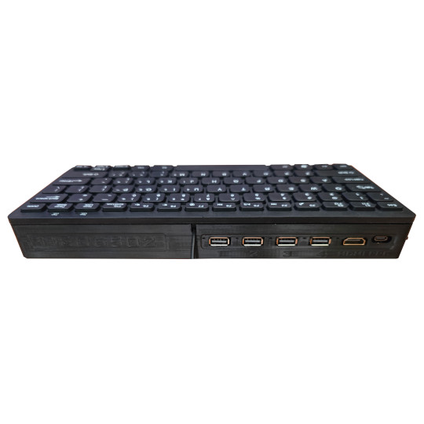
Power USB-C
DVI/HDMI
Four USB-C hosts

Neo6502kbd schematics:

Neo6502kbd latest schematic is on GitHub

UEXT connector:

UEXT connector stands for Universal EXTension connector and contain +3.3V, GND, I2C, SPI, UART signals.
UEXT connector can be in different shapes.
The original UEXT connector is 0.1” 2.54mm step boxed plastic connector. All signals are with 3.3V levels.
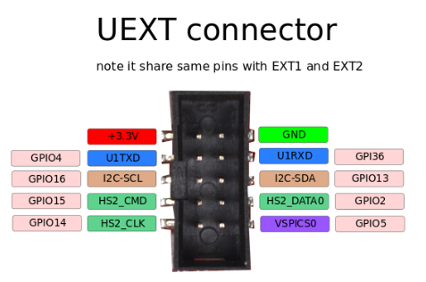

Olimex has developed number of MODULES with this connector. There are temperature, humidity, pressure, magnetic field, light sensors. Modules with LCDs, LED matrix, Relays, Bluetooth, Zigbee, WiFi, GSM, GPS, RFID, RTC, EKG, sensors and etc.

Neo6502kbd UEXT connector is wired to RP2040 GPIOs as follows:
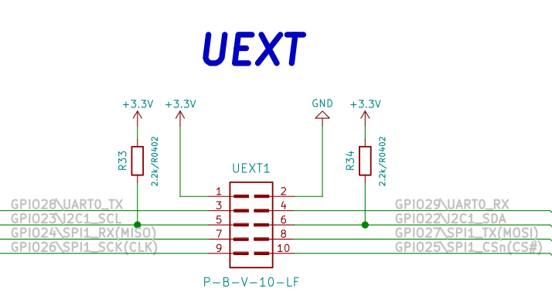

SOFTWARE:

Neo6502 is open flexible system as everything is virtual and depend on RP2040 firmware, this allow you to emulate old architectures like Apple ][ and Oric Atmos, or to make your own completely new architecture.
Veselin Sladkov (veselin.sladkov@gmail.com) did amazing work for Neo6502 and created Apple ][, Oric Atmos and Apple Iic emulation with Reload emulator.
The reload emulator require some ROMs and disks which are hosted on olimex’s ftp.

Rien Matthijsse (rien@marobi.com) made several versions of RP2040 memulator and EHBasic port working on Neo6502 in his GitHub repository.
Paul Robson (paul@robsons.org.uk ) made special version of Neo6502 Basic on GitHub and web browser emulator.

Programming RP2040

The RP2040 firmware is UF2 file. You can get pre-build firmware of reload emulator on olimex’s ftp.

We recommend you for Apple ][ to use: https://ftp.olimex.com/Neo6502/uf2/apple2_800x600_400MHz.uf2
This firmware have latest PRODOS and several games on it ready to play.

For Oric Atmos we recommend you to use:
https://ftp.olimex.com/Neo6502/uf2/oric_960x540_372MHz.uf2

To play Total Replay you need this uf2 file:
https://ftp.olimex.com/Neo6502/apple2e-5.uf2
And you need USB Flash drive with Total Replay 5.1
https://ftp.olimex.com/Neo6502/Total%20Replay%20v5.1.hdv

To program the .uf2 files you need USB A to C cable.
Plug the cable to the left side USB-C connector (PGM)
Press the bootloader button and switch the power on. Your computer will show new drive. Once this new drive show copy the .uf2 file to it. Once the firmware is programmed the drive will dissapear. This means the RP2040 now have the new firmware loaded.
You need to disconnect the cable and to attach it to the back side USB-C power supply connector.

Revision History
Revision 1.0 August 2026

