

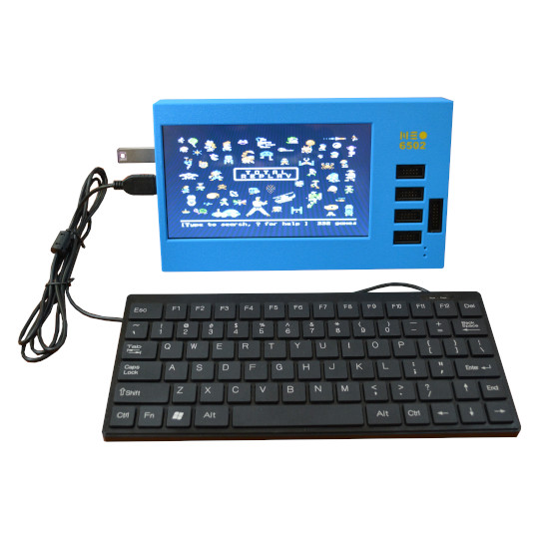

Neo6502pc
User Manual
Document revision 2.1, April 2025 | www.olimex.com

Table of Contents
1. Introduction to Neo6502pc 3
Order codes for Neo6502pc and accessories: 5
HARDWARE 6
Neo6502pc layout: 6
Neo6502pc 6502 bus connector: 11
Neo6502pc schematics: 12
UEXT connector: 13
Slide Configuration Switch 15
12 GPIO EXT1 connector: 16
SOFTWARE: 17
Default software 18
Programming RP2040 19
Using Apple][e simulator with Total Replay 5.1: 22
Document Revision History 23

1. Introduction to Neo6502pc

Neo6502pc open source software and hardware stand alone computer based on W65C02 processor and RP2040 co-processor with the following features:
- Real W65C02 processor clocked at 6.25Mhz
- Graphics co-processor RP2040 which generates HDMI video
- 320 x 240 256 colour display on HDMI/DVI with a palette
- 32k Graphics RAM for tiles and sprites
- 128 sprites up to 32x32 pixels.
- Multiple tile maps (16x16 tiles, can be double sized)
- High speed drawing features
- Turtle Graphics
- Blitter for high speed graphics
- UEXT interface to access a wide range of hardware add ons.
- 1 channel "beeper" sound with SFX library (to be replaced by AY-3-8910 Emulation)
- Storage USB Key (optionally can use SD Card)
- Standard USB keyboard can be connected to Neo6502pc
- Fast structured BASIC with hardware support and inline assembler.
- BASIC can be edited on screen, or using a text editor.
- High Speed Integer/Floating point arithmetic
- Documentation, samples, explainers and games, all open source.
- Cross development support
- Accurate cross platform emulator for Windows/Mac/Linux, only requires SDL2
- Serial link to PC for Cross-Development
- Program in PASCAL using Mad Pascal compiler
- Program in 'C' using CC65 and LLVM
- USB Mouse and Gamepad support
- BASIC support for Serial, I2C and SPI hardware via UEXT Connector- 64KB linear RAM space for code
- LCD display
- Internal battery backup power supply which allow it to operate up to 3 hours without external power supply
- Three external and one internal USB hosts (internal is connected to LCD touch panel)
- Audio output
- Four UEXT connectors for different peripherals
- 12 GPIO extension connector
- USB-C for power and internal battery charger
- Second USB-C for RP2040 firmware programming
- Dimensions (220 x 130 x 35)mm

Neo6502 is a simple but “modern” retro computer with 6502 processor.
By “modern” we mean – a retro computer with contemporary video output interface (like HDMI), popular input (USB keyboard), and popular storage medium (USB flash drive as storage). HDMI because everyone has a monitor with HDMI at home and USB keyboards are the mainstream inout devices.
With the task to provide HDMI and USB interface we choose RP2040 which already has DVI bit bang project and USB host.
RP2040 also has enough RAM so we decided to use RP2040 to emulate also the RAM memory for 6502.
For the 6502 processor we choose W65C02 from WDC as they are still in mass production and can be purchased freely.
The Neo name was taken for two reasons, first it imply the modern design, then we liked the analogy with the movie The Matrix as W65C02 lives in virtual world and thinks it have real memory, video and keyboard but actually all this is virtual and emulated by RP2040.
Neo6502 is Open Source Hardware, all CAD files and firmware and available, so people can study and modify.

Latest Neo6502 (not Neo6502pc) manual is available here. Everything for Neo6502 apply for Neo6502pc which is all in one Neo6502 computer with display and build in USB hub.

Order codes for Neo6502pc and accessories:

Neo6502pc All in one complete stand alone computer operating from external supply or internal LiPo rechargeable battery
CABLE-USB-A-C-1M USB-C cable for power supply
USB-FLASH-8GB USB Flash drive for Neo6502pc
USB-KEYBOARD-PS2 USB keyboard with small dimensions suitable for Neo6502pc
USB-GAMEPAD Wired USB gamepad compatible with NeoBASIC
USB-WIRELESS-GAMEPAD Wireless USB gamepad compatible with NeoBASIC
UEXT modules Many UEXT modules which can connect to Neo6502 UEXT connector

HARDWARE

Neo6502pc layout:

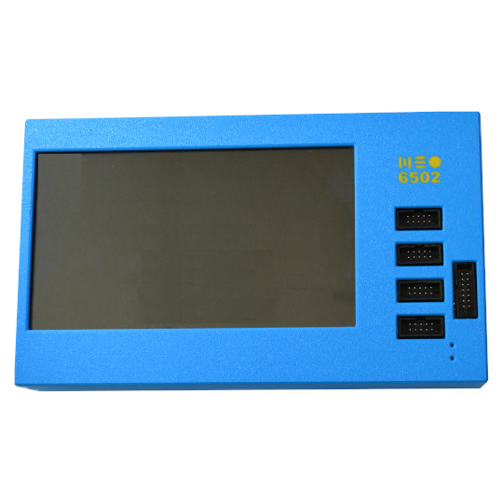
4x UEXT connectors
LCD display

EXT 12 GPIO

Battery charge LED
External power supply LED

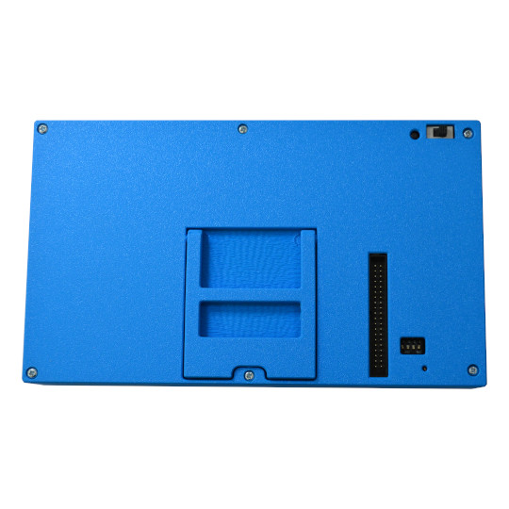
Foldable stand for the box
RP2040 Boot button
RP2040 programming switch
Slide configuration switch
Buzzer
6502 bus
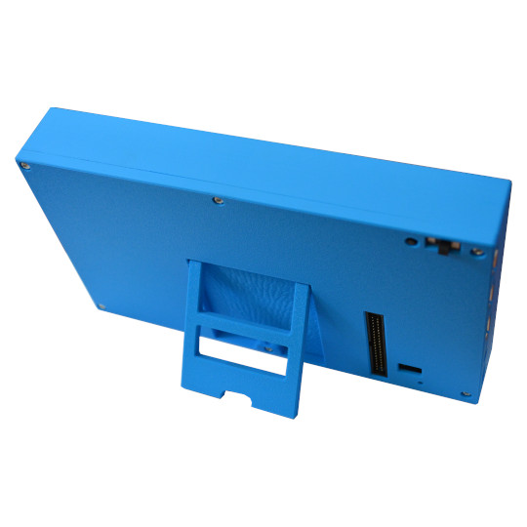
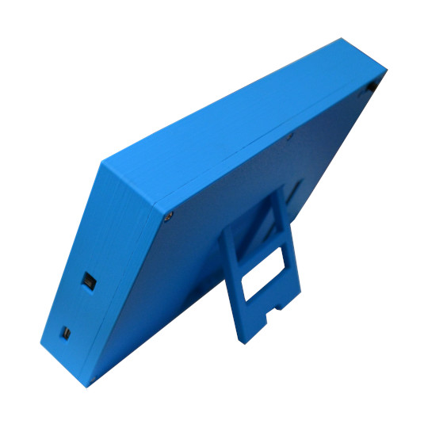
ON-OFF switch
USB-C for external power supply

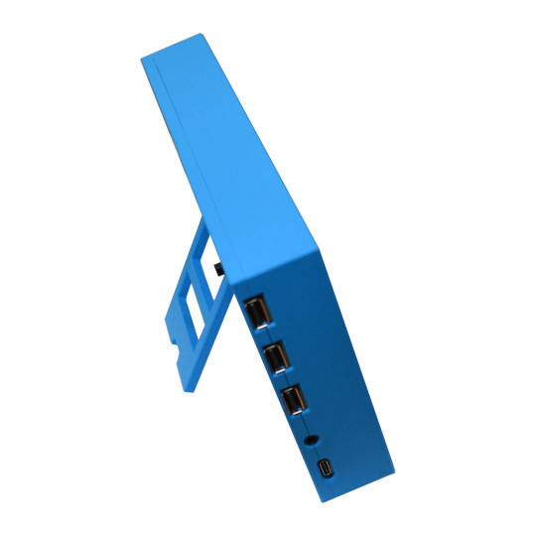
3 x USB hosts
Audio 3.5mm jack
RP2040 programming USB-C connector
Neo6502pc can be ordered in 5 colors: Red, Blue, Green, Yellow, Black.
Please specify the color when ordering in your order NOTES field or you will get random color.
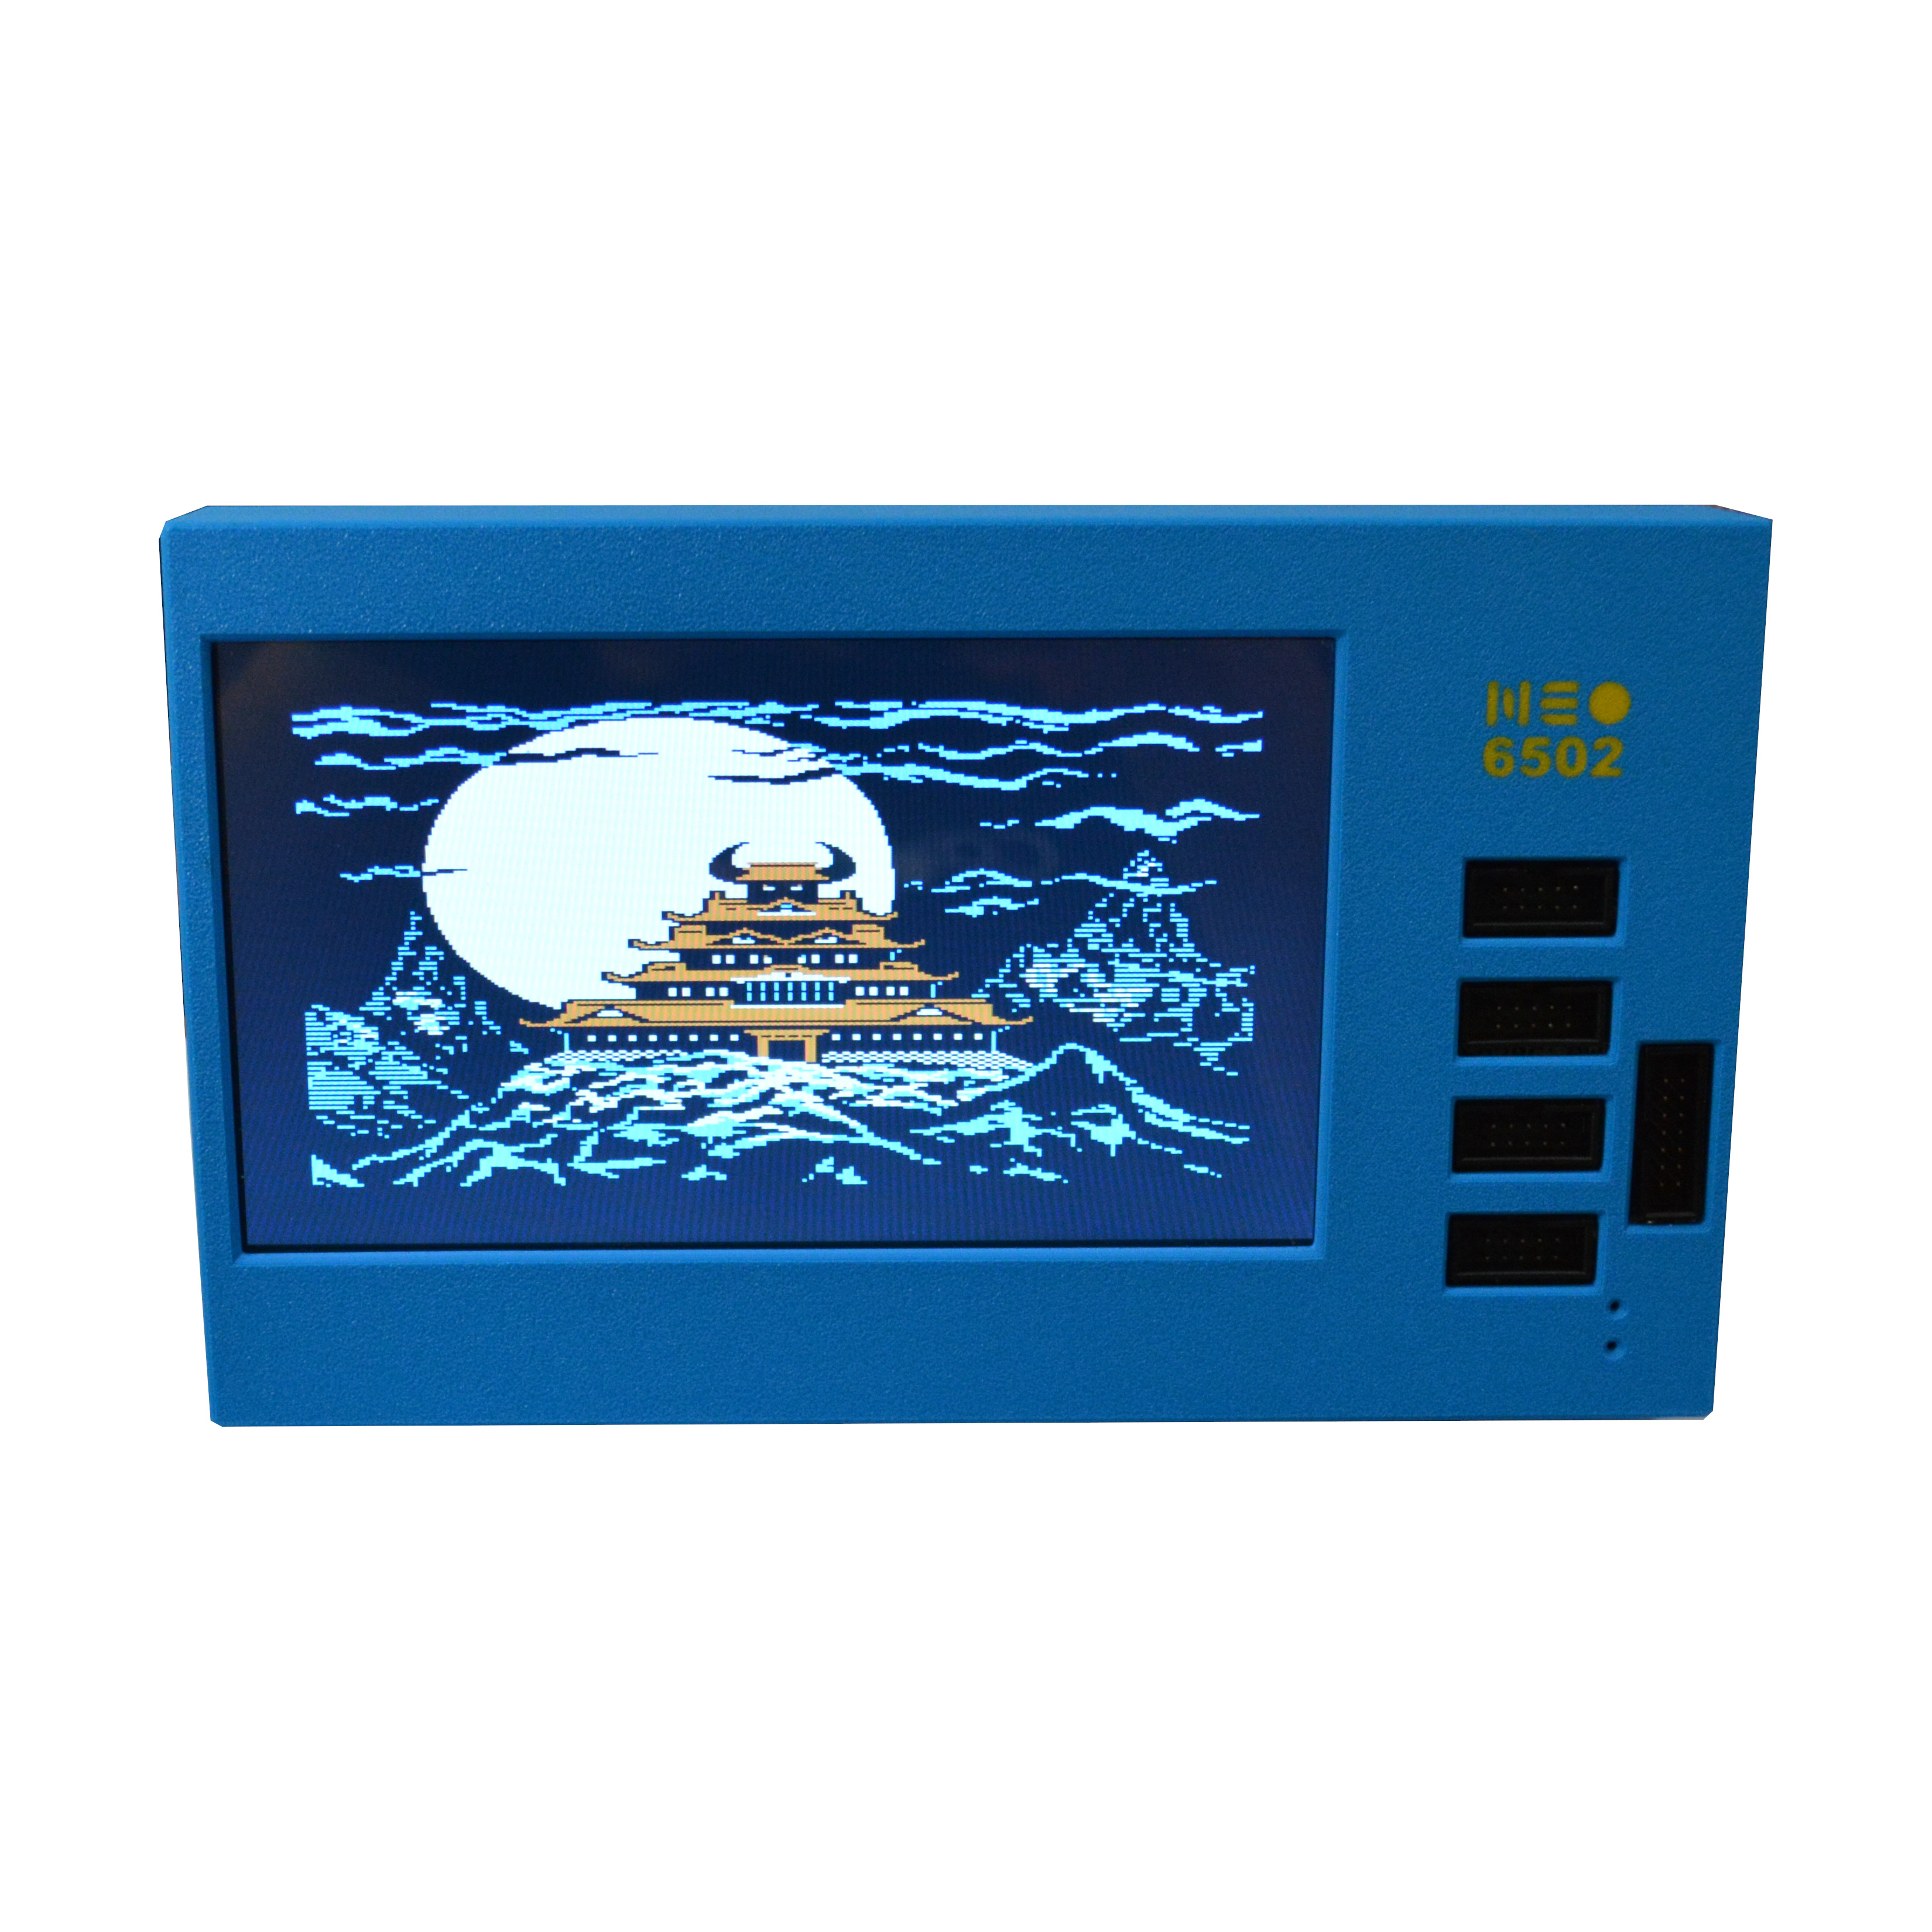
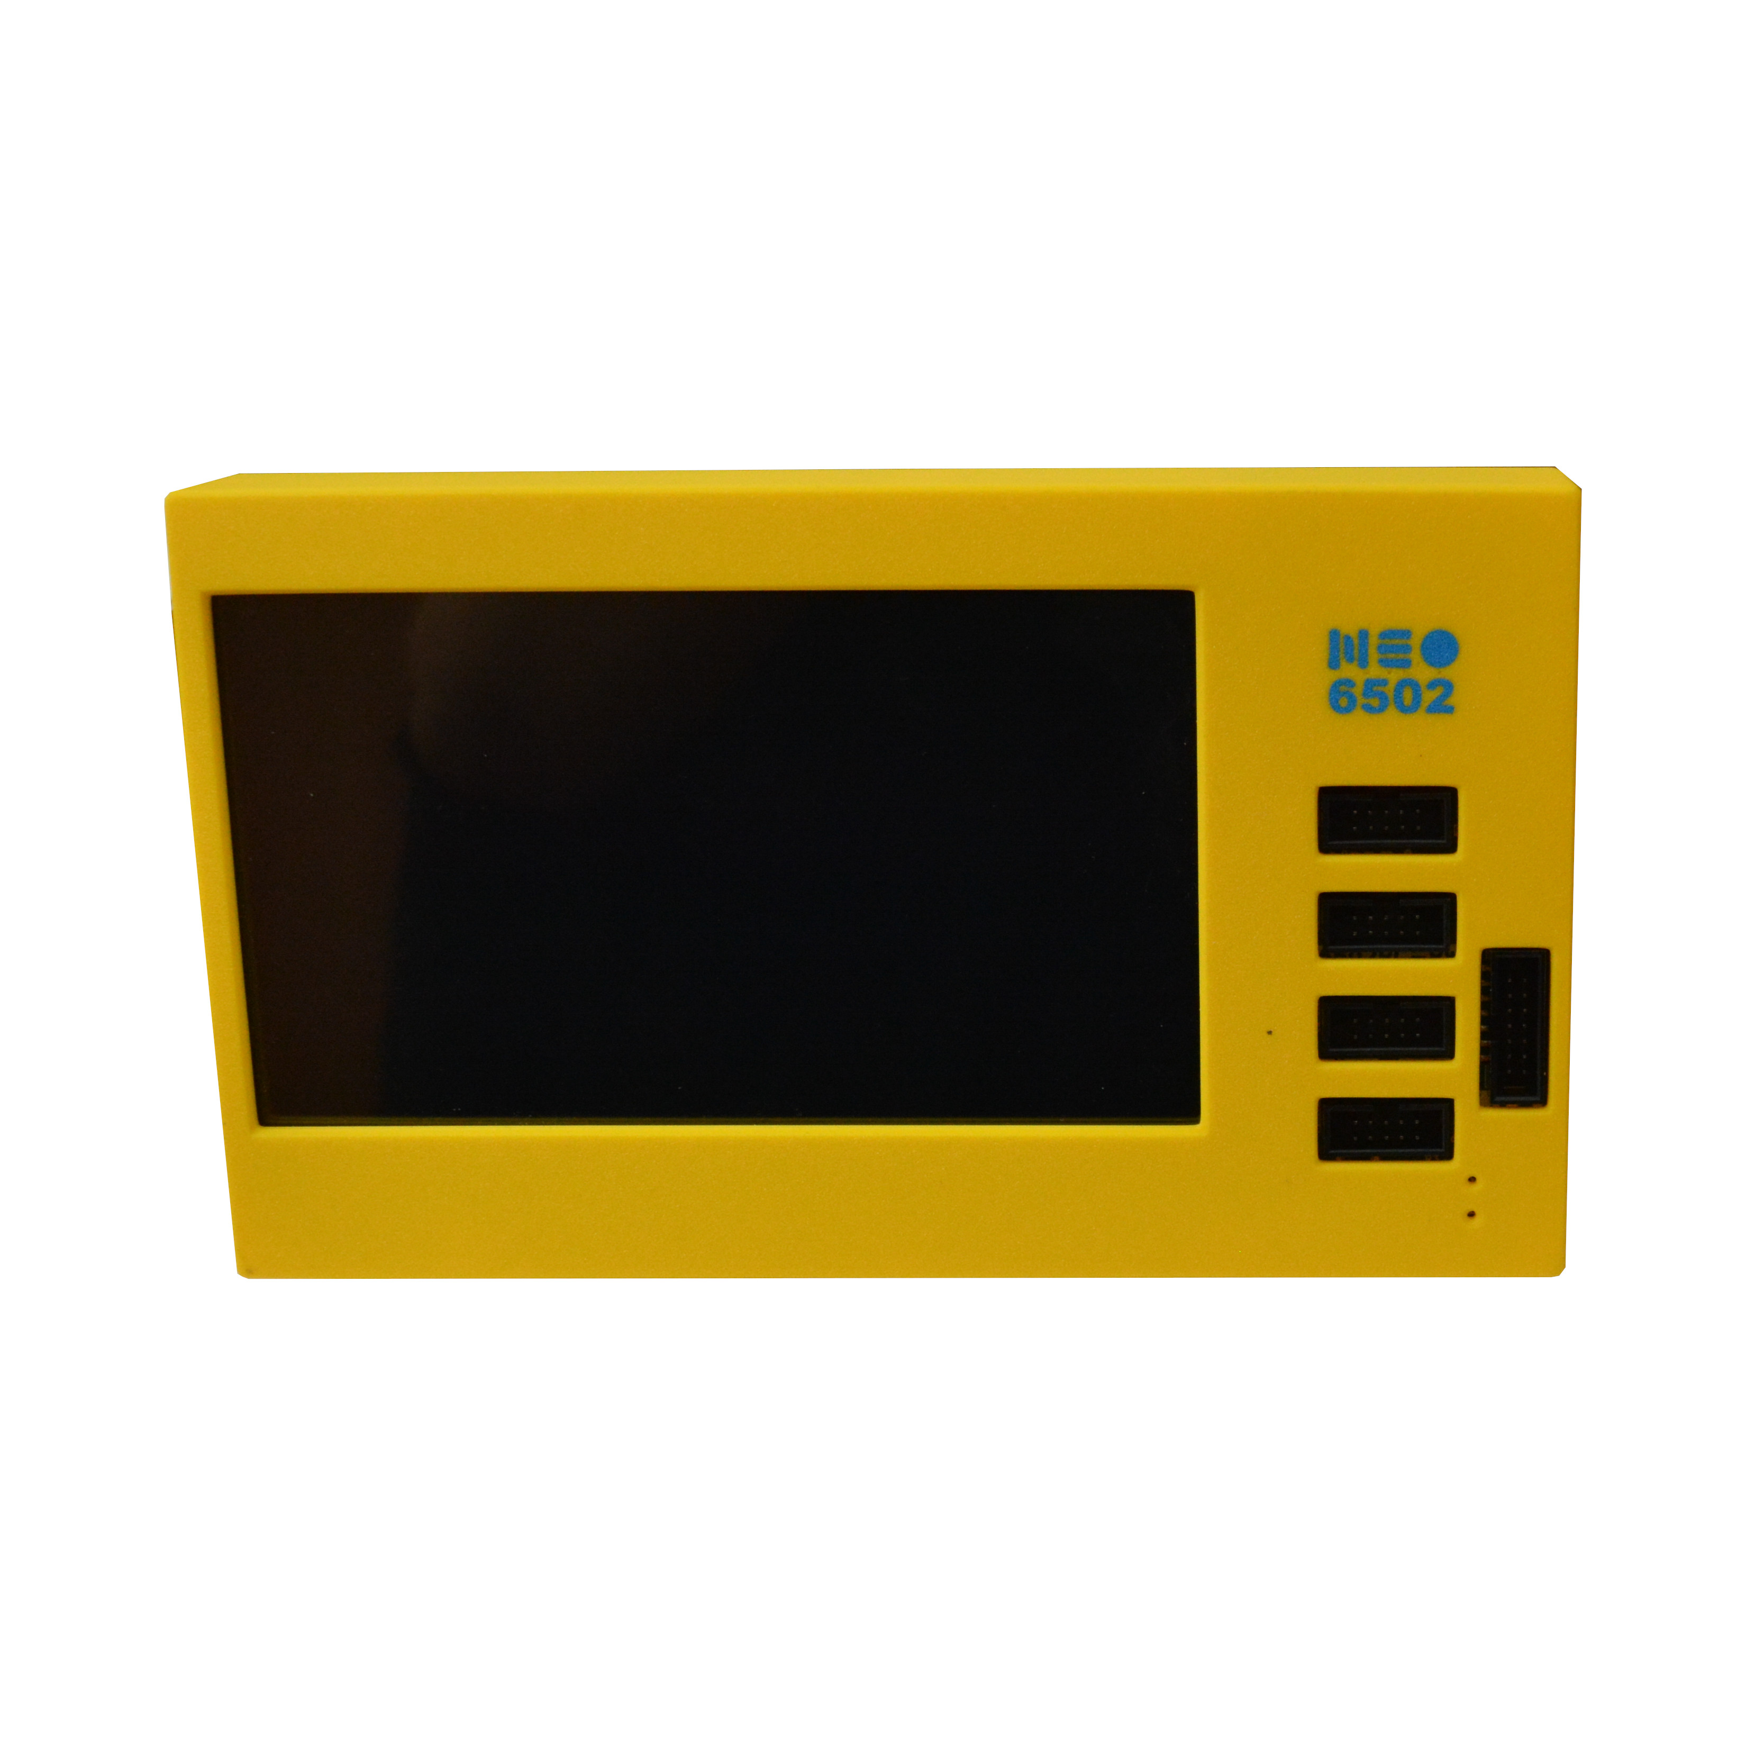
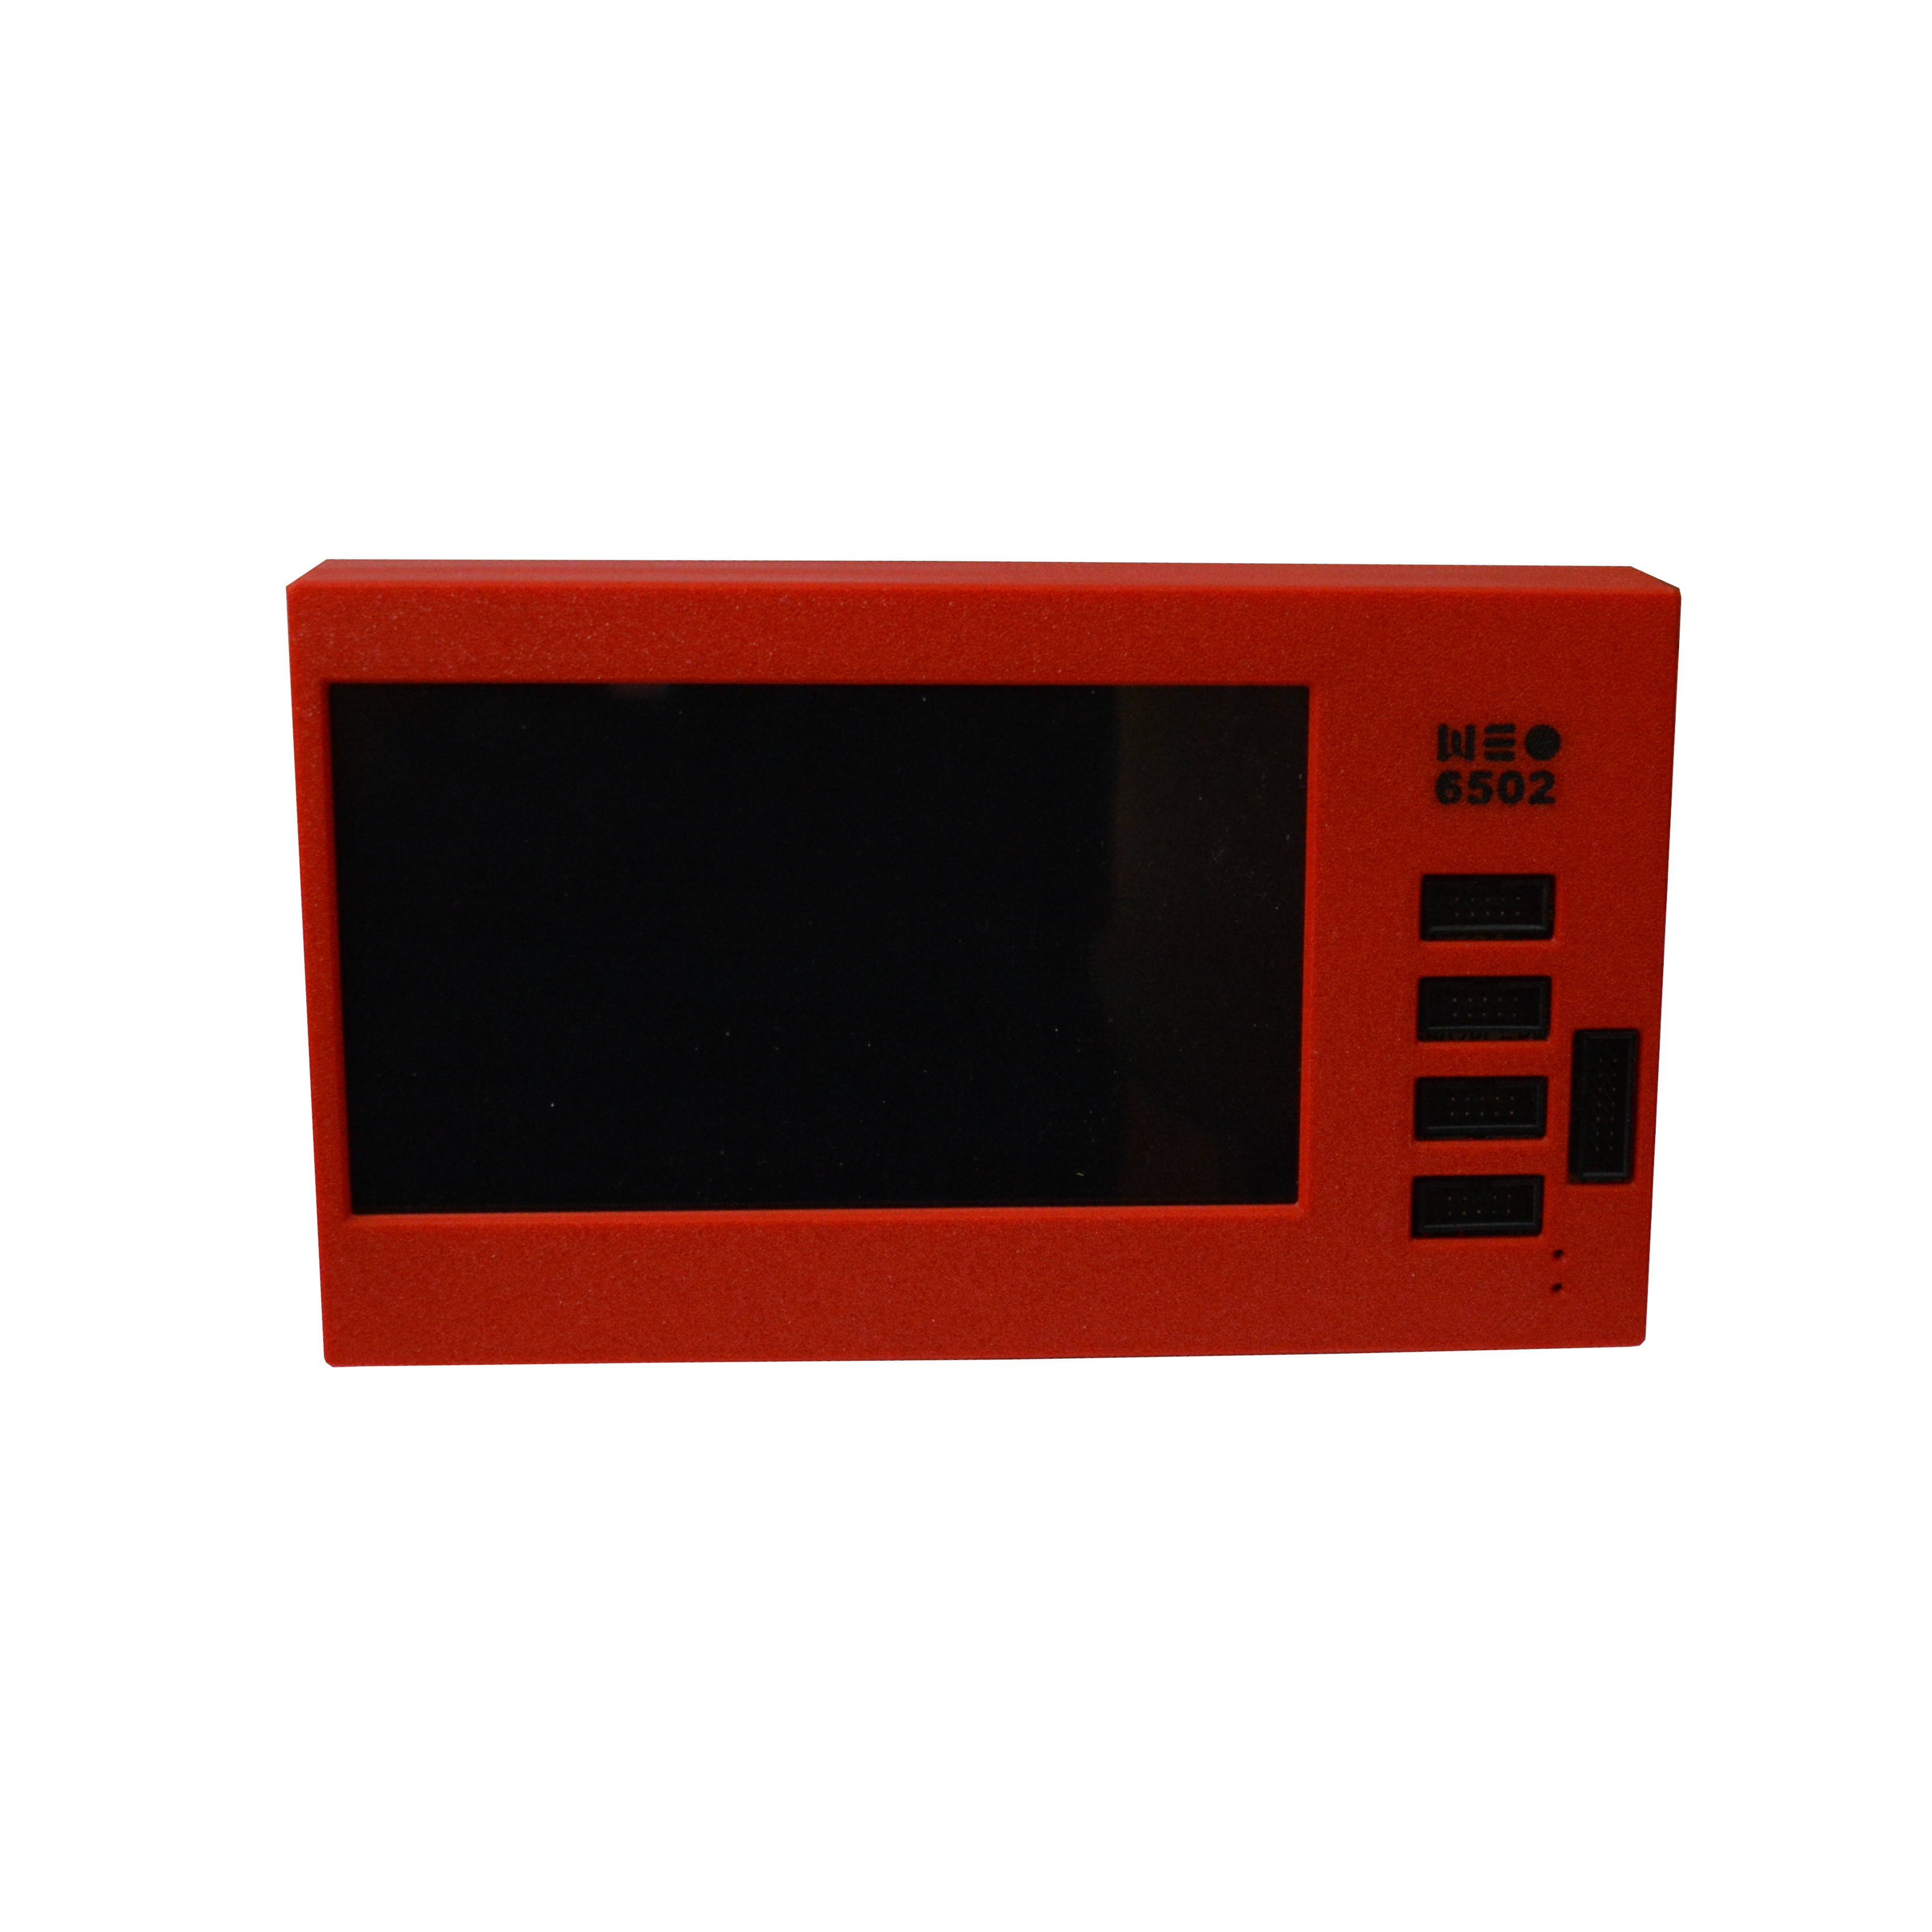
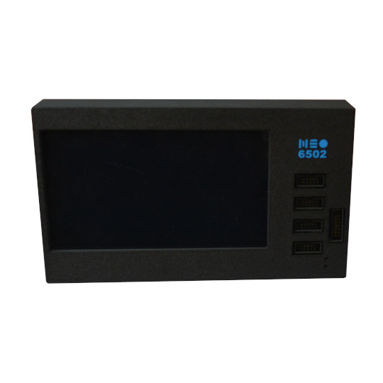
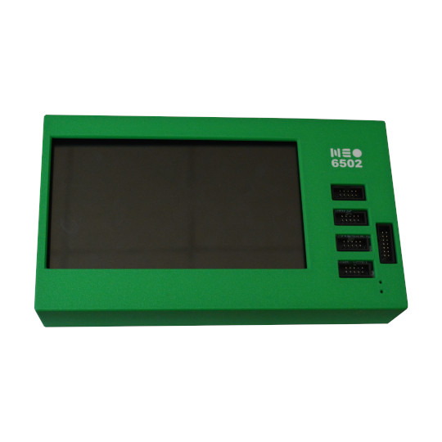

Neo6502pc 6502 bus connector:

All 6502 signals are available on BUS1 connector for attaching external hardware on it.
+5V, 3.3V, GND
D0-D7, A0-A15, PHI2, R/W, RESB, SOB, MLB, VPB, SYNC, NMIB, IRQB
Two signals of RP2040 SWDIO SWCLK are also present for RP2040 debugging, these should be N.C. on the external 6502 peripheral boards.
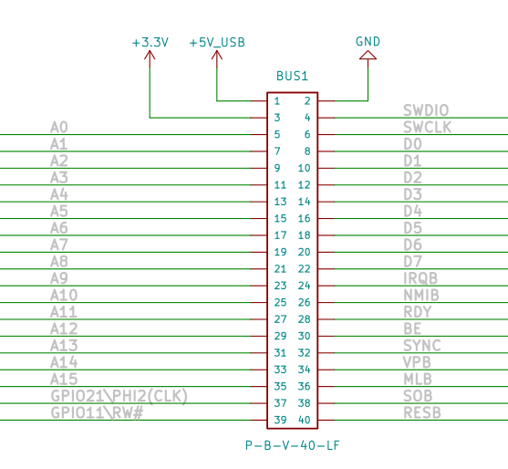

Neo6502pc schematics:

Neo6502pc latest schematic is on GitHub

UEXT connector:

UEXT connector stands for Universal EXTension connector and contain +3.3V, GND, I2C, SPI, UART signals.
UEXT connector can be in different shapes.
The original UEXT connector is 0.1” 2.54mm step boxed plastic connector. All signals are with 3.3V levels.
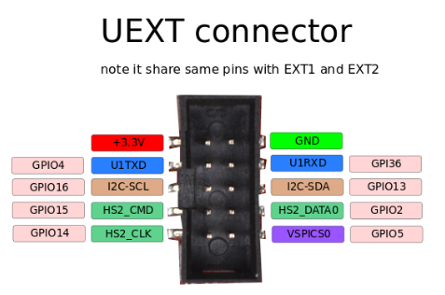

Olimex has developed number of MODULES with this connector. There are temperature, humidity, pressure, magnetic field, light sensors. Modules with LCDs, LED matrix, Relays, Bluetooth, Zigbee, WiFi, GSM, GPS, RFID, RTC, EKG, sensors and etc.

Notice that some software effort might be required to get the UEXT modules working, most of the modules have no ready-to-use software support for working with Neo6502pc.

Neo6502pc UEXT connector is wired to RP2040 GPIOs as follows:
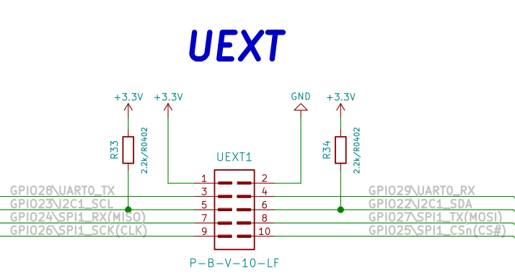

Slide Configuration Switch
The slide configuration switch can enable/disable the buzzer, also can connect or disconnect RESB, NMIB and IRQB to RP2040 UEXT signals.
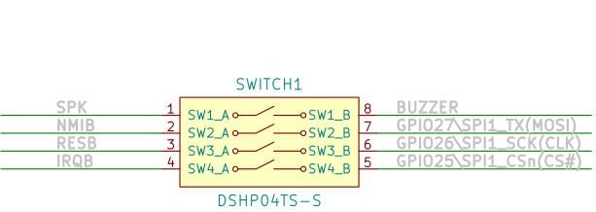

By default Neo6502 is shipped with all sections connected on the switch i.e. buzzer is enabled and all signals are wired to RP2040. This means you can’t use SPI on UEXT connector if you do not disconnect these signals.

12 GPIO EXT1 connector:

Neo6502pc have CH32V003 expander IC which is connected to RP2040 via I2C and can monitor battery charge, if the external power supply is present or to access 12 GPIOs to EXT1 connector:
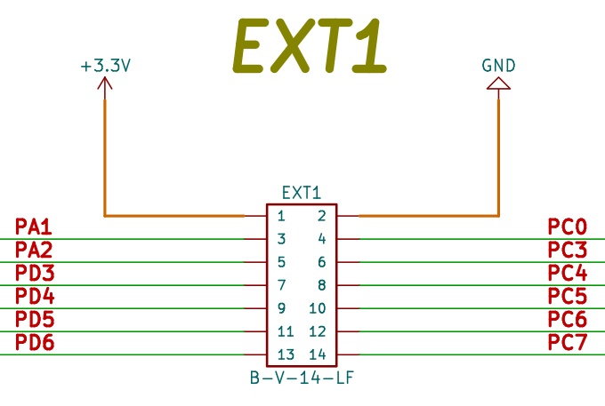

SOFTWARE:

Neo6502 is open flexible system as everything is virtual and depend on RP2040 firmware, this allow you to emulate old architectures like Apple ][ and Oric Atmos, or to make your own completely new architecture.

Veselin Sladkov (veselin.sladkov@gmail.com) did amazing work for Neo6502 and created Apple ][, Oric Atmos and Apple Iic emulation with Reload emulator.
The reload emulator require some ROMs and disks which are hosted on olimex’s ftp.

Paul Robson (paul@robsons.org.uk ) made special version of Neo6502 Basic on GitHub and web browser emulator.

Default software

We ship the 6502pc boards with Neo Basic. Refer to this document for more info about the basic:

https://neo6502.com/pdf/document.pdf

You can change the firmware to any emulator you wish. Refer to the next chapter for details.

Programming RP2040

The RP2040 firmware is UF2 file. You can get pre-build firmware of reload emulator on olimex’s ftp here:

https://ftp.olimex.com/Neo6502/

1. For NeoBASIC you can to go to Paul Robson GitHub and download latest release files then to write to RP2040. This is the firmware we ship Neo6502pc with by default.

2. The RP2040 firmware for the Apple][e emulator is here. If you decide to use Apple remember that you need a flash drive with the TotalReplayx.hdv here.

3. If you want to develop on Apple][e and write your own code you can program the firmware and the flash drive with blank ProDos disk from here. And Neo6502pc will boot as Apple][ and you can load and save your code on the Prodos disk (Flash drive).

4. For Oric Atmos we recommend you to use:
https://ftp.olimex.com/Neo6502/old-uf2/oric.uf2

To program the .uf2 files you need two USB A to C cable.
Connect the first cable to USB and to the USB-C programming connector.
Connect the second cable to USB or 5V charger and connect to USB-C power supply connector.
Move the PROGRAMMING slide switch on the back to outside direction (Program), press the BOOT button.
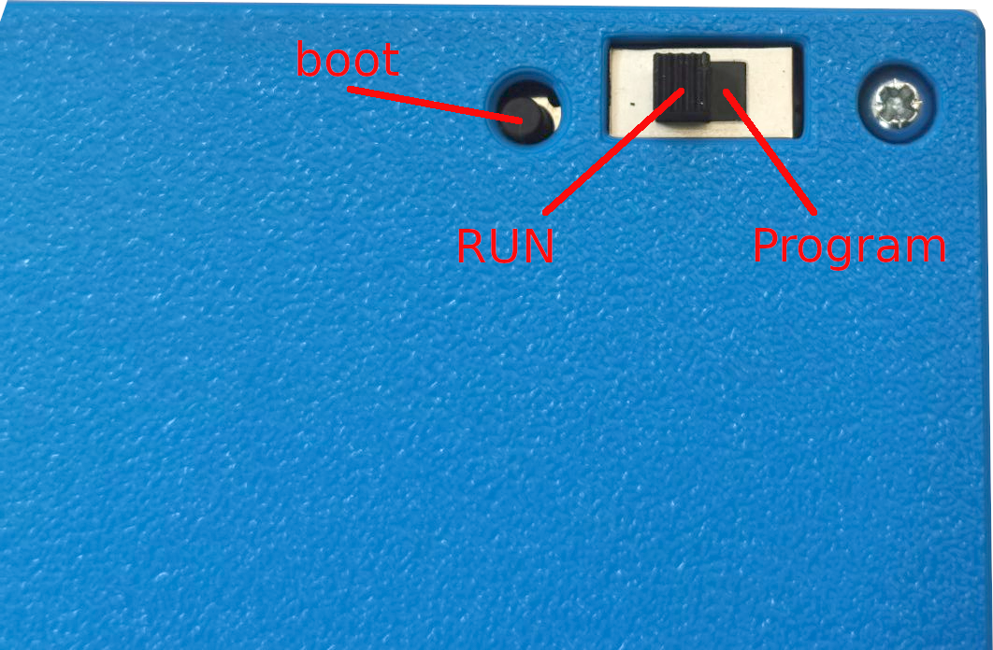
Switch the power ON and depress the boot button, you will see on your computer RP2 disk drive, drag and drop or copy the .uf2 file to this drive.
After the programming this drive will disappear, MOVE the PROGRAMMING switch to inner direction (RUN).

Some emulators require all sections of the slide Configuration Switch to be in ON positon:
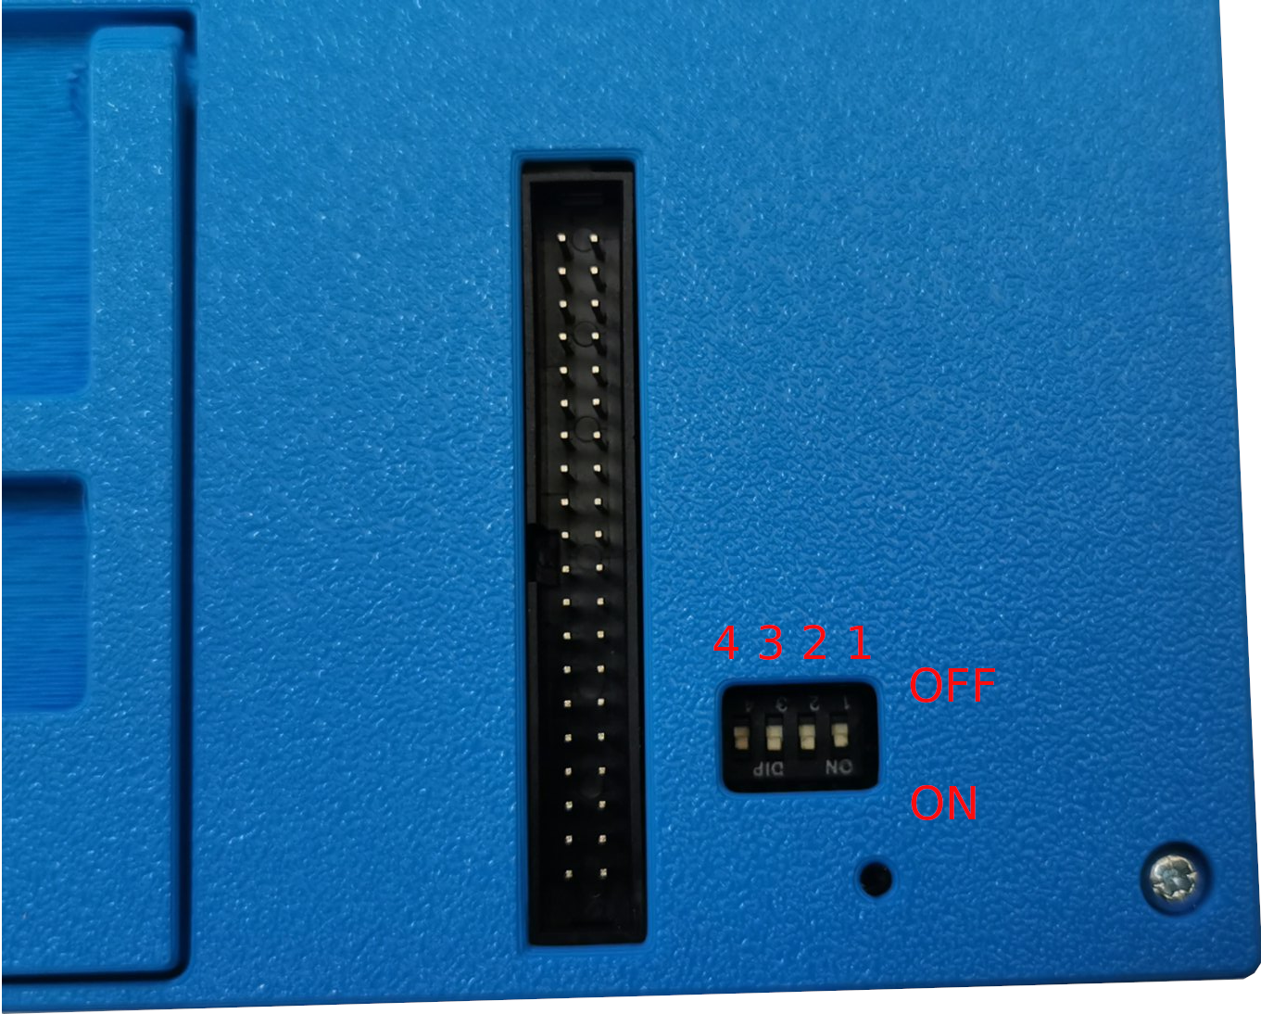

Using Apple][e simulator with Total Replay 5.1:

Get the default uf file from here:

https://ftp.olimex.com/Neo6502/apple2e-5.uf2

Neo6502pc with Apple][e emulator programmed in it, so all you need is USB keyboard and USB Flash drive to make it run 400+ old Apple games.
You can download the Total replay file from here. Place in on flash drive.

Read more about the project here:

https://github.com/vsladkov/reload-emulator

Document Revision History
Revision 2.1 April 2024
- Minor spelling improvements

Revision 2.0 December 2024
- Added info about the change of default firmware
- Minor spelling improvements

Revision 1.0 June 2024
- Initial release

