

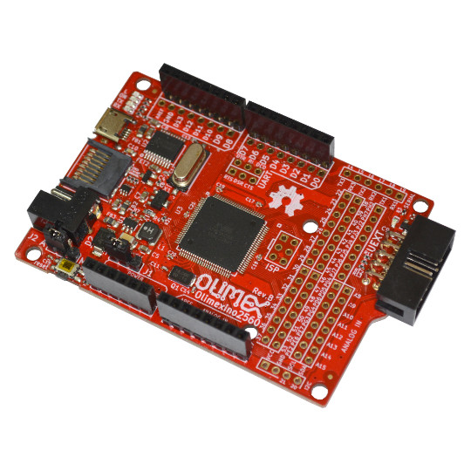

OLIMEXINO-2560
Users manual

Rev.2 May 2021
olimex.com
Table of Contents
OLIMEXINO-2560 features 3
OLIMEXINO-2560 component locations 4
GPIO Digital1 5
GPIO Digital2 5
GPIO Serial 5
GPIO I2C 5
GPIO Digital3 5
GPIO Digital4 6
GPIO Digital5 6
GPIO Digital6 6
GPIO Digital7 6
GPIO Digital8 6
GPIO Analog 1 7
GPIO Analog 2 7
UEXT 7
UART (CH340T USB-to-Serial signals) 7
ISP AVR programming connector 7
LEDs 8
Jumpers 9
J1 9
J2 9
Using Digital GPIOs 10
Using Analog GPIOs 10
Power supply requirements 11
Revision History 12

OLIMEXINO-2560 features
OLIMEXINO-2560 is Arduino Mega 2560 like board with ATMega2560 processor and these features:
- ATMega2560 AVR processor
- 256 KB Flash, 8KB SRAM, 4KB EEPROM
- 64 digital GPIOs, 15 analog GPIOs, 4 UARTs
- micro USB connector
- USB-serial converter with CH340T for Arduino IDE programming via USB
- 4 status LEDs – Power (green), Status (yellow), Tx (green), Rx (red)
- micro SD card for file storage
- Works on either 5V and 3.3V (jumper selectable)
- Programmable with Arduino IDE (www.arduino.cc)
- Power supply is 6-15VDC for 5V operation
- Power supply is 5-15VDC for 3.3V operation
- Can be powered by USB connector power
- UEXT connector with power supply enable/disable
- Reset Button

OLIMEXINO-2560 component locations
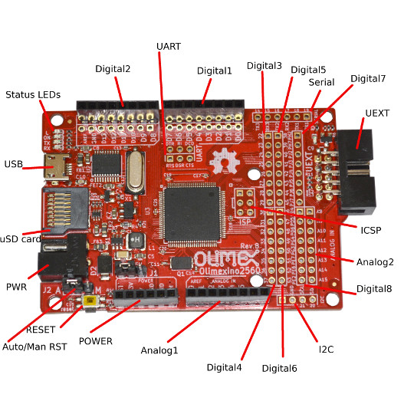

GPIO Digital1

GPIO Digital2

GPIO Serial

GPIO I2C

GPIO Digital3

GPIO Digital4

GPIO Digital5

GPIO Digital6

GPIO Digital7

GPIO Digital8

GPIO Analog 1

GPIO Analog 2

UEXT

UART (CH340T USB-to-Serial signals)

ISP AVR programming connector

LEDs

Jumpers

J1
J1 allows selecting the operating voltage of OLIMEXINO-2560. It can be set for either 5V operation (1-2 pin) or 3.3V operation (2-3pin).
Note! Most Olimex UEXT expansion boards work at 3.3V, so if you use UEXT expansion board ensure that the jumper is set to 3.3V or the UEXT board will be damaged.
Important! According to ATmega2560’s documentation in order for the chip to operate withing specification at 16MHz it needs 5V power supply. Our tests show that it works fine at 16Mhz at 3.3V, but if you wish to follow the specifications – use 5V mode of operation.

J2
J2 jumper selects if Arduino can Reset and program board automatically if pin 1-2 are shorted

Using Digital GPIOs
You can set any of the Digital GPIOs as input or output using their names:
pinMode(D33,INPUT); //D0-D53, PH2..PE2
value = digitalRead(D33);
pinMode(D13,OUTPUT);
digitalWrite(D13,HIGH);

Using Analog GPIOs
value = analogRead(A7); //A0..A15
analogWrite(D44,128); //PWM GPIOs D2..D13, D44..D46, value 0..255

Power supply requirements
OLIMEXINO-2560 can be powered by USB port or External Power supply, Jack inner pin 2 mm and external diameter 5.5mm. Switching between power supplies is automatically, i.e. if external power supply is applied USB power supply is not used.

Revision History
1.00 June 2019 – Initial release
2.00 May 2022 – Added info about clock and voltage operation of the main chip.

