

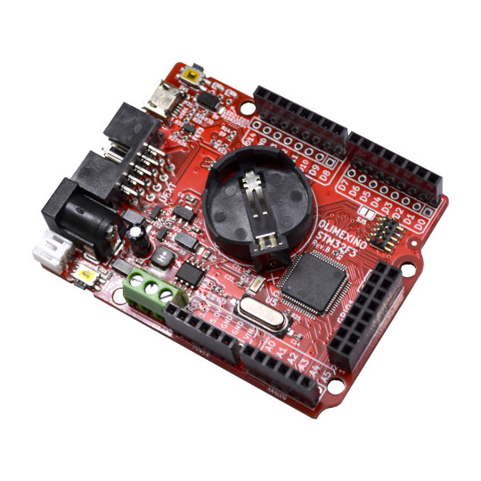

OLIMEXINO-STM32F3
User Manual
Rev.1.0 July 2020
olimex.com

Table of Contents
What is OLIMEXINO-STMF3 3
OLIMEXINO-STM32F3 schematic 4
Arduino IDE installation: 5
Software examples: 6
Revision History 7

What is OLIMEXINO-STMF3

OLIMEXINO-STM32F3 is Industrial grade -40+85C operating temperature, Open Source Hardware board based on STM32F303RCT6. It has 256 KB of Flash and 48 KB of RAM. The board can work on LiPo battery without external supply, switching between USB-external-lipo power supply is automatically. If USB is connected the board is powered by the USB, if External pwower is applied it has priority over USB and battery and board will be powered by the external power supply, if both external power supply and USB power supply are missing but battery is connected the board automatically will start being powered by the LiPo battery as computer UPS.
In STM32F3 series CAN and USB can work at the same time.
Board features are:
- STM32F303RCT6 256KB Flash, 40KB RAM
- Industrial grade -40+85C
- Power supply 9-30VDC good for both industrial and automotive applications
- LiPo battery charger and connector
- micro SD card
- RTC 32.768kHz with CR2032 battery connector
- Boot/User button
- Reset Button
- CAN driver and connector
- UEXT connector
- GPIO 16 pin connector
- Arduino connectors
- JTAG connector for programming and debugging
- USB micro connector for power supply, programming, interface.
- Power supply Jack 5.5mm x 2mm inner pin

OLIMEXINO-STM32F3 schematic
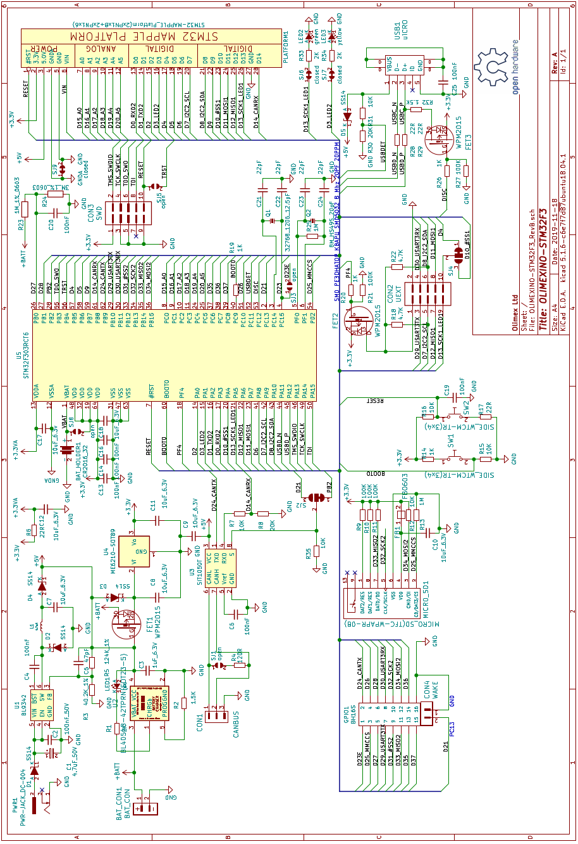

Arduino IDE installation:

1. In Arduino IDE Files→ Preferences add :
https://raw.githubusercontent.com/stm32duino/BoardManagerFiles/master/STM32/package_stm_index.json
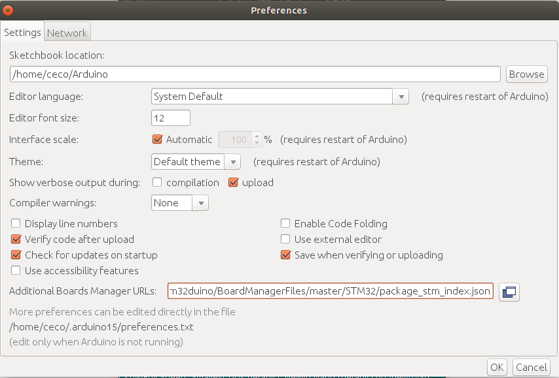

2. In Arduino IDE Tools→ Boards → Board Manager
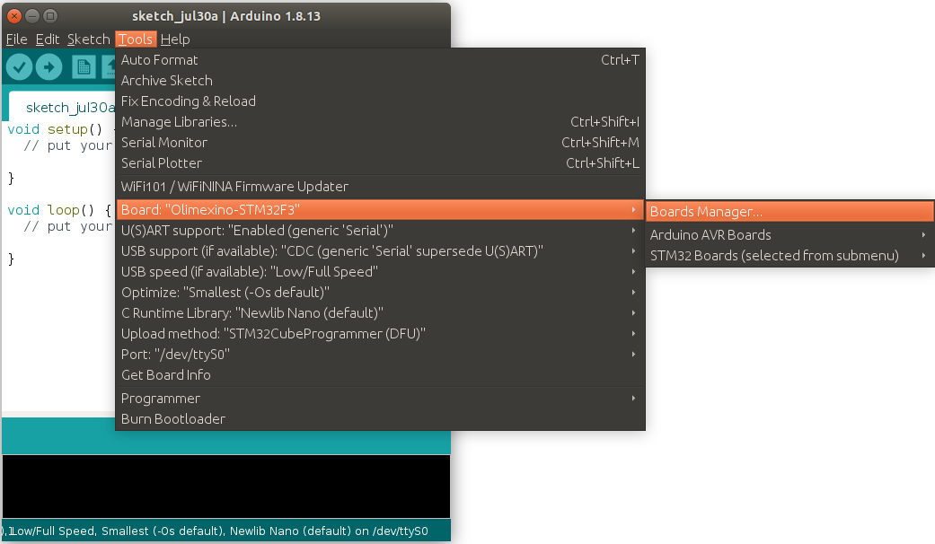
type STM32 and you will see:
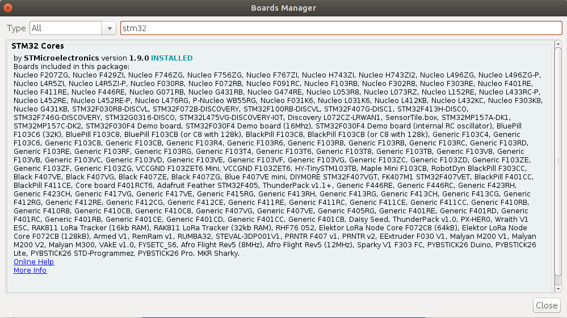
Install it.
Now we need to add OLIMEXINO-STM32F3 board variant in Arduino IDE.
We have submitted PR to stm32duino some time ago but it’s not accepted yet, so we have to do this manually, we will show you how

3. In File→ Preferences there is folder:
Double click on it and you will be pointed to this folder.
Then change directory to ..\packages\STM32\hardware\stm32\1.9.0 and copy the content of Arduino-Package-files in this folder overwriting the content.
Yes we know this is ugly way but until our PR is accepted we have to do this.
4. Restart Arduino
5. For Linux if you do not have STM32 Cube Programmer download and install it. This will also require open-jdk-11 installation.

Software examples:

In GitHub software folder there are 6 examples how to use the GPIOs, I2C, SPI (we add new library for this as otherwise you couldn’t use the micro SD card as original Arduino library support just one SPI), CAN, UART, SD-card, LCD3310.

Revision History
Revision 1.0 July 2020

