

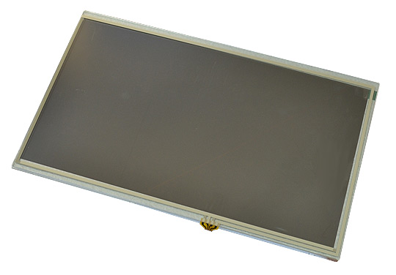
LCD-OLinuXino
Selection Guide

Rev.1.1 March 2020
olimex.com

Table of Contents
LCD-OLinuXino boards LCD connector 3
LCD RGB connector pinouts: 4
LIME 0.05” RGB 4
MICRO 0.1”, LIME2 0.05”, FPC40 RGB 5
MICRO 0.1”, LIME2 0.05”, FPC40 LVDS 6
LCD-OLinuXino variants 7
LCD-OLinuXino-4.3, -4.3TS 7
LCD-OLinuXino-5CTS 9
LCD-OLinuXino-7, -7TS , -7RTS, -7CTS 11
LCD-OLinuXino-10, -10TS , -10RTS, -10CTS 14
LCD-OLinuXino-15.6 – 15.6FHD 17
Digital interface enable on A10, A13, A20 OLinuXino boards 18
Capacitive sense vs Resistive sense technology 20
LCD Plug and Play EEPROM memory 22
Software configuration 23
Allwinner boards 23
What should I check when ordering LCD-OLinuXino-XX 24
LCD dimensions 25
Revision History 27

LCD-OLinuXino boards LCD connector
The LCD-OLinuXino connector can be any of these three types:
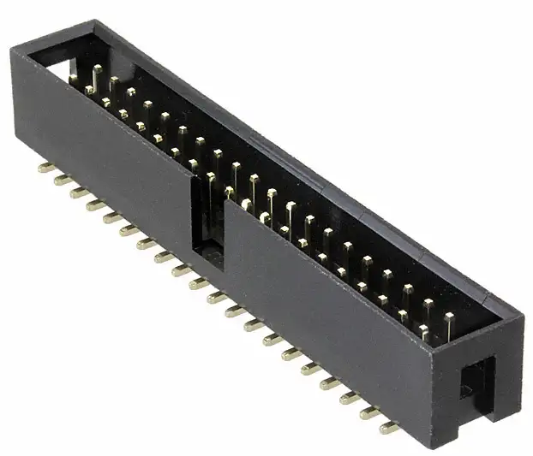
- 40 pin 0.1” step 2x20 connector as in A20-OLinuXino-MICRO board (Digikey 1175-1626-ND)
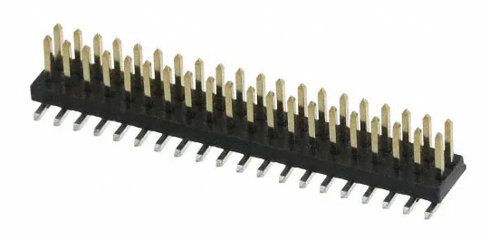
- 40 pin 0.05” step 2x20 connector as in A20-OLinuXino-LIME and LIME2 (Digikey 952-3095-2-ND)
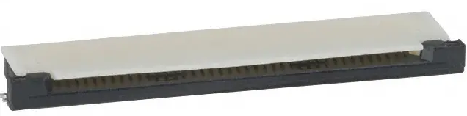
- 40 pin FPC Flat cable connector as in A33 and A64-OLinuXino (Digikey 609-1200-2-ND)

This 40 pin connector allows RGB or LVDS LCDs to be connected sharing same layout.
The connector supports analog touch screens and digital touch screens (capacitive or resistive) sharing same layout.
Note that LIME and LIME2 share same connector type but the signals are with mirror. It’s odd legacy problem which is hard to unify with thousands of boards in operation at customers.

LCD RGB connector pinouts:

LIME 0.05” RGB

Top view:

* LCD_HSYNC and LCD_VSYNC are not used in LCD-OLinuXino-4.3 or its variants
** By default there is nothing connected but some displays might have the option to enable scanning mode direction on those pins by modifying SMT jumpers; the displays are set by default in “Up to Down, Left to Right” mode
*** If the display has no touch screen connected, then there is nothing on pins 37-40; if it named LCD-OLinuXino-xTS then there are X1, X2, Y1, Y2 analog signals present; if it is named LCD-OLinuXino-xRTS or LCD-OLinuXino-xCTS then there are interrupt, reset and I2C (“x” is the size of the display, 4.3, 5, 7, 10)

MICRO 0.1”, LIME2 0.05”, FPC40 RGB

Top view:

* LCD_HSYNC and LCD_VSYNC are not used in LCD-OLinuXino-4.3 or its variants
** By default there is nothing connected but some displays might have the option to enable scanning mode direction on those pins by modifying SMT jumpers; the displays are set by default in “Up to Down, Left to Right” mode
***If the display has no touch screen connected, then there is nothing on pins 37-40; if it named LCD-OLinuXino-xTS then there are X1, X2, Y1, Y2 analog signals present; if it is named LCD-OLinuXino-xRTS or LCD-OLinuXino-xCTS then there are interrupt, reset and I2C (“x” is the size of the display, 4.3, 5, 7, 10)

MICRO 0.1”, LIME2 0.05”, FPC40 LVDS

Top view:

* Even differential data signals present only in the FHD version of the display; these signals are not present when using HD-ready version 1366x768 resolution.

* In LCD-OLinuXino-15.6FHD revision E or older #12 VPWM_EN is used for the backlight PWM; in LCD-OLinuXino-15.6FHD revision G or newer #36 LCD_BKL is used for backlight PWM

* By default 37-40 are not connected and unusable. Only in LCD-OLinuXino-15.6FHD revision G or newer you can a resistor matrix to use them for a possible touchcreen.

LCD-OLinuXino variants

LCD-OLinuXino-4.3, -4.3TS

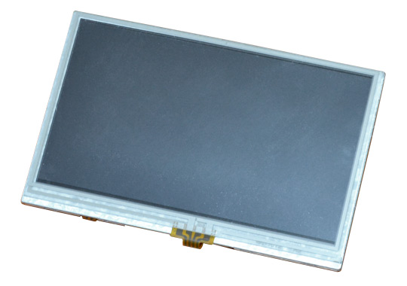
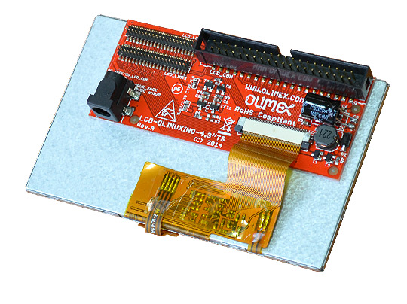

- Diagonal length 4.3”
- Resolution 480x272 pixels
- TFT color LCD technology
- interface RGB parallel
- White backlight
- Touch screen: Resistive
- Connectors: 0.1”, 0.05”-LIME, 0.05”-LIME2
- LCD panel datasheet link

Variants:
- LCD-OLinuXino-4.3 no touch panel
- LCD-OLinuXino-4.3TS with analogue Touch panel controller (works with A13, A10, A20 OLinuXino boards)
- LCD-OLinuXino-4.3RTS with I2C touch panel controller (works with A33, A64 and A13, A10, A20 if digital interface is enabled).

LCD-OLinuXino-4.3
Product name | Native resolution | Current required  @ 5V, mA | Touch screen | Touch screen technology | Touch screen  interface | Plug and Play | Interface type | External powering  supply option | Power select  method | LCD connectors  (MICRO, LIME,  LIME2, FPC)
LCD-OLinuXino-4.3 | 480x272 | 250 | NO | - | - | NO | RGB | YES | JUMPER | NO FPC
LCD-OLinuXino-4.3TS | 480x272 | 250 | YES | RES | ANALOG | NO | RGB | YES | JUMPER | NO FPC
LCD-OLinuXino-4.3RTS | 480x272 | 250 | YES | RES | DIGITAL | YES | RGB | YES | AUTO | YES

LCD-OLinuXino-5CTS
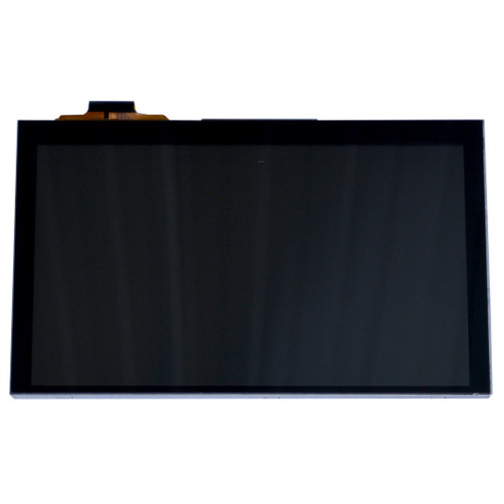
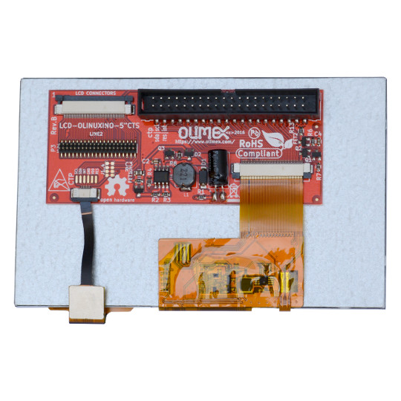

- Diagonal length 5”
- Resolution 800x480 pixels
- TFT color LCD technology
- interface RGB parallel
- White backlight
- Touch screen: Capacitive
- Connectors: 0.1” - MICRO, 0.05”-LIME2, FPC-A33/A64
- LCD panel datasheet link

Variants: LCD-OLinuXino-5CTS with capacitive sense touch panel and digital interface.

LCD-OLinuXino-5CTS
Product name | Native resolution | Current required  @ 5V, mA | Touch screen | Touch screen technology | Touch screen  interface | Plug and Play | Interface type | External powering  supply option | Power select  method | LCD connectors  (MICRO, LIME,  LIME2, FPC)
LCD-OLinuXino-5CTS | 800x480 | 300 | YES | CAP | DIGITAL | NO | RGB | NO | - | NO LIME
LCD-OLinuXino-5CTS+ | 800x480 | 300 | YES | CAP | DIGITAL | NO | RGB | YES | AUTO | YES

LCD-OLinuXino-7, -7TS , -7RTS, -7CTS
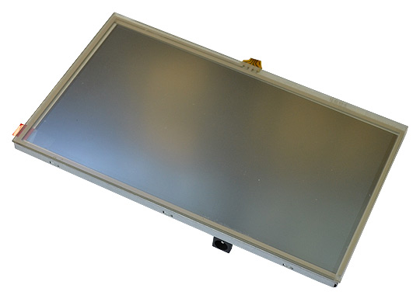
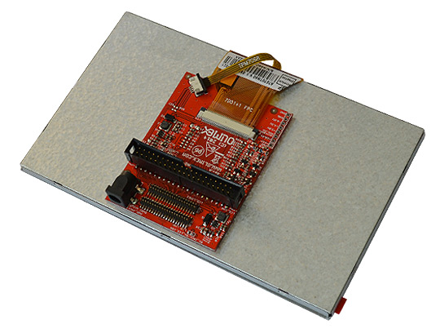

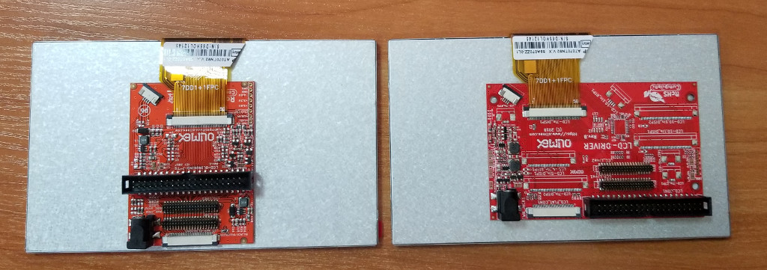

Left side: LCD-OLinuXino-7 and LCD-OLinuXino-7TS driver board capable to fit inside LCD7-METAL-FRAME
Right side: LCD-OLinuXino-7RTS and LCD-OLinuXino-7CTS driver board NOT capable to be used with LCD7-METAL-FRAME.
- Diagonal length 7”
- Resolution 800x480 pixels for LCD-OLinuXino-7,LCD-OLinuXino-7TS, LCD-OLinuXino-7RTS
- Resolution 1024x600 pixels for LCD-OLinuXino-7CTS
- TFT color LCD technology for LCD-OLinuXino-7, LCD-OLinuXino-7TS, LCD-OLinuXino-7RTS
- IPS color LCD technology for LCD-OLinuXino-7CTS
- Interface: RGB parallel
- White backlight
- Touch screen: Resistive (TS, RTS) or Capacitive (CTS)
- Touch panel interface: analog (TS) or digital (CTS, RTS)
- Connectors: 0.1”, 0.05”-LIME, 0.05”-LIME2 for -7, -7TS
- Connectors: 0.1”, 0.05”-LIME, 0.05”-LIME2, FPC40 for -7RTS, -7CTS
- LCD-OLinuXino-7CTS panel datasheet link
- LCD-OLinuXino-7, LCD-OLinuXino-7TS, LCD-OLinuXino-7RTS panel datasheet link
Variants:
- LCD-OLinuXino-7 800x480 pixels no touch panel
- LCD-OLinuXino-7TS 800x480 pixels with analogue resistive touch panel controller (works with A13, A10, A20 OLinuXino boards)
- LCD-OLinuXino-7RTS 800x480 pixels with I2C resistive touch panel controller (works with A33, A64 and A13, A10, A20 if digital interface is enabled).
- LCD-OLinuXino-7CTS 1024x600 pixels with I2C capacitive touch panel controller (works with A33, A64 and A13, A10, A20 if digital interface is enabled).

LCD-OLinuXino-7
Product name | Native resolution | Current required  @ 5V, mA | Touch screen | Touch screen technology | Touch screen  interface | Plug and Play | Interface type | External powering  supply option | Power select  method | LCD connectors  (MICRO, LIME,  LIME2, FPC)
LCD-OLinuXino-7 | 800x480 | 400 | NO | - | - | NO | RGB | YES | JUMPER | YES
LCD-OLinuXino-7+ | 800x480 | 400 | NO | - | - | NO | RGB | YES | AUTO | YES
LCD-OLinuXino-7TS | 800x480 | 400 | YES | RES | ANALOG | NO | RGB | YES | JUMPER | YES
LCD-OLinuXino-7TS+ | 800x480 | 400 | YES | RES | ANALOG | NO | RGB | YES | AUTO | YES
LCD-OLinuXino-7RTS | 800x480 | 400 | YES | RES | DIGITAL | YES | RGB | YES | AUTO | YES
LCD-OLinuXino-7CTS | 1024x600 | 600 | YES | CAP | DIGITAL | YES | RGB | YES | AUTO | YES

LCD-OLinuXino-10, -10TS , -10RTS, -10CTS

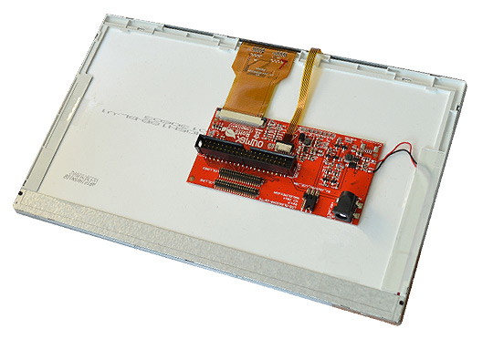

The Above picture show the old LCD driver board
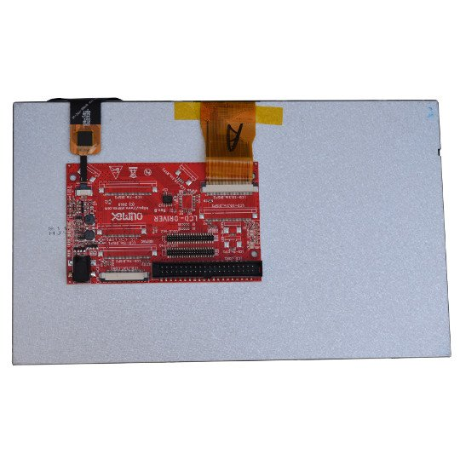

This is the new universal LCD driver board which supports all LCD variants

Both old and new driver boards are compatible with LCD10-METAL-FRAME
- Diagonal length 10.1”
- Resolution 1024x600
- TFT color LCD technology for LCD-OlinuXino-10, LCD-OLinuXino-10TS, LCD-OLinuXino-10RTS
- IPS color LCD technology for LCD-OLinuXino-10CTS
- Interface: RGB parallel
- White backlight
- Touch screen: Resistive (TS, RTS) or Capacitive (CTS)
- Touch panel interface: analog (TS) or digital (CTS, RTS)
- Connectors: 0.1”-MICRO, 0.05”-LIME, 0.05”-LIME2, FPC40
- LCD-OLinuXino-10CTS panel datasheet link
- LCD-OLinuXino-10, LCD-OLinuXino-10TS, LCD-OLinuXino-10RTS panel datasheet link

Variants:
- LCD-OLinuXino-10 no touch panel
- LCD-OLinuXino-10TS with analogue resistive touch panel controller (works with A13, A10, A20 OLinuXino boards)
- LCD-OLinuXino-10RTS 800x480 pixels with I2C resistive touch panel controller (works with A33, A64 and A13, A10, A20 if digital interface is enabled).
- LCD-OLinuXino-10CTS with I2C capacitive touch panel controller (works with A33, A64 and A13, A10, A20 if digital interface is enabled).

LCD-OLinuXino-10
Product name | Native resolution | Current required  @ 5V, mA | Touch screen | Touch screen technology | Touch screen  interface | Plug and Play | Interface type | External powering  supply option | Power select  method | LCD connectors  (MICRO, LIME,  LIME2, FPC)
LCD-OLinuXino-10 | 1024x600 | 650 | NO | - | - | NO | RGB | YES | JUMPER | YES
LCD-OLinuXino-10+ | 1024x600 | 650 | NO | - | - | NO | RGB | YES | AUTO | YES
LCD-OLinuXino-10TS | 1024x600 | 650 | YES | RES | ANALOG | NO | RGB | YES | JUMPER | YES
LCD-OLinuXino-10TS+ | 1024x600 | 650 | YES | RES | ANALOG | NO | RGB | YES | AUTO | YES
LCD-OLinuXino-10RTS | 1024x600 | 650 | YES | RES | DIGITAL | YES | RGB | YES | AUTO | YES
LCD-OLinuXino-10CTS | 1024x600 | 700 | YES | CAP | DIGITAL | YES | RGB | YES | AUTO | YES

LCD-OLinuXino-15.6 – 15.6FHD
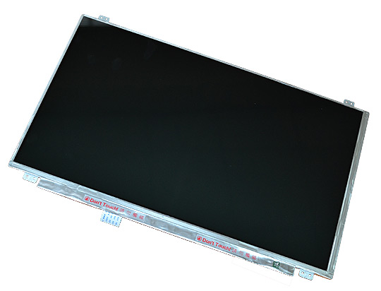
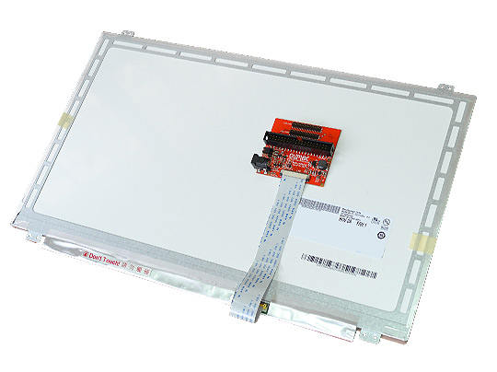

The LCDs are with these features:
- Length of the diagonal 15.6”
- Resolution: 1366x768 or 1980x1080 for FHD version
- 16:9 color TFT-LCD with LED backlight
- Requires external 5V power supply as consumes up to 3.5W
- Interface LVDS
- Touchscreen: no
- Connectors: 0.1” MICRO, 0.05” LIME and LIME2, FPC40
LCD-OLinuXino-15.6
Product name | Native resolution | Current required  @ 5V, mA | Touch screen | Touch screen technology | Touch screen  interface | Plug and Play | Interface type | External powering  supply option | Power select  method | LCD connectors  (MICRO, LIME,  LIME2, FPC)
LCD-OLinuXino-15.6 | 1366x768 | 700 | NO | - | - | NO | LVDS | YES | JUMPER | YES
LCD-OLinuXino-15.6FHD Rev. E or older | 1980x1080 | 1100 | NO | - | - | NO | LVDS | YES | JUMPER | YES
LCD-OLinuXino-15.6FHD Rev.G or newer | 1980x1080 | 850 | NO | - | - | NO | LVDS | YES | JUMPER | YES

Digital interface enable on A10, A13, A20 OLinuXino boards

A10, A13 and А20 SOC has analog touch panel ADC interface. By default the LCD connectors are wired with analog interface on these boards. A33 and A64 has no analog interface and only digital I2C interface for touch panel and by default these boards the LCD connectors are wired with digital interface.
A10, A13 and A20 has possibility to be wired with Digital interface too, for this reason we provide resistor matrix which can be assembled in position for Digital and in position for Analog interface. Depend on where this resistor matrix is assembled A10, A13 and A20 boards can be used with both analog or digital interface.
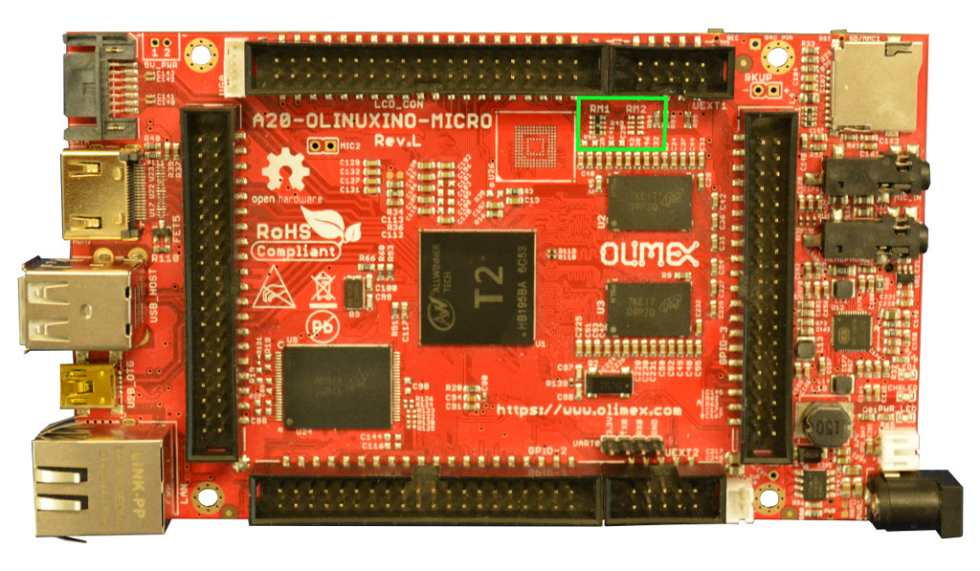
In A20-OLinuXino-MICRO if RM1 is assembled the interface is ANALOG, if RM2 is assembled the interface for touch panel is DIGITAL:By default we assemble RM1 if you want to use A20-OLinuXino-MICRO with LCDs with dgital interface like -CTS and -RTS you can ask us to assembly RM2 when you order your boards.

In A20-OLinuXino-LIME and A10-OLinuXino-LIME boards if RM9 is assembled the touch panel interface is ANALOG if RM10 is assembled the interface is DIGITAL.
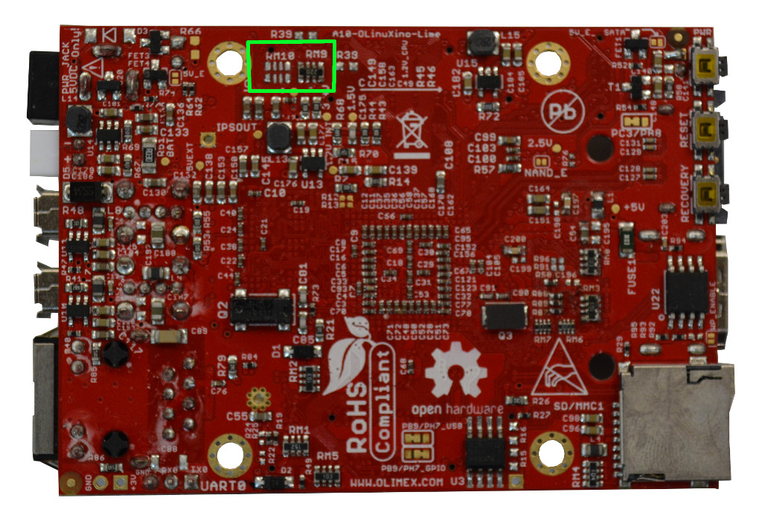
By default we assemble RM9 if you want to use A10/A20-OLinuXino-LIME with LCDs with dgital interface like -CTS and -RTS you can ask us to assembly RM10 when you order your boards.

Capacitive sense vs Resistive sense technology

Resistive touch is made by two conductive transparent layers with small gap between them, when point is touched the conductive layers make contact and point is detected. It’s primary choice for industrial environments as they are not disturbed by dust, water, moisture and can be touch with gloves or any other object which press on the screen.
Resistive technology pros:
- not sensitive to dirt and moisture
- can be touch with any object, with gloves
- very precise detection of touch point
Resistive technology cons:
- not sensitive to light touch
- thick upper screen decrease brightness
- no multi touch
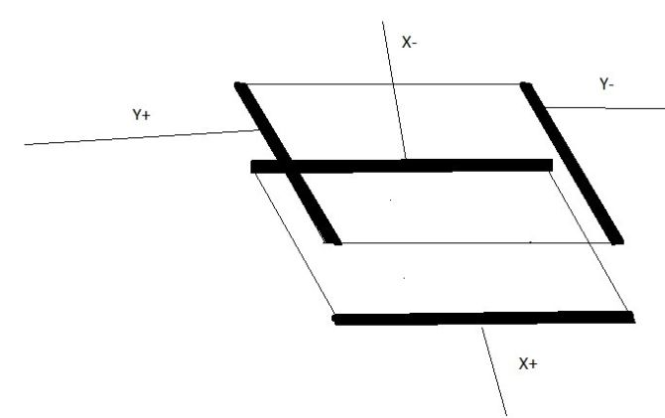
Capacitive touch is made with one conductive layer with sensors at the four edges, when human finger touches the screen. It allows multi touch and can sense if you touch at several points at same time:

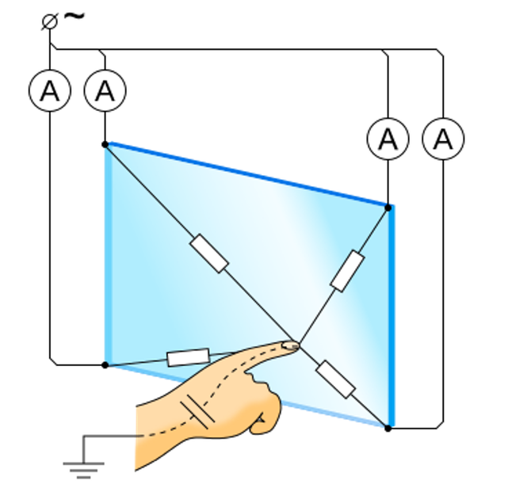
Capacitive technology pros:
- detect slight touch
- allow multi touch

Capacitive technology cons:
- sensitivity depends on noise, moisture, dirty, dust
- can’t be used with any object and gloves
- worse resolution than resistive

LCD Plug and Play EEPROM memory

LCD-OLinuXino-xRTS -xCTS has on board EEPROM with LCD configuration and are plug and play which means when the LCD is connected OlinuXino board will read the LCD configuration at boot time and will configure the proper LCD drivers.

Software configuration
The software configuration with Olimex boards heavily depends on the image used. This guide assumes that you are using the latest official Olimex image for your board.

Allwinner boards
Using latest Armbian-based official image the HDMI video output always has the highest priority. This means that if you plug an HDMI cable, the output always will be on the HDMI monitor, regardless of other settings. If HDMI is not present, then LCD output will be used. By default the image tries to use auto-detect method for the LCD (if the LCD driver supports it). Refer to the comparison table to find which displays have auto-detection enabled. You can manually override this in the u-boot console as follows:
Press any key to interupt kernel boot and to stay in the u-boot:
Autoboot in 1 seconds, press <Space> to stop
List all supported LCD panels with:
olinuxino monitor list
The command returns:
Supported video outputs:
----------------------------------------
LCD-OLinuXino - Enable AUTO detect video output
LCD-OLinuXino-4.3TS - Video output to LCD-OLinuXino-4.3TS
LCD-OLinuXino-7 - Video output to LCD-OLinuXino-7
LCD-OLinuXino-5 - Video output to LCD-OLinuXino-5
LCD-OLinuXino-10 - Video output to LCD-OLinuXino-10
Set configuration, for example LCD-OLinuXino-7:
olinuxino monitor set LCD-OLinuXino-7
You should make changes permanent with:
saveenv
Reboot the board and you're ready:
reset

What should I check when ordering LCD-OLinuXino-XX

- Make sure that your board supports the touch screen interface; currently all Olimex boards come with analog interface on the connector; most of the newly manufactured boards can be configured to I2C interface via a resistor matrix change. You can order your A10/A13/A20 board with Digital interface enabled when ordering write this in the NOTE field. If there is no request for Digital touch interface boards will be shipped with the default Analog teouch interface enabled. A33/A64 has no Analog touch interface so they are shipped only with Digital Touchscreen interface.
- Some LCD displays can be automatically recognized by the Olimex-made Allwinner boards when using the latest official images. These are with +, -RTS and -CTS suffixes.
- Depends on the LCD-DRIVER board revision, in LCD-DRIVER board hardware revision B the power input connector has to be specified via an SMT jumper modification, in LCD-DRIVER hardware revision C or newer the selection is automatic without hardware modification (power jack has priority though)

LCD dimensions

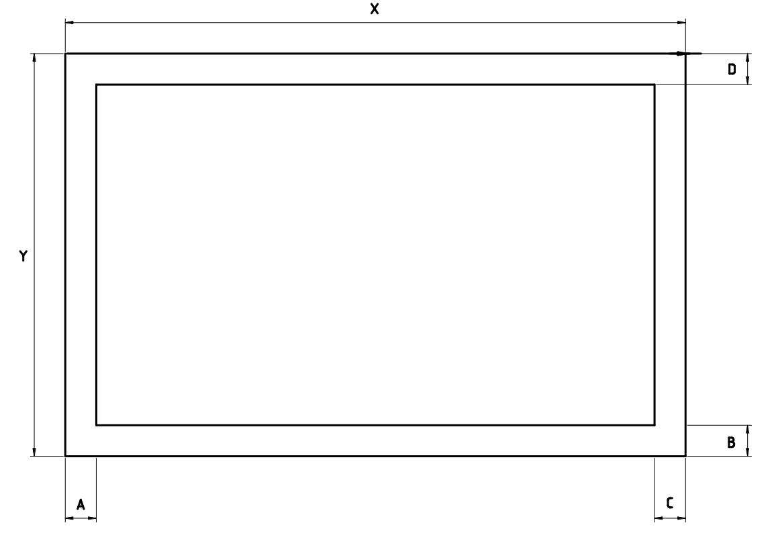
LCD 4.3”TS
X = 105.5 mm Y = 67.5 mm Thickness = 4.0 mm
A = 3.8 mm B = 3.5 mm C = 4.6 mm D = 8.0 mm
LCD 5.0”CTS (capacitive touch panel)
X = 121 mm Y = 76 mm Thickness = 4.5 mm
A = 7.0 mm B = 3.0 mm C = 3.0 mm D = 8.0 mm
LCD 7.0” (no touch panel)
X = 165 mm Y = 100 mm Thickness = 5.75 mm
A = 5.0 mm B = 3.0 mm C = 2.0 mm D = 7.5 mm
LCD 7.0”TS, RTS (resistive touch panel)
X = 165 mm Y = 100 mm Thickness = 7.25 mm
A = 5.0 mm B = 3.0 mm C = 2.0 mm D = 7.5 mm
LCD 7.0”CTS (capacitive touch panel)
X = 165 mm Y = 100 mm Thickness = 7.0 mm
A = 5.5 mm B = 3.0 mm C = 3.0 mm D = 8.0 mm
LCD 10” (no touch panel)
X = 235 mm Y = 143 mm Thickness = 4.8 mm
A = 5.0 mm B = 7.0 mm C = 3.0 mm D = 7.0 mm
LCD 10”TS, RTS (resistive touch panel)
X = 235 mm Y = 143 mm Thickness = 6.3 mm
A = 5.0 mm B = 7.0 mm C = 3.0 mm D = 7.0 mm
LCD 10”CTS (capacitive touch panel)
X = 235 mm Y = 143 mm Thickness = 5.5 mm
A = 6.0 mm B = 4.0 mm C = 4.0 mm D = 11.0 mm

Revision History
Revision 1.0 July 2019
Revision 1.1 March 2020 add LCD dimensions

