

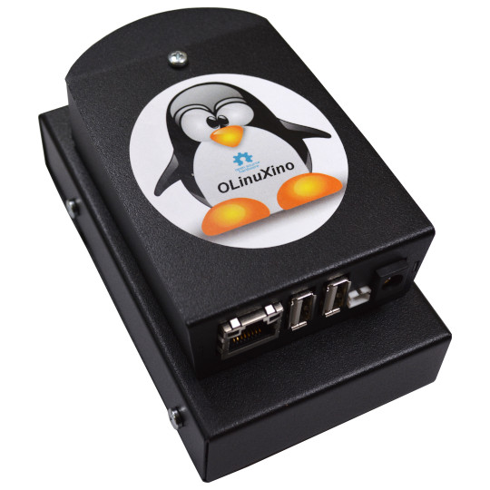
LIME2-SERVER
User Manual
Document revision 1.2 May 2020

www.olimex.com
Table of Contents
What is LIME2-SERVER 3
LIME2-SERVER package content 4
LIME2-SERVER and BAY-HDD/SDD assembly guide 5
LIME2-SERVER variants 9
LIME2-SERVER connectors description 10
LIME2-SERVER battery installation 11
LIME2-SERVER software installation 12
LIME2-SERVER power consumption 18
Revision History 19

What is LIME2-SERVER

LIME2-SERVER is a development kit that can be used to set-up a low power ARM-based server with option for storage and cloud service. It has everything required to run 24/7.
You can run OpenElec-KODI image, Debian or Ubuntu Linux distribution with latest mainline kernel and on top of them you can run services like NextCloud, TOR server, Home Assistant, Yunohost thus being independent from cloud service suppliers and keeping your content in your hands.
The power consumption of LIME2-SERVER depends on the load, it varies from 2W to 5W.
LIME2-SERVER comes pre-assembled and can be ordered along with either 500GB, 1000GB, or 2000GB hard disk drive, or with a 512GB solid state disk.
LIME2-SERVER has a build-in UPS (Uninterruptible Power Supply) that is a Lithium Ion Battery and will continue to work for hours even if the external power supply is interrupted for some reason.

LIME2-SERVER package content

The LIME2-SERVER contains:
- A20-OLinuXino-LIME2 OSHW single-board Linux computer
- BATTERY-LIPO1400mAh for power backup even when there is no external power supply
- 32GB micro SD card
- 500GB/1000GB/2000GB HDD or 512GB SSD connected to SATA interface (selected board variants)
- BOX-LIME-BLACK metal enclosure
- BAY-HDD/SSD metal enclosure with LIME2 SATA bridge board
- 1000MB Ethernet cable 1.2 meters
- 5V 2A Power adapter

LIME2-SERVER and BAY-HDD/SDD assembly guide
LIME2-SERVER comes assembled and tested, these instructions serve purely informational purposes. First step is to assemble the top of BAY-HDD/SDD box with bottom part of BOX-LIME-BLACK:
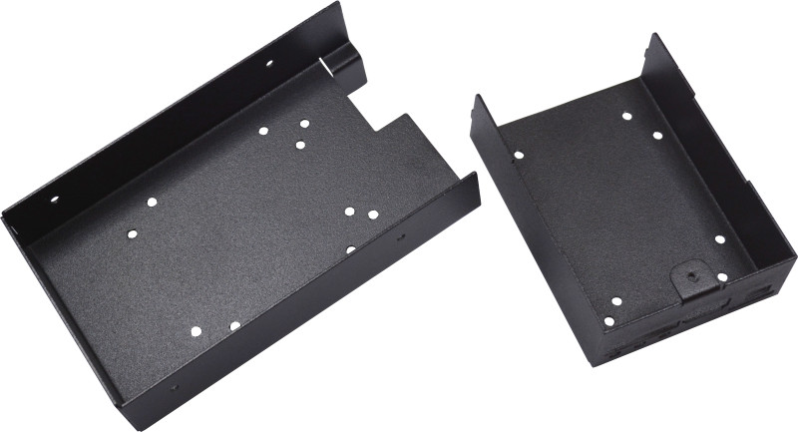

For this purpose four M3x4 screws and M3x6 hex nuts are used:

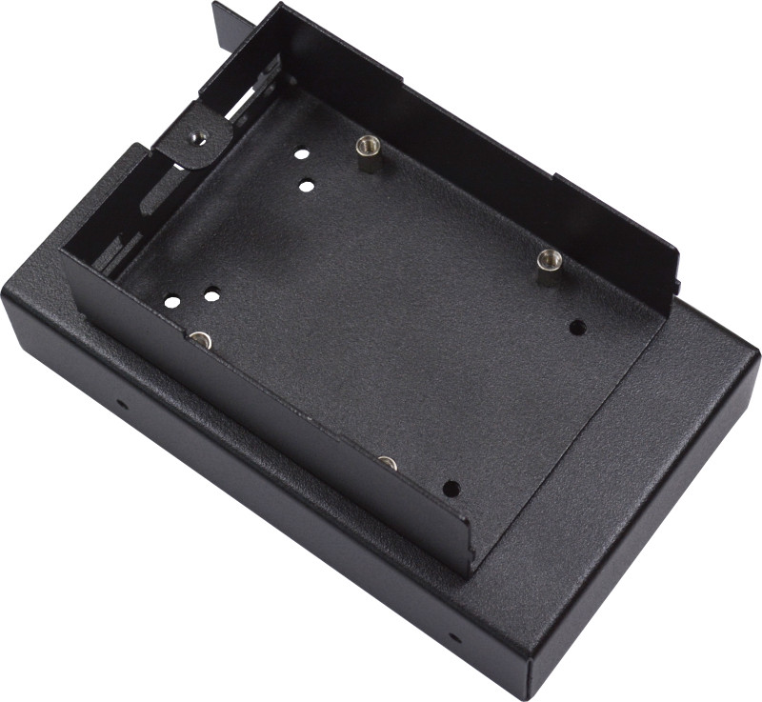

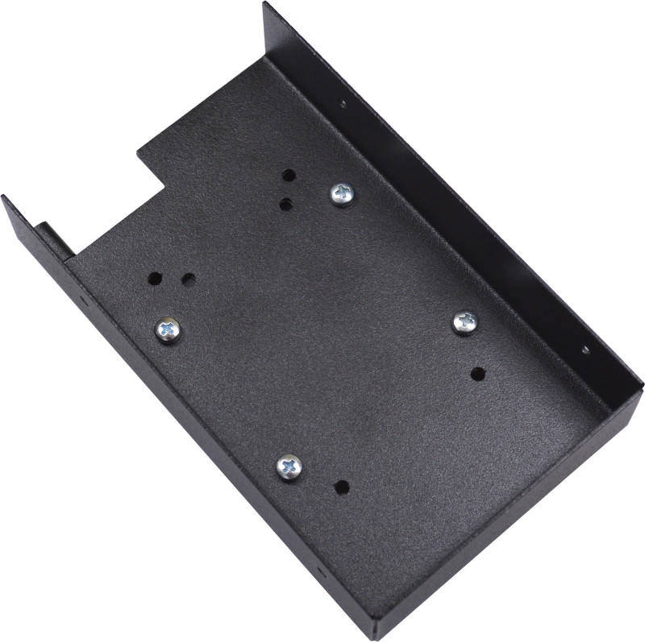

Then the A20-OLinuXino-LIME2 board is placed and fixed with 4 pieces of M3x4 screws:
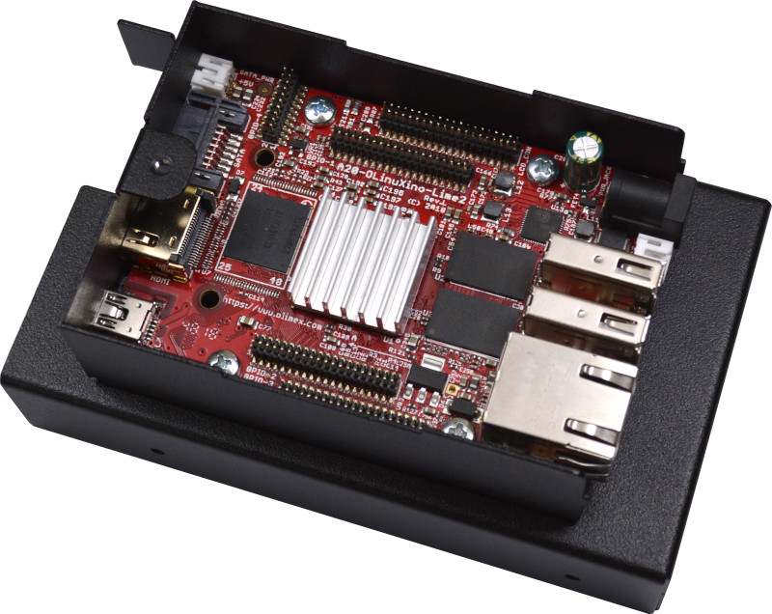

For the next step you need the HDD/SSD drive and the LIME2-SATA PCB which are part of LIME2-SERVER kit:
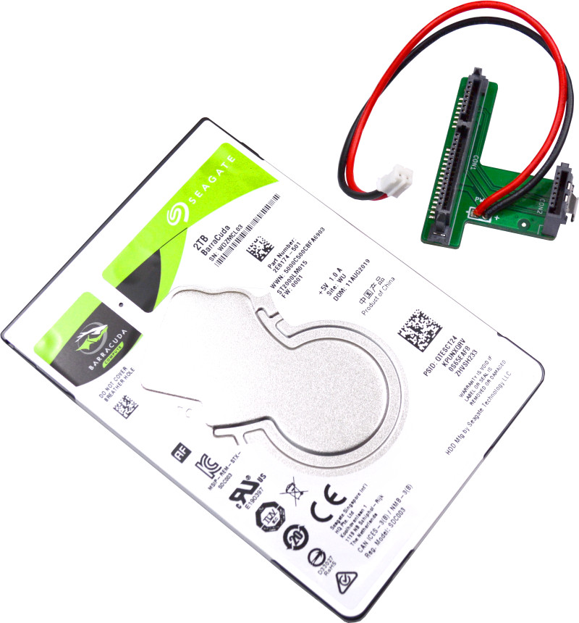

Attach the drive with four M3x4 mm screws at the sides:
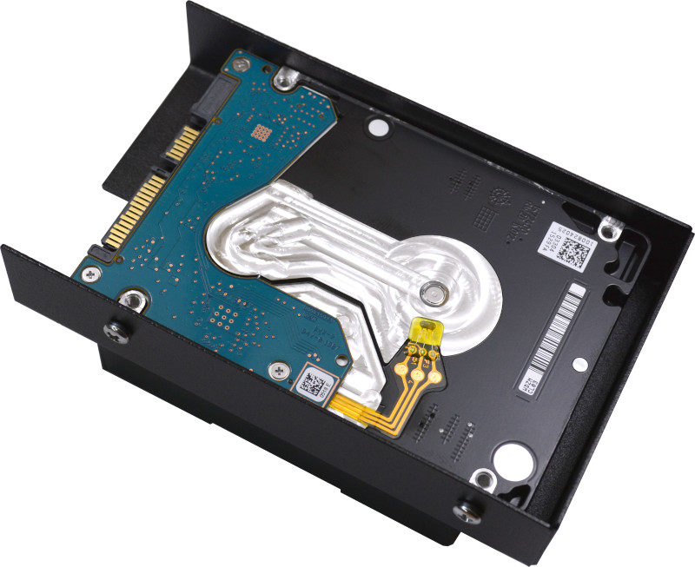

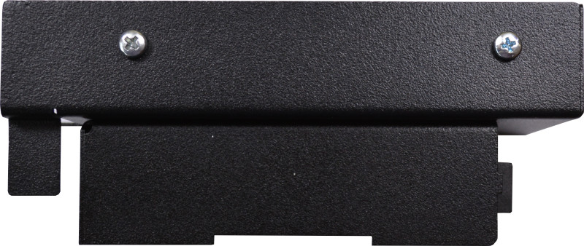

Then snap the Lime2-SATA PCB and connect the power cable to JST2.0 connector:

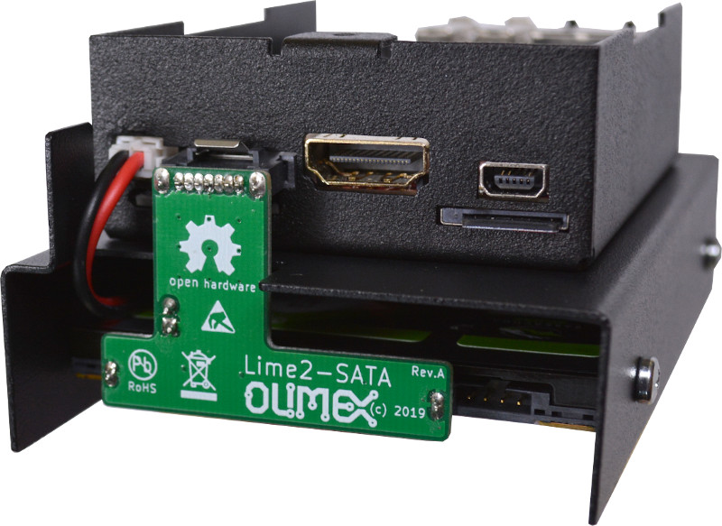

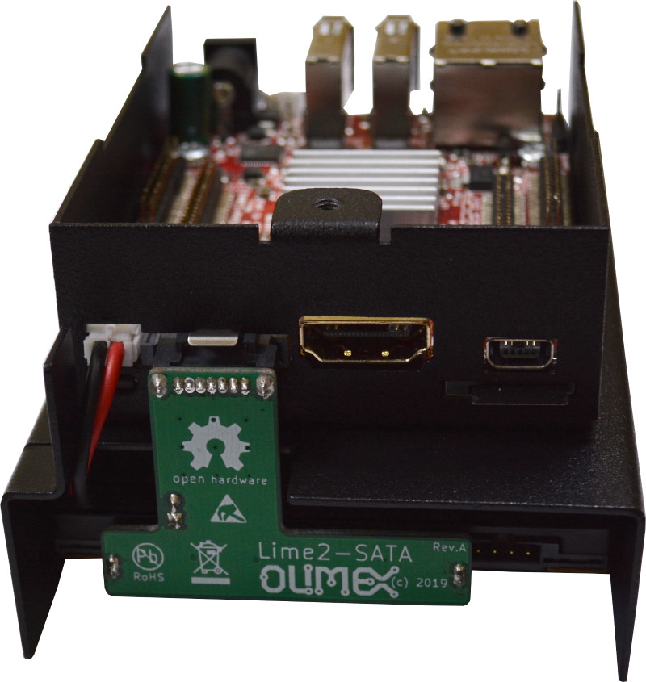

At this point close the bottom metal cover and use HDD mout holes to attach with M3x10 screws:

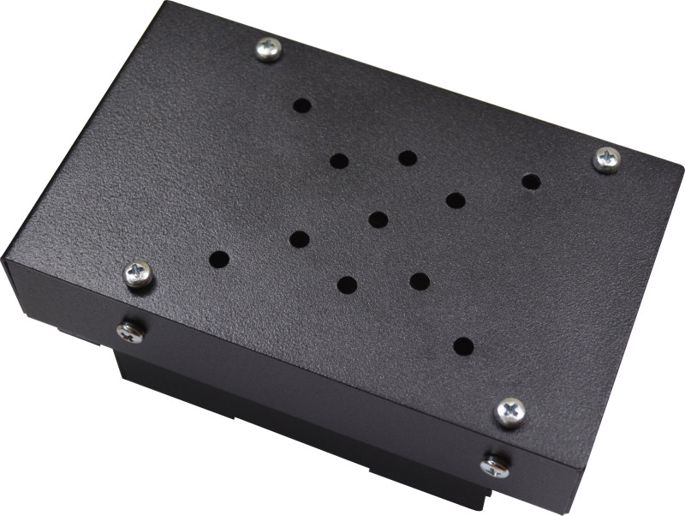

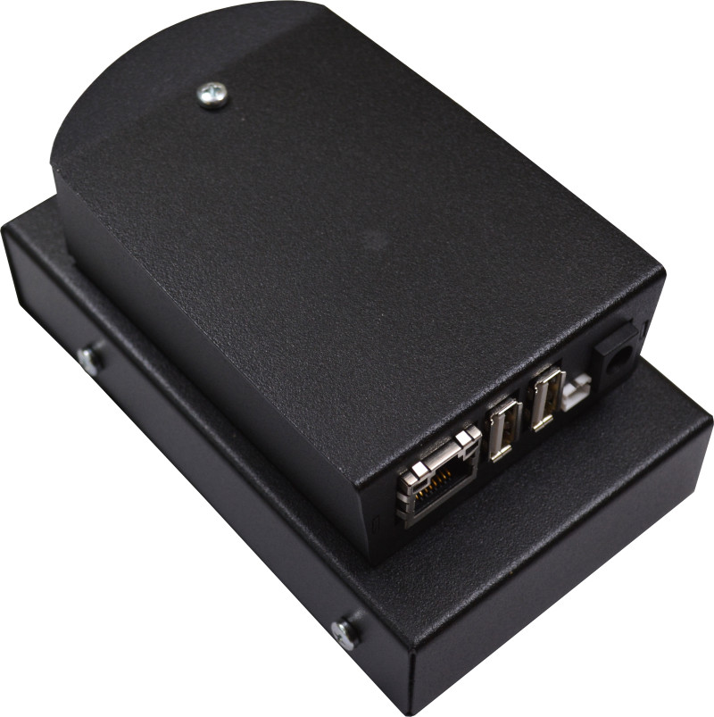

Finally place the OLinuXno sticker on top:

LIME2-SERVER variants

There are several variants with or without HDD or SSD:
- LIME2-SERVER-NO-HDD if you have your own 2.5” HDD or SSD
- LIME2-SERVER-500GB-HDD with mechanical 2.5” 500GB drive
- LIME2-SERVER-1000GB-HDD with mechanical 2.5” 1000GB drive
- LIME2-SERVER-2000GB-HDD with mechanical 2.5” 2000GB drive
- LIME2-SERVER-512GB-SSD with solid state 2.5” 512GB drive

LIME2-SERVER connectors description

Power supply 5V only!

LiPo battery

Ethernet
USB host 1A current
USB host
0.5A current

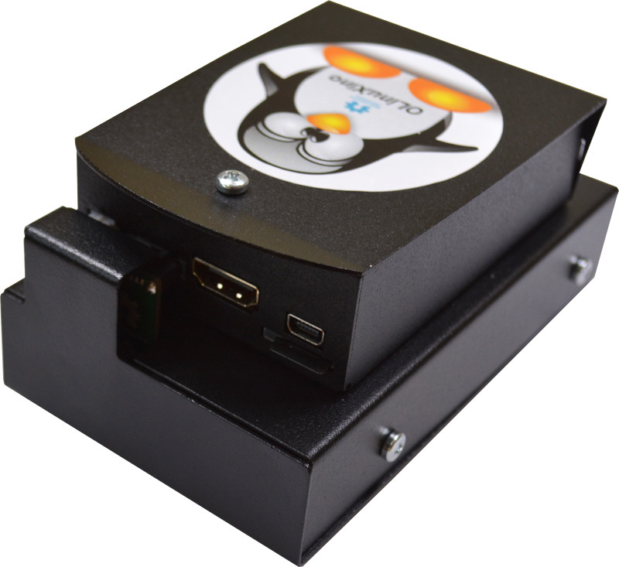

HDMI
32GB microSD card
USB-OTG

LIME2-SERVER battery installation

When you receive your LIME2-SERVER the LiPo battery will not be connected. Unscrew the upper cover and connect the battery as shown on the picture below then re-attach the cover:

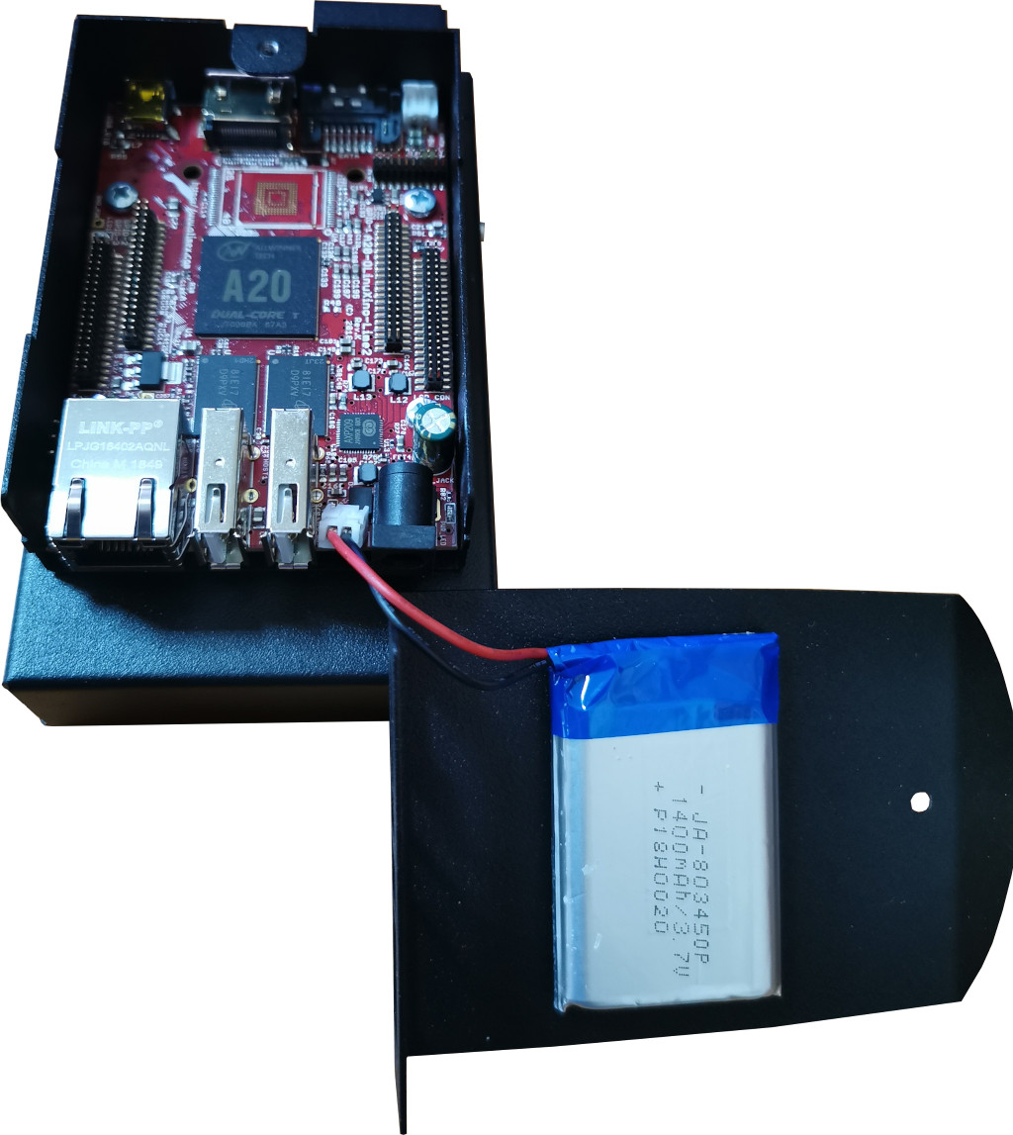

LIME2-SERVER software installation

Installing Ubuntu or Debian

> Where to get the images?

You can download our latest images from our ftp repository.

Ubuntu 18.04 LTS Bionic and Debian 10 Buster are what we have.

Then you need balenaEtcher to write the image to micro SD card class 10. Download it and run. Point the source of the image and the SD card.

Insert the card in LIME2-SERVER and apply power supply.

You can login with HDMI/keyboard or SSH via USB-OTG.

Either connect USB keyboard and HDMI monitor either use USB cable to connect to USB-OTG connector and connect to the board.

Check which serial port is created with:

ls /dev/tty*

the port must be ttyACMx
connect to the board via this serial port

cu -l /dev/ttyACM0

Initial login is root 1234 after which you will be forced to change your password.

Installing KODI

Download the KODI image from our ftp server

Use balenaEtcher to write the image to micro SD card class 10.

Insert the SD card and boot.

Installing NextCloud

Download Armbian_5.92.4_Olinuxino-a20_Ubuntu_bionic_next_5.2.21_desktop.7z and write it with balenaEtcher to blank micro-SD card.

Insert the card and boot.

Use Ethernet cable or WiFi dongle to connect to Internet.

Use USB cable to connect to USB-OTG connector and connect to the board.

Check which serial port is created with:

ls /dev/tty*

the port must be ttyACMx
connect to the board via this serial port
cu -l /dev/ttyACM0

Initial login is root 1234 after which you will be forced to change your password.

Get the install script from our ftp with:
wget ftp://staging.olimex.com/Allwinner_Images/A20-OLinuXino/5.NextCloud/install_NextCloud.sh

then run the script:

chmod +x install_NextCloud.sh

./install_NextCloud.sh

at the end the scrip will run NextCloud server and will display the IP of the server.

Installing Yunohost

work in progress
Installing Home assistant

work in progress

Installing TOR

work in progress

LIME2-SERVER power consumption

A20-OLinuXino-LIME2 typically consumes between 0.3A and 0.5A at 5V (1.5W-2.5W).

If devices are connected to the USB ports this consumption should be taken into consideration. If you do not know power consumption of USB devices you can measure with USB-POWER-METER

Note that USB1 host can source up to 1A, while USB2 host is restricted to 0.5A only. If you power devices like MOD-USB3G you should use USB1.

The different HDD/SSD can use up to 1A current in active state.

LIME2-SERVER comes with 5V / 2A power adapter which is sufficient for running the server with the HDD.

Revision History
Revision 1.0 March 2020
Revision 1.1 April 2020
Revision 1.2 May 2020

