

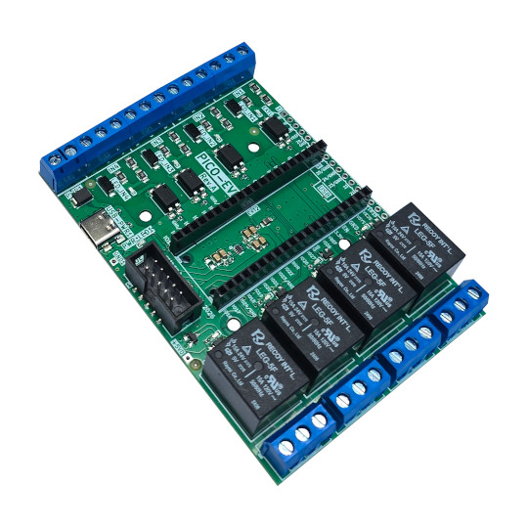

PICO-EVB
User Manual
Rev.1.0 July 2026 olimex.com
Table of Contents
Introduction to PICO-EVB 3
Order codes for PICO-EVB and accessories: 4
HARDWARE 5
PICO-EVB layout: 6
PICO-EVB inputs: 8
PICO-EVB Relays: 9
PICO-EVB schematics: 11
UEXT connector: 12
SOFTWARE: 13
Revision History 14

Introduction to PICO-EVB

PICO-EVB is evaluation board which can be used with Raspberry Pi PICO, PICO-W, PICO2 and PICO2-W. It also can work with Olimex RP2040-PICO30.
PICO-EVB turns PICO into PLC and home automation device as it can drive high voltage loads with relays, and can sense via optoisolated inputs 3.3-30VDC or directly 110-220VAC signals.
PICO-EVB have this features:
- 40 pin DIL connector for PICO modules
- USB-C power supply connector which allow more current to be used by the board
- Four 15A/240VAC relays controlled by the PICO
- UEXT connector
- Four opto-isolated inputs which can work either with 3.3-30VDC or 110-220VAC
- Power supply can be feed to screw connector terminal for more robust connection
- All components are industrial grade -45+85C
- Dimensions 100x70 mm

+ Important notice: The Relays and high voltage inputs should be used with care.
Each input have three connections: one common, one for +3.3-30VDC signals and one for 110/220VAC signals. If you want to drive the inputs with microcontroller feed 0 and +3.3V. If you want to drive the input with high voltage use live and neutral to connect. DO NOT CONNECT low voltage and high voltage to SAME input at the same time!

Order codes for PICO-EVB and accessories:

PICO-EVB industrial grade PICO evaluation board
USB-CABLE-A-TO-C-1M USB-C quality cable for data and power
RP2040-PICO-HDR PICO with soldered headers
RP2040-PICO-W-HDR PICO-W with soldered headers
RP2350-PICO2-HDR PICO2 with soldered headers
RP2350-PICO2-W-HDR PICO2-W with soldered headers

HARDWARE

PICO-EVB layout:

PICO
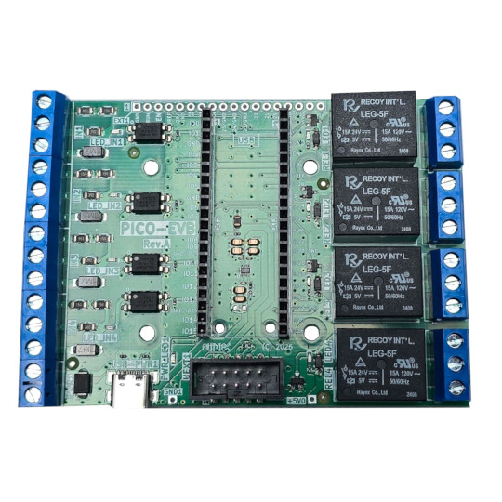
RELAY1
RELAY2
RELAY3
RELAY4
UEXT
GPIO connector
Input1
Input2
Input3
Input4
+5V PWR
USB-C
Relay staus LED
Power LED
Input status LED

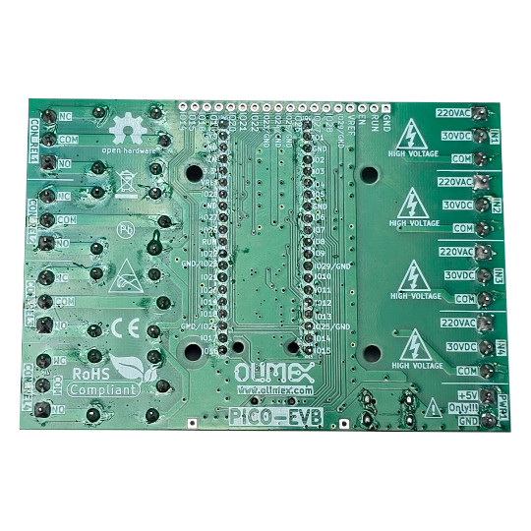

PICO-EVB inputs:
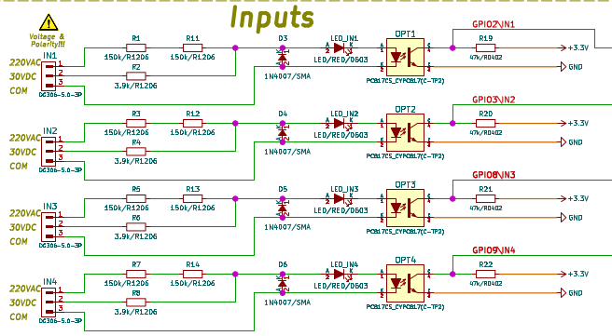

PICO-EVB Relays:
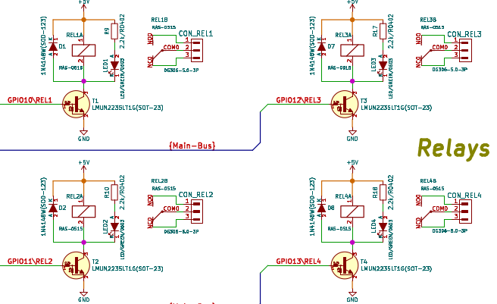

POWER SUPPLY:

PICO-EVB can be powered by: USB-C connector, Terminal Block connector, PICO USB connector
You can connect any of them or all at the same time and it will be safe.
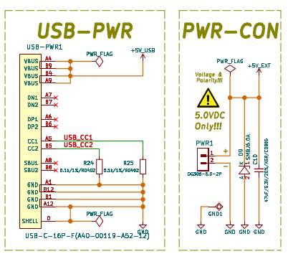

There is priority circuit if you connect together USB-C and Termianl block external power, the priority will be USB-C.
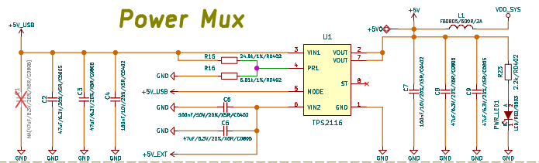

PICO-EVB schematics:

PICO-EVB latest schematic is on GitHub

UEXT connector:

UEXT connector stands for Universal EXTension connector and contain +3.3V, GND, I2C, SPI, UART signals.
UEXT connector can be in different shapes.
The original UEXT connector is 0.1” 2.54mm step boxed plastic connector. All signals are with 3.3V levels.
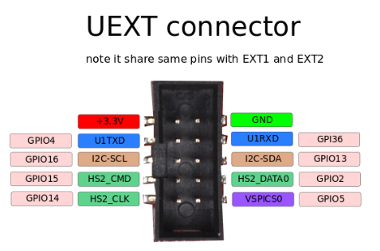

As the boards become smaller and smaller some smaller packages were introduced too beside the original UEXT connector
- mUEXT is 1.27 mm step boxed header connector which is with same layout as UEXT
- pUEXT is 1.0 mm single row connector (this is the connector used in RP2040-PICO30)

Olimex has developed number of MODULES with this connector. There are temperature, humidity, pressure, magnetic field, light sensors. Modules with LCDs, LED matrix, Relays, Bluetooth, Zigbee, WiFi, GSM, GPS, RFID, RTC, EKG, sensors and etc.

SOFTWARE:

PICO-EVB repository have these software:
- Arduino-demo
- ESPHome
- MicroPython-demo
- MicroPython-server

Revision History
Revision 1.0 July 2026

