

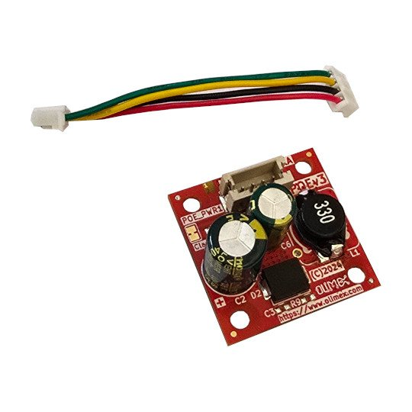

POEv3
User Manual
Rev.1.0 March 2025 olimex.com
Table of Contents
Introduction to POEv3 3
Order codes for POEv3: 4
HARDWARE 5
POEv3 schematic 6
POEv3 connector: 7
Revision History 8

Introduction to POEv3

POEv3 is small 25x25mm Power Over Ethernet negotiator and voltage regulator. It is designed to work with ESP32-P4-Devkit but it will work with any other board which have POE capable magnetic transformer.
The maximal current of POEv3 is about 1A, although it will be able to provide more we do not recommend to be used with higher power without active cooling.

Note:
POEv3 is not galvanically isolated. It provides 5V 1A to the target board but it’s connected to the Ethernet cable, so care should be taken when operating with the product powered by POEv3.

Order codes for POEv3:

POEv3 industrial grade Power over Ethernet negotiator and voltage regulator

HARDWARE

POEv3 schematic

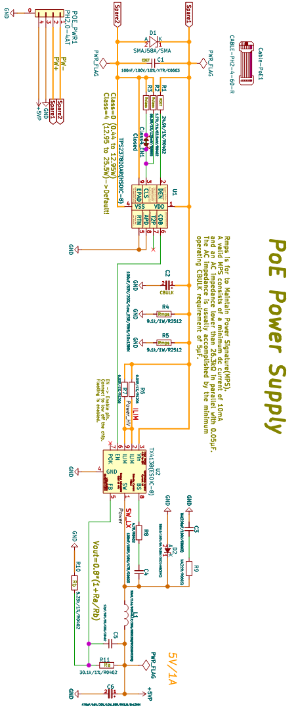

POEv3 connector:
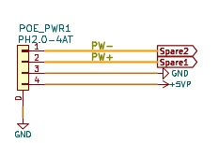

Revision History
Revision 1.0 March 2025

