

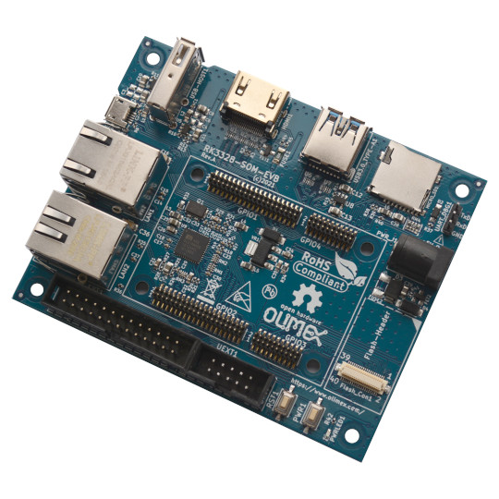

RK3328-SOM-EVB
User Manual
Rev.1.0 May 2021
olimex.com

Table of Contents
Overview 3
General information 4
Order codes 5
RK3328-SOM-EVB Features 6
Software 7
Power supply 8
Hardware components 9
SOC 9
Memory 9
PMU 9
USB 9
Display 9
Audio 9
Connectors 10
EXT1 10
UEXT 11
Open Source Hardware design 12
Revision History 13
Contact information 14

Overview

RK3328-SOM-EVB is Evaluation board for RK3328-SOM System On Module with Quad core Cortex-A53 64 bit ARM SOC.
The RK3328-SOM-EVB allow all features of the SOM to be explored.
Top view:
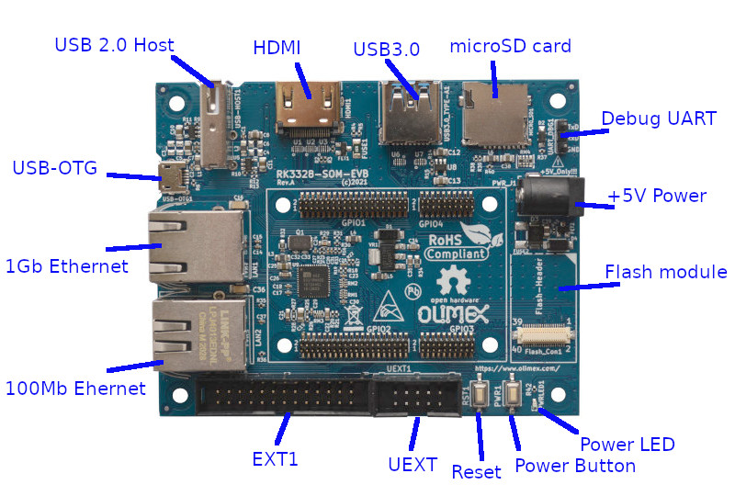

General information

RK3328 SOC is Quad core Cortex-A53 running up to 1.5 Ghz, USB 3.0, 2x USB 2.0, I2S, UART, SPI, I2C, Audio Codec, DDR3L memory, HDMI.
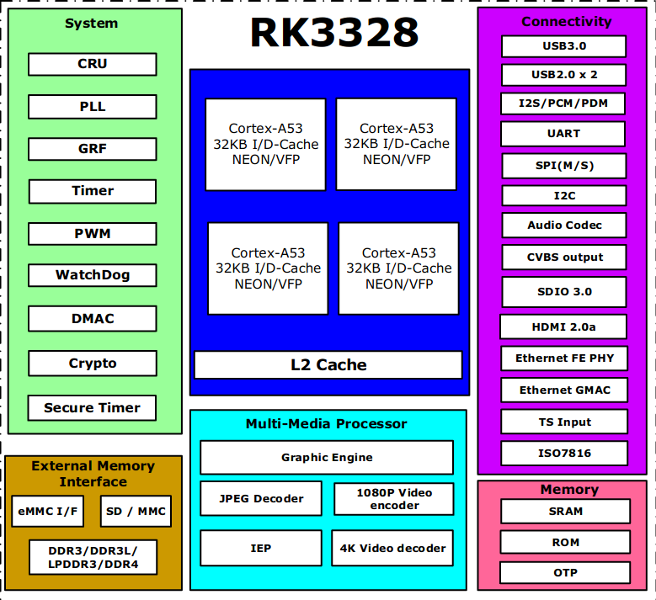
The system on modules are produced in commercial 0-70C temperature.

Order codes

RK3328-SOM-EVB commercial grade 0-70C. Note that this board do not include SOM module, so you have to purchase separately RK3328-SOM-1G or RK3328-SOM-2G

RK3328-SOM-EVB Features

- Connectors for RK3328-SOM
- USB-Host
- USB-OTG
- USB 3.0
- Megabit Ethernet
- Gigabit Ethernet
- Flash module connector
- HDMI
- micro SD card
- Debug UART
- UEXT connector
- EXT1 connector
- Power supply jack +5VDC
- Reset and Power buttons
- Power LED
- Operating temperature 0-70C

Software

Rockchip provides Android 7.1 and Android 8.1 SDK with sources, Debian and Ubuntu Linux distributions with all hardware accelerators working. The Linux is not mainline.

Pre-built images are hosted at:
http://images.olimex.com/release/rk3328/

We recommend the images to be written to SD card with minimum 16GB Class10 speed like:
https://www.olimex.com/Products/Components/Storage/MICRO-SD-CLASS10/

To write the images we recommend balenaEtcher:
https://www.balena.io/etcher/

Power supply

RK3328-SOM-EVB requires +5V, 1A to operate.
Do not apply more than 5V as this would damage the RK3328-SOM-EVB and RK3328-SOM.

Power consumption is:
- around 0.4A during boot and idle
- around 0.6A when working at full speed
- around 0.8A at stress

Hardware components

SOC

RK3328 is Quad core Cortex-A53 ARM running @1.5Ghz

Memory
RK3328-SOM can have 1GB or 2GB DDR3L memory, powered with 1.35V, with 16 bit data bus width and running at 1066Mhz (533Mhz clock).

PMU
RK3328-SOM have Power Management Unit based on RK805. It allow the power voltage to SOC core, peripherals, DDR3L memory and etc to be programmable via I2C. Special driver in Linux take care for the different power modes.

USB
One USB 3.0 and two High Speed USB 2.0 Host and OTG

Display
HDMI output 1080p Full HD resolution.

Audio
Build in Stereo Audio codec.

Connectors

EXT1

EXT1 is 26 pin 0.1 inch (2.54 mm) step connector with 2x ADC, VDAC, Audio Codec, UART1, SPDIF, IR Rx, PWM2, 11x GPIOs:

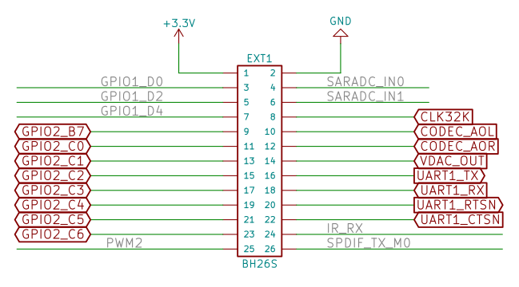

UEXT

UEXT is universal connector where different modules can be connected: interfaces, adaptors, sensors, relays, RFID, RTC etc. You can see all them on Olimex web page:

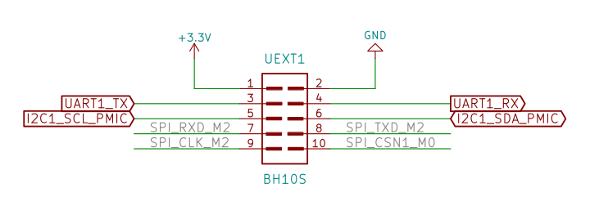

Open Source Hardware design

RK3328-SOM-EVB is open source hardware, this means that all CAD sources are available to be learn, study, modify, distribute, make, and sell the design or hardware based on that design.
The board is designed using KiCad.
KiCad is open source software and completely free to download and use.
All files are available on GitHub.

Revision History
Revision 1.0 May 2021

Contact information

Headquarters and Factory address:

OLIMEX Ltd
ul. Pravda 2
Plovdiv 4000
BULGARIA

Sales: sales@olimex.com
Technical Support: support@olimex.com
Corporate Website: www.olimex.com

For latest news and developments - follow our
- Blog
- GitHub
- Twitter
- Facebook
- Mastodon
- Pluspora
- IRC
- flicr

