

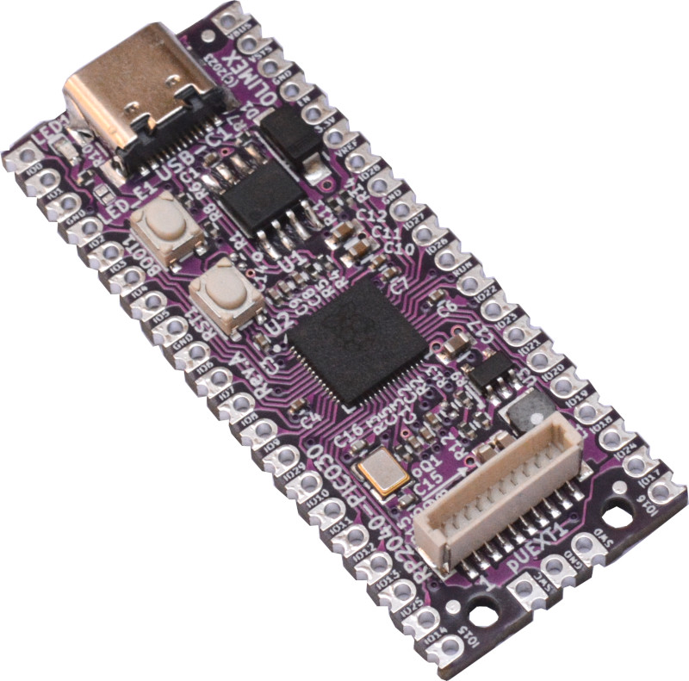

RP2040-PICO30
User Manual

Rev.1.1 June 2023 www.olimex.com

Table of Contents
Introduction to RP2040-PICO30 3
Order codes for RP2040-PICO30 and accessories: 4
HARDWARE 5
RP2040-PICO30 hardware layout: 5
RP2040-PICO30 GPIOs: 6
RP2040-PICO30 schematics: 8
UEXT connector: 9
pUEXT signals: 10
SOFTWARE 11
DOCUMENT REVISION HISTORY 12

Introduction to RP2040-PICO30

RP2040-PICO30 is a re-design of the popular Raspberry Pi Pico (with RP2040) board with these improvements:
- All 30 of RP2040 GPIOs are available to the user
- USB-C power supply connector which allows more current to be used by the board
- SY8089A 3.3V 2A (3A peak) DCDC power supply
- 2MB or 16MB Flash versions are possible
- RESET button added
- Four layer board for better noise immunity and USB differential pair routing
- UEXT connector (pUEXT 1.0 mm step connector)
- Dimensions: 21 x 51 mm
RP2040-PICO30 keeps same layout and pinout as the original Raspberry Pi Pico (RP204), however the four extra GPIOs are placed on locations that are GNDs in the original design (original deisgn has 8 GNDs on the headers, while RP2040-PICO30 has 4 GNDs exposed).
The original RP2040-PICO exposes only 26 out of the 30 RP2040 GPIOs and RP2040-PICO30 solves this issue.
+ Important notice: RP2040-PICO30 keeps the same layout as Raspberry Pi Pico, however in order to expose the 4 extra GPIOs, we sacrfice 4 of the GNDs (that are exposed in the original design). RP2040-PICO30 adds the four missing GPIOs: GPIO23, GPIO24, GPIO25, GPIO29 on four of the eight GND pads. When you use RP2040-PICO30 on RPi Pico board make sure these GPIOs are INPUTS!

Order codes for RP2040-PICO30 and accessories:

RP2040-PICO30 industrial grade RPi Pico (RP2040) with 30 GPIOs exposed
RP2040-PICO30U RP2040-PICO30 with UEXT, LED, R10, R15, R16
RP2040-PICO30-16 RP2040-PICO30 with 16MB of Flash (max possible for RP2040)
RP2040-PICO30U-16 RP2040-PICO30 with 16MB of Flash, UEXT, LED, R10, R15, R16

HARDWARE

RP2040-PICO30 hardware layout:

RP2040
UEXT connector with SPI I2C UART
PIN.40
PIN.21
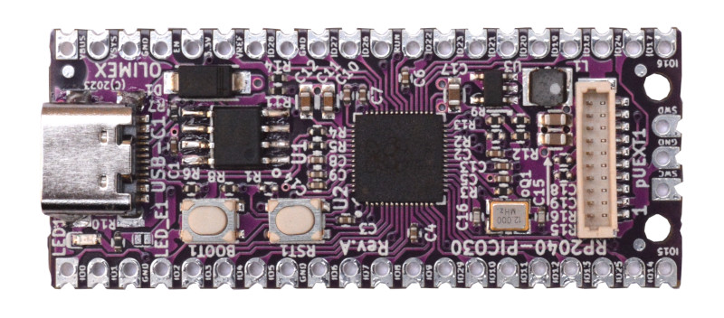
Flash
USB-C

DEBUG

LED

LED enable jumper
RESET button
PIN.20
Boot button
PIN.1
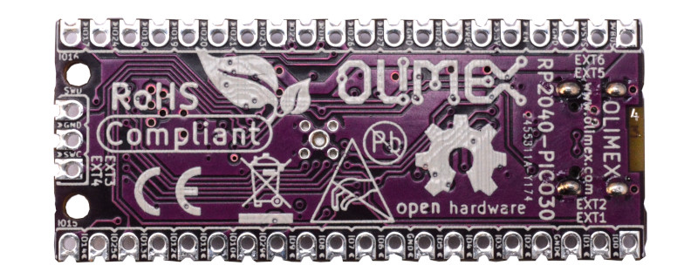

RP2040-PICO30 GPIOs:
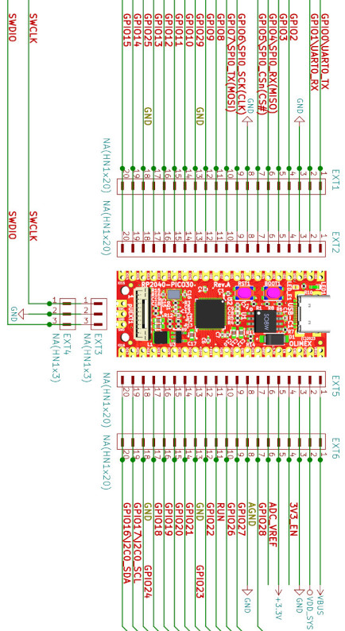

Table1. Notable pins
Power-related
VBUS | +5V line coming from USB-C, can be used as output
VDD_SYS | +5V line that can be used as output or input but if you want to use it as an input (to power the board from an external 5V source) make sure that the board is not powered (connected) to USB! Having power source connecting to USB and VDD_SYS simultaneously would lead to short-circuit and damage.
+3.3V | +3.3V line, can be used as output which can source up to 2A @ 3.3V
3V3_EN | Input, when pulled to GND stops the 3.3V DCDC converter
GPIO-related
GPIO23  (Pin #28 from the original RPi Pico layout) | This GPIO is not led out in the original RP2040-PICO design and on this place there is GND line so if you use RP2040-PICO30 in RP2040-PICO design make sure to initialize it as INPUT
GPIO24  (Pin #23 from the original RPi Pico layout) | This GPIO is not led out in the original RP2040-PICO design and on this place there is GND line so if you use RP2040-PICO30 in RP2040-PICO design make sure to initialize it as INPUT
GPIO25  (Pin #18 from the original RPi Pico layout) | This GPIO is not led out in the original RP2040-PICO design and on this place there is GND line so if you use RP2040-PICO30 in RP2040-PICO design make sure to initialize it as INPUT
GPIO29  (Pin #13 from the original RPi Pico layout) | This GPIO is not led out in the original RP2040-PICO design and on this place there is GND line so if you use RP2040-PICO30 in RP2040-PICO design make sure to initialize it as INPUT

Basically RPi Pico has 8 GNDs in total exposed on the connectors. While RP2040-PICO30 has 4GNDs and 4 extra GPIOs.

RP2040-PICO30 schematics:

RP2040-PICO30 latest schematic is available at our GitHub

UEXT connector:

UEXT connector stands for Universal EXTension connector and contains +3.3V, GND, I2C, SPI, UART signals.
UEXT connector can be in different shapes.
The original UEXT connector is 0.1” 2.54mm step boxed plastic connector. All signals are at 3.3V levels.
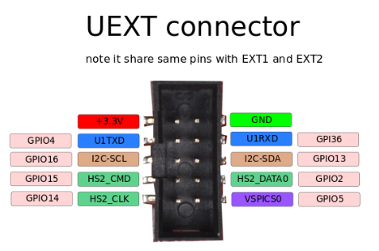

As the boards become smaller and smaller, we introduced smaller form-factor UEXT connectors too alongside the original UEXT connector:
- mUEXT is 1.27 mm step boxed header connector which is with same layout as UEXT;
- pUEXT is 1.0 mm single row connector (this is the connector used in RP2040-PICO30).
We are in process of releasing adapter that can be used to into connect devices with different type and size of UEXT connector.
Olimex manufactures a number of MODULES compatible with this connector. There are temperature, humidity, pressure, magnetic field, light sensors. Modules with LCDs, LED matrix, relays, Bluetooth, Zigbee, WiFi, GSM, GPS, RFID, RTC, EKG, sensors, and more.

pUEXT signals:
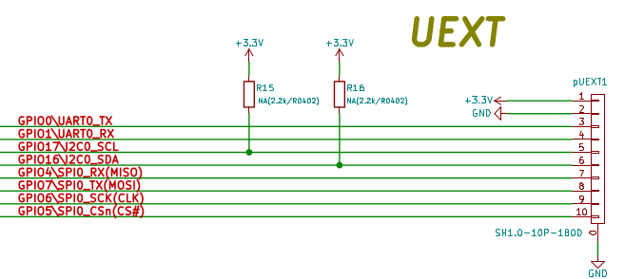

SOFTWARE

RP2040-PICO30 uses the same software as RP2040-PICO:
- Raspberry PI C-SDK
- MicroPython SDK

DOCUMENT REVISION HISTORY

Document revision 1.1 June 2023
- product names fixes
- general improvements

Document revision 1.0 May 2023
- initial release

