

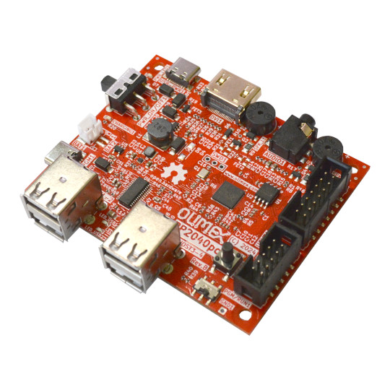

RP2040pc
User Manual
Rev.1.0 December 2024 olimex.com
Table of Contents
What is RP2040pc 3
Order codes for RP2040pc and accessories: 4
HARDWARE 5
RP2040pc layout: 6
RP2040pc EXT1 connector: 7
UEXT connector: 8
RP2040pc schematics: 10
SOFTWARE: 11
Programming RP2040 12
Revision History 13

What is RP2040pc

RP2040pc is complete all in one computer based on RP2040 Dual core Cortex-M0 processor from the Raspberry Pi foundation.

The features of RP2040pc are:
- RP2040 with 16MB of SPI Flash, easy to load new firmware via drag and drop virtual drive
- DVI/HDMI output
- USB with 4 USB2.0 hub which can be used for programming and to connect to keyboard, mouse, USB Flash, USB Gamepads etc
- Stereo Audio buzzer which you can enable/disable
- Audio 3.5mm connector for external audio amplifier
- USB-C connector for power supply
- USB-C connector for programming
- UEXT connector with I2C, UART and SPI for connecting to external boards
- Power switch
- Programming/Execution switch
- RP2040 programming bootloader button
- four mounting holes 3.3mm diameter
- Lipo battery charger which allow the board to run from LiPo battery.
- Dimension 80x65mm

RP2040pc is Open Source Hardware, all CAD files and firmware and available, so people can study and modify.
+ Important notice: If RP2040pc is not mounted in box be careful to not place it on metal surface, nor drop metal objects on top of the PCB! This will lead to damage.

Order codes for RP2040pc and accessories:

RP2040pc RP2040 all in one computer with 4 USB hosts and HDMI display
USB-KEYBOARD-PS2 Keyboard which is compatible with RP2040pc
USB-GAMEPAD USB Gamepad supported by Reload emulator
USB-CABLE-AM-USB3-C High speed, High current cable for power supply and programming
CABLE-HDMI-50CM HDMI cable
UEXT modules many UEXT modules which can connect to Neo6502 UEXT connector
BOX-RP2040pc plastic box for RP2040pc

HARDWARE

RP2040pc layout:

USB-C
power supply
DVI/HDMI output
Stereo Audio 3.5mm jack
Left audio
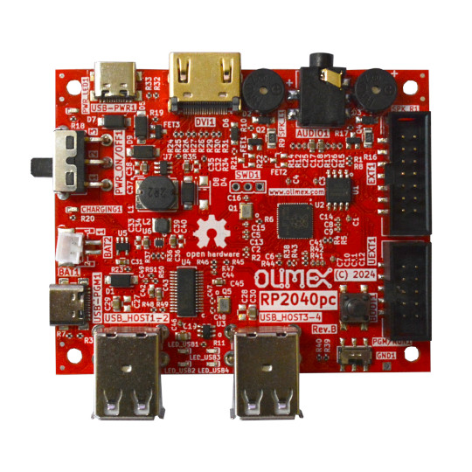
Right audio

ON/OFF switch
EXT1 connector

LiPo battery

UEXT connector

BOOT button
USB-C programming

Programing / RUN switch
USB2.0 host 1 and 2
USB2.0 host 3 and 4

RP2040pc EXT1 connector:

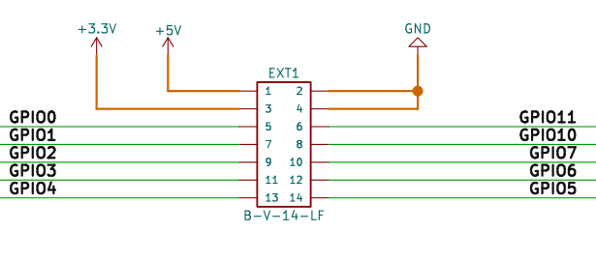

UEXT connector:

UEXT connector stands for Universal EXTension connector and contain +3.3V, GND, I2C, SPI, UART signals.
UEXT connector can be in different shapes.
The original UEXT connector is 0.1” 2.54mm step boxed plastic connector. All signals are with 3.3V levels.
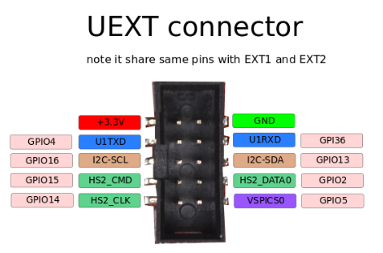

Olimex has developed number of MODULES with this connector. There are temperature, humidity, pressure, magnetic field, light sensors. Modules with LCDs, LED matrix, Relays, Bluetooth, Zigbee, WiFi, GSM, GPS, RFID, RTC, EKG, sensors and etc.

RP2040pc UEXT connector is wired to RP2040 GPIOs as follows:
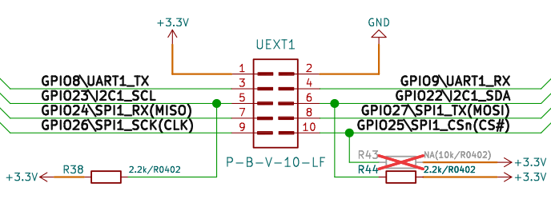

RP2040pc schematics:

RP2040pc latest schematic is on GitHub

SOFTWARE:

RP2040pc can be programmed with RaspberryPi C-SDK or MicroPython SDK.

For the retro computing fans the Reload emulator written by Veselin Sladkov (veselin.sladkov@gmail.com) supports RP2040pc and can emulate Apple ][, Apple][e, Oric Atmos, Pravetz 82, Pravetz 8D and all games from Total Replay 5.2 are supported.

If you want to build reload emulator you will need some ROMs and Disk images which are hosted on olimex’s ftp.

The .uf2 image of the Reload is on ftp. You will need Flash drive formatted with FAT and with copy of Total relay 5.2 from the ftp.

Programming RP2040

The RP2040 firmware is UF2 file. You can get pre-build firmware of reload emulator on olimex’s ftp.

To program the .uf2 files you need USB-A to USB-C cable like USB-CABLE-AM-USB3-C.

1. Disconnect the power supply from USB-PWR1 connector and connect it to USB-PGM1 connector.
2. Move PGM/RUN1 switch to PGM position.
3. Press the BOOT1 button and switch on the power supply with PWR_ON/OFF1 switch then release BOOT1 button.
4. You will see on your computer new disk drive RPI-RP2.
5. Copy the .uf2 file to this drive, once it’s copied the drive will disappear.
6. Switch OFF the PWR_ON/OFF1 switch
7. Move PGM/RUN1 switch to RUN position.
8. Disconnect the USB-C cable from USB-PGM1 and connect to USB-PWR1 connector.
9. Switch ON power supply.

Revision History
Revision 1.0 December 2024

