

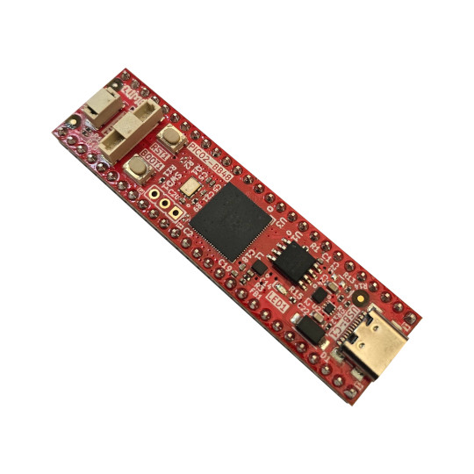

RP2350-PICO2-BB48
User Manual
Rev.1.0 September 2025 olimex.com
Table of Contents
Introduction to RP2350-PICO2-BB48 3
Order codes for RP2350-PICO2-BB48 and accessories: 4
HARDWARE 5
RP2350-PICO2-BB48 layout: 6
Bottom for BB48R 8
RP2350-PICO2-BB48 GPIOs: 9
RP2350-PICO2-BB48 schematics: 11
UEXT connector: 12
pUEXT signals: 13
Qwiic/Stemma connector: 13
Micro SD card connection: 14
PSRAM connection: 15
LED connection: 16
SOFTWARE: 17
Revision History 18

Introduction to RP2350-PICO2-BB48

RP2350-PICO2-BB48 is re-design of the popular Raspberry PI PICO2 board with these improvements:
- all 48 RP2350 GPIOs are available to the user
- USB-C power supply connector which allow more current to be used by the board
- DCDC power supply voltage regulator 3.3V 2A (3A peak)
- 16MB Flash versions
- 8MB PSRAM for BB48R version
- micro SD card connector for XXL version
- RESET button is add
- Four layer board for better noise immunity and USB differential pair routing
- UEXT connector (pUEXT 1.0 mm step connector)
- Qwiic/Stemma connector
- Distance between signal rows 0.6” (15.24mm)
- Dimensions 69x18 mm

Note:
Both RP2350-PICO2-BB48 and RP2350-PICO2-BB48R share same PCB with same silkscreen where PP2350-PICO2-BB48 is written! The only difference is that in BB48 version PSRAM and micro SD card (both on bottom side of the PCB) are not populated.

Order codes for RP2350-PICO2-BB48 and accessories:

RP2350-PICO2-BB48 industrial grade RP2350-PICO2 board with 48 GPIOs exposed
RP2350-PICO2-BB48R includes everything in BB48 plus 8MB PSRAM and microSD card
USB-CABLE-AM-USB3-C high quality USB-C cable for power and programming
pUEXT pack of cables pack of 3 pcs 200 mm pUEXT cables
UEXT-MPQ converter board from pUEXT to UEXT

HARDWARE

RP2350-PICO2-BB48 layout:

Top for BB48 and BB48R
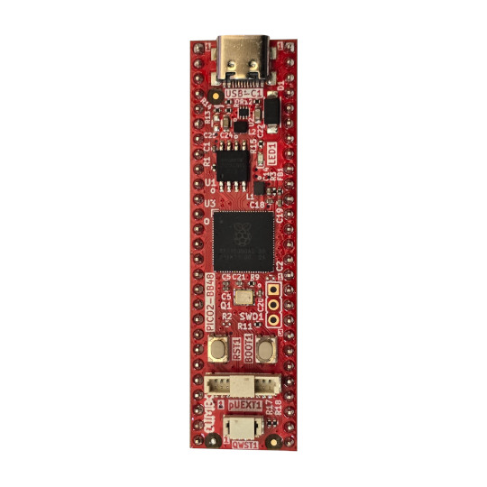
USB-C
Status LED
Boot button
UEXT
Qwicc STemma
Reset button
RP2350B
16MB Flash
Bottom for BB48

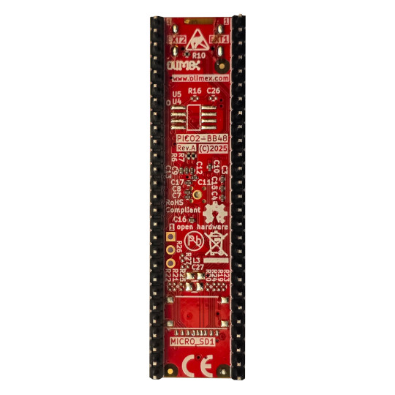

Bottom for BB48R
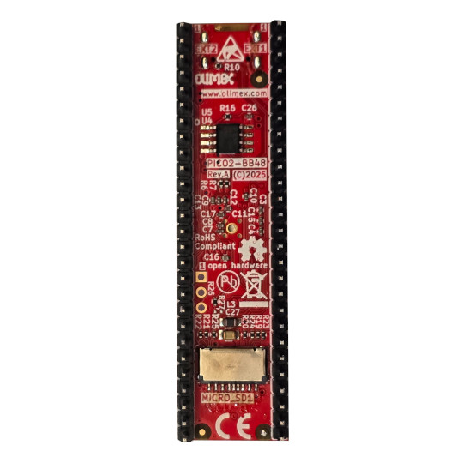
8MB PSRAM
Micro SD card

RP2350-PICO2-BB48 GPIOs:

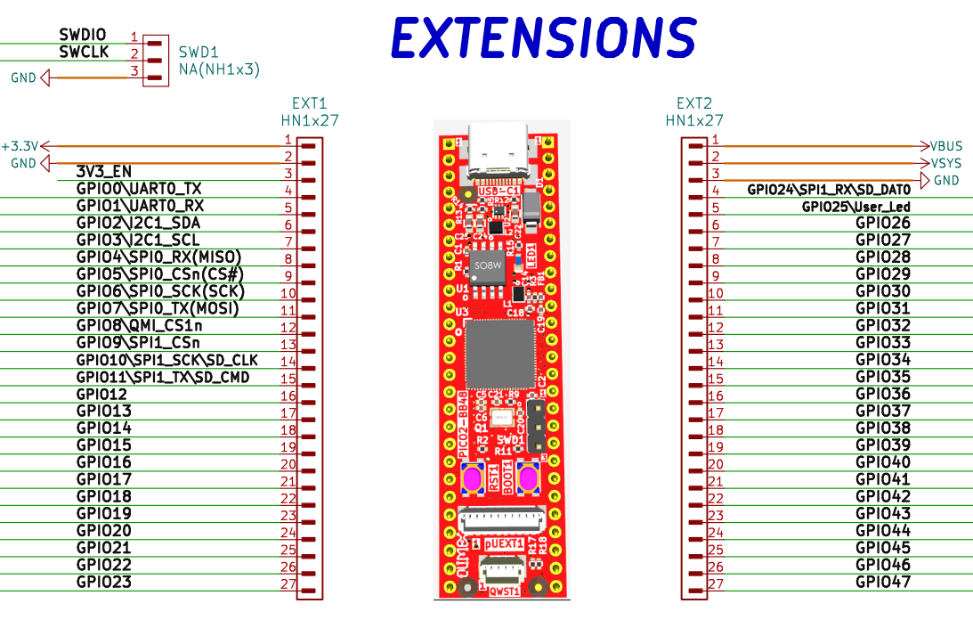

POWER SUPPLY:

VBUS +5V from, USB-C output
VDD_SYS +5V may be output or input
if you want to use as input i.e. to feed power from external 5V to this line make sure board is not connected to USB!
when you use as output i.e. you feed external electronics from it up to 1A @ 5V
+3.3V output which can source up to 2A @ 3.3V
3V3_EN input, when pulled to GND stops the 3.3V DCDC convertor

RP2350-PICO2-BB48 schematics:

RP2350-PICO2-BB48 latest schematic is on GitHub.

UEXT connector:

UEXT connector stands for Universal EXTension connector and contain +3.3V, GND, I2C, SPI, UART signals.
UEXT connector can be in different shapes.
The original UEXT connector is 0.1” 2.54mm step boxed plastic connector. All signals are with 3.3V levels.
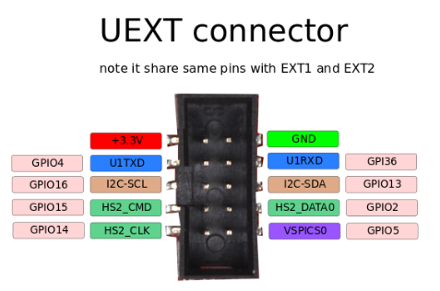

As the boards become smaller and smaller some smaller packages were introduced too beside the original UEXT connector
- mUEXT is 1.27 mm step boxed header connector which is with same layout as UEXT
- pUEXT is 1.0 mm single row connector (this is the connector used in RP2040-PICO30)

Olimex has developed number of MODULES with this connector. There are temperature, humidity, pressure, magnetic field, light sensors. Modules with LCDs, LED matrix, Relays, Bluetooth, Zigbee, WiFi, GSM, GPS, RFID, RTC, EKG, sensors and etc.

pUEXT signals:
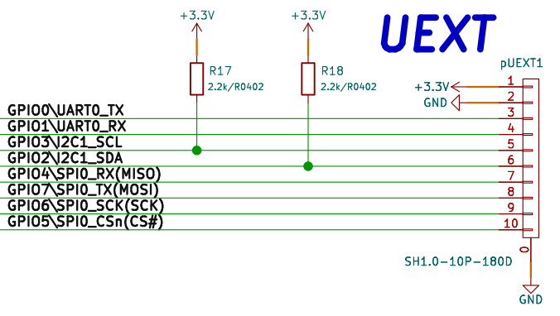

Qwiic/Stemma connector:
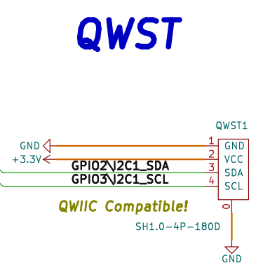

Micro SD card connection:
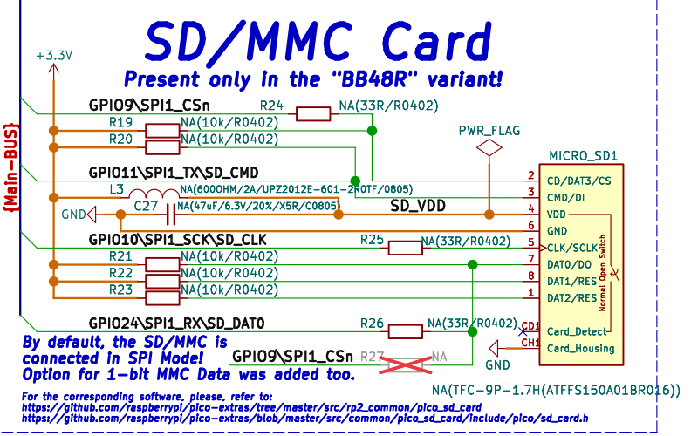

PSRAM connection:
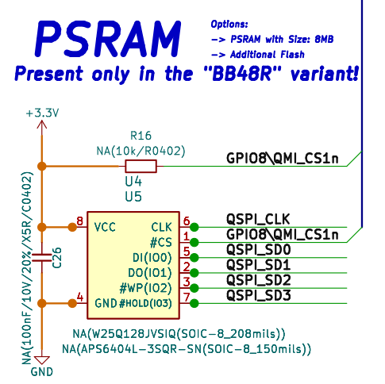

LED connection:

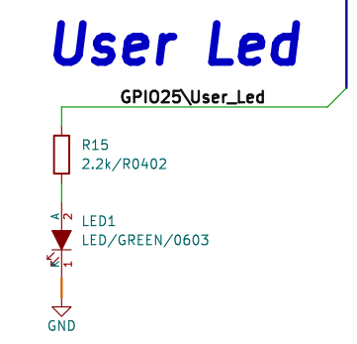

SOFTWARE:

RP2350-PICO2-BB48 uses same software as PICO2
- Raspberry PI C-SDK
- MicroPython SDK (note that to the current date RP2350B chip support is not implemented in MicroPython and the access of the GPIO30-47 in MicroPython is not implemented.
- CircuitPython from Adafruit – all 48 GPIOs are implemented.

Revision History
Revision 1.0 September 2025

