

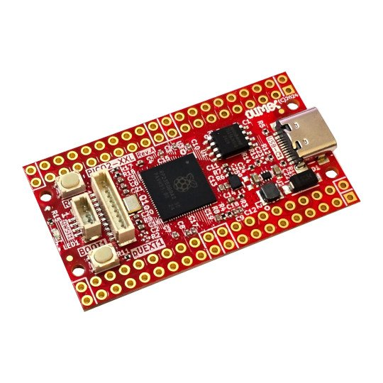

RP2350-PICO2-XXL
User Manual
Rev.1.0 January 2025 olimex.com
Table of Contents
Introduction to RP2350-PICO2-XXL 3
Order codes for RP2350-PICO2-XXL and accessories: 4
HARDWARE 5
RP2350-PICO2-XXL layout: 6
Bottom for XXL 8
RP2350-PICO2-XXL GPIOs: 9
RP2350-PICO2-XXL schematics: 11
UEXT connector: 12
pUEXT signals: 13
Qwiic/Stemma connector: 13
Micro SD card connection: 14
PSRAM connection: 15
LED connection: 16
SOFTWARE: 17
Revision History 18

Introduction to RP2350-PICO2-XXL

RP2350-PICO2-XXL is re-design of the popular Raspberry PI PICO2 board with these improvements:
- all 48 RP2350 GPIOs are available to the user
- USB-C power supply connector which allow more current to be used by the board
- DCDC power supply voltage regulator 3.3V 2A (3A peak)
- 2MB or 16MB Flash versions are possible (-XL and -XXL)
- 8MB PSRAM for XXL version
- micro SD card connector for XXL version
- RESET button is add
- Four layer board for better noise immunity and USB differential pair routing
- UEXT connector (pUEXT 1.0 mm step connector)
- Qwiic/Stemma connector
- Dimensions 50x28 mm

Note:
Both RP2350-PICO2-XL and RP2350-PICO2-XXL share same PCB with same silkscreen where PP2350-PICO2-XXL is written! The only difference is that in XL version PSRAM, micro SD card (both on bottom side of the PCB) are not populated.

Order codes for RP2350-PICO2-XXL and accessories:

RP2350-PICO2-XL industrial grade RP2350-PICO2 board with 48 GPIOs exposed
RP2350-PICO2-XXL includes everything in XL plus 8MB PSRAM and microSD card
USB-CABLE-AM-USB3-C high quality USB-C cable for power and programming
pUEXT pack of cables pack of 3 pcs 200 mm pUEXT cables
UEXT-MPQ converter board from pUEXT to UEXT

HARDWARE

RP2350-PICO2-XXL layout:

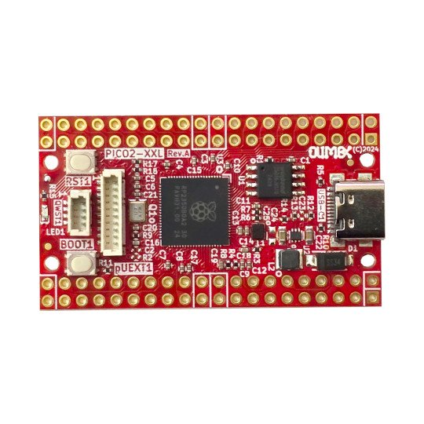
Top for XL and XXL
Boot button
Qwiic Stemma
LED
RESET
UEXT
RP2350B
2MB or 16MB Flash
USB-C
Power supply
Bottom for XL

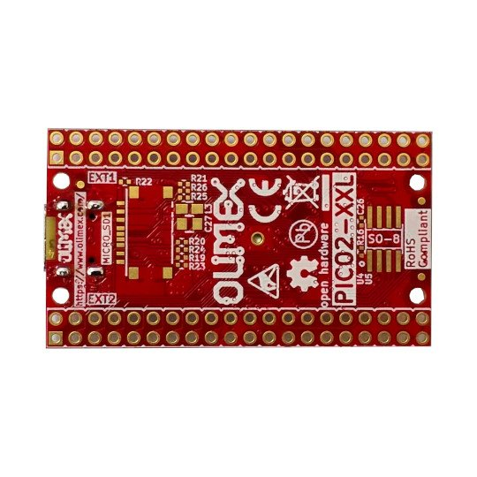

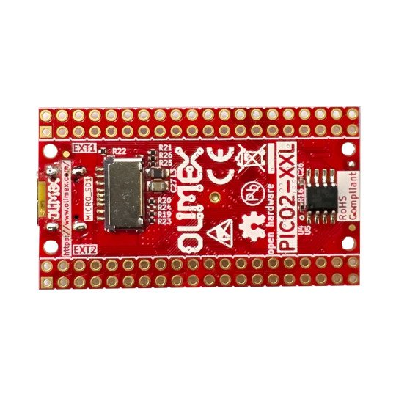
Bottom for XXL
Micro SD card
8MB PSRAM

RP2350-PICO2-XXL GPIOs:

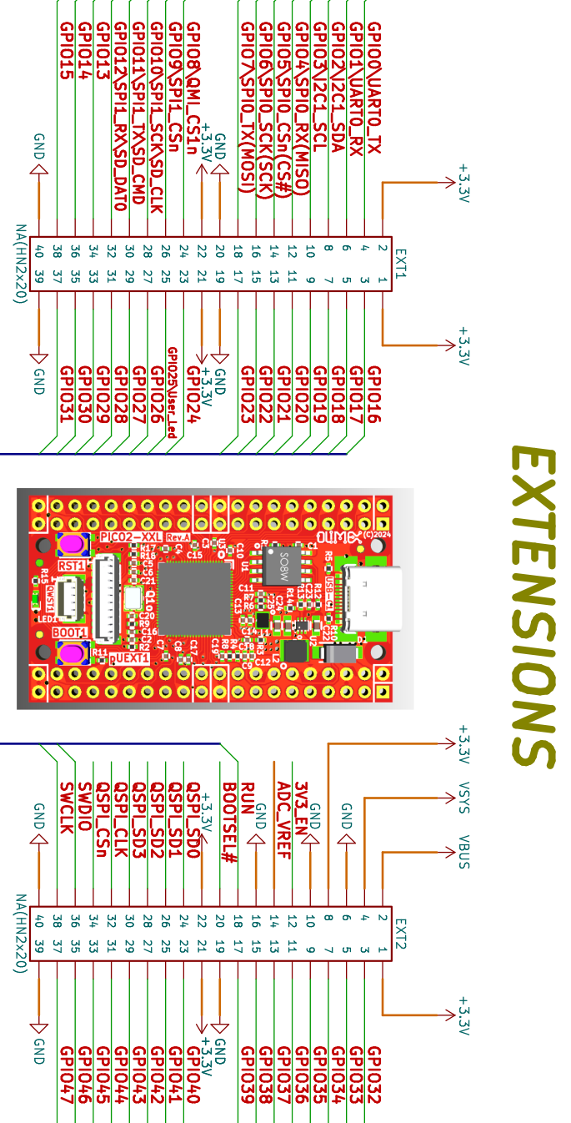

POWER SUPPLY:

VBUS +5V from, USB-C output
VDD_SYS +5V may be output or input
if you want to use as input i.e. to feed power from external 5V to this line make sure board is not connected to USB!
when you use as output i.e. you feed external electronics from it up to 1A @ 5V
+3.3V output which can source up to 2A @ 3.3V
3V3_EN input, when pulled to GND stops the 3.3V DCDC convertor

RP2350-PICO2-XXL schematics:

RP2350-PICO2-XXL latest schematic is on GitHub

UEXT connector:

UEXT connector stands for Universal EXTension connector and contain +3.3V, GND, I2C, SPI, UART signals.
UEXT connector can be in different shapes.
The original UEXT connector is 0.1” 2.54mm step boxed plastic connector. All signals are with 3.3V levels.
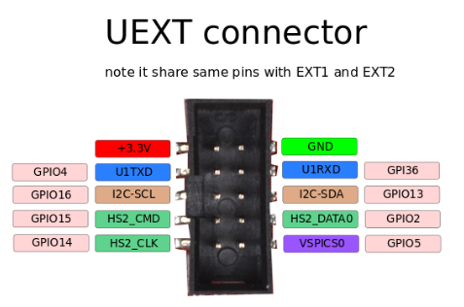

As the boards become smaller and smaller some smaller packages were introduced too beside the original UEXT connector
- mUEXT is 1.27 mm step boxed header connector which is with same layout as UEXT
- pUEXT is 1.0 mm single row connector (this is the connector used in RP2040-PICO30)

Olimex has developed number of MODULES with this connector. There are temperature, humidity, pressure, magnetic field, light sensors. Modules with LCDs, LED matrix, Relays, Bluetooth, Zigbee, WiFi, GSM, GPS, RFID, RTC, EKG, sensors and etc.

pUEXT signals:
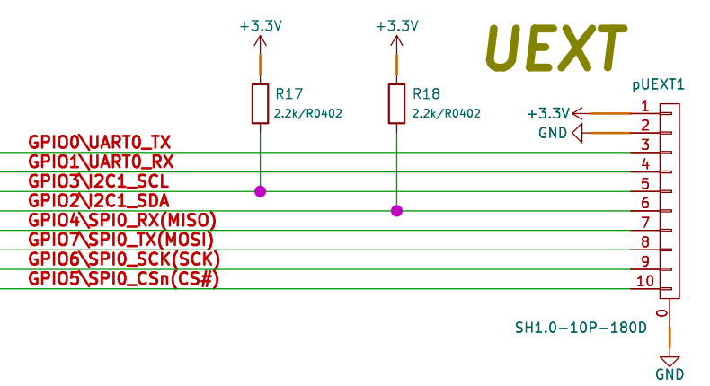

Qwiic/Stemma connector:
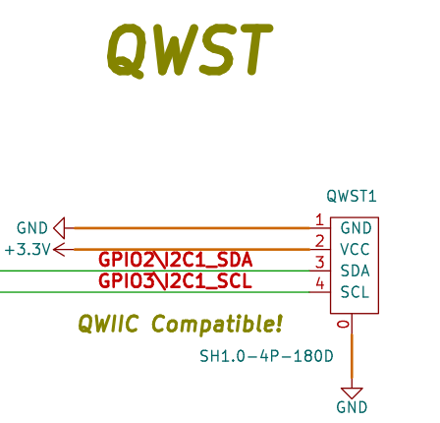

Micro SD card connection:
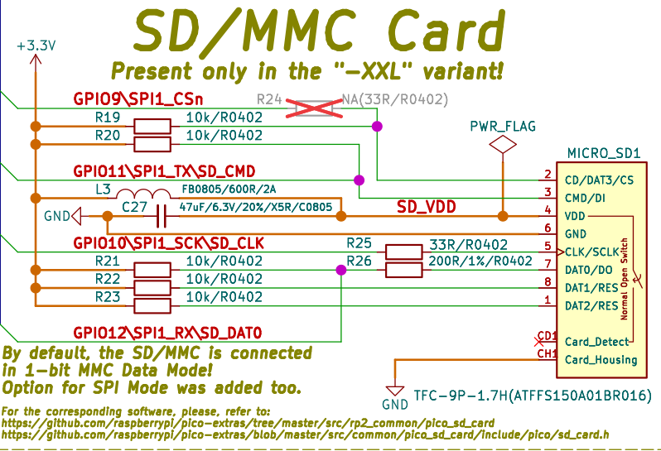

PSRAM connection:
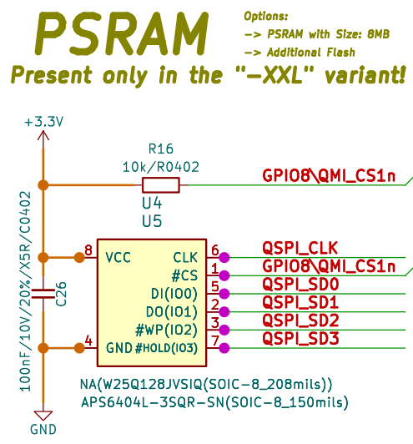

LED connection:
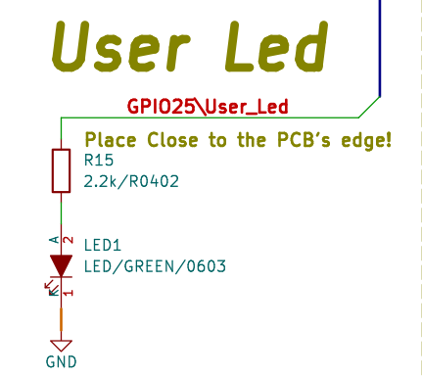

SOFTWARE:

RP2350-PICO2-XXL uses same software as PICO2
- Raspberry PI C-SDK
- MicroPython SDK (note that to the current date RP2350B chip support is not implemented in MicroPython and the access of the GPIO30-47 in MicroPython is not implemented.
- CircuitPython from Adafruit – all 48 GPIOs are implemented.

Revision History
Revision 1.0 January 2025

