

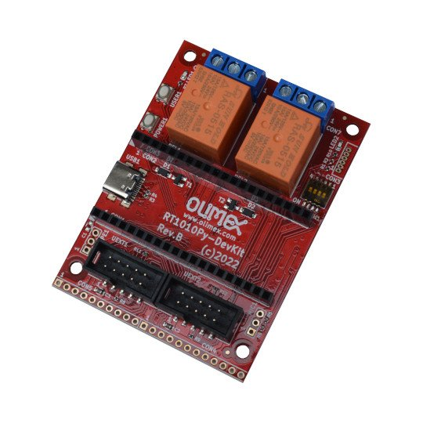

RT1010Py-DevKit
User Manual
Rev.1.0 January 2024 olimex.com
Table of Contents
What is RT1010Py-DevKit 3
Order codes for RT1010Py-DevKit and accessories: 4
HARDWARE 5
RT1010PyDevKit layout: 6
RT1010Py-DevKit schematics: 7
GPIO connectors: 8
UEXT connector: 9
SOFTWARE: 10
Revision History 12

What is RT1010Py-DevKit

RT1010Py-DevKit is development board for RT1010Py module

RT1010Py-DevKit has these features:
- socket for RT1010Py
- USB-C power supply input
- Two buttons
- Two relays 10A/250VAC
- two UEXT connectors
- Boot configuration slide switch
- Dimensions: (55 x 75)mm ~ (2.17 x 2.95)"

Order codes for RT1010Py-DevKit and accessories:

RT1010Py-DevKit evaluation board for RT1010Py with two relays, two UEXT, USB-C
RT1010Py RT1011 board running at 500Mhz with MicroPython
USB-CABLE-A-MICRO-1.8M USB-A to micro cable
MICRO-SD-16GB-CLASS10 16GB microSD card
UEXT modules There are temperature, humidity, pressure, magnetic field, light sensors. Modules with LCDs, LED matrix, Relays, Bluetooth, Zigbee, WiFi, GSM, GPS, RFID, RTC, EKG, sensors and etc.

HARDWARE

RT1010PyDevKit layout:

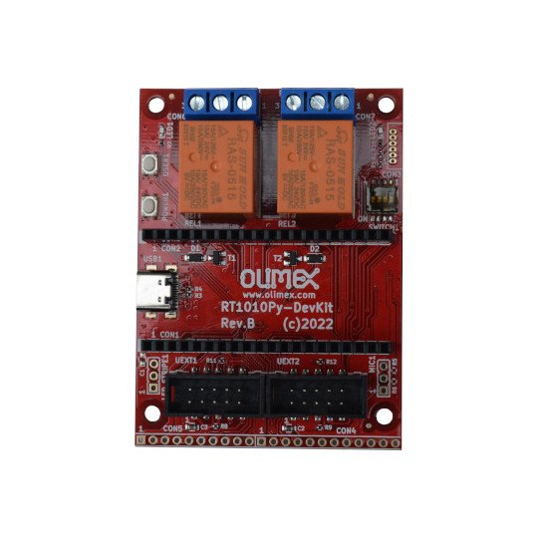
Relay 1 and 2

Relay 1 activity LED
Relay 2 activity LED
CON3 debug
Boot config
Power USB-C
Power button
User button
LED stripe
Microphone
RT1010Py signals
UEXT1
UEXT2

RT1010Py-DevKit schematics:

RT1010Py-DevKit latest schematic is on GitHub

GPIO connectors:

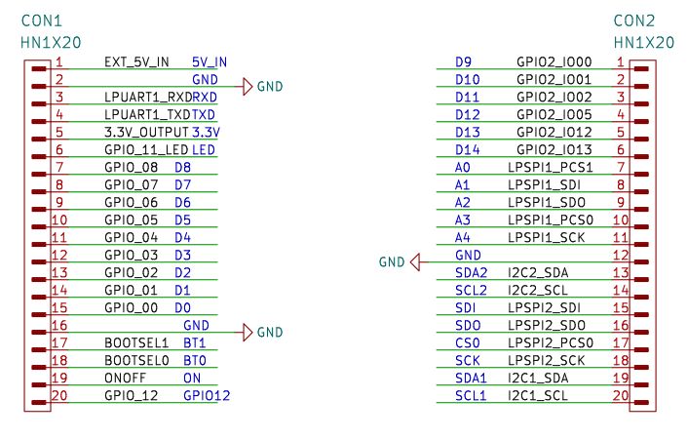

UEXT connector:

UEXT connector stands for Universal EXTension connector and contain +3.3V, GND, I2C, SPI, UART signals.
UEXT connector can be in different shapes.
The original UEXT connector is 0.1” 2.54mm step boxed plastic connector. All signals are with 3.3V levels.
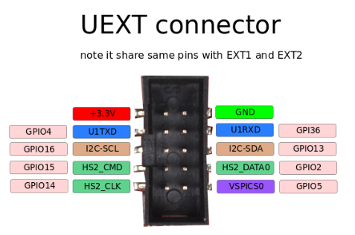

As the boards become smaller and smaller some smaller packages were introduced too beside the original UEXT connector
- mUEXT is 1.27 mm step boxed header connector which is with same layout as UEXT
- pUEXT is 1.0 mm single row connector (this is the connector used in RP2040-PICO30)
- fUEXT is Flat cable 0.5 mm step connector

Olimex has developed number of MODULES with this connector. There are temperature, humidity, pressure, magnetic field, light sensors. Modules with LCDs, LED matrix, Relays, Bluetooth, Zigbee, WiFi, GSM, GPS, RFID, RTC, EKG, sensors and etc.

SOFTWARE:

Revision History
Revision 1.0 January 2024 initial

