

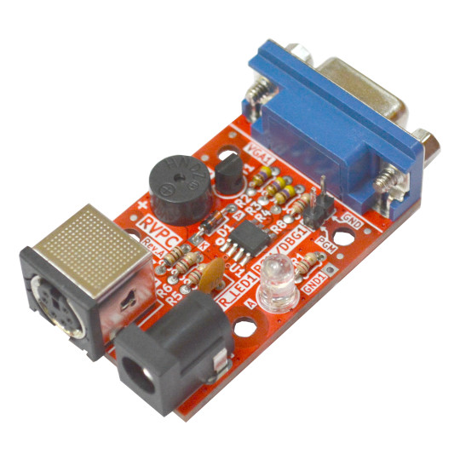

RVPC
User Manual
Rev.1.0 June 2024 olimex.com
Table of Contents
What is RVPC? 3
Order codes for RVPC and accessories: 4
HARDWARE 5
RVPC layout: 6
RVPC schematic: 7
SOFTWARE: 8
Install - packages 8
Install - Visual Studio Code 8
Install - Platform IO 8
Install - CH32V-Platform 8
Prepare the CH32V003 programmer 9
Create project: 10
Revision History 11

What is RVPC?

RVPC is an attempt to produce very low cost EURO 1.00 educational computer with RISC-V processor which to have everything one complete computer have: Keyboard input, VGA display output and Audio output.
The idea of RVPC evolved on TuxCon 2024 as a Lighting talk https://youtu.be/YlYE9a7zsqY.
The goal set was:
- Easy to solder DIY kit
- Complete all in one RISC-V computer with bare minimum Woz like monitor which will allow you to learn the RISC-V instructions by poking, peeking and disassembling the memory
- Price of EUR 1.00!
Here is the result:
CH32V003 in SO8 package – for easy soldering was chosen. It has just 6 GPIOs
- PS2 takes two GPIOs
- VGA takes three GPIOs – Vsync, Hsync and RGB
- Audio buzzer is connected to the last GPIO
All done in beginner friendly PTH components
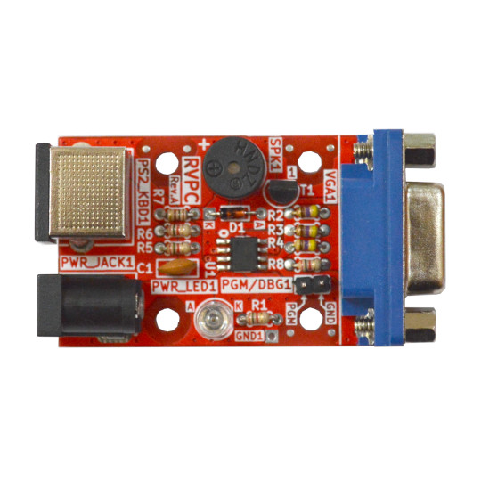

Order codes for RVPC and accessories:

RVPC Do It Yourself soldering kit
SY0605E 5V power supply adapter
PS2-Keyboard PS2 keyboard
ESP32-S2-DevKitLiPo-USB ESP32-S2 development board which can be used as CH32V003
programmer

HARDWARE

RVPC layout:

PS2 keyboard connector
Buzzer
VGA display

+5V power
jack
Power supply LED indicator
CH32V003 programming

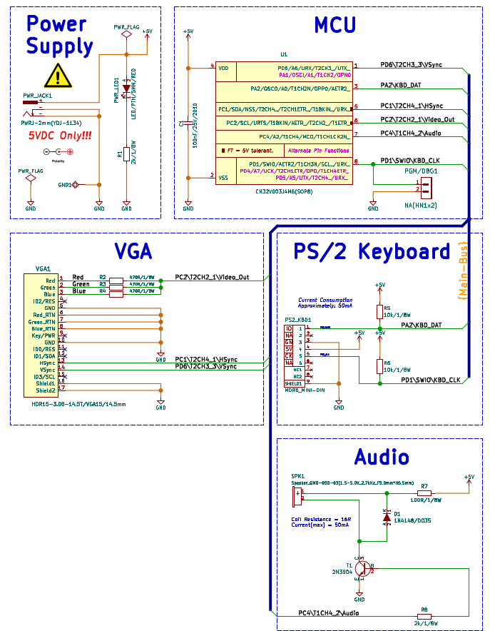
RVPC schematic:

SOFTWARE:

Here below is our setup under Linux:

Install - packages
$ apt-get install build-essential libnewlib-dev gcc-riscv64-unknown-elf libusb-1.0-0-dev libudev-dev gdb-multiarch

Install - Visual Studio Code
Described here: https://code.visualstudio.com/docs/setup/linux

Install - Platform IO
Described here: https://platformio.org/install/ide?install=vscode

Install - CH32V-Platform
https://github.com/Community-PIO-CH32V/ch32-pio-projects?tab=readme-ov-file#installing-the-ch32v-platform
by default the platformio generates only .elf file, to build firmware.bin and firmware.elf select
> PlatformIO > PROJECT TASKS > Default > Advanced > Verbose build

Sample Beeper project is in RVPC repository.

Prepare the CH32V003 programmer

ESP32-S2-DevKitLiPo-USB can be used as programmer.
The firmware is here you can build from sources or you can download the ready built binaries from here and use this sequence to prepare the programmer:
1. hold the Boot button and connect the USB cable, the yellow LED will stay ON
check with
$ls /dev/ttyA*
which is the ttyACM it’s usually 0 or 1
execute this command:
$ python3 ./rvpc/esptool/esptool.py -p /dev/ttyACM0 -b 460800 --before=no_reset --after=no_reset write_flash --flash_mode dio --flash_freq 80m --flash_size 4MB 0x1000 ./rvpc/esp32s2/bootloader.bin 0x10000 ./rvpc/esp32s2/usb_sandbox.bin 0x8000 ./rvpc/esp32s2/partition-table.bin

check if the programmer is already OK with
$ dmesg
you have to see this message:
hid-generic 0003:303A:4004.0015: input,hidraw5: USB HID v1.11 Gamepad [CNLohr ESP32-S2 CH32V003Programmer] on usb-0000:00:14.0-2/input0
which means the ESP32-S2-DevKitLipo-USB now act as programmer and can be used with the demo project above from PlatformIO, but first you have to enable it with:
$ sudo cp ./rvpc/tools/ch32v003fun/minichlink/99-minichlink.rules /etc/udev/rules.d/
$ sudo udevadm control --reload-rules && sudo udevadm trigger

Now you can use GPIO6 and GND to connect to RVPC programming connector PGM-GND

Now CH32V003 flashing will work directly from PlatformIO but if you want to use command line this is the command:
./rvpc/tools/ch32v003fun/minichlink/minichlink -w ./firmware.bin 0x08000000

Create project:

If you create new project to enable the ESP32-S2 programmer you should edit platformio.ini and add this line
upload_protocol = minichlink

It’s already added to the demo project.

Revision History
Revision 1.0 June 2024

