

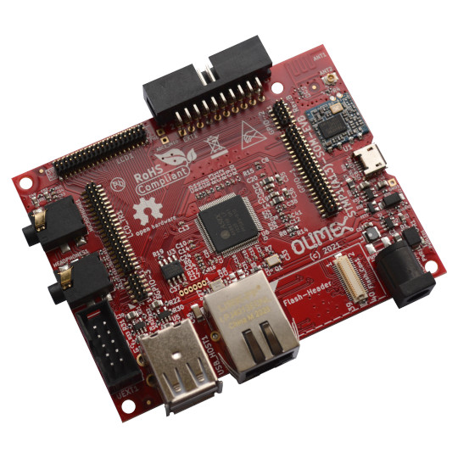

STMP1(A13)-EVB
User Manual
Rev.1.0 May 2021
olimex.com

Table of Contents
Overview 3
General information 4
Order codes 4
STMP1(A13)-EVB Features 5
Power supply 6
Connectors 7
LCD 7
GPIO 8
UEXT 9
Revision History 10
Contact information 11

Overview

STMP1(A13)-EVB is evaluation board for STMP15x-SOM or A13-SOM System On Module running Linux mainline Kernel and Uboot on ST Microelectronics industrial grade Dual Core Cortex-A7 ARM SOC.
As A13-SOM and STMP15x-SOM share same pinout this evaluation board is suitable also for A13-SOM System On Module.
Top view:
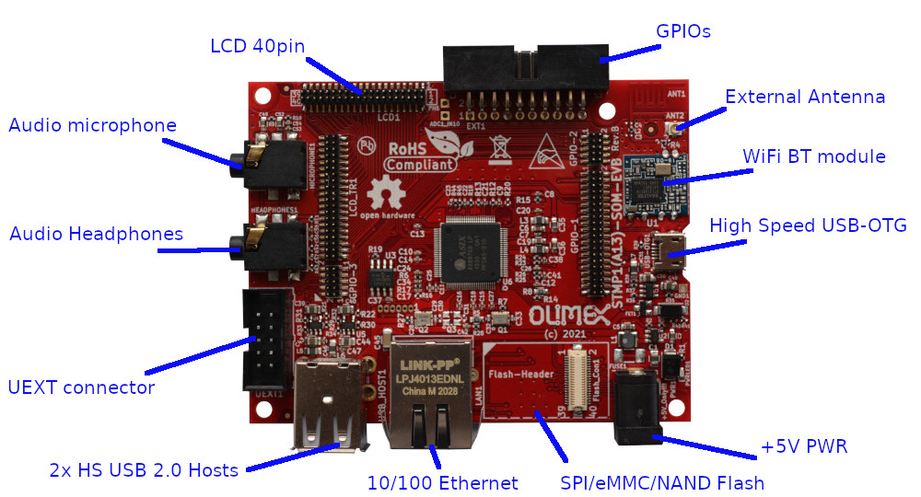

General information

STM32MP15X SOC are Dual-core Arm Cortex-A7 running up to 800 MHz and Cortex-M4 at 209 MHz combined with a LCD interface, dedicated 3D graphics processing unit (GPU).
STMP1(A13)-EVB demo evaluation board is produced only in commercial temperature grade 0-70C.

Order codes

STMP1(A13)-EVB only evaluation board for STMP15x-SOM or A13-SOM, does not include SOM module which have to be bough separately

STMP1(A13)-EVB Features

- 0.05 inch (1.27 mm) connectors for STMP15x-SOM or A13-SOM
- Two High Speed USB 2.0 Hosts
- High Speed USB 2.0 OTG
- 10/100Mb Ethernet connector
- WiFi / Bluetooth module with PCB antenna and option for external antenna
- Flash module connector for: SPI, eMMC, NAND Flash options
- 3.5mm Audio jack for microphone
- 3.5mm Audio jack for headphones
- UEXT connector
- GPIO connector
- 40 pin 0.05 inch (1.27 mm) step connector compatible with LCD-OLinuXino
- Power supply connector 5VDC

Power supply

STMP1(A13)-EVB requires +5V, 0.2A to operate.
Do not apply more than 5V as this would damage the board.
Power consumption (including SOM module) is:
- around 0.4 A during boot
- around 0.6A when working at full speed
- around 1.2A when working at full speed and charge the LiPo battery

Connectors

LCD

RGB LCD signals and I2C connector to digital touch panel interface.
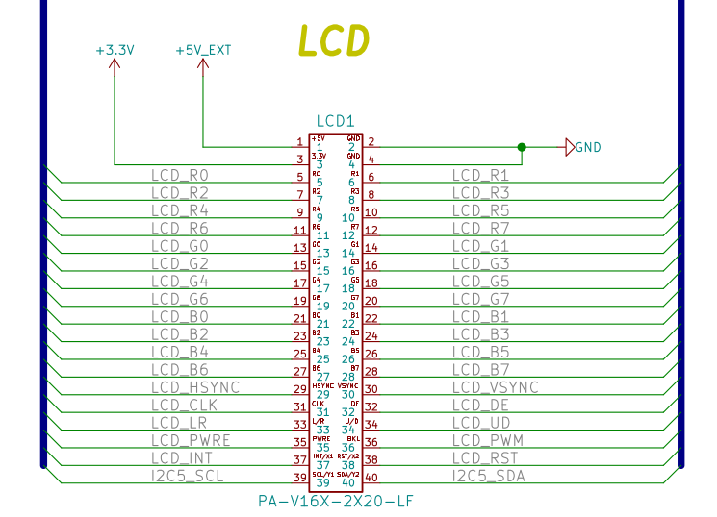

GPIO

Right angle 20 pin connector with 2x I2C, UART, SDMMC, 2 GPIO, NRST, +3.3V and GND.
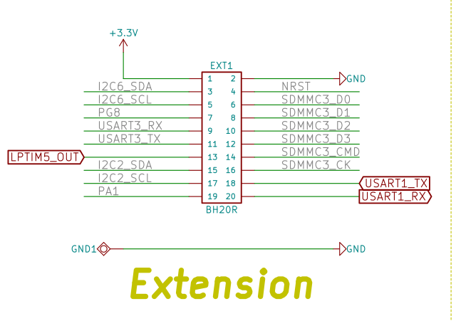

UEXT

UEXT connector for attaching different modules and sensors to SPI, UART, I2C:

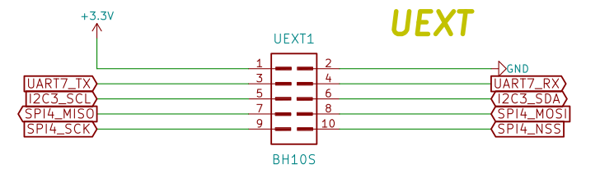

Revision History
Revision 1.0 May 2021

Contact information

Headquarters and Factory address:

OLIMEX Ltd
ul. Pravda 2
Plovdiv 4000
BULGARIA

Sales: sales@olimex.com
Technical Support: support@olimex.com
Corporate Website: www.olimex.com

For latest news and developments - follow our
- Blog
- GitHub
- Twitter
- Facebook
- Mastodon
- Pluspora
- IRC
- flicr

