

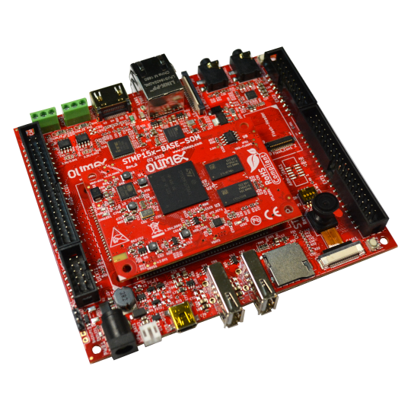

STMP157-BASE-SOM-EVB
User Manual
Rev.1.0 November 2023 olimex.com
Table of Contents
What is STMP157-BASE-SOM-EVB 3
STMP157-BASE-SOM-EVB features: 6
Order codes for STMP157-BASE-SOM-EVB and accessories: 7
HARDWARE 8
STMP157-BASE-SOM-EVB layout: 9
STMP157-BASE-SOM-EVB schematics: 10
SOFTWARE 11
Recommended Olimage Linux images and changelog 11
Olimage Linux guide 11
Revision History 12

What is STMP157-BASE-SOM-EVB

STMP157-BASE-SOM-EVB is evaluation board for STMP157-BASE-SOM-EXT system on module with STM32MP157DAA1 Dual Core Cortex A7 running @800Mhz + Cortex-M4 co-processor running at 209Mhz.

STM32MP157DAA1 targets industrial application and have plenty of features:

- Core
  - 32-bit dual-core Arm® Cortex®-A7
    - L1 32-Kbyte I / 32-Kbyte D for each core
    - 256-Kbyte unified level 2 cache
    - Arm® NEON™ and Arm® TrustZone®
  - 32-bit Arm® Cortex®-M4 with FPU/MPU
    - Up to 209 MHz (Up to 703 CoreMark®)
- Memories
  - External DDR memory up to 1 Gbyte
    - up to LPDDR2/LPDDR3-1066 16/32-bit
    - up to DDR3/DDR3L-1066 16/32-bit
  - 708 Kbytes of internal SRAM: 256 Kbytes of AXI SYSRAM + 384 Kbytes of AHB SRAM + 64 Kbytes of AHB SRAM in Backup domain and 4 Kbytes of SRAM in Backup domain
  - Dual mode Quad-SPI memory interface
  - Flexible external memory controller with up to 16-bit data bus: parallel interface to connect external ICs and SLC NAND memories with up to 8-bit ECC
- Security/safety
  - TrustZone® peripherals, active tamper
  - Cortex®-M4 resources isolation
- Reset and power management
  - 1.71 V to 3.6 V I/Os supply (5 V-tolerant I/Os)
  - POR, PDR, PVD and BOR
  - On-chip LDOs (RETRAM, BKPSRAM, DSI 1.2 V, USB 1.8 V, 1.1 V)
  - Backup regulator (~0.9 V)
  - Internal temperature sensors
  - Low-power modes: Sleep, Stop and Standby
  - DDR memory retention in Standby mode
  - Controls for PMIC companion chip
- Low-power consumption
  - Total current consumption down to 2 µA (Standby mode, no RTC, no LSE, no BKPSRAM, no RETRAM)
- Clock management
  - Internal oscillators: 64 MHz HSI oscillator, 4 MHz CSI oscillator, 32 kHz LSI oscillator
  - External oscillators: 8-48 MHz HSE oscillator, 32.768 kHz LSE oscillator
  - 6 × PLLs with fractional mode
- General-purpose input/outputs
  - Up to 176 I/O ports with interrupt capability
    - Up to 8 secure I/Os
    - Up to 6 Wakeup, 3 tampers, 1 active tamper
- Interconnect matrix
  - 2 bus matrices
    - 64-bit Arm® AMBA® AXI interconnect, up to 266 MHz
    - 32-bit Arm® AMBA® AHB interconnect, up to 209 MHz
- 3 DMA controllers to unload the CPU
  - 48 physical channels in total
  - 1 × high-speed general-purpose master direct memory access controller (MDMA)
  - 2 × dual-port DMAs with FIFO and request router capabilities for optimal peripheral management
- Up to 37 communication peripherals
  - 6 × I2C FM+ (1 Mbit/s, SMBus/PMBus)
  - 4 × UART + 4 × USART (12.5 Mbit/s, ISO7816 interface, LIN, IrDA, SPI slave)
  - 6 × SPI (50 Mbit/s, including 3 with full duplex I2S audio class accuracy via internal audio PLL or external clock)
  - 4 × SAI (stereo audio: I2S, PDM, SPDIF Tx)
  - SPDIF Rx with 4 inputs
  - HDMI-CEC interface
  - MDIO Slave interface
  - 3 × SDMMC up to 8-bit (SD / e•MMC™/ SDIO)
  - 2 × CAN controllers supporting CAN FD protocol, out of which one supports time-triggered CAN (TTCAN)
  - 2 × USB 2.0 high-speed Host+ 1 × USB 2.0 full-speed OTG simultaneously
    - or 1 × USB 2.0 high-speed Host+ 1 × USB 2.0 high-speed OTG simultaneously
  - 10/100M or Gigabit Ethernet GMAC
    - IEEE 1588v2 hardware, MII/RMII/GMII/RGMII
  - 8- to 14-bit camera interface up to 140 Mbyte/s
- 6 analog peripherals
  - 2 × ADCs with 16-bit max. resolution (12 bits up to 4.5 Msps, 14 bits up to 4 Msps, 16 bits up to 3.6 Msps)
  - 1 × temperature sensor
  - 2 × 12-bit D/A converters (1 MHz)
  - 1 × digital filters for sigma delta modulator (DFSDM) with 8 channels/6 filters
  - Internal or external ADC/DAC reference VREF+
- Graphics
  - 3D GPU: Vivante® - OpenGL® ES 2.0
    - Up to 26 Mtriangle/s, 133 Mpixel/s
  - LCD-TFT controller, up to 24-bit // RGB888
    - up to WXGA (1366 × 768) @60 fps or up to Full HD (1920 × 1080) @30 fps
    - Pixel clock up to 90 MHz
    - Two layers with programmable colour LUT
  - MIPI® DSI 2 data lanes up to 1 Gbps each
- Up to 29 timers and 3 watchdogs
  - 2 × 32-bit timers with up to 4 IC/OC/PWM or pulse counter and quadrature (incremental) encoder input
  - 2 × 16-bit advanced motor control timers
  - 10 × 16-bit general-purpose timers (including 2 basic timers without PWM)
  - 5 × 16-bit low-power timers
  - RTC with sub-second accuracy and hardware calendar
  - 2 × 4 Cortex®-A7 system timers (secure, non-secure, virtual, hypervisor)
  - 1 × SysTick M4 timer
  - 3 × watchdogs (2 × independent and window)
- Hardware acceleration
  - HASH (MD5, SHA-1, SHA224, SHA256), HMAC
  - 2 × true random number generator (3 oscillators each)
  - 2 × CRC calculation unit
- Debug mode
  - Arm® CoreSight™ trace and debug: SWD and JTAG interfaces
  - 8-Kbyte embedded trace buffer
- 3072-bit fuses including 96-bit unique ID, up to 1184-bit available for user
- All packages are ECOPACK2 compliant

STMP157-BASE-SOM-EVB features:

STMP157-BASE-SOM-EXT exposes all STM32MP157DAA1 GPIOs and features in very compact format. It takes care for power supply and high speed memory signals complexities. STM157-BASE-SOM-EVB allow all features to be tested:

- 6 connectors for STMP157-BASE-SOM
- Two USB host 2.0
- USB-OTG
- Two CAN drivers and connectors
- HDMI output
- CSI OV2640-120 2M pixel camera
- Gigabit Ethernet
- MIPI LCD connector
- Audio CODEC
- Microphone 3.5mm connector
- Headphones 3.5mm connector
- RESET button
- RGB LCD connector compatible with LCD-OLinuXino-5CTS, LCD-OLinuXino-7.0CTS, LCD-OLinuXino-10CTS
- UEXT connector
- EXT1, EXT2 connectors
- PWR connector
- LiPo charger and battery connector
- PWR LED
- DBG connector
- Flash module connector
- Boot configuration slide switch
- SD-card
- optional JTAG connector (not populated)
- Dimensions: 122 x 106 mm

Order codes for STMP157-BASE-SOM-EVB and accessories:

STMP157-BASE-SOM-EXT system on module with 1GB RAM, EEPROM, PMIC
STMP157-BASE-SOM-EVB evaluation board for STMP157-BASE-SOM-EXT which can be used as reference design
MICRO-SD-16GB-CLASS10 16GB microSD card
SY1005E power adapter 5V 2A
USB-SERIAL-F serial debug cable for console log
CABLE-HDMI-50CM HDMI cable
BATTERY-LIPO1400mAh LiPo battery for standalone operation
LCD/LCD-OLinuXino-5CTS 5 inch LCD 800x480 pixels with capacitive touch panel
LCD-OLinuXino-7CTS 7 inch LCD 1024x600 pixels with capacitive touch panel
LCD-OLinuXino-10CTS 10 inch LCD 1024x600 pixels with capacitive touch panel
UEXT modules There are temperature, humidity, pressure, magnetic field, light sensors. Modules with LCDs, LED matrix, Relays, Bluetooth, Zigbee, WiFi, GSM, GPS, RFID, RTC, EKG, sensors and etc.

HARDWARE

STMP157-BASE-SOM-EVB layout:

MIPI
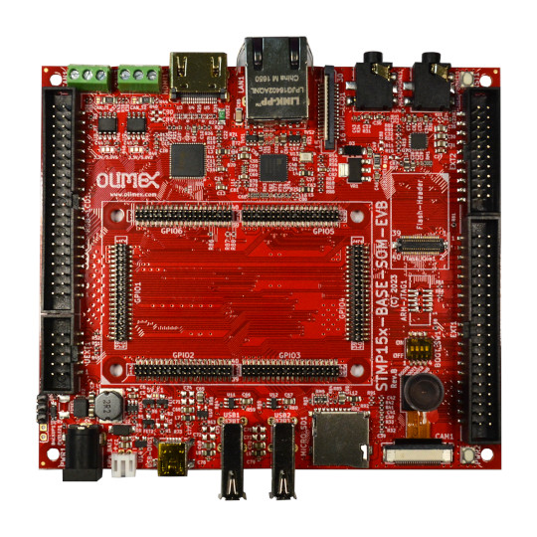
CAN1 CAN2
HDMI
LAN
MIC
headphones
RESET
Audio codec

EXT2
Flash module
LCD

JTAG
EXT1
STMP157-BASE-SOM
Boot config
CSI 2Mpix camera
POWER
Micro SD card
USB 2.0 Host x2
USB-OTG
LiPo
PWR +5V
Debug
UEXT

STMP157-BASE-SOM-EVB schematics:

STMP157-BASE-SOM-EVB latest schematic is on GitHub
STMP157-BASE-SOM-EVB is Open Source Hardware and all source CAD files are on GitHub.

SOFTWARE

- Recommended Olimage Linux images and changelog
- Olimage Linux guide

Revision History
Revision 1.0 November 2023 initial

