

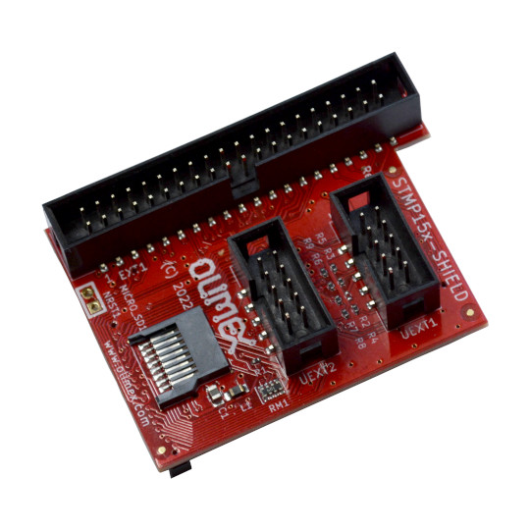

STMP15X-SHIELD
User Manual

Rev.1.0 October 2022
olimex.com

Table of Contents
What is STMP15X-SHIELD 3
STMP15X-SHIELD ordering options 4
STMP15X-SHIELD Open Source Licensee 5
STMP15X-SHIELD software installation 6
STMP15X-SHIELD connector pinout description: 7
STMP15X-SHIELD schematic 9
STMP15X-SHIELD schematic on GitHub 9
Revision History 10

What is STMP15X-SHIELD

STMP15X-SHIELD is Open Source Hardware Industrial grade -25+85ºC development board compatible with STMP157-OLinuXino and adds:

- two UEXT connectors
- 40 pin GPIO connector with 0.1” step (2.54 mm) step
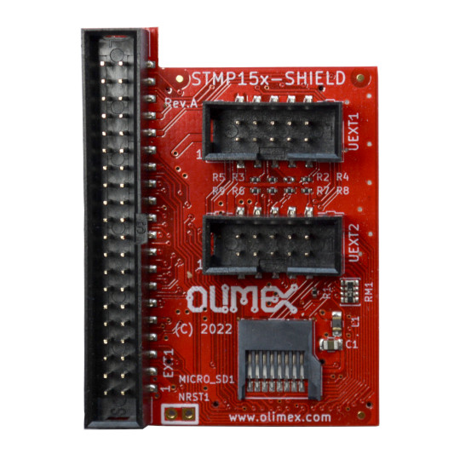
- micro SD card connector
UEXT 1
UEXT 2
Micro SD card
40 pin GPIO 0.1” (2.54 mm) step connector

STMP15X-SHIELD ordering options

STMP15X-SHIELD can be ordered as:
- STMP15X-SHIELD

Additional accessories:
Micro SD cards: MICRO-SD-CLASS10
UEXT cables: CABLE-IDC10-15cm
UEXT modules: UEXT-MODULES
Jumper wires: JW-200x10-FF, JW-200x10-FM

STMP15X-SHIELD Open Source Licensee
STMP15X-SHIELD is Open Source Hardware.

The Hardware files are released under CERN OSHW licensee.
The software is released under GPL 3 licensee.
The documentation is released under CC BY-SA 3.0 licensee.

STMP15X-SHIELD software installation

STMP15X-SHIELD overlays are set by default in OLIMAGE Linux generated images.

STMP15X-SHIELD connector pinout description:
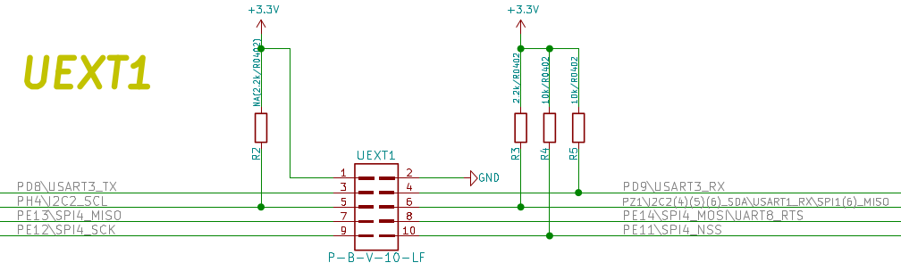
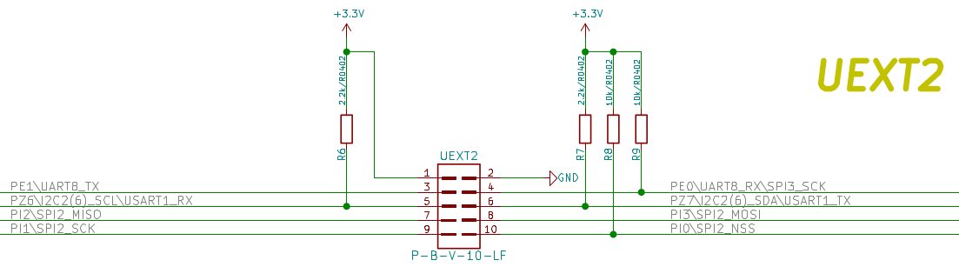
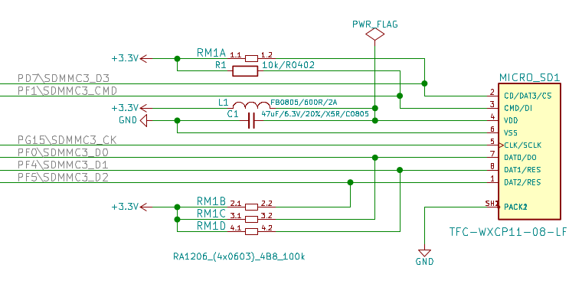

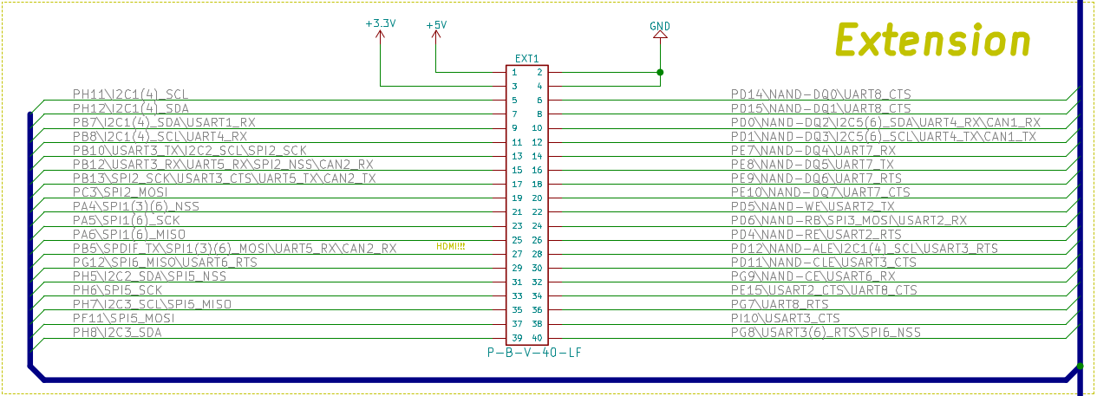

STMP15X-SHIELD schematic

STMP15X-SHIELD schematic on GitHub

Revision History
Revision 1.0 October 2022

