

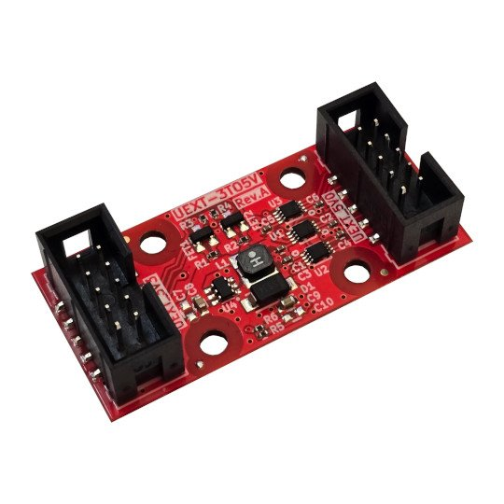

UEXT-3TO5V
User Manual
Rev.1.0 June 2025 olimex.com
Table of Contents
Introduction to UEXT-3TO5V 3
Order codes for UEXT-3TO5V: 4
HARDWARE 5
UEXT-3TO5V layout 6
UEXT-3TO5V schematic: 7
UEXT connector signals: 8
Revision History 9

Introduction to UEXT-3TO5V

UEXT standard is for 3.3V devices. This is natural as most of modern processors work on 3.3V.
Sometimes though is necessary to access sensors and devices which work on 5V. In this case we need level converters.
Also it’s nice to power these sensors and devices from the UEXT, so step up converter from 3 to 5V is also necessary.

UEXT-3TO5V solves these issues. It have step up converter which takes power from the 3V UEXT connector and convert it to 5V.
Also all UEXT signals UART, I2C, SPI have proper level shifters so these interfaces can be used on 5V devices.

Note that UEXT-3TO5V is not reversible i.e. can’t be used to access 3V devices from 5V UEXT because of the step up converter it’s unidirectional and only produces 5V from 3.3V not vice versa!
The maximum current which the step up converter can produce is 1A (if the UEXT 3.3V can provide enough current).

Order codes for UEXT-3TO5V:

UEXT-3TO5V UEXT converter from 3V to 5V with step up converter and level shifters

HARDWARE

UEXT-3TO5V layout

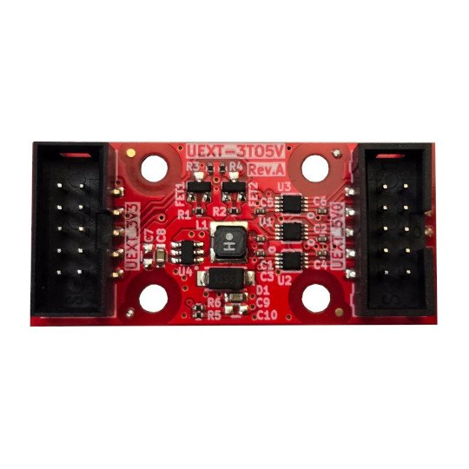
UEXT 3.3V side
UEXT 5V side
3V to 5V converter
Level Shifters

UEXT-3TO5V schematic:
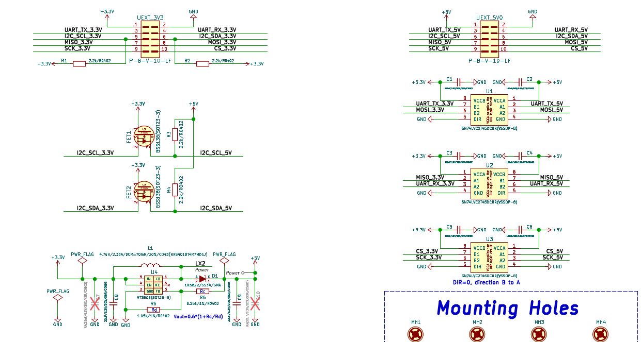

UEXT connector signals:
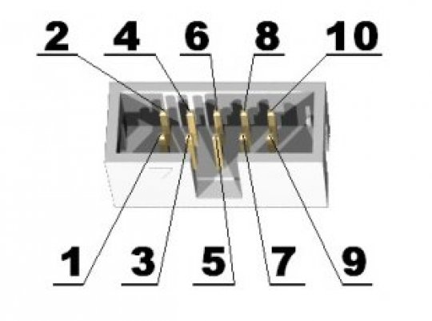
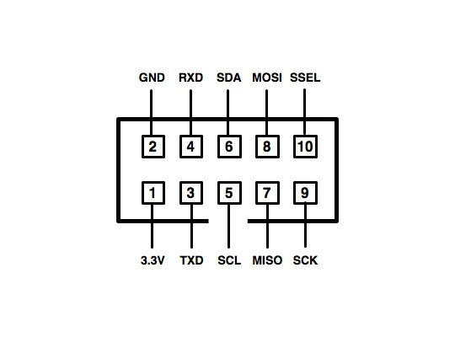

Revision History
Revision 1.0 June 2025

