

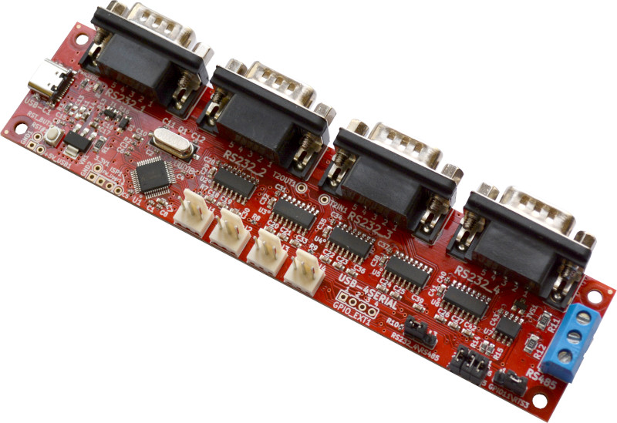

USB-4SERIAL
User Manual
Rev.1.0 May 2023 olimex.com

Table of Contents
Introduction to USB-4SERIAL 3
USB-4SERIAL features 4
Order codes for USB-4SERIAL and accessories: 5
HARDWARE 6
USB-4SERIAL layout: 7
USB-4SERIAL schematic: 8
USB-4SERIAL jumpers 9
SOFTWARE: 10
Revision History 11

Introduction to USB-4SERIAL

USB-4SERIAL is Open Source Hardware Industrial grade board which adds Four Serial ports to any computer with USB port.
The First one of these Four Serial ports have RTS / CTS control while the other three are only with Tx and Rx signals.
The Fourth Serial port can be configured to have RS232 levels or RS485 current loop, thus enabling communication with industrial RS485 equipment.
The Serial ports have DB9 connectors with RS232 levels, but TTL 3.3V level Serial ports are also available on separate 0.1” 2.54mm step connectors which you can connect to embedded boards working on 3.3V
If you have more than one USB ports you can connect more USB-4SERIAL to each of them and you can have multiply x 4 Serial ports.

USB-4SERIAL features

- USB-C High Speed USB 2.0 connector for powering the board and communication
- The serial ports can be with baud rate up to 12Mbps on the TTL connector and up to 115200 bpx on RS232 levels connectors.
- The serial ports are compatible with 16C550 UART and support 5, 6, 7 or 8 data bits and 1 or 2 stop bits, odd, even, none, blank0, mark1 and other parity.
- Supports RTS and CTS hardware automatic flow control for the First one RS232 Serial port.
- Supports half-duplex and RS485 switching for the Fourth port.
- RS485 direction flow selectable by RTS3 or GPIO11
- Reset button
- High reliable industrial grade design -40+85C
- CE-RED and LVD certification
- Four mount holes 3 mm
- PCB dimensions: (150 x 35)mm ~ (5.9 x 1.38)"

Order codes for USB-4SERIAL and accessories:

USB-4SERIAL industrial grade -40+85C board
CABLE-USB-A-C-1M USB-A to USB-C cable 1 meter long

HARDWARE

USB-4SERIAL layout:

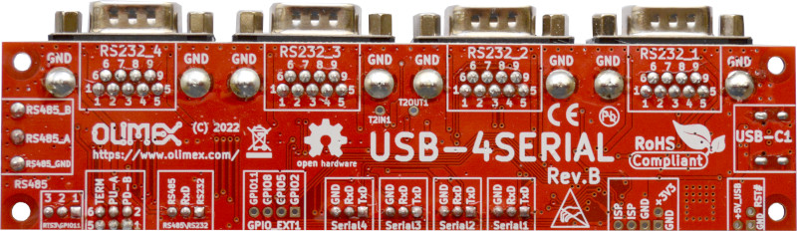
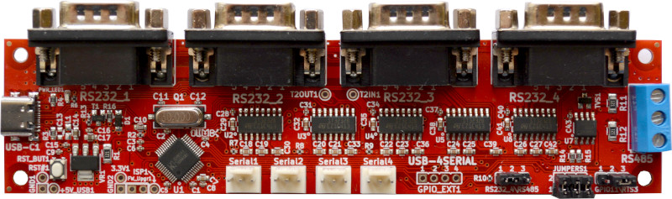
RS232 Serial1
RS232 Serial2
RS232 Serial3
RS232 Serial4
RS485
USB-C
TTL Serial1
TTL Serial2
TTL Serial3
TTL Serial4
RS232/RS485
Select Jumper
RS485 config
Jumper
RTS3/GPIO
Jumper

USB-4SERIAL schematic:

USB-4SERIAL is Open Source Hardware designed with KiCAD, the source files are on GitHub and the Latest schematic in PDF format is here.

USB-4SERIAL jumpers

RS232/RS485 Jumper
1-2 selects RS232 function for Serial4
2-3 selects RS485 function for Serial4

RS485 Jumer
1-2 Pull down resistor to RS485 B node
3-4 Pull up resistor to RS485 A node
5-6 Terminal Resistor between A-B

RTS3/GPIO Jumper
1-2 selects RS485 data flow to be controlled by GPIO11
2-3 selects RS485 data flow to be controlled by RTS3

SOFTWARE:

Linux drivers:
You need to download and install the drivers from GitHub.
When USB-C is plug Four new serial ports will be visible in /dev/tty*

Windows drivers:
Usually are not necessary, When USB-C is plug Four COM ports will be visible in the Windows Device Manager

Revision History
Revision 1.0 May 2023

