

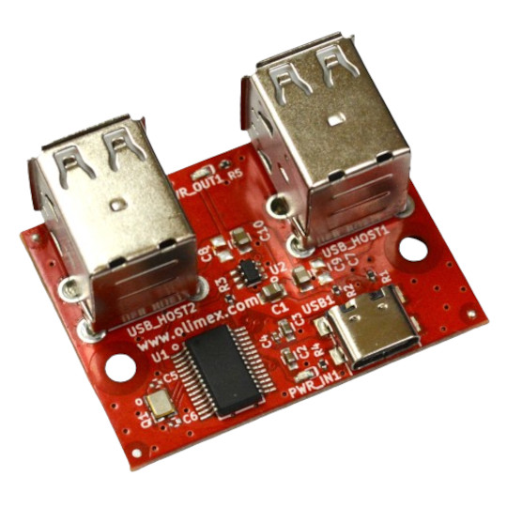

USB-NeoHub
User Manual
Rev.1.0 February 2024 olimex.com
Table of Contents
What is USB-NeoHub 3
USB-NeoHub features: 4
Order codes for USB-NeoHub: 5
HARDWARE 6
USB-NeoHub layout: 7
USB-NeoHub schematics: 8
Revision History 9

What is USB-NeoHub

USB-NeoHub is USB hub which is both USB 1.1 and USB 2.0 compatible. This is important as Neo6502 modern retro computer uses RP2040 to interface USB keyboards and USB Flash drives.
RP2040 USB interface is USB 1.1
For some weird reason not all USB hubs on the market support this standard which leads to incompatibilities. If you attach USB keyboard to Neo6502 it works, same is if you attach directly USB Flash. But if you attach USB keyboard through USB hub there is 50:50 chance that it may or may not work.
To save the customer frustration we decided to find USB hub chip set which guaranteed works with Neo6502.
This is how USB-NeoHub was made.

USB-NeoHub features:

- USB 1.1 and USB 2.0 compliant
- USB-C device input
- USB-A x4 host outputs
- works with Neo6502, PC, OLinuXino, Raspberry Pi, RP2040-PICO and RP2040-PICO W
- Industrial grade -40+85C
- Dimensions are: 46 x 34

Order codes for USB-NeoHub:

USB-NeoHub industrial grade -40+85C USB hub compatible with Neo6502
USB-CABLE-A-TO-C-1M USB-C cable

HARDWARE

USB-NeoHub layout:

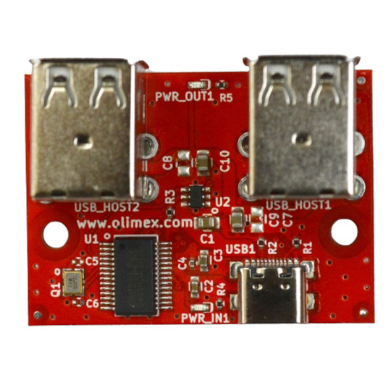
USB-C power indicator
USB-C device input
Dual USB-A host
USB host power indicator
Dual USB-A host

USB-NeoHub schematics:

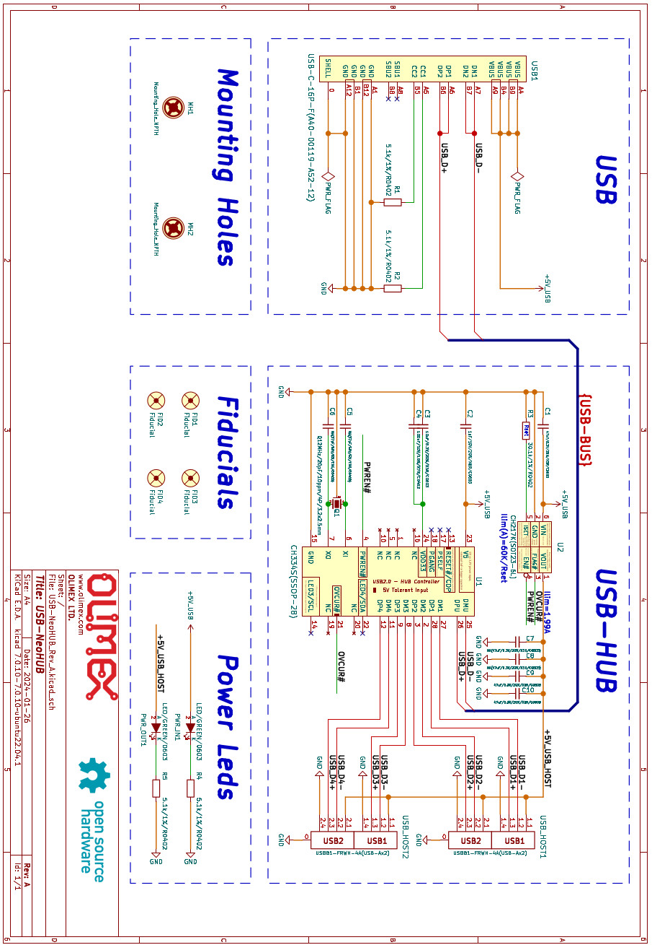

Revision History
Revision 1.0 February 2024

