

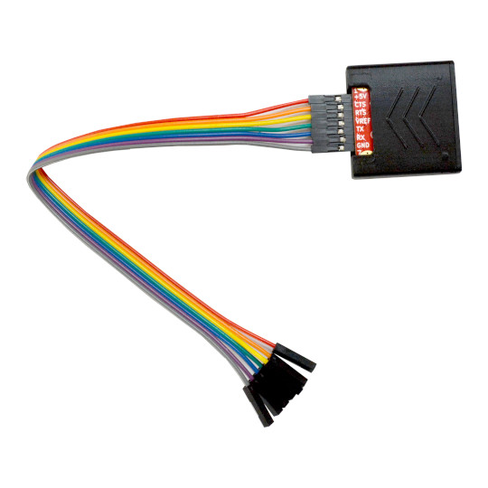

USB-SERIAL-L
User Manual
Rev.1.1 November 2024 olimex.com
Table of Contents
What is USB-SERIAL-L 3
USB-SERIAL-L features: 4
HARDWARE 5
Schematic: 6
SOFTWARE 7
Order codes for USB-SERIAL-L 8
Revision History 9

What is USB-SERIAL-L

USB-SERIAL-L is our most sophisticated USB to Serial convertor. It can work with any of our development boards as serial debug cable, or bootloader programmer for ESP32.
Compared to our other USB to SERIAL products it have two major advantages:
1. Speed - The high speed up to 3Mbps, for comparison USB-SERIAL-F can work only up to 1Mbps, BB-CH340T can work only up to 2Mbps.
2. Voltage levels - USB-SERIAL-L can work with targets from 0.65V up to 5.5V. To adjust the voltage levels USB-SERIAL-L have dedcated signal line Vref which has to be connected to target VCC. If this signal is left floating the voltage levels will be default to 3V.
3. Signals - USB-SERIAL-L provide +5V from the USB to the target circuit.
The SERIAL interface has 4 signals Tx, Rx, RTS, CTS. Vref allow the voltage levels to be adjusted to these of the target.
USB-SERIAL-L have nice 3D printed enclosure and comes with 200 mm long cables. The USB is connected with USB-C connector.
USB-SERIAL-L provide 7 signals in this order +5V, CTS, RTS, Vref, Tx, Rx, GND.

USB-SERIAL-L features:

- vaiable baud rate from 50bps up to 3Mbps
- output buffers with adjustable levels from 0.65 up to 5.5V
- Seven signal lines: +5V, GND, CTS, RTS, TX, RX, Vref
- provide +5V to the target from USB power
- Based on CP2102N from SiliconLabs and have drivers for Windows, Linux, Android, MacOS
- Three status LEDs: power, TX, RX
- Custom 3D printed plastic box
- Dimensions: 35 x 35 x 8 mm

HARDWARE

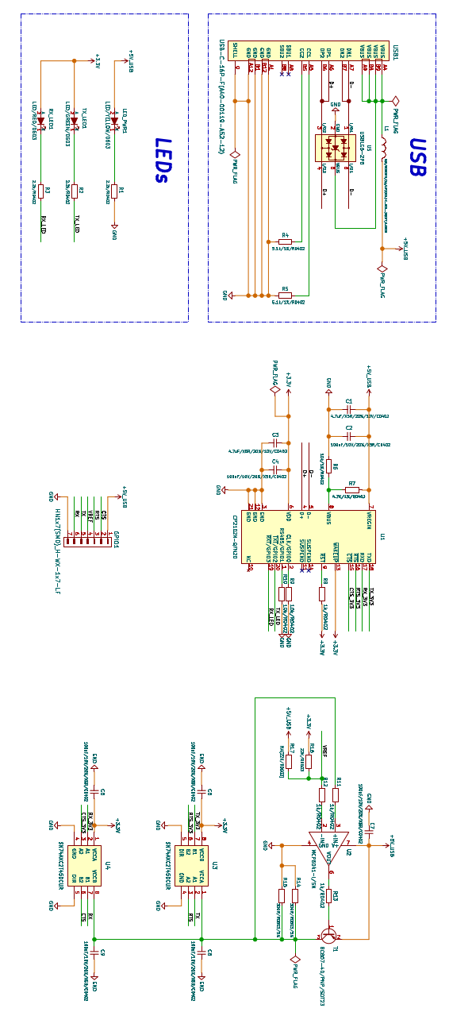
Schematic:

SOFTWARE

Drivers for CP2102N can be download from here.
Note that you have to install your drivers before you plug USB-SERIAL-L to your computer.

Order codes for USB-SERIAL-L

USB-SERIAL-L USB2.0 to Serial converter with speed up to 3Mbps and adjustable voltage levels from 0.65V to 5.5V

Revision History
Revision 1.0 October 2024
Revision 1.1 November 2024

